1.Query the list of *CITY* names from **STATION** that either do not start with vowels or do not end with vowels. Your result cannot contain duplicates.

**Input Format**

The **STATION** table is described as follows:

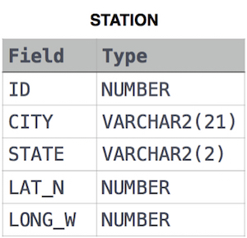

Ans:

SELECT DISTINCT CITY FROM STATION WHERE CITY NOT LIKE 'A%' AND CITY NOT LIKE 'E%' AND CITY NOT LIKE 'I%' AND CITY NOT LIKE 'O%' AND CITY NOT LIKE 'U%'OR CITY NOT LIKE '%A'AND CITY NOT LIKE '%E' AND CITY NOT LIKE '%I' AND CITY NOT LIKE '%O' AND CITY NOT LIKE '%U';

2.Query the list of *CITY* names from **STATION** that *do not start* with vowels and *do not end* with vowels. Your result cannot contain duplicates.

**Input Format**

The **STATION** table is described as follows:



Ans:

SELECT DISTINCT CITY FROM STATION WHERE CITY NOT LIKE 'A%' AND CITY NOT LIKE 'E%' AND CITY NOT LIKE 'I%' AND CITY NOT LIKE 'O%' AND CITY NOT LIKE 'U%' AND CITY NOT LIKE '%A' AND CITY NOT LIKE '%E' AND CITY NOT LIKE '%I' AND CITY NOT LIKE '%O' AND CITY NOT LIKE '%U';

3.Write a query that prints a list of employee names (i.e.: the *name* attribute) for employees in **Employee** having a salary greater than  per month who have been employees for less than  months. Sort your result by ascending *employee_id*.

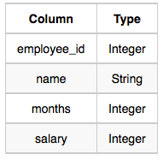

Ans:

SELECT NAME FROM EMPLOYEE WHERE SALARY>2000 AND MONTHS<10 ORDER BY EMPLOYEE_ID ASC

4. Samantha was tasked with calculating the average monthly salaries for all employees in the **EMPLOYEES** table, but did not realize her keyboard's  key was broken until after completing the calculation. She wants your help finding the difference between her miscalculation (using salaries with any zeros removed), and the actual average salary.

Write a query calculating the amount of error (i.e.:  average monthly salaries), and round it up to the next integer.

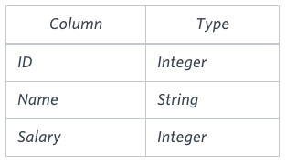

Ans:

SELECT CEIL(AVG(SALARY)-AVG(REPLACE(SALARY,0,''))) FROM EMPLOYEES;