1. We define an employee's *total earnings* to be their monthly  worked, and the *maximum total earnings* to be the maximum total earnings for any employee in the **Employee** table. Write a query to find the *maximum total earnings* for all employees as well as the total number of employees who have maximum total earnings. Then print these values as  space-separated integers.

**Input Format**

The **Employee** table containing employee data for a company is described as follows:

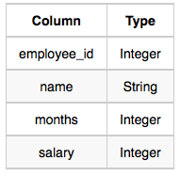

Ans:

SELECT (MONTHS*SALARY) AS EARNINGS,COUNT(*) FROM EMPLOYEE

GROUP BY EARNINGS

ORDER BY EARNINGS DESC LIMIT 1;

2. Query the following two values from the **STATION** table:

1. The sum of all values in *LAT_N* rounded to a scale of  decimal places.
2. The sum of all values in *LONG_W* rounded to a scale of  decimal places.

**Input Format**

The **STATION** table is described as follows:

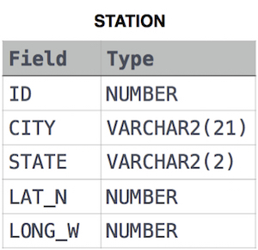

Ans:

SELECT ROUND(SUM(LAT_N), 2), ROUND(SUM(LONG_W), 2) FROM STATION;

3. Query the sum of *Northern Latitudes* (*LAT_N*) from **STATION** having values greater than 38.7880 and less than 137.2345. Truncate your answer to 4 decimal places.

**Input Format**

The **STATION** table is described as follows:



Ans:

SELECT ROUND(SUM(LAT_N),4) FROM STATION WHERE LAT_N>38.7880 AND LAT_N<137.2345;

4. Query the greatest value of the *Northern Latitudes* (*LAT_N*) from **STATION** that is less than . Truncate your answer to  decimal places.

**Input Format**

The **STATION** table is described as follows:



Ans:

SELECT ROUND(MAX(LAT_N),4) FROM STATION WHERE LAT_N<137.2345;