1. Query the list of *CITY* names starting with vowels (i.e., a, e, i, o, or u) from **STATION**. Your result *cannot* contain duplicates.

**Input Format**

The **STATION** table is described as follows:

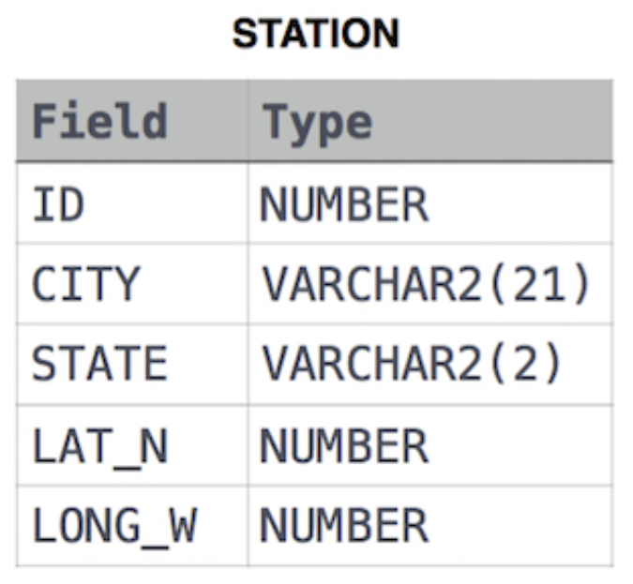

**Ans**:

SELECT DISTINCT CITY FROM STATION WHERE CITY LIKE 'a%' OR CITY LIKE 'e%' OR CITY LIKE 'i%' OR CITY LIKE 'o%' OR CITY LIKE 'u%';

**Output**:

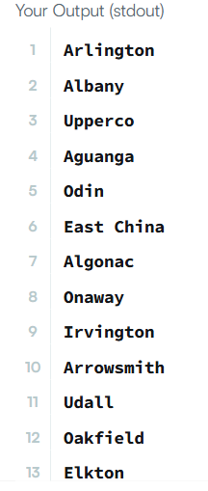

2. Query the list of *CITY* names ending with vowels (a, e, i, o, u) from **STATION**. Your result *cannot* contain duplicates.

**Input Format**

The **STATION** table is described as follows:



**Ans**:

SELECT DISTINCT CITY FROM STATION WHERE CITY LIKE '%a' OR CITY LIKE '%e' OR CITY LIKE '%i' OR CITY LIKE '%o' OR CITY LIKE '%u';

**Output**:

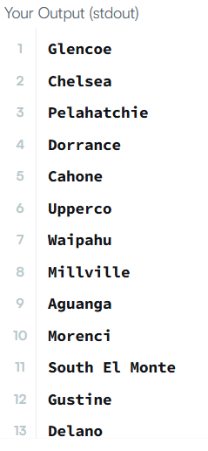

3. Query the list of *CITY* names from **STATION** which have vowels (i.e., *a*, *e*, *i*, *o*, and *u*) as both their first *and* last characters. Your result cannot contain duplicates.

**Input Format**

The **STATION** table is described as follows:



**Ans**:

SELECT distinct CITY FROM STATION where (CITY LIKE 'a%' OR CITY LIKE 'e%' OR CITY LIKE 'i%' OR CITY LIKE 'o%' OR CITY LIKE 'u%') AND (CITY LIKE '%a' OR CITY LIKE '%e' OR CITY LIKE '%i' OR CITY LIKE '%o' OR CITY LIKE '%u')

**Output**:

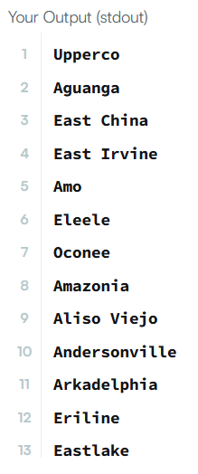

4. Query the list of *CITY* names from **STATION** that *do not start* with vowels. Your result cannot contain duplicates.

**Input Format**

The **STATION** table is described as follows:



**Ans**:

SELECT DISTINCT city FROM STATION WHERE city Not like 'A%' and city Not like 'E%' and city Not like 'I%' and city Not like 'o%' and city not like 'U%';

**Output**:

