Publishing an App on Play Store details(Android Application)

Play Store developer account
Username: email@mail.com
Password: ******

(I). Product Details

(1). Title (Mandatory) – App Title

(2). Short Description (Mandatory) –
Short description about your Application. There is an 80 characters limit in this.

(3). Full Description (Mandatory) –
Detailed description about your application. There is a 4000 characters limit in this.

(II). Graphic assets

(1). App Screenshots (Mandatory)
App screenshots are required in following dimensions –
Width: 480 px
Height: 850 px
You can take screenshots for Home Scree, Login, Signup, and Product View. Like below
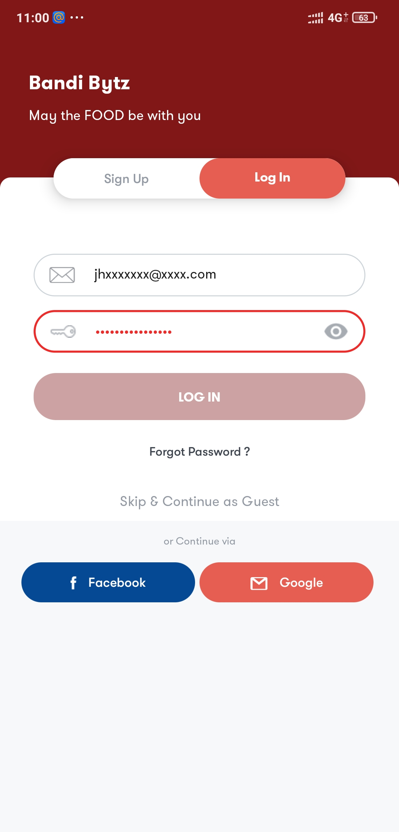

(2). Hi-res app icon (Mandatory)

Dimension for App icon is 512px * 512px, example below -


(3). Feature Graphic (Mandatory)
A featured banner is required to be uploaded on Play-store while app submission. Dimension should be
Width: 1024px
Height: 500px
Sample banner is attached below -
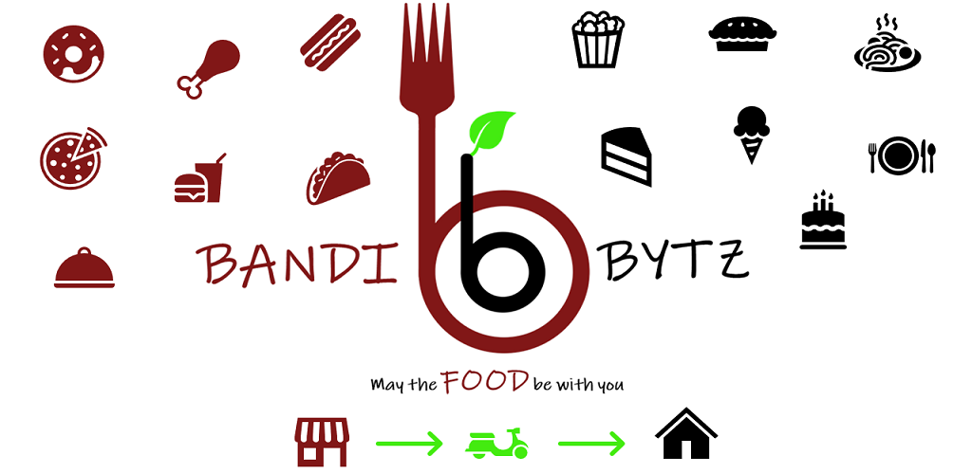

(III). Categorization of App

(1). Application Type (Mandatory) – Type of your Application, like “Online Food Delivery”

(2). Category (Mandatory) – __________________

Select any one Category from below:
- Art & Design
- Auto & Vehicles
- Beauty
- Books & Reference
- Business
- Comics
- Communication
- Dating
- Education
- Entertainment
- Events
- Finance
- Food & Drink
- Health & Fitness
- House & Home
- Libraries & Demo
- Lifestyle
- Maps & Navigation
- Medical
- Music & Audio
- News & Magazines
- Parenting
- Personalization
- Photography
- Productivity
- Shopping
- Social
- Sports
- Tools
- Travel & Local
- Video Players & Editors
- Weather

(IV). Contact Details

(1). Website (Optional) –

(2). Email (mandatory) – support@example.com

(3). Phone (Optional) – +91 89512*****

(V). TNC & Privacy Policy

(1). Privacy Policy – https://bandibytz.com/privacy-policy
(1). Terms & Condition –

(VI). Pricing & Distribution

(1). Paid/Free - Free
(2). Default price (Mandatory if paid) – Not applicable

(3). Auto price conversion – Not applicable

(4). Distribute in these countries - India

(5). Android Wear – Not Applicable

(6). Google Play for Education - No

(7). Content guidelines (Mandatory) - Check this box for the app to meet Android Content Guidelines.

(8). US export laws (Mandatory) – No

(9). Target audience and content
(You must let us know the target age group of your app, and other information about its contents. This helps make sure that apps designed for children are safe and appropriate)
- 5 and under
- 6-8
- 9-12
- 13-15
- 16-17
- 18 and over

(10). Tags (Add up to 5 tags to describe the content and functionality of your app.)
Add tags to describe the content and functionality of your app. Tags may affect where your app is displayed on Google Play, and the peer groups you're compared against. Choose from the available ones from –
Complete List of Available Google Play Store Tags - ASO Blog (apptweak.com)

