1. System requirements: Arcmap 10.5 or higher version, ArboLiDAR 3.13.0 or greater version, Python 3.8 or higher version, OSGeo4W/GDAL installation (<https://www.youtube.com/watch?v=4viTd3n9C9g> follow the video instruction), 7-Zip.
2. Create folders:
3. Create “xml2shp_Finland” folder and inside that folder create second folder “Newfolder”
4. Put all the files in xml2shp_Finland folder
5. XML files which you want to transfer:

Forestpropertydata.xml

specialfeaturedata.xml

1. AggregationResult3 ArboLiDAR tool

AggregateResults3.bat

StandAggregationTargets.xml

1. Python files which convert input stand data from xml to shp

Test_xml2shp_1.py

Stand_intersect_2.py

Unzip_gpkg_3.py

merge_griddata_renameField_4.py

Hila_intersect_forestdata_5.py

Shp2gdb_6.py

StandGdb2arbolidar_7.py

1. Running PYTHON files
2. Please make sure all the required python libraries are installed! You can uncomment python files libraries installation part!
3. Please make sure to change the path of each folder as described in python script.
4. Please make sure that program run successfully, and it prints “Program run successfully!'”
5. PLEASE RUN THERSE FILES SEQUENCIAL
6. Test_xml2shp_1.py file uses python advance library Geopandas. Run following with the python3.exe
7. Stand_intersect_2.py file requires Arcmap python library so please run following code with the arcmap python27.exe
8. Open arcmap installed folder

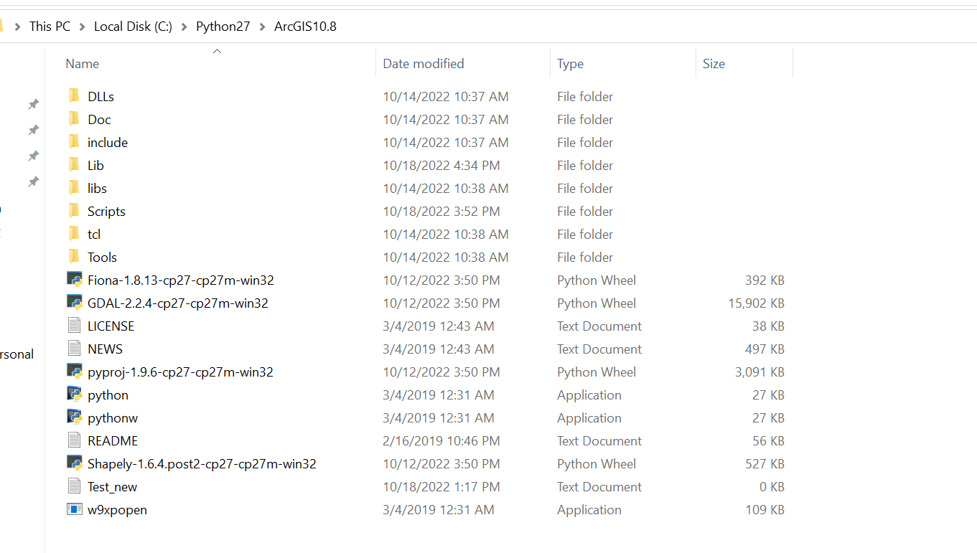

1. Type cmd at the folder path and press ENTER button

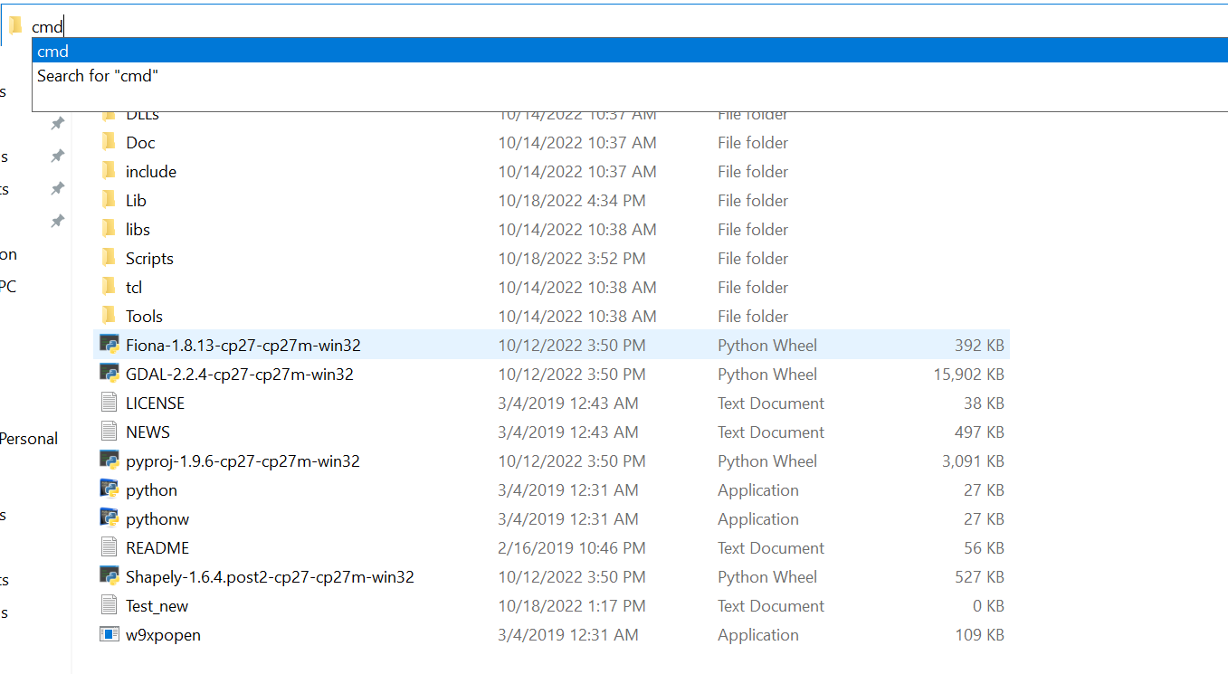

And after ENTER button, it will open command prompt

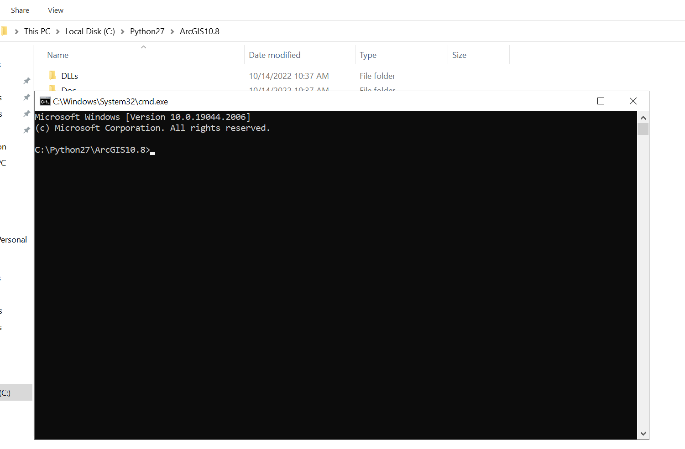

Now type python in the command prompt

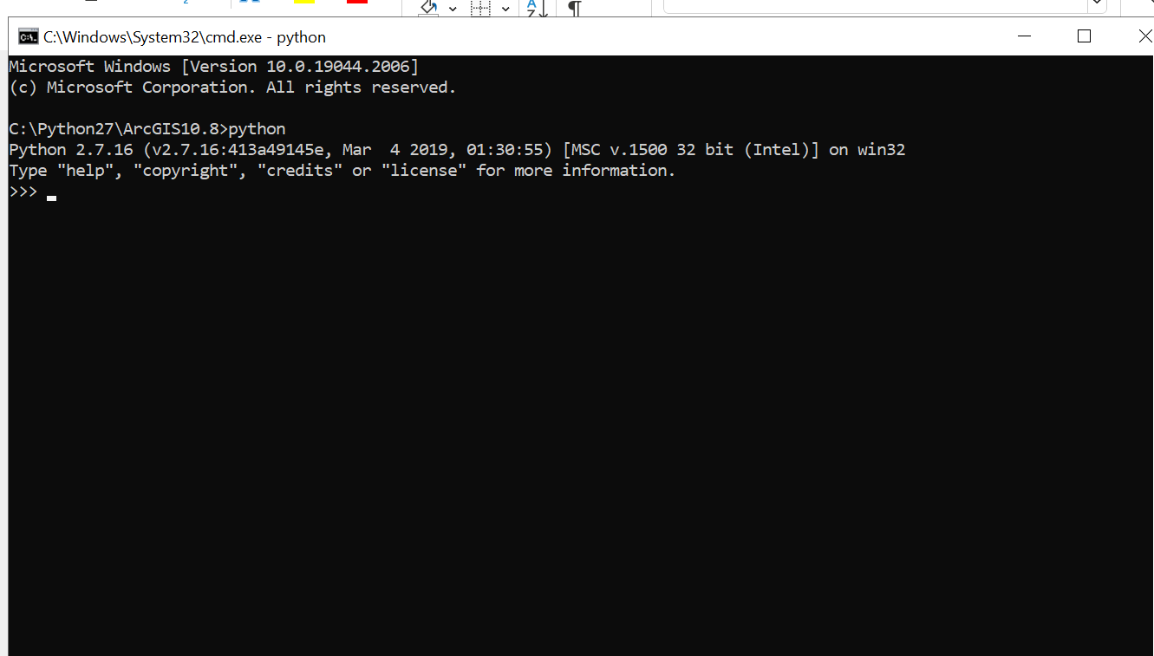

Next, paste your Stand_intersect_2.py code there and let it run

1. Unzip_gpkg_3.py run it with python3.exe
2. merge_griddata_renameField_4.py also run it with python3.exe, however this file will take time to run depending upon how big data is so make sure to let process finish.

It will print “Program run successfully!” which indicates it is finished.

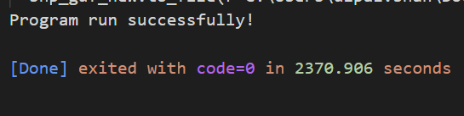

1. Hila_intersect_forestdata_5.py, Shp2gdb_6.py and StandGdb2arbolidar_7.py files you need to run with arcmap python.exe as described previously.
2. Once these file runs your result will get stored into Data.gdb folder.
3. Now to run new stand data to xml delete previous XML files which you transfer:

Forestpropertydata.xml

1. Repeat previous steps