1. A main page displaying all the chat messages.

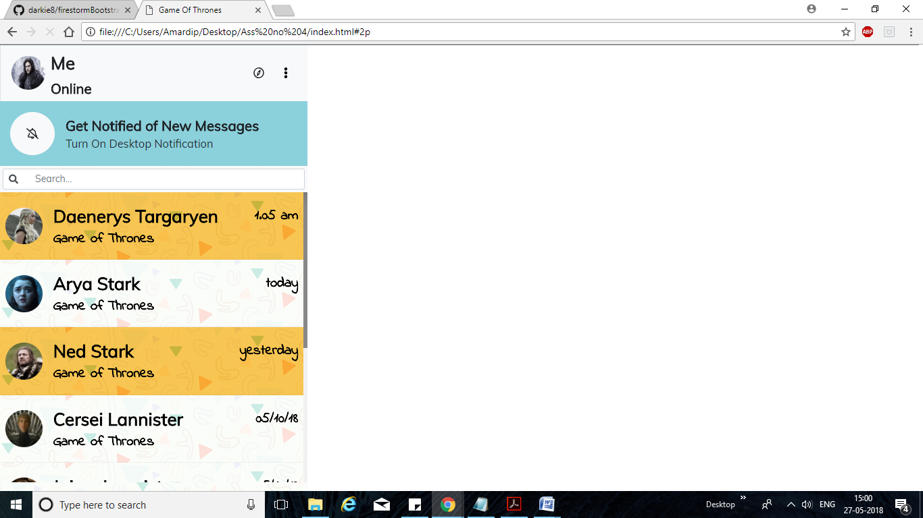

2) A chat view page containing messages with an individual or a group

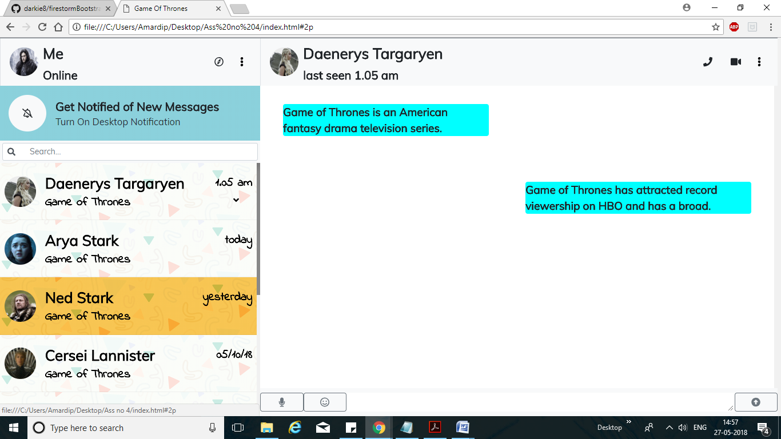

3) A view to change the profile picture.

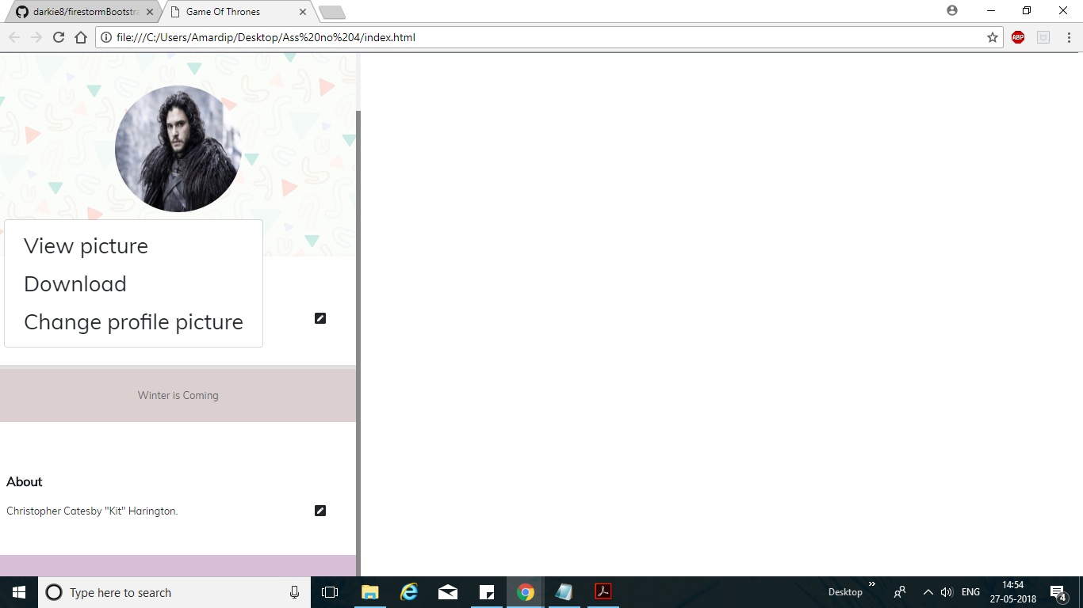

4) Another main page view which displays all the chat messages but contains some

unread messages from some people.

