Session 9

**Defect Life Cycle**

* Also called as Bug Life Cycle.

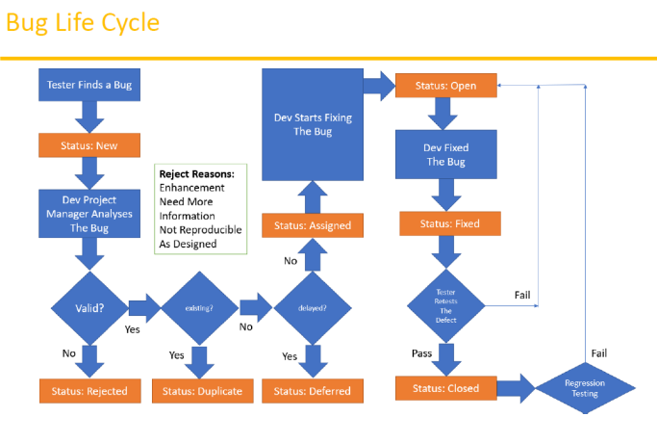

* Different statuses of Bug:
  + New
  + Rejected
  + Duplicate
  + Deferred
  + Assigned
  + Fixed
  + Close
* Reasons of Bug Rejection:
  + Means, in upcoming versions the bug would be converted to a feature.
  + Sometimes need more info.
  + Maybe as per the designed.

**Test Cycle Closure**

* It is the last phase of STLC.
* Activities performed:
  + Evaluate the cycle completion based on some criteria like Time, Cost, etc.
  + Prepare Test summary.
  + A report to the customer about the quality of work.
* Deliverables:
  + Test Closure Report
  + The metrics.

**Test Metrics**

* Data required before writing the metrics
  + No. of requirements
  + Test Cases performed (Passed and Failed)
  + Defects count.
* It’s notable that metrics is in various percentage forms like:
* Test related metrics%
  + of test cases Executed
  + % of tests cases not Executed
  + % of test cases passed
  + % of test cases failed
  + % of test cases blocked.
* Defect related metrics
  + No. of defects identified
  + DRE (Defect Removal Efficiency)
  + Defect leakage
  + *Defect Rejection Ratio*
  + Defect age
  + Customer satisfaction

**QA Activities**

* Understanding requirements
* Identifying required test scenarios
* Design test case
* Setting up Test Bed
* Execute test cases
* Log of test results
* Defect tracking
* Performs different Testing.

**Principles of Software Testing**

1. Start software testing at the early stages.
2. Test the software in order to find the defects.
3. Nearly impossible to provide the bug free product.
4. Should not do **Exhaustive Testing** (it means use variety of data for testing).
5. Testing should be **Context based**.
6. We should follow **Pesticide Paradox**.
7. We should follow **Defect Clustering**.