Chrome Dev Tools

A brief intro of Chrome DevTools:

* Chrome DevTools is a set of web development tools built directly into the Google Chrome browser.
* These tools provide developers with powerful debugging and diagnostic capabilities, making it easier to build, test, and optimize web applications.
* DevTools allows you to inspect the DOM, monitor network activity, debug JavaScript, analyze performance, and much more.
* Purpose:
  + Inspecting and modifying DOM
  + Debugging JS
  + Monitoring Network Activity
  + Performance Profiling
  + Security and App. Audits
  + Mobile Emulation

Usage of Chrome DevTools for QA:

* We use it for easier testing, to improve our bug reports and help developers with bug fixing.
* Some scenarios in which we can use Chrome DevTools:
  + when there is a backend bug and you cannot see it on UI
  + when you want to clear cache, cookies or server data
  + when you want to check if the page is implemented by design
  + when you want to see if the frontend app is sending requests to backend
* Chrome DevTools:
  + Inspect element
  + Device Toolbar
  + Styles Tab
  + Console
  + Network Panel
  + Lighthouse
  + Application Panel (for cache, cookies, session and local storage)
  + (Doubt: where is content in this folder?) <https://prnt.sc/fkDJyjAmHf8Y>

Inspecting Page Markup

* Elements: In elements panel you can see page structure in HTML and CSS.
* Inspect Element: Used to select any specific element.

Difference between Client Side and Server-Side Validation

| **Aspect** | **Client-Side Validation** | **Server-Side Validation** |
| --- | --- | --- |

|  |  |  |
| --- | --- | --- |
| **Location** | Happens in the browser (user's device). | Happens on the server after data is sent from the client. |

|  |  |  |
| --- | --- | --- |
| **Purpose** | Provides immediate feedback to users and reduces server load. | Ensures security, data integrity, and final validation. |

|  |  |  |
| --- | --- | --- |
| **Tools in Chrome DevTools** | - **Elements Tab**: Modify HTML to test validation.  - **Console Tab**: Test JavaScript-based validations.  - **Network Tab**: Observe if invalid data is sent to the server. | - **Network Tab**: Check server responses for invalid data submissions.  - Modify requests to test server-side handling of invalid inputs. |

|  |
| --- |
|  |

Using Inspector tool to modify elements in order to bypass Client-Side Validation

* Using Chrome DevTools, you can modify a webpage's HTML to bypass client-side validation. For example, you can remove the `required` attribute or change an `input` field's `type` (e.g., from `email` to `text`) to allow invalid inputs. This lets you test how the server handles bad data that skips client-side checks.

Accessibility Testing

* Accessibility testing is a process of making your web and mobile applications easily accessible to people with disabilities such as visual, hearing, mobility, and cognitive impairment.

Features in Chrome DevTools for Accessibility Testing

* Lighthouse:
* Run an Accessibility audit in Lighthouse to identify issues like contrast, missing labels, or ARIA attributes.
* Access via Lighthouse tab → Generate report.
* Accessibility Tree:
* Found in the Elements tab → Accessibility pane.
* Shows how assistive technologies (like screen readers) interpret the page structure.
* Color Picker:
* Use the Styles pane → Color preview tool to check contrast ratios against accessibility standards.
* Inspect ARIA and Semantic Elements:
* Check for proper use of ARIA roles and semantic HTML tags in the Elements tab.
* Accessible Rich Internet Applications (ARIA) is a W3C specification for markup that can be added to HTML to help screen readers and other assistive technologies to better understand the elements on a web page.

Simulating Mobile Devices

* Chrome dev tools provide the check on the multiple mobile resolutions via device toolbar.

Network panel

* In other words, in the network panel you can see all the data that is coming from the server. This data is needed for the page to load.
* Network throttling in Chrome DevTools simulates slower network conditions to test how your website or app behaves under different connection speeds, such as 3G, 4G, or offline scenarios. It helps you evaluate loading times, responsiveness, and user experience in varying conditions.

Console Panel

* In console panel you will see errors marked in red.
* The Console panel in Chrome DevTools is a powerful tool for debugging, testing, and experimenting with JavaScript on your web page.

Example:

<https://prnt.sc/K3TtjLdanbo6>

Lighthouse

* Lighthouse is a tool used for analysing web apps and web pages.
* Once the report is generated, it will give you 4 core aspects about Performance, Accessibility, Best Practices, and SEO.

Screenshot

* <https://prnt.sc/r7zn2cbWJY8J>
* Screenshot taken by Chrome DevTools
* 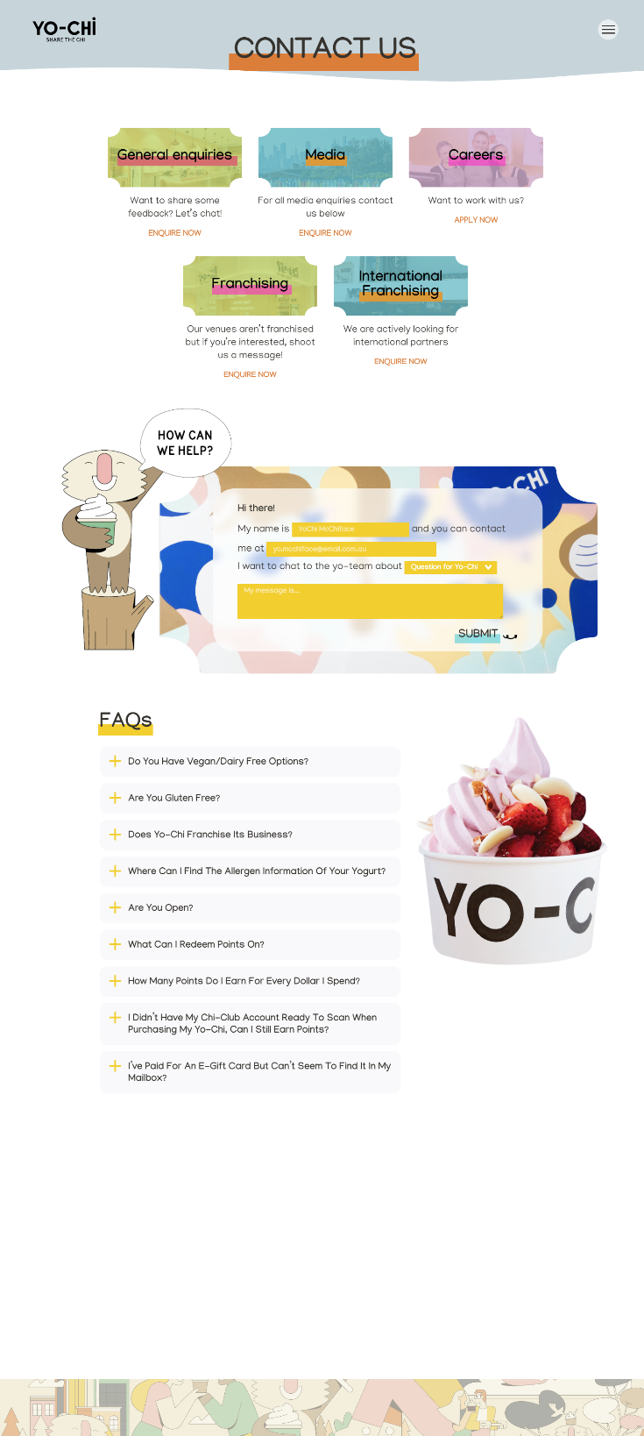
* Shortcut: Ctrl+Shift+P
* Screenshot using Lighthouse for Performance audit

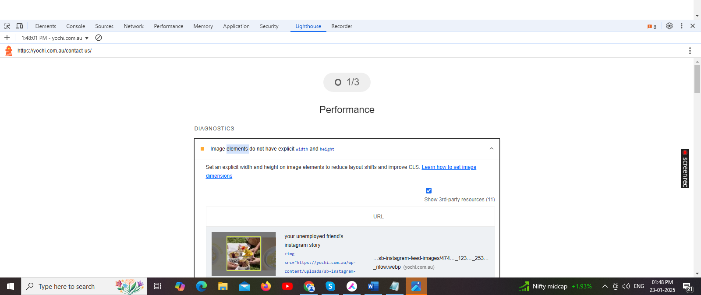

| **Screen Size (inches)** | **Resolution (px)** | **Device Type** | **Examples** |
| --- | --- | --- | --- |
| 1.2" | 240 x 240 | Smartwatch | Garmin, Fitbit |
| 1.5" | 280 x 280 | Smartwatch | Apple Watch Series 3 (small) |
| 2.4" | 240 x 320 | Feature Phone | Nokia 3310 (2017), Basic Phones |
| 3.5" | 320 x 480 | Older Smartphone | iPhone 3G, iPhone 3GS |
| 4.0" | 480 x 800 | Entry-level Smartphone | Samsung Galaxy Y, Older Android |
| 4.7" | 750 x 1334 | Smartphone | iPhone SE (1st Gen) |
| 5.5" | 1080 x 1920 | Smartphone | Google Pixel, Galaxy S5 |
| 6.1" | 1170 x 2532 | Smartphone | iPhone 14, iPhone 13 |
| 6.7" | 1284 x 2778 | Smartphone (Large) | iPhone 14 Pro Max, Galaxy S22 Ultra |
| 7.9" | 1536 x 2048 | Mini Tablet | iPad Mini (5th Gen) |
| 10.2" | 2160 x 1620 | Tablet | iPad (9th Gen) |
| 11" | 2388 x 1668 | Tablet | iPad Pro (11-inch, 4th Gen) |
| 12.9" | 2732 x 2048 | Tablet (Large) | iPad Pro (12.9-inch) |
| 13.3" | 1440 x 900 | Laptop | MacBook Air (M1), Entry-level laptops |
| 14" | 2880 x 1800 | Laptop (High-end) | MacBook Pro 14" (2021) |
| 15.6" | 1920 x 1080 | Laptop (Standard) | Dell XPS, HP Envy 15 |
| 17" | 2560 x 1440 | Large Laptop | Gaming laptops, Lenovo Legion 7 |
| 21.5" | 1920 x 1080 | Desktop Monitor | Standard Full HD Monitors |
| 24" | 2560 x 1440 | Desktop Monitor | Quad HD (2K) Monitors |
| 27" | 3840 x 2160 | 4K Monitor | 4K UHD Monitors |
| 32" | 3840 x 2160 | 4K TV/Monitor | Large 4K Monitors, TVs |
| 43" | 3840 x 2160 | 4K TV | Medium-sized 4K TVs |
| 55" | 3840 x 2160 | 4K TV | Large TVs (Samsung, LG, Sony) |
| 65" | 3840 x 2160 | 4K TV (Large) | Home Theater TVs |
| 77" | 7680 x 4320 | 8K TV | 8K Ultra HD TVs |
| 85" | 7680 x 4320 | 8K TV (Large) | Premium 8K TVs (Samsung, LG) |