Bootstrap

* Bootstrap is a free front-end framework for faster and easier web development.
* Bootstrap includes HTML and CSS based design templates for typography, forms, buttons, tables, navigation, modals, image carousels and many other, as well as optional JavaScript plugins.
* Bootstrap also gives you the ability to easily create responsive designs.
* Advantages of Bootstrap:
  + Easy to use: Anybody with just basic knowledge of HTML and CSS can start using Bootstrap
  + Responsive features: Bootstrap's responsive CSS adjusts to phones, tablets, and desktops
  + Mobile first approach: In Bootstrap, mobile-first styles are part of the core framework
  + Browser compatibility: Bootstrap 5 is compatible with all modern browsers (Chrome, Firefox, Edge, Safari, and Opera).
* To ensure proper rendering and touch zooming, add the following <meta> tag inside the <head> element:
* <meta name="viewport" content="width=device-width, initial-scale=1">
* Bootstrap requires a containing element to wrap site contents.

**Grids:**

* Bootstrap's grid system is built with flexbox and allows up to 12 columns across the page.
* The grid system is responsive, and the columns will re-arrange automatically depending on the screen size.
* The Bootstrap 5 grid system has six classes:
  + .col- (extra small devices - screen width less than 576px)
  + .col-sm- (small devices - screen width equal to or greater than 576px)
  + .col-md- (medium devices - screen width equal to or greater than 768px)
  + .col-lg- (large devices - screen width equal to or greater than 992px)
  + .col-xl- (xlarge devices - screen width equal to or greater than 1200px)
  + .col-xxl- (xxlarge devices - screen width equal to or greater than 1400px)

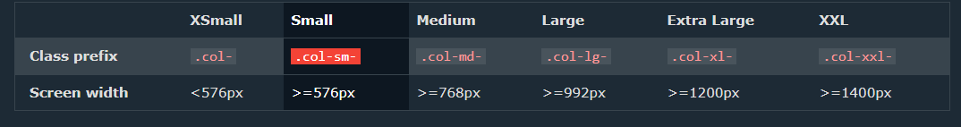

* Ex. of responsiveness using Grids:

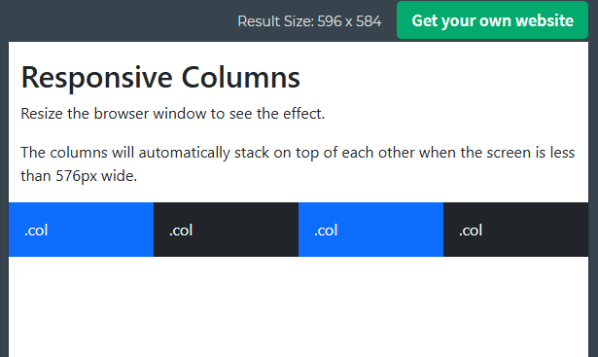

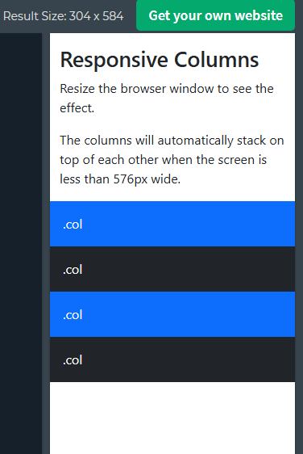

* Ex. 2 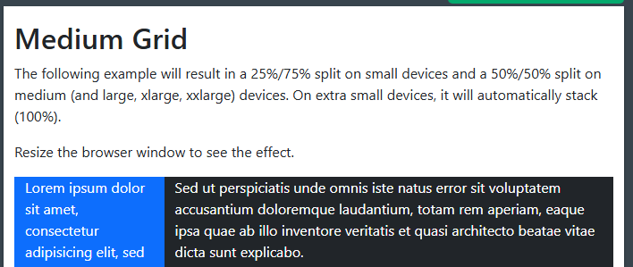

We can change order by using order-*

**Tables:**

* A basic Bootstrap 5 table has a light padding and horizontal dividers.
* Responsive Tables
* The .table-responsive class adds a scrollbar to the table when needed (when it is too big horizontally)
* The .img-fluid class is used to provide Responsive Images.

Iggy’s Bugs

(when compared with image and actual development *in same size ratio)

1. Difference in text [(i.e more and less brighten text is observed) https://prnt.sc/m0tPUkVUWrh_](https://prnt.sc/m0tPUkVUWrh_) & <https://prnt.sc/iw0HLlroMoOS>

2. Difference in FB logo <https://prnt.sc/E3ech2hyEPw7> & <https://prnt.sc/vubRjrkucuU->

3. No TikTok feed <https://prnt.sc/N9l6zRkZIDs2>

4. Round and Square edges difference found in Location section near google maps (Find Iggy’s) <https://prnt.sc/MDUQFnd1fcd-> & <https://prnt.sc/kc6NtLOLPYNQ>

5. A thin pink line in header is observed <https://prnt.sc/c85aRAo6D_6-> which is probably differs with this <https://prnt.sc/GX8pvOyhUho->

(When checking Responsiveness)

1. Suggestion: The carousels could be at the end of the content i.e. it shouldn’t come over the contents image. This is what we hv <https://prnt.sc/-PNiOc_bJ--F> bt it could be better.

2. When I reduce size nearly to 500 then content with carousel (i.e. in our flavors section) gets disappear after hitting the carousel at the very last one flavor i.e. wild berries like this:   
<https://prnt.sc/LEfDYgbVChDB>, <https://prnt.sc/mpoOn84jxxyK> [It should come to first image after hitting the last one also it could be added]

3. the email id should be clickable or should show a popup like thing to direct into the mailbox. <https://prnt.sc/rzSVhihucoeg>

4. In copyrights year should be updated from ’24 to ‘25 <https://prnt.sc/E6yPe1_o62KO>

5. Error Testing example i.e. a proper error msg should appear while writing invalid email format but it throws error “Registration Failed” after hitting the Sign Up button under this section Newsletter Signup, <https://prnt.sc/ZwSb88Hj0FTV>

6. Different behavior of Carousel for different screen sizes : <https://prnt.sc/3e_HyBx38260> &

<https://prnt.sc/wFsRY6FS915l>

7. Spacing possible between this two <https://prnt.sc/IwLs56dbXWH->

Responsiveness in Real Devices

1. Galaxy S22

* When we touch Who We Are from the menu it directs to the exact destination but Who We Are text itself is seeming half i.e. either it should appear entirely or shouldn’t. 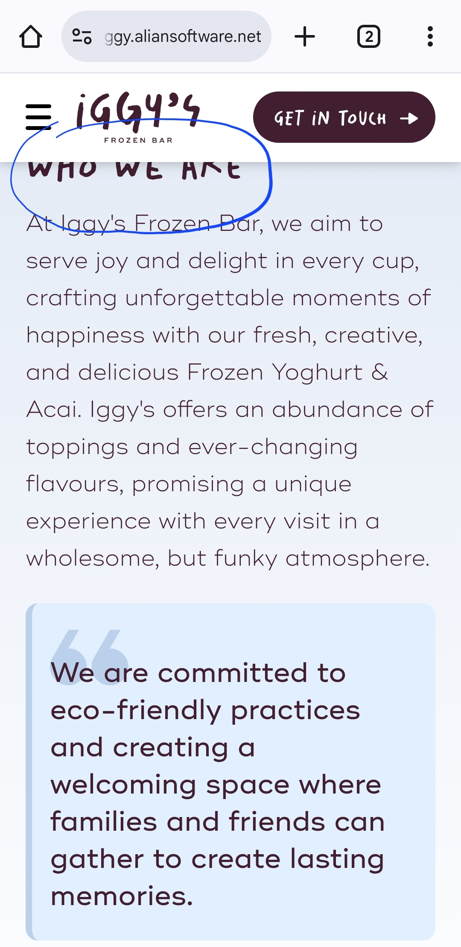
* Both “Get in Touch” (one at the top right and other one below Who We Are section) button directs to the specific content but both having difference in spacing

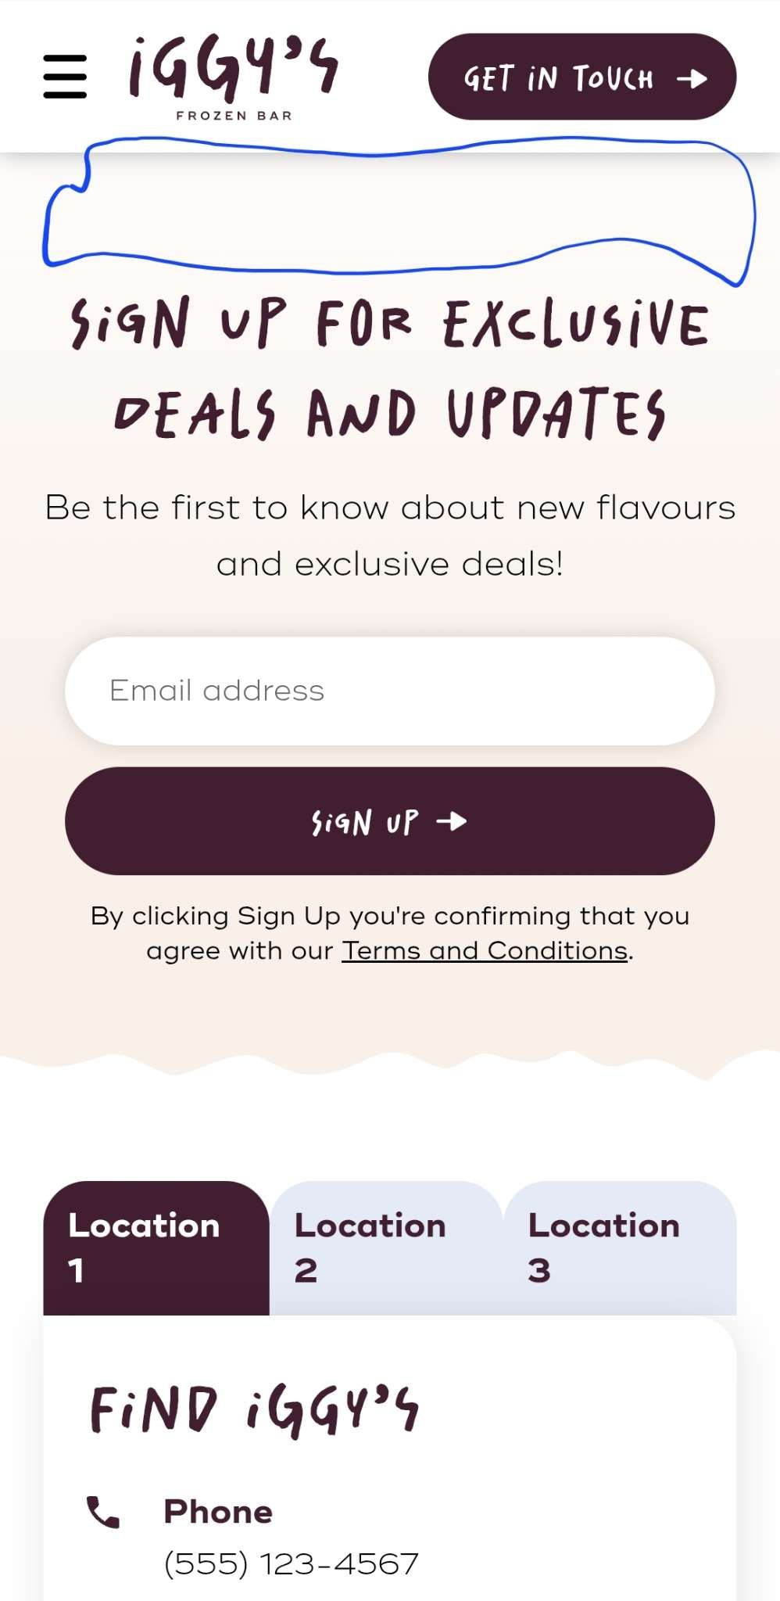

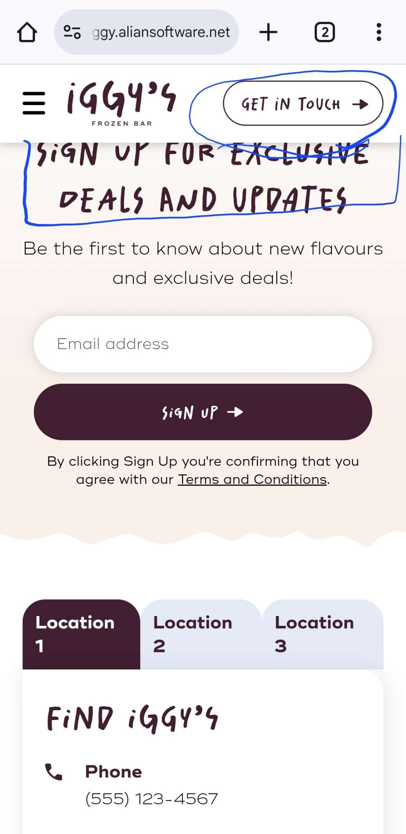

* Here y of Yoghurt could be capital <https://prnt.sc/w68YxaiIRfr8>
* No issues in iPhone 13 and 13 pro (safari) but both shows a link to address in Chrome.
* No issue in MacBook Pro 15.4 retina
* The text written in menu list should be placed a bit upward so user doesn’t require to scroll down again and again <https://prnt.sc/gKm-_v2m9wns>

HTML tags

1) email id to mailbox

<https://chatgpt.com/c/67985450-5e74-8005-8ca0-c7d0ae83be93>

