|  |  |  |
| --- | --- | --- |
| Tata AIA Life Insurance Company Ltd | | |
|  | Investigating Agency Details: FOXIVISION SCREENING SERVICES PVT. LTD | Date of Visit: 05-Apr-2023 |
| Name of Field Investigators: Raghuveer singh | Date of Report: 06-Apr-2023 |

|  |  |  |
| --- | --- | --- |
| Point No. | Points to Cover on Field Verification | Remarks |
| (Gist of PIV Findings to be mentioned against each Point  given against Scenarios) |
|  | Name of the LA : SANJAY YADAV  Policy No. U172609355 |  |
| Scenario 1: Life Assured Met or Deceased | | |
| Section 1 | If LA is Alive and in Good Health (Please answer the below) |  |
| 1.1 | Financial Status of Life Assured (Please mention your observation basis life style etc) | Middle class |
| 1.2 | Life Assured's Physical appearance checked | La met -insured takes hukka  (duration not disclosed) |
| 1.3 | Neighbour Check done (Neighbour check done to verify Health Status of LA) | Yes 02 Neighbour confirmation check |
| 1.4 | Photographs collected of LA/House (Proof of visit required) | Yes |
|  |  |  |
| Remarks | * **Qualification :- 12th** * **Occupation :- Self employed (property dealer)** * **Annual Income : 8 lacs**   **Health status :- Healthy -insured takes hukka (duration not disclosed)**  Remarks:- Before visiting at the given address our field executive has done proper vicinity check and neighbor Dharampal he confirmed that insured is staying at the given address since birth to till date and insured is self employed and provide us positive feedback about insured health.  After that visited at the given address and we met with insured self (SANJAY YADAV), he has shown uid card in mobile as photo id proof,, insured is staying at the given address since birth to till date and this is insured owned house, insured dob is 20-Nov-1983, insured have tata aia and lic policy, insured is non-drinker but insured takes hukka (duration not disclosed), other details about insured could not be confirmed, insured self-confirmed that he is healthy and not taking any medicine, as per field executive observation insured is healthy, Fr result is – 99.3%. | |

|  |  |  |
| --- | --- | --- |
|  | After visiting insured given address our field executive has done proper vicinity check and neighbors Karanveer he confirmed that insured name, stay and provide us positive feedback about insured health.  Over the quality call, Call picked by insured self/fe behavior - good /id shown - uid card in phone  /d.o.b - 20/11/1983/occupation - self employed/annual income - 8 lac/medicine - no/operation - no/bad habits - he takes hukka in occasionally from 1 years/education - 12th/nominee - sarita,wife | |
|  |  |  |
|  |  |  |
| Section 2 | If LA is Alive & Un Healthy (Please answer the below) |  |
| 2.1 | Details about the Disease/Illness (Please also specify the duration) |  |
| 2.2 | Financial Status of Life Assured (Please mention your observation basis life style etc) |  |
| 2.3 | Life Assured's Physical appearance checked (any abnormality observed),  please specify in remarks if any noted |  |
| 2.4 | Vicinity Check/Neighbour Check done  (Please specify the feedback like LA alive but suffering from cancer etc, or LA alive & good Health) |  |
| 2.5 | Photographs collected of LA/House (Proof of visit required) |  |
|  |  |  |
| Remarks |  | |
| Section 3 | If LA is Deceased (Please answer the below) |  |
| 3.1 | Details about the Disease/Illness if any (Please also specify the duration) |  |
| 3.2 | Financial Status of Life Assured (Please mention your observation basis life style etc) |  |
| 3.3 | Life Assured's Physical appearance checked (any abnormality observed),  please specify in remarks if any noted |  |
| 3.4 | Vicinity Check/Neighbour Check done  (Please specify the feedback like LA alive but suffering from cancer etc, or LA alive & good Health) |  |
| 3.5 | Photographs collected of House/Nearby landmark (Proof of visit required) |  |

|  |  |  |
| --- | --- | --- |
| 3.6 | Date of death, place of death etc |  |
| Remarks |  | |
| Scenario 2. Life Assured not met at first attempt (house locked etc) | | |
| 1 | Do One more attempt |  |
| 2 | Do Follow other check, Viz. Family/relative, neighbourhood/Vicinity check as listed |  |
| 3 | If fail on second attempt proceed submit the report with findings basis Point No. 2 |  |
| Scenario 3. Life Assured existence refused to met/ identity not established/address or whereabouts not traced | | |
| Do Verification with Neighbourhood/Vicinity and workplace - collect as much as information on ground about Life Assured existence, age, occupation/income, health, habit, physical appearance etc, collect information from neighbours etc. | |  |
| Section 4 | Additional Findings (basis information gathered from Life assured, family, vicinity survey) |  |
| 4.1 | Whether LA is Smoker/Non Smoker | Takes hukka |
| 4.2 | Whether LA is Alcoholic/Non Alcoholic | Non drinker |
| 4.3 | Whether LA is Self Employed/Salaried | Self employed |

Points to remember:

1. Date and time of all visit and verification done
2. Investigation format to be executed and printed on Investigation agency letter head
3. All procured documents to be annexed with the PIRV report
4. Name of field investigator and contact number should be mention in report
5. Photograph is mandatory for all visit viz. LA’s house, workplace, premises / land mark
6. All format to be shared in PDF format
7. All documents to be attested by Agency seal/stamp

# Insured photo

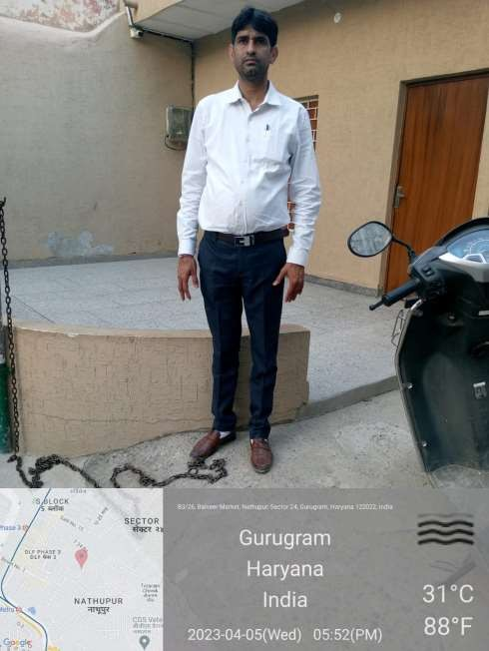

Visited address

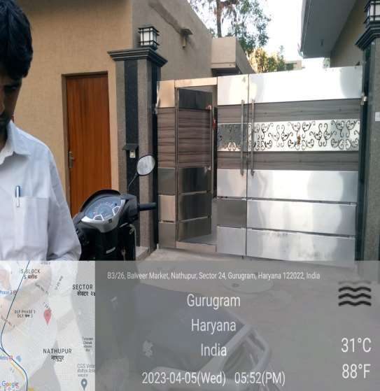

I d proof

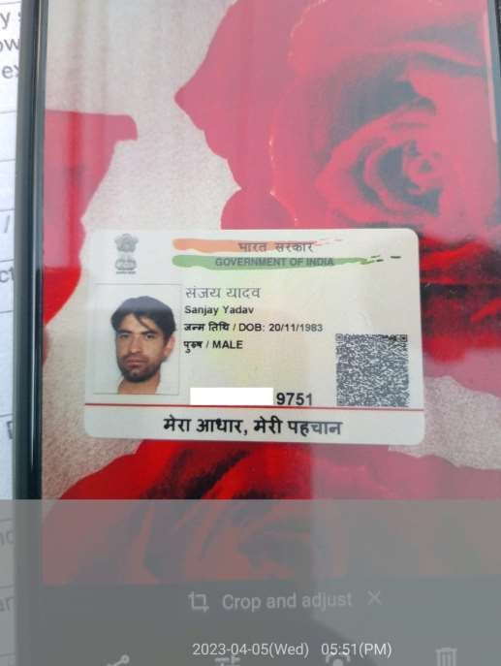

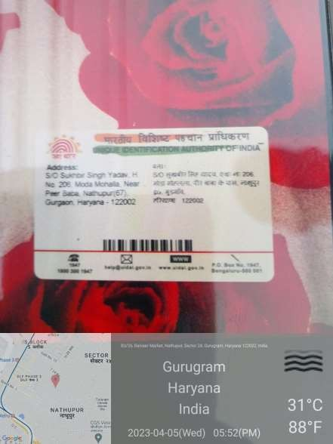

FE photo

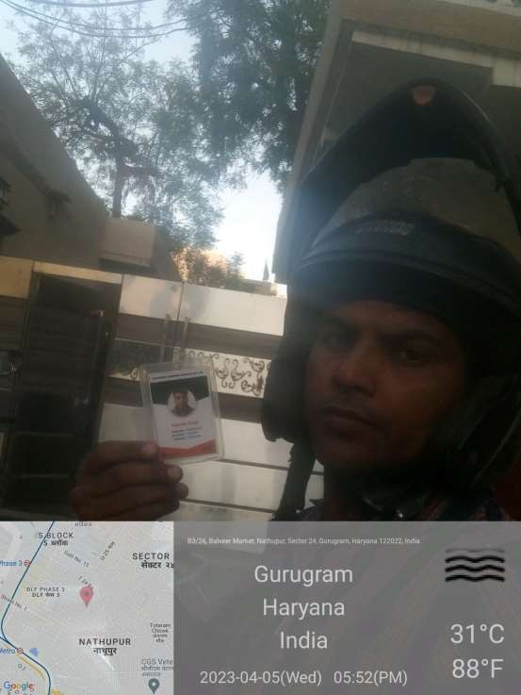

FR

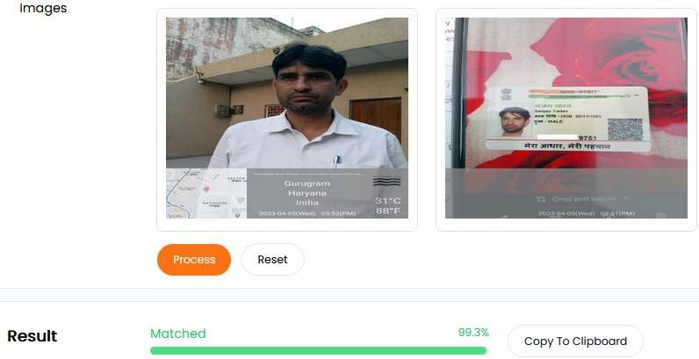

Location photo

