Microwave Remote Sensing Lab (MRSLab), IIT Bombay

12/30/2020

**Extract backscatter intensities by Sampling Points from Multi-date RADARSAT-2 in QGIS**

We use QGIS Desktop environment, Stacked terrain corrected RADARSAT-2 products, and in-situ sampling points (.shp vector file) files for processing.

**User Guide:**

1. Download QGIS extraction model (BackscatterIntensity_Data_Ex33.model3) from Github repository, and modify as per user requirement.
2. Load RADARSAT-2 terrain corrected coregistered stack product (RS2-SLC-FQ15W-ASC-24-Jul-2019_12.tif) in QGIS. Also note it has resolution of 10m x10m, and in UTM projection. The 7 bands are also listed as:

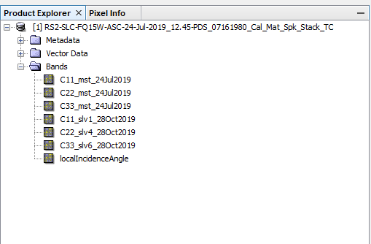

1. Also load the in-situ data vector file (.shp) in QGIS. Please note the sampling point name and attribute column. For example, our field data is Field_Points.shp and has attribute ‘Name’ where points are stored with a specific notation e.g. P182. Alos, this vector file has UTM projection.

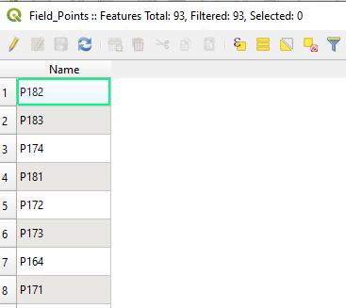

1. Load the QGIS model using Processing>Graphical Modeler; And load the given model. We set a radius of 15m while creating a buffer, which resemblance of 3x3 window at the sampling location.

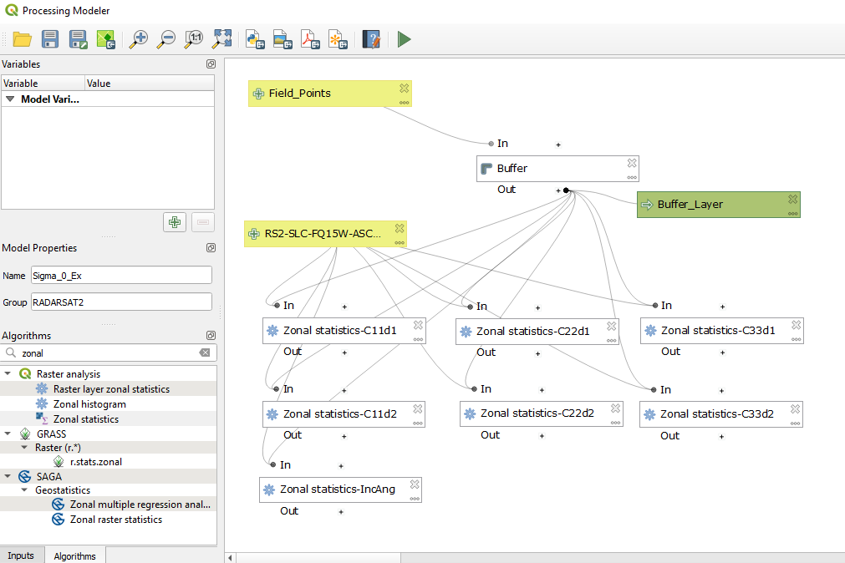

Run this model and it will create a file ‘Buffer_Layer’ as table. Export this layer as .csv file. This file tabulate extracted backscatter intensities as one to one map with ‘Name’ attribute.

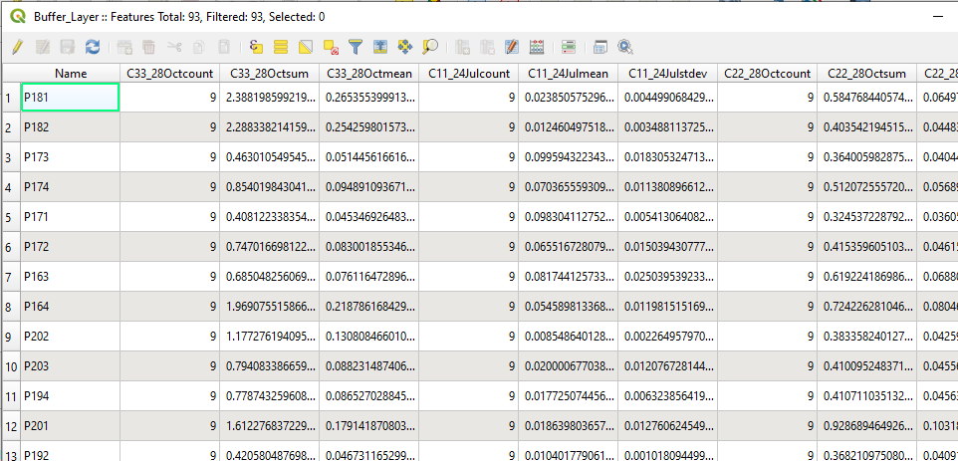

Look for the *mean columns, which are average over a 3x3 window around the sampling points.