Microwave Remote Sensing Lab (MRSLab), IIT Bombay

12/30/2020

**Multi-date RADARSAT-2 full-pol SLC data preprocessing in SNAP**

We use SNAP Desktop environment and graph.xml files for processing.

**User Guide:**

* Save all processing graphs (.xml files) in a folder. Graphs can be downloaded from Github repository, and modify as per user requirement. Here, we show multi-date RADARSAT-2 SLC data processing example with two dataset.

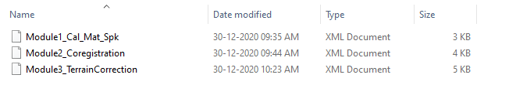

* Download RADARSAT-2 data from data provider services (FTP servers) in .zip format. Unzip them and extract in designated folders as given in example with only two dates:



Each folder contains complex images in HH, HV, VH and VV channels and associated meta files (product.xml), as shown in the following example.

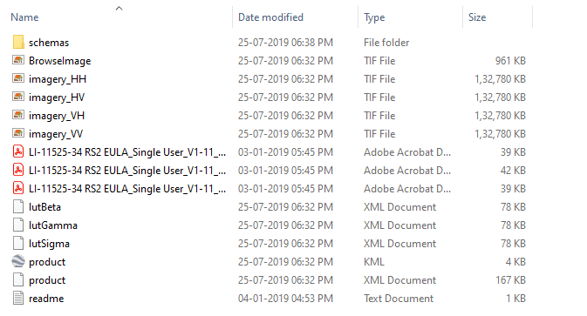

**Running SNAP Desktop and processing**

1. Load both the products in SNAP desktop using File>Import>SAR Sensors>RADARSAT-2 , and then by selecting product.xml files.
2. Now, we process each date separately using Module1_Cal_Mat_Spk.xml graph.

Open Graph interface from Tools>GraphBuilder; Then load the Module1_Cal_Mat_Spk.xml

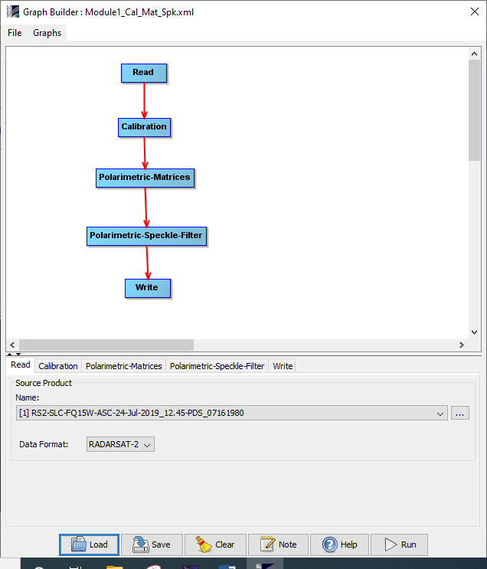

Change the read and write files and directories as per user folders. And finally hit the Run button. It will write Calibrated and speckle filtered Covariance matrix (C3) elements in the writing directory. Repeat the same process for the another date.

1. Now it is essential to coregister these two products (multi-date). Load the products from the previous step (if not loaded yet). Then load Module2_coregistration.xml and set the input and output files properly and run the graph.

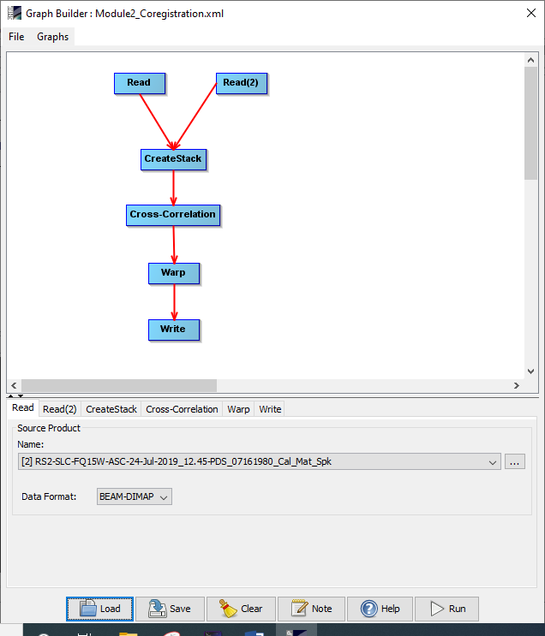

This step will create a stacked coregistered product, where each bands have their associated dates and master or slave nomenclature.

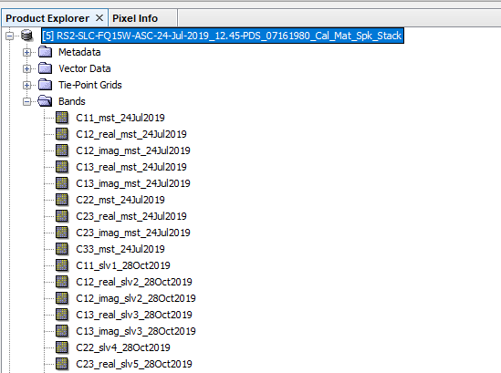

Additionally it saves residual errors in a log file, which indicated the RMS mean and std. The log file can be accessed from User\.snap\var\log\ *_residual.txt

1. In this step we terrain correct and geocode the coregistered stack product using the Module3_TerrainCorrection.xml. We have only saved the C11, C22 and C33 elements (source band) and local incidence angle from each date while writing TC products. Be specific about the projection (preferably UTM) and pixel size (we kept 10m).

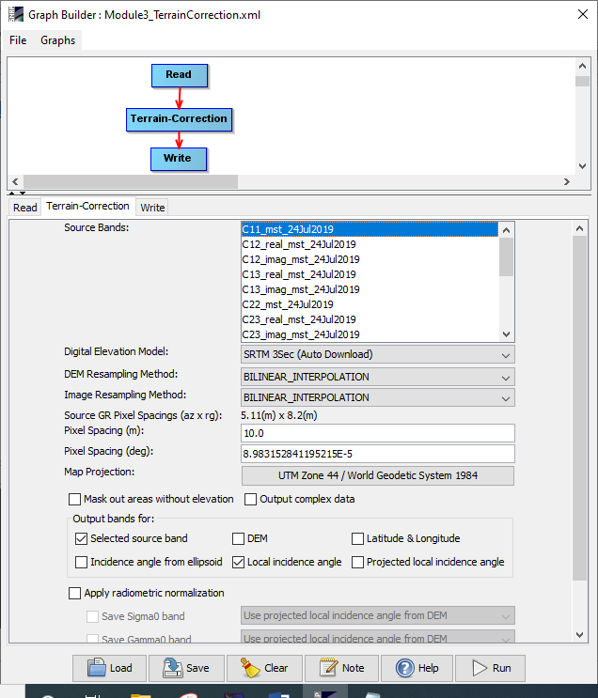

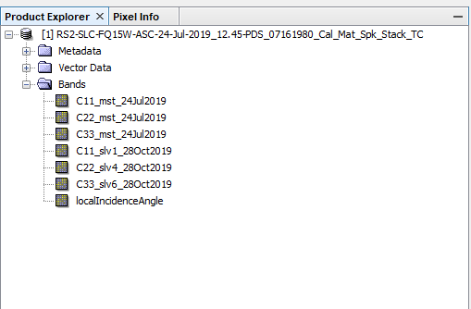

1. Finally the terrain corrected product is exported as GeoTiff format for further operations File>Export>Geotiff. This single Geotiff image will have 7 bands as shown in the previous image.