[**Project brief**](https://developer.mozilla.org/en-US/docs/Learn/HTML/Introduction_to_HTML/Marking_up_a_letter#project_brief)

For this project, your task is to mark up a letter that needs to be hosted on a university intranet. The letter is a response from a research fellow to a prospective PhD student concerning their application to the university.

[**Block/structural semantics**](https://developer.mozilla.org/en-US/docs/Learn/HTML/Introduction_to_HTML/Marking_up_a_letter#blockstructural_semantics)

* Use appropriate document structure including doctype, and [<html>](https://developer.mozilla.org/en-US/docs/Web/HTML/Element/html), [<head>](https://developer.mozilla.org/en-US/docs/Web/HTML/Element/head) and [<body>](https://developer.mozilla.org/en-US/docs/Web/HTML/Element/body) elements.
* In general, the letter should be marked up as an organization of headings and  paragraphs, with the following exception. There is one top level heading (the "Re:" line) and three second level headings.
* Use an appropriate list type to mark up the semester start dates, study subjects, and exotic dances.
* Put the two addresses inside [<address>](https://developer.mozilla.org/en-US/docs/Web/HTML/Element/address) elements. Each line of the address should sit on a new line, but not be in a new paragraph.

[**Inline semantics**](https://developer.mozilla.org/en-US/docs/Learn/HTML/Introduction_to_HTML/Marking_up_a_letter#inline_semantics)

* The names of the sender and receiver (and *Tel* and *Email*) should be marked up with strong importance.
* The four dates in the document should have appropriate elements containing machine-readable dates.
* The first address and first date in the letter should have a class attribute value of *sender-column*. The CSS you'll add later will cause these to be right aligned, as it should be in the case in a classic letter layout.
* Mark up the following five acronyms/abbreviations in the main text of the letter — "PhD," "HTML," "CSS," "BC," and "Esq." — to provide expansions of each one.
* The six sub/superscripts should be marked up appropriately — in the chemical formulae,  and the numbers 103 and 104 (they should be 10 to the power of 3 and 4, respectively).
* Try to mark up at least two appropriate words in the text with strong importance/emphasis.
* There are two places where the letter should have a hyperlink. Add appropriate links with titles. For the location that the links point to, you may use http://example.com as the URL.
* Mark up the university motto quote and citation with appropriate elements.

[**The head of the document**](https://developer.mozilla.org/en-US/docs/Learn/HTML/Introduction_to_HTML/Marking_up_a_letter#the_head_of_the_document)

* The character set of the document should be set as utf-8 using the appropriate meta tag.
* The author of the letter should be specified in an appropriate meta tag.
* The provided CSS should be included inside an appropriate tag.

[**Hints and tips**](https://developer.mozilla.org/en-US/docs/Learn/HTML/Introduction_to_HTML/Marking_up_a_letter#hints_and_tips)

* Use the [W3C HTML validator](https://validator.w3.org/) to validate your HTML. Award yourself bonus points if it validates.
* You don't need to know any CSS to do this assignment.  You just need to put the provided CSS inside an HTML element.

[**Example**](https://developer.mozilla.org/en-US/docs/Learn/HTML/Introduction_to_HTML/Marking_up_a_letter#example)

The following screenshot shows an example of what the letter might look like after being marked up.

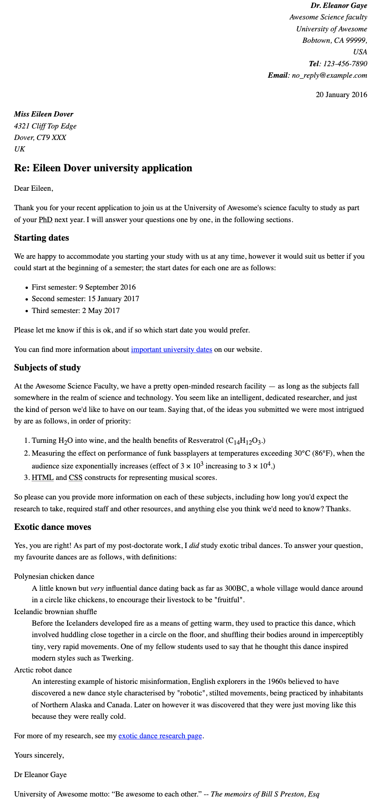

[**Assessment or further help**](https://developer.mozilla.org/en-US/docs/Learn/HTML/Introduction_to_HTML/Marking_up_a_letter#assessment_or_further_help)

If you would like your work assessed, or if you get stuck and want to ask for help:

1. Put your work in an online shareable editor such as [CodePen](https://codepen.io/), [jsFiddle](https://jsfiddle.net/), or [Glitch](https://glitch.com/).
2. Write a post asking for assessment and/or help at the [MDN Discourse forum Learning category](https://discourse.mozilla.org/c/mdn/learn). Your post should include:
   * A descriptive title such as "Assessment wanted for Marking up a letter".
   * Details of what you have already tried, and what you would like us to do (if you are stuck and need help, or if you want an assessment).
   * A link to the example you want evaluated or need help with, in an online shareable editor (as mentioned in step 1 above). This is a good habit to develop. It's very hard to help someone with a coding problem without seeing their code.
   * A link to the actual task or assessment page, so we can read the exact wording of the relevant question(s).