F1 Website Project Guide
Build, deploy, and automated prediction refresh steps
Repository path: projects/F1
Public URL: https://dipanshu1203.github.io/AI/projects/F1/
Purpose: This guide documents how the simple F1 site was built, where the files live, how it is deployed on GitHub Pages, and how the prediction data updates after race weekends.

Project Snapshot
Area | Details
Site type | Static HTML, CSS, and JavaScript
Main folder | projects/F1
Homepage | projects/F1/index.html
Prediction data | projects/F1/data/prediction.json
Automation | .github/workflows/update-f1-prediction.yml
Updater script | scripts/update-f1-prediction.mjs

What We Built
- A minimal Formula 1 dashboard with upcoming Grand Prix calendar, standings, news links, and prediction widget.
- Driver portraits and team car images are pulled from Formula 1 media URLs.
- The prediction model weighs current team form and last year track-result history.
- GitHub Pages publishes the site publicly at the requested URL.
- A scheduled GitHub Action refreshes prediction data from the Jolpica-F1 API.

Folder Structure
projects/F1/
index.html
styles.css
script.js
assets/f1-hero.png
data/prediction.json
docs/F1_Project_Guide.docx
docs/visuals/
.github/workflows/update-f1-prediction.yml
scripts/update-f1-prediction.mjs

Deployment Path
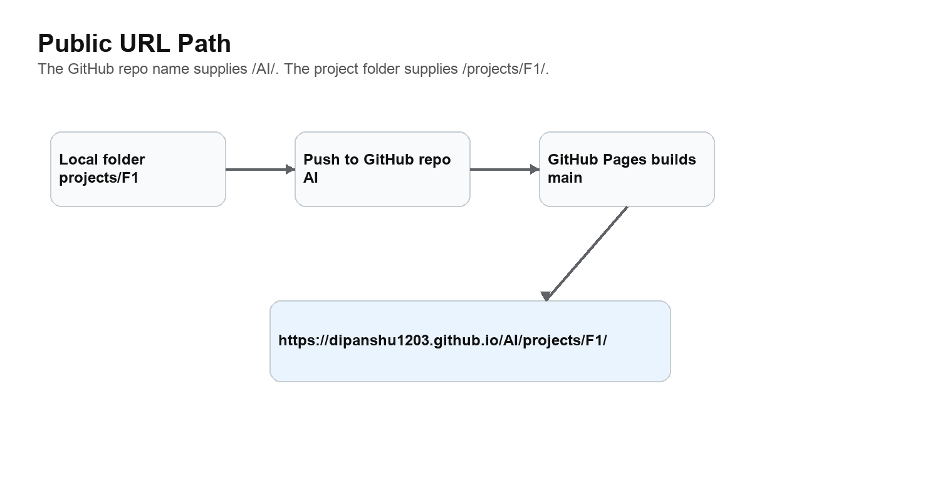
Why this URL works: GitHub Pages adds the repository name, AI, to the base URL. The project folder is projects/F1, so the final path becomes /AI/projects/F1/.

Build and Publish Steps
- Create the static site in projects/F1 with index.html, styles.css, script.js, and local assets.
- Verify locally at http://localhost:8000/projects/F1/ using a simple static server.
- Commit the site files to the main branch.
- Push main to https://github.com/dipanshu1203/AI.git.
- Enable GitHub Pages from the main branch root.
- Open https://dipanshu1203.github.io/AI/projects/F1/ and confirm it returns HTTP 200.

Prediction Refresh Flow
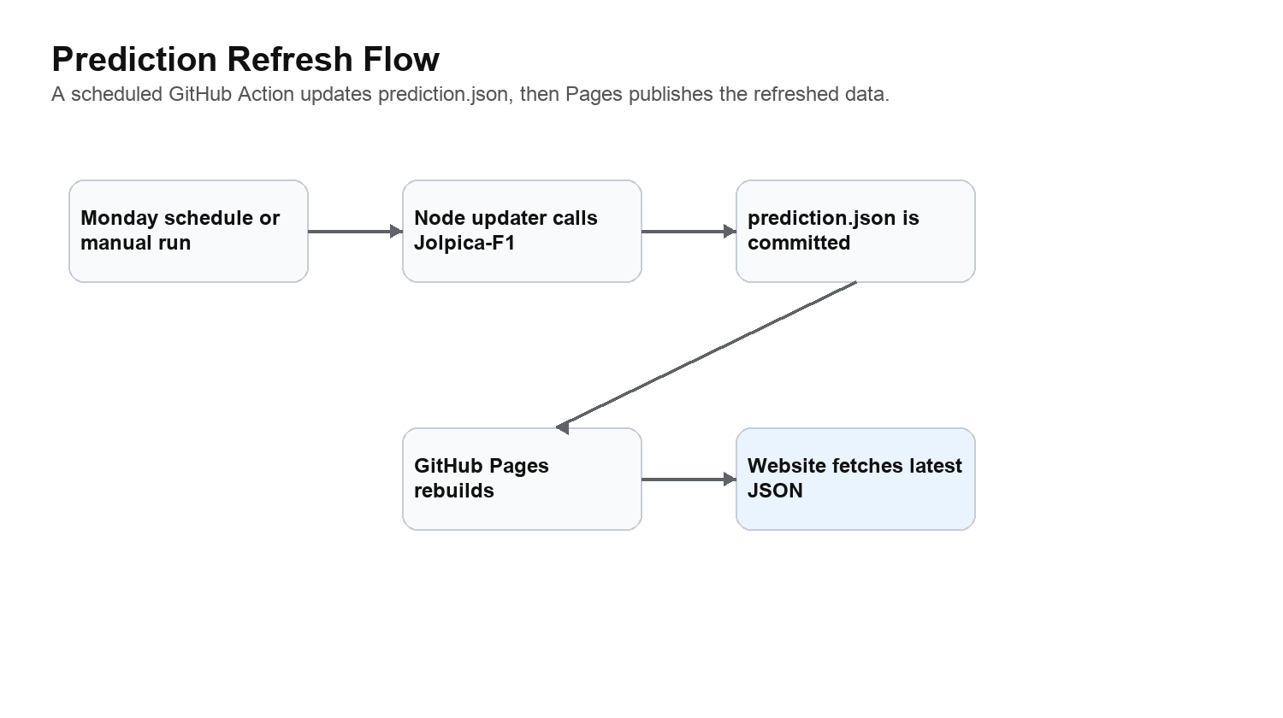
- The workflow runs every Monday at 08:30 UTC and can also be started manually from GitHub Actions.
- The Node script calls Jolpica-F1 for schedule, current constructor standings, and last season result at the same circuit.
- The script rewrites projects/F1/data/prediction.json when the model changes.
- The GitHub Action commits the updated JSON and pushes it back to main.
- GitHub Pages rebuilds, and the browser fetches the latest JSON on page load.

Manual Commands
Task | Command or URL
Run locally | python3 -m http.server 8000
Open local site | http://localhost:8000/projects/F1/
Refresh prediction data locally | node scripts/update-f1-prediction.mjs
Push updates | git add . && git commit -m "Update F1 project" && git push origin main
Trigger workflow manually | gh workflow run update-f1-prediction.yml --repo dipanshu1203/AI

How To Maintain It
- Edit page layout/content in index.html and styles.css.
- Edit prediction UI behavior in script.js.
- Change model scoring logic in scripts/update-f1-prediction.mjs.
- Keep prediction.json committed because the static site reads it directly from GitHub Pages.
- If the public URL changes, check the repository name and project folder path first.

Verification Checklist
Check | How | Expected result
Local page | Open /projects/F1/ | Hero, standings, prediction, and news render
Images | Inspect page or browser console | No broken driver/team images
Prediction JSON | Open /projects/F1/data/prediction.json | HTTP 200 and valid JSON
GitHub Action | GitHub Actions run history | Update F1 Prediction Data succeeds
Public page | Open public URL | HTTP 200 and current site visible

