

**SVKM’S NMIMS, MPSTME, Shirpur Campus**

**FINAL REPORT**

FINAL REPORT

PROJECT: **STOCK MARKET FORECAST**

A report submitted in partial fulfilment of the requirements of 5 Years Integrated MBA (Tech) Program of Mukesh Patel School of Technology Management & Engineering, NMIMS.

|  |  |
| --- | --- |
| Faculty Mentor:  Mrs Varsha Nemade  (Assistant Professor)  MPSTME,  NMIMS Shirpur | Submitted By:  Dipanshu Agarwal – N201  Riya Airen – N204  Saurabh Ajit – N205  Campus Course: MBATECH CE  Batch: 2017 – 2022 |

ACKNOWLEDGEMENT

I would like to thank my institution SVKM’s NMIMS Mukesh Patel School of Technology Management and Engineering, Dr R. S. Gaud Director (SVKM’s NMIMS, Shirpur Campus), Dr Nikhilesh Kumar Sharma Director (Engineering Program, MPSTME NMIMS Shirpur Campus), Dr Narayan Chandak, (MPSTME NMIMS, Shirpur Campus) Associate Dean, Dr Radhakrishna Rambola Head of Department (MPSTME NMIMS, Shirpur Campus) for introducing me to this Project, which gave me the great opportunity to expose myself to the real world besides giving me a platform to have hands-on experience to learn new technologies and apply them.

My faculty mentor Ms Varsha Nemade, Assistant Professor (MPSTME NMIMS, Shirpur Campus) has given me constant support, always motivate me to step forward and besides being a source of inspiration through her words of encouragement. Her continuous supervision and much needed guidance has really helped me in conceptualizing my project and executing the same.

I place a deep sense of gratitude towards my family members and my friends who have been a constant source of inspiration to make this project executable.

I perceive this opportunity as a big milestone in my career development. I will strive to use gained skills and knowledge in the best possible way, and I will continue to work on their improvement, to attain desired career objectives.

Dipanshu Agarwal

Riya Airen

Saurabh Ajit

Date: 23-June-2020

INDEX

* ABSTRACT
* LIST OF ILLUSTRATIONS

1. INTRODUCTION
   1. OBJECTIVE
      1. TECHNICAL OBJECTIVE
2. LITERATURE REVIEW
3. TIME-SERIES
   1. AUTO-CORRELATION
   2. SEASONALITY
   3. STATIONARY
4. MEAN ABSOLUTE PERCENTAGE ERROR
5. ROOT MEAN SQUARED ERROR
6. FUNDAMENTALS OF TRADING
   1. BASICS
   2. TREND ANALYSIS
   3. WHAT DOES TREND ANALYSIS TELLS YOU
   4. EXAMPLES OF TREND ANALYSIS
   5. TREND TRADING STRATEGIES
   6. LIMITATIONS OF TREND TRADING
7. METHODOLOGY
   1. PROGRAMMING LANGUAGE USED
   2. LIBRARIES
   3. UNDERSTANDING THE DATASET
   4. CLEANING AND PLOTTING THE DATA
   5. MODEL IMPLEMENTATION
      1. MOVING AVERAGE
      2. LINEAR REGRESSION
      3. K-NEAREST NEIGHBORS
      4. PROPHET
      5. AUTO-ARIMA
      6. LONG SHORT TERM MEMORY
8. CONCLUSION
9. REFERENCES

ABSTRACT

Predicting the Stock Market has been the bane and goal of investors since its existence. Everyday billions of dollars are traded on the exchange, and behind each dollar is an investor hoping to profit in one way or another. Entire companies rise and fall daily based on the behaviour of the market. Should an investor be able to accurately predict market movements, it offers a tantalizing promises of wealth and influence. In the real world, the stock market predictions can be categorized in 2 parts, Fundamental Analysis and Technical Analysis.

Predicting how the stock market will perform is one of the most difficult things to do. There are so many factors involved in the prediction – physical factors vs. psychological, rational and irrational behaviour, etc. All these aspects combine to make share prices volatile and very difficult to predict with a high degree of accuracy.

In this undertaking, we will be creating supervised machine learning models which will help us to somewhat predict the price value of stocks/security of a company i.e. State Bank of India to be specific. The Model will be using Time-Series Analysis, Time series is a set of observations or data points taken at specified time usually at equal intervals and it’s used to predict the future values based on the previous observed values.

The stock data for the past 9 years (2011-2019) has been collected and trained using different model with different parameters. The models were applied to dataset to forecast the value of stock of Sate bank of India (SBI).

LIST OF ILLUSTRATIONS

|  |  |  |
| --- | --- | --- |
| Sr. No. | Name of Figure | Page Number |
| 1 | EXAMPLE OF AUTO-CORRELATION | 4 |
| 2 | EXAMPLE OF SEASONALITY | 4 |
| 3 | EXAMPLE OF SEASONALITY | 5 |
| 4 | SAMPLE OF A TECHNICAL CHART | 5 |
| 5 | TECHNICALITITES OF A CANDLESTICK FIGURE | 6 |
| 6 | BULLISH TREND | 8 |
| 7 | BEARISH TREND | 8 |
| 8 | SIDEWAYS TREND | 9 |
| 9 | FLOWCHART DEFINING OUR APPROACH | 13 |
| 10 | IMPORTING LIBRARIES | 14 |
| 11 | IMPORTING THE DATASET | 16 |
| 12 | SCREENSHOT OF DATASET | 17 |
| 13 | CLEANING THE DATASET | 17 |
| 14 | PLOTTING THE GRAPH OF CLOSE | 17 |
| 15 | VISUALIZATION OF COMPLETE DATASET | 18 |
| 16 | VISULAIZATION OF TRAINING DATASET | 18 |
| 17 | PICTORIAL DEPICTION OF HOW MOVING AVERAGE | 19 |
| 18 | RMSE AND MAPE VALUES (MOVING AVERAGE) | 19 |
| 19 | GRAPH DEPICTING PREDICTED VS ACTUAL | 20 |
| 20 | HOW LINEAR REGRESSION WORKS | 20 |
| 21 | RMSE AND MAPE VALUES (LINEAR REGRESSIONS) | 21 |
| 22 | GRAPH DEPICTING PREDICTED VS ACTUAL | 21 |
| 23 | DEPICTING HOW K-NEAREST NEIGBORS WORKS | 22 |
| 24 | RMSE AND MAPE VALUES (K-NEAREST NEIGHBORS) | 22 |
| 25 | GRAPH DEPICTING PREDICTED VS ACTUAL | 23 |
| 26 | RMSE AND MAPE VALUES (fbPROPHET) | 23 |
| 27 | GRAPH DEPICTING PREDICTED VS ACTUAL | 24 |
| 28 | OUTPUT OF MODEL FIT FUNCTION | 24 |
| 29 | RMSE AND MAPE VALUES (AUTO-ARIMA) | 25 |
| 30 | GRAPH DEPICTING PREDICTED VS ACTUAL | 25 |
| 31 | OUTPUT OF MODEL TARINING | 26 |
| 32 | RMSE AND MAPE VALUES (LSTM) | 27 |
| 33 | GRAPH DEPICTING PREDICTED VS ACTUAL | 27 |
| 34 | PLOTTING GRAPH FOR ALL RMSE AND MAPE VALUES | 28 |
| 35 | GRAPH OF COMPARISON OF MAPE VALUES | 28 |
| 36 | GRAPH OF COMPARISON OF RMS VALUES | 29 |
| 37 | COMPARITIVE STUDY OF RMSE & MAPE VALUES | 29 |
| 38 | COMPARISON OF MAPE & RMSE VALUES | 29 |

INTRODUCTION

Stock Market prediction has always had a certain appeal for researchers. While numerous scientific attempts have been made, no method has been discovered to accurately predict stock price movement. The difficulty of prediction lies in the complexities of modelling market dynamics. Even with a lack of consistent prediction methods, there have been some mild successes. Stock Market research encapsulates two elemental trading philosophies; Fundamental and Technical approaches. In Fundamental analysis, Stock Market price movements are believed to derive from a security’s relative data. Fundamentalists use numeric information such as earnings, ratios, and management effectiveness to determine future forecasts. In Technical analysis, it is believed that market timing is key. Technicians utilize charts and modelling techniques to identify trends in price and volume. These later individuals rely on historical data in order to predict future outcomes.

The stock market appears in the news every day. Every time it reaches a new high or a new low. The rate of investment and business opportunities in the Stock market can increase if an efficient algorithm could be devised to predict the short term price of an individual stock.

# **OBJECTIVES:**

In the past decades, there is an increasing interest in predicting markets among economists, policymakers, academics and market makers. The objective of the proposed work is to study and implement the supervised learning algorithm to predict the stock price.

## ***TECHNICAL OBJECTIVE***

The technical objectives will be implemented in Python. The system must be able to access a list of historical prices. It must calculate the estimated price of stock based on the historical data. It must also provide an instantaneous visualization of the market index.

* To add to the academic understanding of stock market prediction
* This project will focus exclusively on predicting the daily trend (price movement) of individual stocks
* The project will also analyse the accuracies of these predictions
* The project will also compare the accuracy percentage between the different models implemented.

LITERATURE REVIEW

Contreras et al. [3] used ARIMA models to predict next day electricity prices; they have found two ARIMA models to predict hourly prices in the electricity markets of Spain and California. The Spanish model needs 5 hours to predict future prices as opposed to the 2 hours needed by the Californian model.

Kumar et al. [4] used ARIMA model to forecast daily maximum surface ozone concentrations in Brunei Darussalam. They have found that ARIMA (1,0,1) was suitable for the surface 03 data collected at the airport in Brunei Darussalam.

Tsitsika et al. [5] used ARIMA model to forecast pelagic fish production. The final model selected were of the form AR[MA (1,0,1) and AR[MA (0,1,1 ).

Azad et al. [6] used ARIMA model in forecasting Exchange Rates of Bangladesh. By using Box-Jenkins methodology they tried to find out the best model for forecasting.

Debadrita Banerjee et al.[7] has collected data on the monthly closing stock indices of sensex for six years(2007-2012) and based on these she has tried to develop an appropriate model which would help her to forecast the future unobserved values of the Indian stock market indices. This study offers an application of ARIMA model based on which she predicts the future stock indices which have a strong influence on the performance of the Indian economy. To establish the model she applied the validation technique with the observed data of sensex of 2013.

Q. Xie S. et al.[8] adopted an ensemble model of LSTM networks in predicting stock market data and compares the results obtained to that of a multilayer LSTM network. The proposed model approches the ensemble learning process by dividing the test data into a number of smaller data sets using the Bagging algorithm. The smaller datasets are then trained on a number of LSTM networks. The Bagging algoritm is then used to obtain a prediction result from the multiple test results. Data from the Shanghai Composite Index and Shenzen Composite Index, among others, were used. Results of the study showed that the amsemble LSTM network model had an increased accuracy of 11.7%, a precission increase of 8.5%, and a recall rate increase of 10%. The ensemble LSTM network model had a greater predictive accuracy than the multilayer LSTM network.

Yao F. et al.[9] apply LSTM networks to predict the price movement of a short-term and test it by an experiment on some stocks randomly selected from CSI 300 constituent stocks. The experiment shows that the precision, recall rate and critical error of LSTM are all better than that of the random prediction. It indicates that LSTM can be used in the trend prediction of stock price.

Qian et al.[10] conducted a stationary analysis of the stock's time-series data and then used the LSTM neural network algorithm to predict stock data under different stationary conditions, and performed statistical analysis on multiple experimental data. In addition, an ARIMA algorithm was introduced to compare with the LSTM. A large number of experimental results show that the LSTM neural network prediction algorithm has higher prediction accuracy and is not sensitive to the stability response.

S.Kamath et al.[11] made use of Hadoop and ML. The big data technique by performing sentiment analysis of tweets and twitter and finding the correlation. Also, machine learning techniques are applied on the data of companies to predict the stock price of next day. Python code is used to perform the task and text editor used is Pycharm. Map-reduce technique is used to combine individual sentiment results and find a sentiment for each day. The big data technique is used to handle the large amount of data. All the four model, KNN, Random forest, neural network, and linear regression are used to predict the value of daily exchange. The predicted values showed that name of the four models were able to predict the values accurately. However the closest values were predicted by linear regression. The conclusion of their project was that the stock value change does not depend on the stock exchange index. It is dependent on the sentiments of social media

P.Domingos et al.[12] made use of linear regression. The aim of the research study is to help the stock broken and investors for investing money in the stock market. Python 2.7version is used for implementing linear, polynomial and RBF. The python scientific computing library numpy was used along with the data analysis library pandas in order to convert these CSV files into panda data frames. The stock price was predicted based on linear regression, polynomial and RBF regression using five variable. The linear regression gives the best result compare to another method stock exchange index. It is dependent on the sentiments of social media.

# **TIME-SERIES**

It is simply a series of data points ordered in time. In a time series, time is often the independent variable and the goal is usually to make a forecast for the future.

The Time-Series generated may have any of the 3 properties:-

## **AUTO-CORRELATION**

Refers to the similarity between observations as a function of the time lag between them. For example, in the graph below the first and the 24th value have a high autocorrelation similarly for the 12th and 36th value

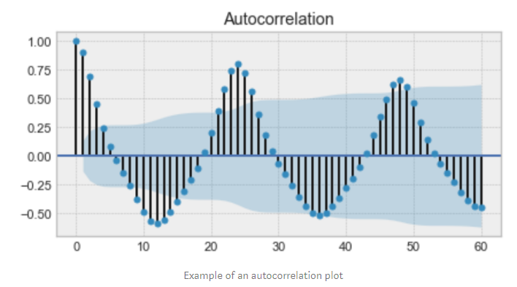

Figure 1: EXAMPLE OF AN AUTO-CORRELATION PLOT

## **SEASONALITY**

Refers to periodic functions, for example electricity consumption is high during the day and low during night, or online sales increase during Christmas before slowing down again. Seasonality can also be derived from an **Auto-Correlation Plot** if it has a sinusoidal shape.

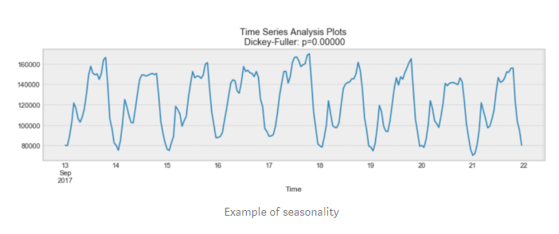

Figure 2: EXAMPLE OF SEASONALITY

## **STATIONARY**

Refers to an important characteristic of time-series. A time-series is said to be stationary if its statistical properties do not change over time. In other words, it has constant mean and variance, and co-variance is independent of time.

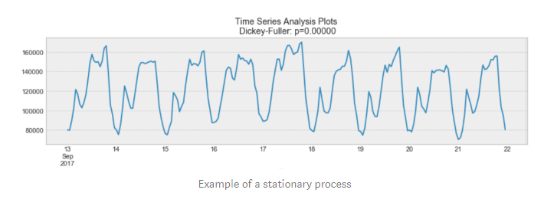

Figure 3: EXAMPLE OF SEASONALITY

In the above, we see that the process above is stationary. The mean and variance do not vary over time.

Often **Stock Prices** are not a stationary process, since we might see a growing trend, or its volatility might increase over time i.e. variance is ever-changing.

Ideally, we want to have a stationary time-series for modelling. Of course, not all of them are stationary, but we can make different transformations to make them stationary.

# **FUNDAMENTALS OF TRADING**

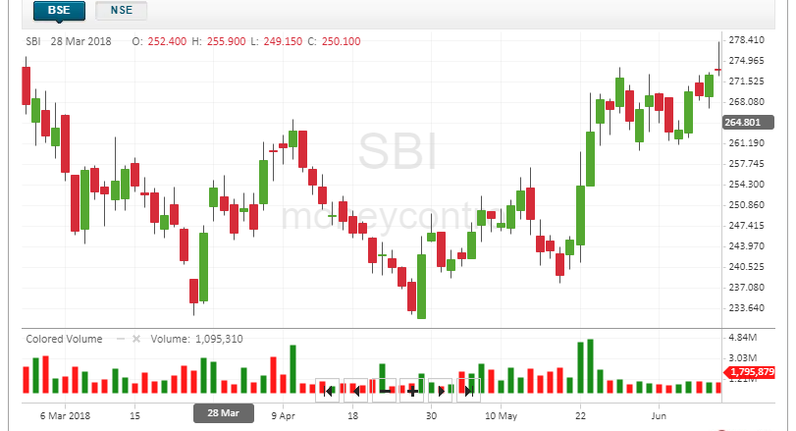

Figure 4: A SAMPLE OF HOW THE TECHNICAL CHART IN BSE LOOKS LIKE

In the above graph,

We see a peculiar representation technique being used which is known as a candlestick, a candlestick is a type of price chart used in technical analysis that displays the high, low, open, and closing prices of a security for a specific period.

The Color of the Bar i.e. Red or Green denotes that the stock closed on a Lower price or a Higher Price respectively on that particular day.

There is a third state which is known as a consolidated state, in which the number of buyers and sellers for a security are the same in the market. In this case, it is denoted using a simple horizontal line.

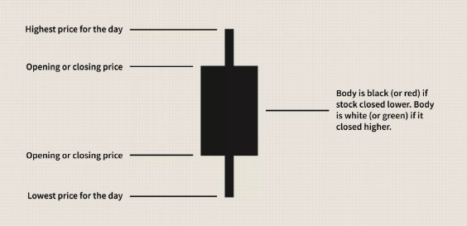

Figure 5: TECHNICALITITES OF A CANDLESTICK FIGURE

## The Main Factors Which Bring About A Huge Change In The Variance And Mean Of The Security Prices Are:-

1. **Buyer and Seller: -** From the colours, we can also conclude that Red or Black means there are more number of buyers in the market as they will try to drive the price of security down so as to buy it at a low cost, and Green or White means that the numbers of seller of that particular security is more as they will try to drive the price higher so as to earn maximum profit on selling the security.
2. **IPO: -** stand for Initial Public Offering. When the news media report that a company is "going public," this **means** that company is making an **initial public offering**. This **means** that the company is offering its shares for sale to the public for the first time.
3. **Pandemics: -** External shocks can derail economic trends and abruptly alter market sentiment. Not all risk is economic policy or monetary
4. **Merger and Acquisitions: -** Mergers and acquisitions are transactions in which the ownership of companies, other business organizations, or their operating units are transferred or consolidated with other entities.
5. **Import and Export: -** An economic condition that occurs when a country is importing more goods than it is exporting is called trade deficit. It is also referred to as net exports. A trade deficit is calculated by deducting value of goods being exported from the goods being imported by a country. It is mentioned in the currency that a particular country uses. An extended trade deficit can adversely impact a country’s economy and its stock markets. A country with extended trade deficit means it’s into debt. The investors take notice of such financial parameters and also take note of plunge in spending on locally produced goods. This hurts domestic producers and their share prices. This reduces demand in the domestic stock markets and result in decline of market.
6. **Government Issues/Changes to Laws: -** The laws and ordinance passed by the government may stimulate the market or it may even bring a pause on the Foreign Investments happening in the market on the basis of the current situations of the global economy and trade treaties.

## **TREND ANALYSIS**

Trend analysis is a technique used in [technical analysis](https://www.investopedia.com/terms/t/technicalanalysis.asp) that attempts to predict the future stock price movements based on recently observed trend data. Trend analysis is based on the idea that what has happened in the past gives traders an idea of what will happen in the future.

A trend is the general direction the market is taking during a specified period of time. Trends can be both upward and downward, relating to bullish and bearish markets, respectively. While there is no specified minimum amount of time required for a direction to be considered a trend, the longer the direction is maintained, the more notable the trend.

### *TYPES OF TRENDS*

* BULLISH OR UPWARD TREND

A bull market is a rising market. In a bull market, investors are positive. Trend line is a line that is drawn over pivot highs or under pivot lows to show the prevailing direction of price. Trendlines are a visual representation of support and resistance in any time frame. Since in a bullish trend orders are placed upwards it is very important to determine the lower trendline of an upward movement. Break through a lower trend line signals that a general trend weakens or changes its previous direction.

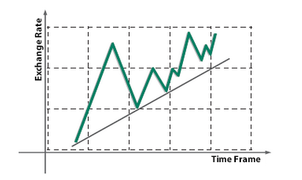

Figure 6: BULLISH TREND

* BEARISH OR DOWNTREND

A prolonged period in which investment prices fall, accompanied by widespread pessimism. A bear market is a market showing a lack of confidence. Lower trend line is a line that is drawn under pivot lows to show the prevailing direction of price. Bullish trendline is a visual representation of a resistance. Since in a bearish trend orders are placed downwards it is very important to determine the upper trendline. Break through an upward trend line signals that a general trend weakens or changes its previous direction.

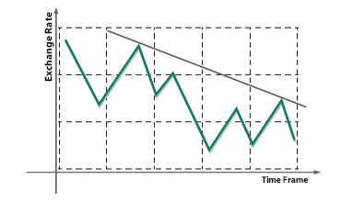

Figure 7: BEARISH TREND

* SIDEWAYS TREND

A sideways market occurs where the price trend of a certain trading instrument has been experiencing neither an uptrend nor a downtrend. Sideways trend is generally a result of the price traveling between strong levels of support and resistance. Sometimes, when a price moves in a reverse direction once the upward or downward trend is over, there are no certain price directions at the market. In this case, price fall or rise movements in a vertical direction are not expected. As a rule, when the sideways trend ends an uptrend or downtrend may begin.

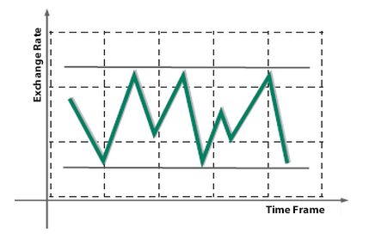

Figure 8: SIDEWAYS TREND

### *What Does Trend Analysis Tell You?*

Trend analysis tries to predict a trend, such as a [bull market](https://www.investopedia.com/terms/b/bullmarket.asp) run, and ride that trend until data suggests a trend [reversal](https://www.investopedia.com/terms/r/reversal.asp), such as a bull-to-bear market. Trend analysis is helpful because moving with trends, and not against them, will lead to profit for an investor.

A trend is the general direction the market is taking during a specified period of time. Trends can be both upward and downward, relating to bullish and bearish markets, respectively. While there is no specified minimum amount of time required for a direction to be considered a trend, the longer the direction is maintained, the more notable the trend.

Trend analysis is the process of trying to look at current trends in order to predict future ones and is considered a form of comparative analysis. This can include attempting to determine whether a current market trend, such as gains in a particular market sector, is likely to continue, as well as whether a trend in one market area could result in a trend in another. Though an analysis may involve a large amount of data, there is no guarantee that the results will be correct.

### *Examples of Trend Analysis*

In order to begin analyzing applicable data, it is necessary to first determine which [market segment](https://www.investopedia.com/terms/m/market-segment.asp) will be analyzed. An example of sectors can include a focus on a particular industry, such as the automotive or pharmaceuticals sector, as well as a particular type of investment, such as the [bond market](https://www.investopedia.com/terms/b/bondmarket.asp). Once the sector has been selected, it is possible to examine the general performance of the sector. This can include how the sector was affected by internal and external forces. For example, [changes in a similar industry](https://www.investopedia.com/terms/c/chikouspan.asp) or the creation of a new governmental regulation would qualify as forces impacting the market. Analysts then take this data and attempt to predict the direction the market will take moving forward.

### *Trend Trading Strategies*

[Trend traders](https://www.investopedia.com/terms/t/trendtrading.asp) attempt to isolate and extract profit from trends. There are many different trend trading strategies using a variety of [indicators](https://www.investopedia.com/terms/i/indicator.asp):

* **Moving Averages:**These strategies involve entering into long positions when a short-term [moving average](https://www.investopedia.com/terms/m/movingaverage.asp) crosses over above a long-term moving [average](https://www.investopedia.com/ask/answers/071414/whats-difference-between-moving-average-and-weighted-moving-average.asp), and entering short positions when a short-term moving average crosses below a long-term moving average.
* **Momentum Indicators:**These strategies involve entering into long positions when a security is trending with strong momentum and exiting long positions when a security loses momentum. Often times, the [relative strength index (RSI)](https://www.investopedia.com/terms/r/rsi.asp) is used in these strategies.
* **Trendlines & Chart Patterns:**These strategies involve entering long positions when a security is trending higher and placing a stop-loss below key trendline [support levels](https://www.investopedia.com/terms/s/support.asp). If the stock starts to reverse, the position is exited for a profit.

Indicators can simplify price information, as well as [provide trend trade signals](https://www.investopedia.com/articles/forex/09/trade-with-the-trend.asp) or warn of [reversals](https://www.investopedia.com/terms/r/reversal.asp). Indicators can be used on all time frames, and have variables that can be adjusted to suit each trader's specific preferences. Combine indicator strategies, or come up with your own guidelines, so entry and exit criteria are clearly established for trades. Each indicator can be used in more ways than outlined. If you like an indicator, research it further, and most importantly, test it out before using it to make live trades.

### *Limitations of Trend Analysis*

Critics of trend analysis, and technical trading in general, argue that [markets are efficient](https://www.investopedia.com/terms/e/efficientmarkethypothesis.asp), and so they already price in all available information. That means that history does not necessarily need to repeat itself, and that the past does not predict the future. Adherents of [fundamental analysis](https://www.investopedia.com/terms/f/fundamentalanalysis.asp), for example, analyze the financial condition of companies using financial statements and economic models to predict future price. For these types of investors, day-to-day stock movements follow a random walk that cannot be interpreted as patterns or trends.

# **MAPE Value**

The mean absolute percentage error (MAPE) is the mean or average of the absolute percentage errors of forecasts. Error is defined as actual or observed value minus the forecasted value. Percentage errors are summed without regard to sign to compute MAPE. This measure is easy to understand because it provides the error in terms of percentages. Also, because absolute percentage errors are used, the problem of positive and negative errors cancelling each other out is avoided. Consequently, MAPE has managerial appeal and is a measure commonly used in forecasting. The smaller the MAPE the better the forecast.

The mean absolute percentage error (MAPE) can be calculated as the average absolute percent error for each time period minus actual values divided by actual values. Where At is the actual value and Ft is the forecast value, this is given by:



The MAPE is also sometimes reported as a percentage, which is the above equation multiplied by 100. The difference between At and Ft is divided by the actual value At again. The absolute value in this calculation is summed for every forecasted point in time and divided by the number of fitted points n. multiplying by 100% makes it a percentage error.

The mean absolute percentage error (MAPE) is the most common measure used to forecast error, and works best if there are no extremes to the data (and no zeros).

Although MAPE is straightforward to calculate and easy to interpret, there are a couple potential drawbacks to using it:

1. Since the formula to calculate absolute percent error is |actual-forecast| / |actual| this means that it will be undefined if any of the actual values are zero.

2. MAPE should not be used with low volume data. For example, if the actual demand for some item is 2 and the forecast is 1, the value for the absolute percent error will be |2-1| / |2| = 50%, which makes it seem like the forecast error is quite high, despite the forecast only being off by one unit.

# **RMSE Value**

Root Mean Square Error (RMSE) is the standard deviation of the [residuals](https://www.statisticshowto.com/residual/) ([prediction errors](https://www.statisticshowto.com/prediction-error-definition/)). Residuals are a measure of how far from the regression line data points are; RMSE is a measure of how spread out these residuals are. In other words, it tells you how concentrated the data is around the [line of best fit](https://www.statisticshowto.com/line-of-best-fit/). Root mean square error is commonly used in climatology, forecasting, and [regression analysis](https://www.statisticshowto.com/probability-and-statistics/regression-analysis/) to verify experimental results.

The root-mean-square deviation (RMSD) or root-mean-square error (RMSE) is a frequently used measure of the differences between values (sample or population values) predicted by a model or an [estimator](https://en.m.wikipedia.org/wiki/Estimator) and the values observed. The RMSD represents the square root of the second [sample moment](https://en.m.wikipedia.org/wiki/Sample_moment) of the differences between predicted values and observed values of these differences. These [deviations](https://en.m.wikipedia.org/wiki/Statistical_deviation) are called [residuals](https://en.m.wikipedia.org/wiki/Errors_and_residuals_in_statistics) when the calculations are performed over the data sample that was used for estimation and are called errors (or prediction errors) when computed out-of-sample. The RMSD serves to aggregate the magnitudes of the errors in predictions for various times into a single measure of predictive power. RMSD is a measure of accuracy.

We can compare any predicted value with an actual measurement (observed value).

* Predicted value
* Observed value

Root mean square error takes the difference for each observed and predicted value.

You can swap the order of subtraction because the next step is to take the square of the difference. This is because the square of a negative value will always be a positive value. But just make sure that you keep the same order throughout.

After that, divide the sum of all values by the number of observations. Finally, we get a RMSE value. Here’s what the **RMSE Formula** looks like:

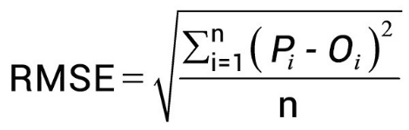

METHODOLOGY

We will be using a 6-step approach to build each model then we will compare the accuracy for each.

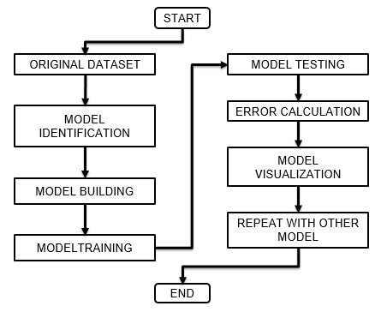

Figure 9: FLOWCHART DEFINING THE APPROACH OF OUR PROJECT

# **PYTHON**

It has been chosen as the language of choice for this project. This was an easy decision for the multiple reasons.

1. Python as a language has an enormous community behind it. Any problems that might be encountered can be easily solved with a trip to Stack Overflow. Python is among the most popular languages on the site which makes it very likely there will be a direct answer to any query.
2. Python has an abundance of powerful tools ready for scientific computing. Packages such as Numpy, Pandas, and Scikit are freely available and well documented. Packages such as these can dramatically reduce, and simplify the code needed to write a given program. This makes iteration quick.
3. Python as a language is forgiving and allows for programs that look like pseudo code. This is useful when pseudocode given in academic papers needs to be implemented and tested. Using Python, this step is usually reasonably trivial.

However, Python is not without its flaws. The language is dynamically typed and packages are notorious for Duck Typing. This can be frustrating when a package method returns something that, for example, looks like an array rather than being an actual array. Coupled with the fact that standard Python documentation does not explicitly state the return type of a method, this can lead to a lot of trials and error testing that would not otherwise happen in a strongly typed language. This is an issue that makes learning to use a new Python package or library more difficult than it otherwise could be.

# **IMPORTING THE NECESSARY LIBRARIES**

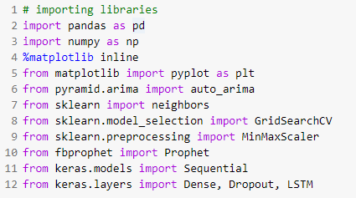

Figure 10: SCREENSHOT OF CODE, IMPORTING LIBRARIES

## **NUMPY**

**It** is a general-purpose array-processing package. It provides a high-performance multidimensional array object, and tools for working with these arrays. It is the fundamental package for scientific computing with Python. Besides its obvious scientific uses, Numpy can also be used as an efficient multi-dimensional container of generic data.

## **PANDAS**

It is an open-source library that is built on top of NumPy library. It is a Python package that offers various data structures and operations for manipulating numerical data and time series. It is mainly popular for importing and analyzing data much easier. Pandas is fast and it has high-performance & productivity for users.

## **MATPLOTLIB**

Matplotlib is an amazing visualization library in Python for 2D plots of arrays. Matplotlib is a multi-platform data visualization library built on NumPy arrays and designed to work with the broader SciPy stack. It was introduced by John Hunter in the year 2002.

One of the greatest benefits of visualization is that it allows us visual access to huge amounts of data in easily digestible visuals. Matplotlib consists of several plots like line, bar, scatter, histogram etc.

## **SCIKIT-LEARN**

Scikit-learn is a free software machine learning library for the Python programming language. It features various classification, regression and clustering algorithms including support vector machine, random forest, gradient boosting, k-means etc. It is mainly designed to interoperate with the Python numerical and scientific libraries NumPy and SciPy.

Scikit-learn is largely written in Python, with some core algorithms written in Cython to achieve performance. Support vector machines are implemented by a Cython wrapper around LIBSVM .i.e., logistic regression and linear support vector machines by a similar wrapper around LIBLINEAR.

## **PMDARIMA**

Pmdarima (originally pyramid-arima, for the anagram of 'py' + 'arima') is a statistical library designed to fill the void in Python's time series analysis capabilities. It brings R’s belove to Python, auto-arima making an even stronger case for why you don’t need R for data science. It is 100% Python + Cython and does not leverage any R code, and implements a single, easy-to-use scikit-learn-esque estimator. Pmdarima wraps [statsmodels](https://github.com/statsmodels/statsmodels/blob/master/statsmodels) under the hood, but is designed with an interface that's familiar to users coming from a scikit-learn background.

## **PROPHET**

Implements a procedure for forecasting time series data based on an additive model where non-linear trends are fit with yearly, weekly, and daily seasonality, plus holiday effects. It works best with time series that have strong seasonal effects and several seasons of historical data. Prophet is robust to missing data and shifts in the trend, and typically handles outliers well.

Prophet follows the sklearn model API. We create an instance of the Prophet class and then call its fit and predict methods.

The input to Prophet is always a dataframe with two columns: ds and y. The ds (datestamp) column should be of a format expected by Pandas, ideally YYYY-MM-DD for a date or YYYY-MM-DD HH:MM:SS for a timestamp. The y column must be numeric, and represents the measurement we wish to forecast.

## **KERAS**

Keras is an [open-source](https://en.wikipedia.org/wiki/Open-source_software) [neural-network](https://en.wikipedia.org/wiki/Artificial_neural_network) library written in [Python](https://en.wikipedia.org/wiki/Python_(programming_language)). It is capable of running on top of [TensorFlow](https://en.wikipedia.org/wiki/TensorFlow" \o "TensorFlow), [Microsoft Cognitive Toolkit](https://en.wikipedia.org/wiki/Microsoft_Cognitive_Toolkit), [R](https://en.wikipedia.org/wiki/R_(programming_language)), [Theano](https://en.wikipedia.org/wiki/Theano_(software)" \o "Theano (software)), or [PlaidML](https://en.wikipedia.org/wiki/PlaidML" \o "PlaidML). Designed to enable fast experimentation with [deep neural networks](https://en.wikipedia.org/wiki/Deep_learning), it focuses on being user-friendly, modular, and extensible. It was developed as part of the research effort of project ONEIROS (Open-ended Neuro-Electronic Intelligent Robot Operating System), and its primary author and maintainer is François Chollet, a [Google](https://en.wikipedia.org/wiki/Google) engineer. Chollet also is the author of the XCeption deep neural network model.

Keras contains numerous implementations of commonly used neural-network building blocks such as layers, [objectives](https://en.wikipedia.org/wiki/Objective_function), [activation functions](https://en.wikipedia.org/wiki/Activation_function), [optimizers](https://en.wikipedia.org/wiki/Mathematical_optimization), and a host of tools to make working with image and text data easier to simplify the coding necessary for writing deep neural network code. The code is hosted on [GitHub](https://en.wikipedia.org/wiki/GitHub), and community support forums include the GitHub issues page, and a [Slack](https://en.wikipedia.org/wiki/Slack_(software)) channel.

In addition to standard neural networks, Keras has support for [convolutional](https://en.wikipedia.org/wiki/Convolutional_neural_networks) and [recurrent neural networks](https://en.wikipedia.org/wiki/Recurrent_neural_networks). It supports other common utility layers like [dropout](https://en.wikipedia.org/wiki/Dropout_(neural_networks)), [batch normalization](https://en.wikipedia.org/wiki/Batch_normalization), and [pooling](https://en.wikipedia.org/wiki/Pooling_(neural_networks)).

# **UNDERSTANDING THE DATASET**

We’ll be using a dataset from [https://www.moneycontrol.com](https://www.moneycontrol.com/) (you can find historical data for various stocks here) and for this particular project, we have used the data for ‘STATE BANK OF INDIA’. We have collected data from January 2011 to December 2019 and after a successful implementation and training of our model, we will use the respective accuracies of the model to draw inferences to find the best suitable model out there which can be used for stock market prediction. The Data collected has been stored in the form of a CSV file; in Comma-Separated Values format.

## **IMPORTING THE DATASET**



Figure 11: SCREENSHOT OF CODE, IMPORTING THE DATASET

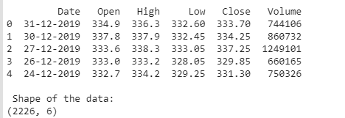

Figure 12: SCREENSHOT OF OUTPUT OF CODE IN FIG. 11

There are multiple variables in the dataset – date, open, high, low, close, and volume.

* The columns Open and Close represent the starting and final price at which the stock is traded on a particular day.
* High and Low represent the maximum and minimum of the share for the day.
* Volume is the number of shares bought or sold in the day.

Another important thing to note is that the market is closed on weekends and public holidays.

The profit or loss calculation is usually determined by the closing price of a stock for the day, hence we will consider the closing price as the target variable.

## **CLEAN THE DATASET**

In this we will be setting the Date variable as the Index Variable so that it can be used as a point of reference from now on, as well we will be creating a copy of dataset in sorted on which the work will be performed so that any new feature created does not affect the original data.

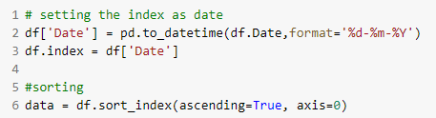

Figure 13: SCREENSHOT OF CODE, CLEANING THE DATASET

## **PLOT THE DATASET**

Plot the target variable (Close) to understand how it’s shaping up in our data



Figure 14: SCREENSHOT OF CODE, PLOTTING THE GRAPH OF CLOSE

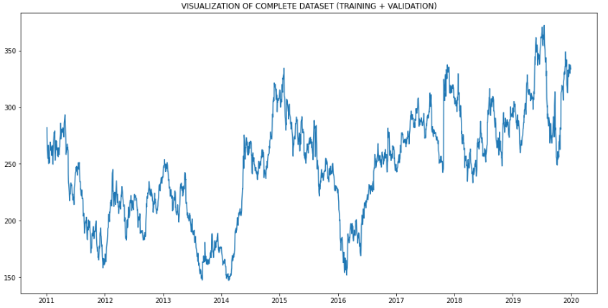

Figure 15: VISUALIZATION OF COMPLETE DATASET (TRAINING + VALIDATION)

## **TRAINING DATASET**

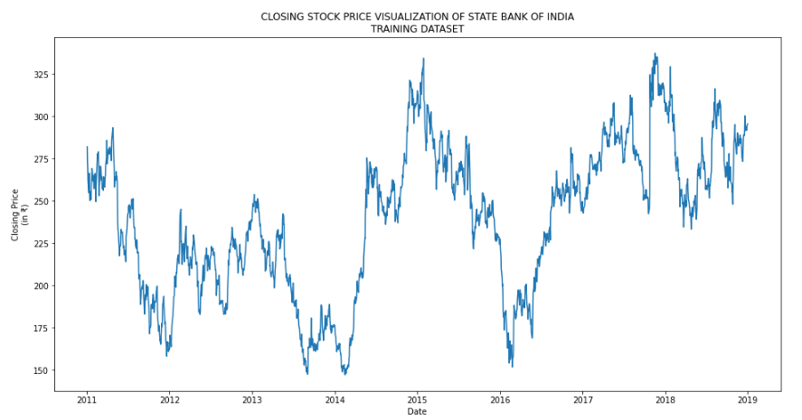

Figure 16: VISULAIZATION OF TRAINING DATASET

#NOTE: THE TRAINING SET WILL BE SAME FOR ALL MODELS

# **MODEL SELECTION**

We selected a total of 6 models for implementation and training & testing of our Dataset. We will be comparing the Root Mean Squared Error value and Mean Absolute Percentage Error values of the same.

**Moving Average Model: -** ‘Average’ is easily one of the most common things we use in our day-to-day lives. For instance, calculating the average marks to determine overall performance, or finding the average temperature of the past few days to get an idea about today’s temperature – these all are routine tasks we do on a regular basis. So this is a good starting point to use on our dataset for making predictions.

The predicted closing price for each day will be the average of a set of previously observed values. Instead of using the simple average, we will be using the moving average technique which uses the latest set of values for each prediction. In other words, for each subsequent step, the predicted values are taken into consideration while removing the oldest observed value from the set. Here is a simple figure that will help you understand this with more clarity.

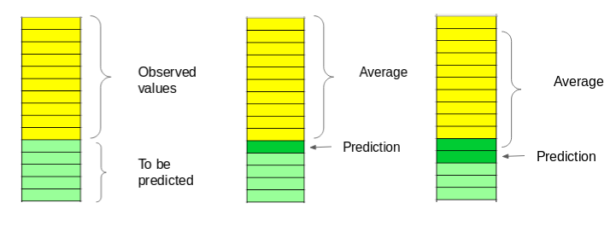

Figure 17: PICTORIAL DEPICTION OF HOW MOVING AVERAGE LOOKS LIKE

We will implement this technique on our dataset. The first step is to create a dataframe that contains only the Date and Close price columns, then split it into train and validation sets to verify our predictions.

CLACULATION OF VALUES

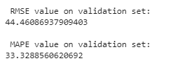

Figure 18: RMSE AND MAPE VALUES

Just checking the RMSE does not help us in understanding how the model performed. Let’s visualize this to get a more intuitive understanding. So here is a plot of the predicted values along with the actual values.

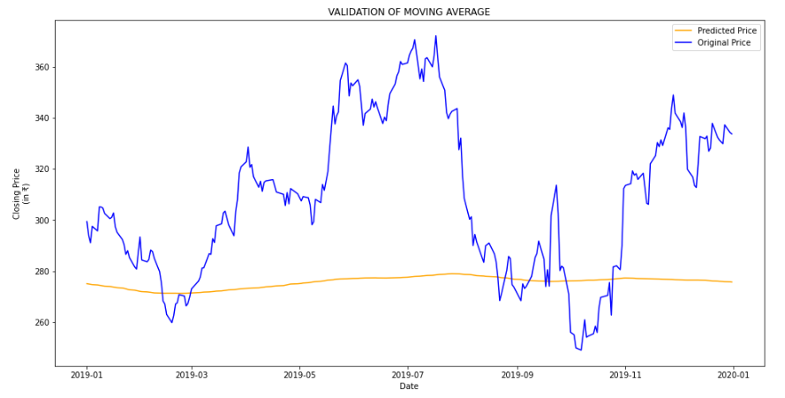

Figure 19: GRAPH DEPICTING PREDICTED (ORANGE) VS ACTUAL (GREEN)

The RMSE value is close to 44 but the results are not very promising (as you can gather from the plot). The predicted values are of the same range as the highest of observed values in the train set.

**Linear Regression: -** The most basic machine learning algorithm that can be implemented on this data is linear regression. The linear regression model returns an equation that determines the relationship between the independent variables and the dependent variable.

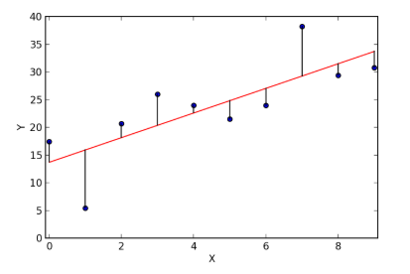

Figure 20: HOW LINEAR REGRESSION LOOKS LIKE WHEN IT WORKS

For our problem statement, we do not have a set of independent variables. We have only the dates instead. Let us use the date column to extract features like – day, month, year, mon/Friday etc. and then fit a linear regression model.

This creates features such as:

‘Year’, ‘Month’, ‘Week’, ‘Day’, ‘Dayofweek’, ‘Dayofyear’, ‘Is_month_end’, ‘Is_month_start’, ‘Is_quarter_end’, ‘Is_quarter_start’,  ‘Is_year_end’, and  ‘Is_year_start’.

Our hypothesis is that the first and last days of the week could potentially affect the closing price of the stock far more than the other days. So I have created a feature that identifies whether a given day is Monday/Friday or Tuesday/Wednesday/Thursday.

CLACULATION OF VALUES

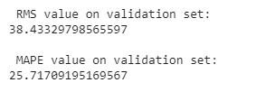

Figure 21: RMSE AND MAPE VALUES

The RMSE value is still higher than the desired, which clearly shows that linear regression has performed poorly. Let’s look at the plot and understand why linear regression has not done well:

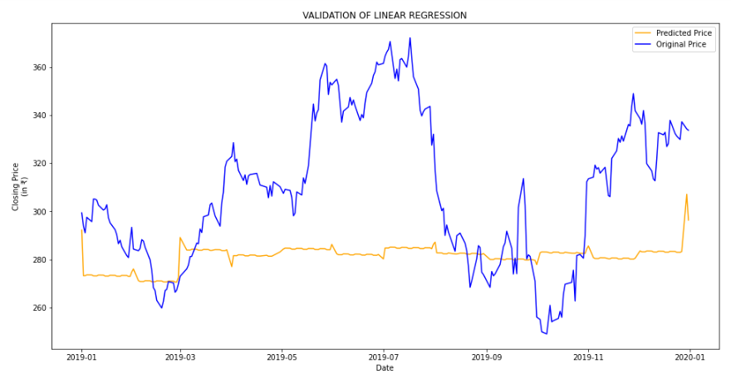

Figure 22: GRAPH OF PREDICTED (ORANGE) VS ACTUAL (GREEN)

Linear regression is a simple technique and quite easy to interpret, but there are a few obvious disadvantages. One problem in using regression algorithms is that the model overfits to the date and month column. Instead of taking into account the previous values from the point of prediction, the model will consider the value from the same *date* a month ago, or the same *date/month* a year ago.

**K-Nearest Neighbors: -**Another interesting ML algorithm that one can use here is K-NN (K-Nearest Neighbours). Based on the independent variables, K-NN finds the similarity between new data points and old data points.

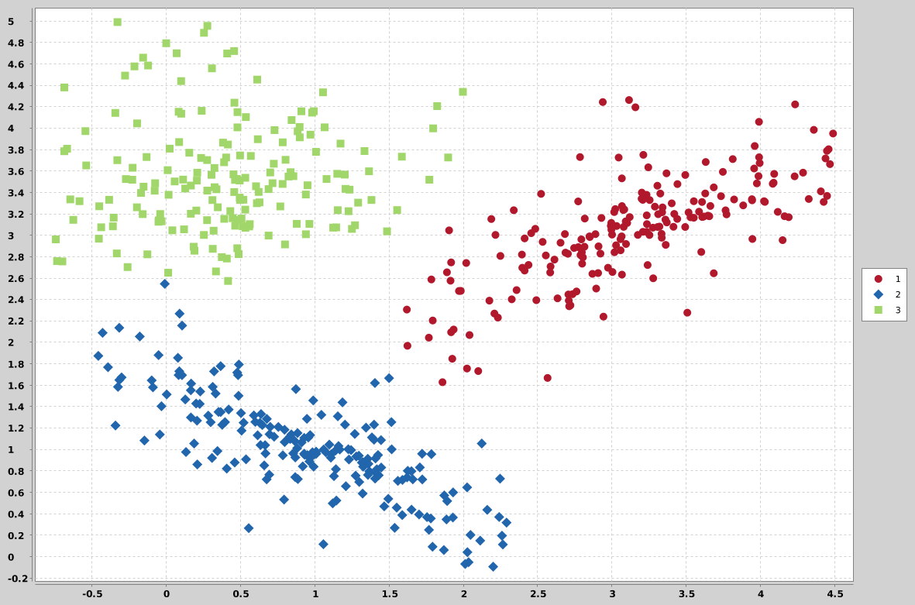

Figure 23: DEPICTING HOW K-NEAREST NEIGBORS LOOKS LIKE

CLACULATION OF VALUES

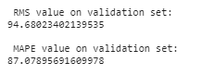

Figure 24: RMSE AND MAPE VALUES

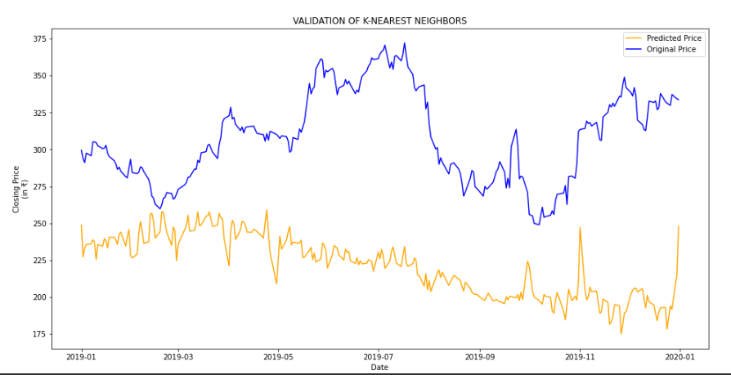

Figure 25: GRAPH SHOWING THE PREDICTED (ORANGE) VS ACTUAL (BLUE)

The RMSE value is almost similar to the linear regression model and the plot shows the same pattern. We can safely say that regression algorithms have not performed well on this dataset.

**fbPhrophet: -** There are a number of time series techniques that can be implemented on the stock prediction dataset, but most of these techniques require a lot of data preprocessing before fitting the model. Prophet, designed and pioneered by Facebook, is a time series forecasting library that requires no data preprocessing and is extremely simple to implement. The input for Prophet is a dataframe with two columns: date and target (ds and y). Prophet tries to capture the seasonality in the past data and works well when the dataset is large.

CLACULATION OF VALUES

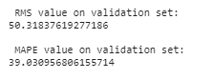

Figure 26: RMSE AND MAPE VALUES

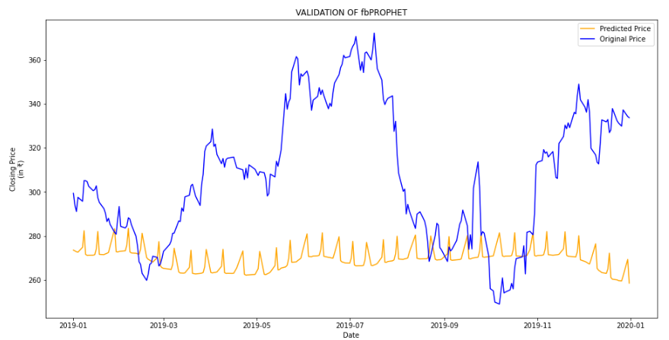

Figure 27: GRAPH DEPICITING PREDICTED (ORANGE) VS ACTUAL (GREEN)

Prophet (like most time series forecasting techniques) tries to capture the trend and seasonality from past data. This model usually performs well on time series datasets, but fails to live up to its reputation in this case.

**AUTO-ARIMA: -** ARIMA is a very popular statistical method for time series forecasting. ARIMA models take into account the past values to predict the future values. There are three important parameters in ARIMA:

p (past values used for forecasting the next value)

q (past forecast errors used to predict the future values)

d (order of differencing)

Parameter tuning for ARIMA consumes a lot of time. So we will use auto ARIMA which automatically selects the best combination of (p, q, and d) that provides the least error.

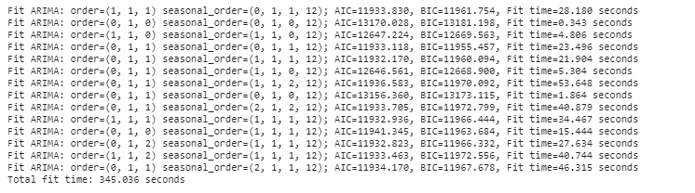

Figure 28: OUTPUT OF MODEL FIT FUNCTION

CLACULATION OF VALUES

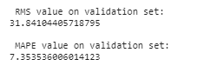

Figure 29: RMSE AND MAPE VALUES

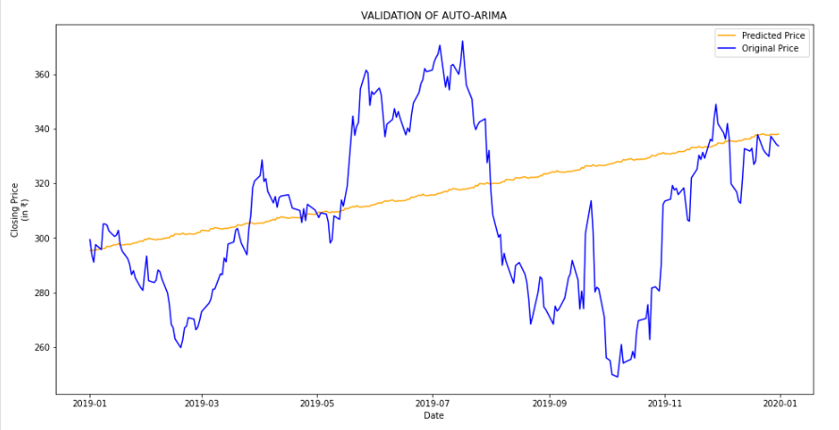

Figure 30: GRAPH DEPICTING PREDICTED (ORANGE) VS ACTUAL (GREEN)

As we saw earlier, an auto ARIMA model uses past data to understand the pattern in the time series. Using these values, the model captured an increasing trend in the series. Although the predictions using this technique are far better than that of the previously implemented machine learning models, these predictions are still not close to the real values.

As it’s evident from the plot, the model has captured a trend in the series, but does not focus on the seasonal part.

As it turns out, stock prices do not have a particular trend or seasonality. It highly depends on what is currently going on in the market and thus the prices rise and fall. Hence forecasting techniques like ARIMA, SARIMA and Prophet would not show good results for this particular problem.

Let us go ahead and try another advanced technique – Long Short Term Memory (LSTM).

**LONG SHORT TERM MEMORY: -** Long Short Term Memory (LSTM) are widely used for sequence prediction problems and have proven to be extremely effective. The reason they work so well is because LSTM is able to store past information that is important, and forget the information that is not.

LSTM has three gates:

* The input gate: The input gate adds information to the cell state
* The forget gate: It removes the information that is no longer required by the model
* The output gate: Output Gate at LSTM selects the information to be shown as output

CLACULATION OF LOSS

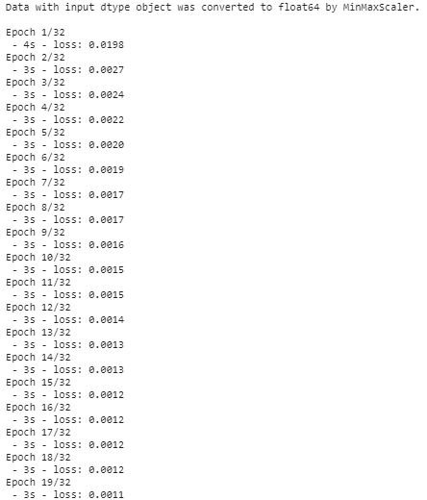 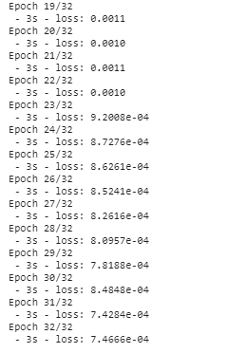

Figure 31: OUTPUT OF MODEL TARINING

CLACULATION OF VALUES

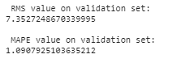

Figure 32: RMSE AND MAPE VALUES

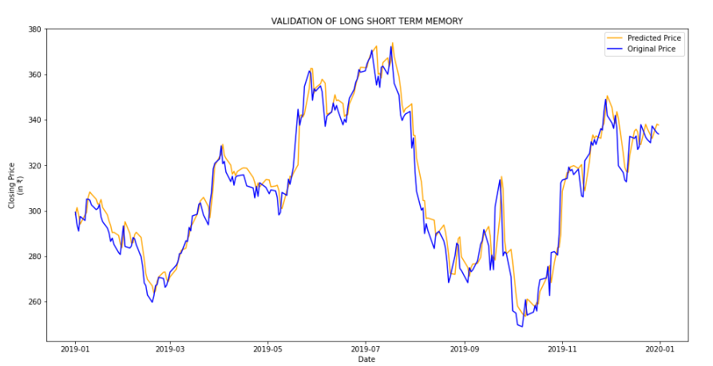

Figure 33: GRAPH DEPICTING THE PREDICTED (ORANGE) AND ACTUAL (GREEN)

Wow! The LSTM model can be tuned for various parameters such as changing the number of LSTM layers, adding dropout value or increasing the number of epochs.

CONCLUSION

For comparison of all the models till now we will plot the values of RMSE and MAPE obtained for each of the model. Then we will derive further conclusions based on the values, such as the optimal model out of all the implanted ones, which of the models are same as to that of their predicting natures and such on.

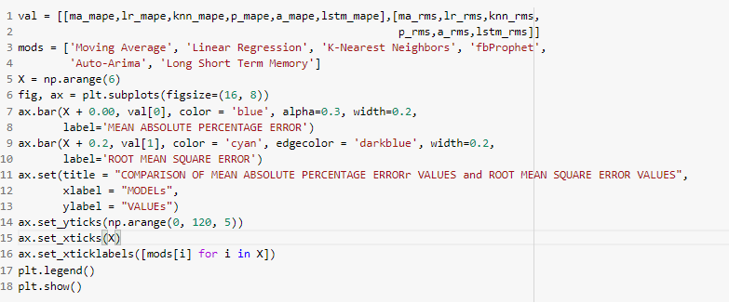

Figure 34: PLOTTING GRAPH FOR ALL THE RMSE AND MAPE VALUES

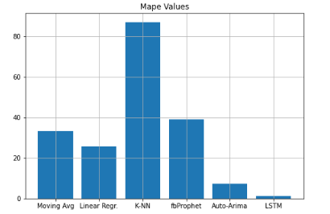

Figure 35: GRAPH OF COMPARISON OF MAPE VALUES

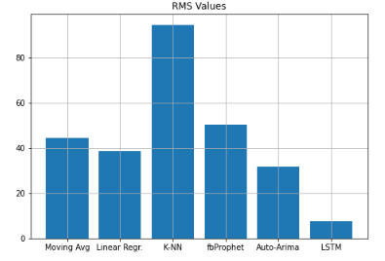

Figure 36: GRAPH OF COMPARISON OF RMS VALUES

Table 1: COMPARITIVE STUDY OF RMSE & MAPE VALUES (ODER BY EFFICIENCY)

|  |  |  |
| --- | --- | --- |
| MODEL NAME | RMSE VALUE | MAPE VALUE |
| Long Short Term Memory | 7.35 | 1.09 |
| Auto Arima | 31.84 | 7.35 |
| Linear Regression | 38.43 | 25.72 |
| Moving Average | 33.33 | 44.46 |
| fbProphet | 50.32 | 39.03 |
| K-Nearest Neighbors | 94.68 | 87.08 |

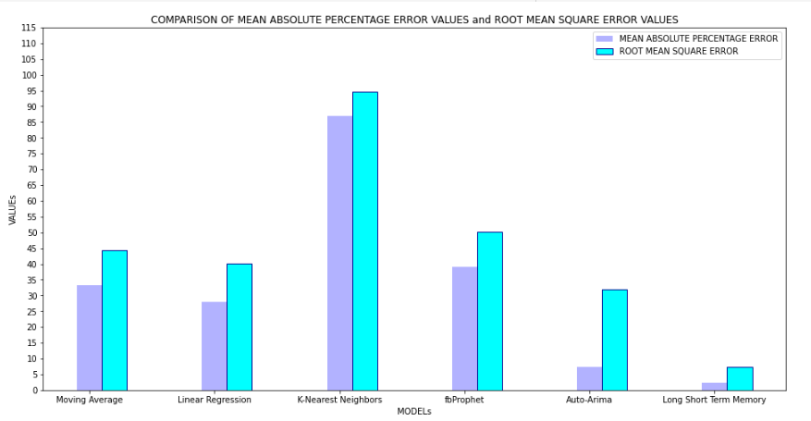

Figure 37: COMPARISON OF MEAN ABSOLUTE PERCENTAGE ERROR VALUES and ROOT MEAN SQUARE ERROR VALUES

As we can see in Table 1 and Figure 36, LSTM is the most efficient model which was implemented on our particular dataset, because as LSTM is an R-NN model, which is able to selectively work on the past data i.e. only on the needed values which may effect on the trend and seasonality, thus showing a much more effective outcome and very less loss in the predictions.

The second best model implemented was the Auto-Arima model, the Arima model was able to effectively capture the trend which was present in our dataset, but it could not work with the seasonality in order to minimize the loss. We can still improve the efficiency of the arima model if we were to hyper-tune its p, d, and q variables, but even then it may not perform upto the standards of the LSTM model on an equal no of hyper-tuned parameters.

The KNN and Linear Regression models did not work well with our particular time-series dataset, since we were only focused on the variables, DATE and CLOSE, and we were predicting the CLOSE so it had only DATE as a viable option for feature extraction, and we all know that from a DATE, one can only study it TIME, DAY, MONTH, WEEK and YEAR. There are not a lot of different features which can be worked upon thus, they fail to even predict the trend much less the seasonality.

The Prophet model which was specifically designed the Facebook, to work with TIME-SERIES, has failed in our case because, a Stock Market Dataset may be a Time-Series Dataset, but at the end of the day, it does not follows as strict trend or seasonality, as the other Time-Series, because there are other factors also present in the real-world which may bring about a drastic change in Stock Prices.

### *End Note:*

The LSTM model was the best model implemented out of all to work with Time-Series. But are the predictions from LSTM enough to identify whether the stock price will increase or decrease? Certainly not!

As we know, stock price is affected by the news about the company and other factors like demonetization or merger/demerger of the companies. There are certain intangible factors as well which can often be impossible to predict beforehand.

Time series forecasting is a very intriguing field to work with, as we have realized during the time spent on this project. There is a perception in the community that it’s a complex field, and while there is a grain of truth in there, it’s not so difficult once you get the hang of the basic techniques.

REFERENCES

1. A 6 Step Field Guide for Building Machine Learning Projects by Daniel Bourke
2. Introduction to Time Series Forecasting With Python by Jason Brownlee
3. Contreras, 1. Espinola, R.NogaJes, F1.and conejo,AJ.(2003) "ARIMA models to predict next day electricity prices", IFEE transactions on power system, vo1.18, noJ,pp: I 014-1 020.
4. Kumar; K Yadav;A.KSingh, M.P; Hassan and H.Jain,V.K(2004)"Forecasting Daily Maximum Surface Ozone".
5. Tsitsika,E.V;Maravelias,C.D& Haralatous,J. (2007)"Modelling and forecasting pelagic fish production using univariate and multivariate ARIMA models". Fisheries science volume 73,pp:979-988.
6. Datta K.(2011)"ARIMA forecasting of Inflation in the Bangladesh Economy",The IUP journal of bank management,voI.X,No.4,pp-7-15.
7. D. Banerjee, "Forecasting of Indian stock market using time-series ARIMA model," 2014 2nd International Conference on Business andInformation Management (ICBIM), Durgapur, 2014, pp. 131-135, doi: 10.1109/ICBIM.2014.6970973.
8. Q. Xie, G. Cheng, X. Xu, and Z. Zhao, “Research based on stock predicting model of neural networks ensemble learning,” in MATEC Web of Conferences, vol. 232. EDP Sciences, 2018, p. 02029. S. Yao, L. Luo and H. Peng, "High-Frequency Stock Trend Forecast Using LSTM Model," *2018 13th International Conference on Computer Science & Education (ICCSE)*, Colombo, 2018, pp. 1-4, doi: 10.1109/ICCSE.2018.8468703.
9. F. Qian and X. Chen, "Stock Prediction Based on LSTM under Different Stability," 2019 IEEE 4th International Conference on Cloud Computing and Big Data Analysis (ICCCBDA), Chengdu, China, 2019, pp. 483-486, doi: 10.1109/ICCCBDA.2019.8725709.
10. S.Kamath, “Stock Market Analysis”, Master’s Projects, pp. 326, 2012
11. P.Domingos, “A Few Useful Things to Know about Machine Learning,”Communications of the ACM, Vol. 55 No. 10, October 2012.
12. “Introduction to Time Series Analysis and Forecasting” by Douglas C. Montgomery, Cheryl L. Jennings, and Murat Kulahci
13. “Time Series Analysis: Forecasting and Control” by George E. P. Box, Gwilym M. Jenkins, Gregory C. Reinsel, and Greta M. Ljung
14. Chris Chatfield, "The analysis of time series An introduction"