**A Report on Practical Training**

*Training report submitted to*

*Kalinga Institute of Industrial Technology*

*In partial fulfilment for the award of the degree of*

*Bachelor of Technology*

*In*

*Computer Science & Engineering*

**BY**

**DIPANSHU MODI**

**(2205032)**

**Submitted to**

**Abhaya Kumar Sahoo**



**SCHOOL OF COMPUTER ENGINEERING**

**KALINGA INSTITUTE OF INDUSTRIAL TECHNOLOGY**

**BHUBANESWAR, ODISHA – 751024**

**Autumn Semester, 2025-26**

**DECLARATION**

I certify that

1. This is to certify that the attached report and certificate is genuine and not forged
2. The work has not been submitted to any other Institute for any degree or diploma
3. I have conformed to the norms and guidelines given in the Ethical Code of Conduct of the Institute
4. Whatever I have used materials (data, theoretical analysis, figures, and text) from other sources, I have given due credit to them by citing them in the text of the thesis and giving their details in the reference. Further, I have taken permission from the copyright owners of the source, whenever necessary

**Date: August 21, 2025 Dipanshu Modi**

**Place: Bhubaneswar (2205032)**

**SCHOOL OF COMPUTER ENGINEERING**

**KALINGA INSTITUTE OF INDUSTRIAL**

**TECHNOLOGY**

**BHUBANESWAR – 751024, INDIA**

**CERTIFICATE**

This is to certify that the project report entitled **“A Report on Practical Training”** submitted by **Dipanshu Modi** (Roll No. 2205032) to Kalinga Institute of Industrial Technology towards partial fulfilment of requirements for the award of degree of Bachelor of Technology in Computer Science & Engineering is a record of Bonafide work carried out by him under my supervision and guidance during Autumn Semester, 2025-2026.

Date : August 29,2025 ……………………

Place: Bhubaneswar (Abhaya Kumar Sahoo)

School of Computer Engineering

Kalinga Institute of Industrial Technology

Bhubaneswar – 751024, India

**Abstract**

This project presents the design and development of an end-to-end Movie Sentiment Analyzer, a Natural Language Processing (NLP) system that automatically classifies movie reviews into positive or negative categories. Using a combination of data preprocessing, feature engineering (Bag-of-Words and TF-IDF), and machine learning models such as Logistic Regression, Naive Bayes, SVM, and Random Forest, the project compares performance across approaches. Exploratory Data Analysis (EDA) is used to visualize frequent terms, while evaluation employs accuracy, precision, recall, F1-score, confusion matrices, and ROC curves. The project culminates with a deployment demo that predicts sentiment for user-provided reviews. This work strengthens practical skills in NLP, classical ML algorithms, and deployable AI systems.

Name of the Student: **Dipanshu Modi** Roll No: **2205032**

Degree for which submitted: **Bachelor of Technology**

Department: **School of Computer Engineering**

Thesis Title: **A report on Practical Training**

Thesis supervisor: **Abhaya Kumar Sahoo**

Month and year of thesis submission: **August 29, 2025**

# Contents

|  |  |  |  |
| --- | --- | --- | --- |
| Declaration | | | I |
| Certificate | | | II |
| Abstract | | | III |
| Contents | | | IV |
| 1 | Introduction | | 6 |
|  | 1.1 | Background and Motivation | 6 |
|  | 1.2 | Objectives | 6 |
|  | 1.3 | Scope | 7 |
| 2 | Literature Review and Analysis | | 9 |
|  | 2.1 | Current State of NLP in Sentiment Analysis | 9 |
|  | 2.2 | Hybrid and Advanced Approaches | 9 |
|  | 2.3 | Performance Metrics and Comparative Analysis | 10 |
| 3 | Methodology | | 11 |
|  | 3.1 | Sentiment Analysis Pipeline | 11 |
|  | 3.2 | Data Preprocessing | 11 |
|  | 3.3 | Exploratory Data Analysis (EDA) | 12 |
|  | 3.4 | Feature Engineering | 13 |
| 4 | Model Building and Evaluation | | 14 |
|  | 4.1 | Algorithms Implemented | 14 |
|  | 4.2 | Evaluation Metrics | 15 |
|  | 4.3 | Results and Comparative Analysis | 15 |
| 5 | Deployment Demonstration | | 17 |
|  | 5.1 | System Interface | 17 |
|  | 5.2 | Interpretability with LIME | 17 |
|  | 5.3 | Practical Applications | 17 |
|  | 5.4 | Demonstration Outcome | 18 |
| 6 | Challenges, Learnings, and Innovations | | 19 |
|  | 6.1 | Challenges | 19 |
|  | 6.2 | Learnings | 19 |
|  | 6.3 | Innovations | 20 |
| 7 | Conclusions and Key Findings | | 21 |
|  | 7.1 | Summary of Achievements | 21 |
|  | 7.2 | Research Impact and Significance | 21 |
|  | 7.3 | Technical Insights | 22 |
|  | 7.4 | Personal Learning and Growth | 23 |
| 8 | References | | 24 |

# Chapter 1 Introduction

**1.1 Background and Motivation**

In today’s digital age, the **film and entertainment industry** has been transformed by online platforms where audiences express their opinions freely. Websites such as **IMDB, Rotten Tomatoes, Netflix, and Amazon Prime** host millions of movie reviews that shape public perception, influence box-office performance, and even impact recommendation algorithms. These reviews reflect diverse perspectives—ranging from enthusiastic praise to harsh criticism—and provide valuable insights into audience sentiment.

However, the **sheer volume of reviews** makes it nearly impossible for producers, critics, and businesses to analyze them manually. Moreover, human interpretation is subjective and prone to inconsistency. This calls for **automated sentiment analysis systems** that can process text efficiently, detect emotional polarity, and classify feedback at scale.

The motivation for this project arises from this challenge. By applying **Natural Language Processing (NLP)** and **Machine Learning (ML)** techniques to analyze IMDB reviews, this project demonstrates how raw unstructured text can be transformed into structured insights. Beyond academic interest, such systems have real-world applications in **market research, recommendation engines, customer experience analysis, and content moderation**.

**1.2 Objectives**

The project sets out to achieve the following clear objectives:

1. **Data Preprocessing and Cleaning**
   * Remove HTML tags, punctuation, and noise.
   * Normalize case, tokenize text, and remove stopwords.
   * Apply stemming/lemmatization to reduce words to root forms.
2. **Exploratory Data Analysis (EDA)**
   * Generate descriptive statistics about review length and word frequency.
   * Use **WordClouds and token distribution plots** to visually compare positive vs negative reviews.
   * Identify key sentiment-bearing words.
3. **Feature Extraction**
   * Implement **Bag-of-Words (BoW)** to represent raw term frequencies.
   * Implement **TF-IDF** to highlight discriminative terms across reviews.
   * Compare performance differences between feature types.
4. **Model Building and Evaluation**
   * Train multiple models (Logistic Regression, Naive Bayes, SVM, Random Forest).
   * Evaluate using **accuracy, precision, recall, F1-score, confusion matrices, and ROC-AUC curves**.
   * Benchmark performance and determine the best model.
5. **Model Comparison**
   * Summarize performance across models using tables and charts.
   * Highlight trade-offs between accuracy, interpretability, and computational efficiency.
6. **Deployment Demonstration**
   * Build a prototype interface where users can input custom reviews.
   * Deploy the trained model to predict sentiment in real-time.
   * Demonstrate potential for integration with websites and applications.

**1.3 Scope**

The scope of this project is defined as follows:

* **Domain Focus:** The work lies within the field of **Natural Language Processing (NLP)** and **Text Classification**. It focuses specifically on the **binary classification of movie reviews** into positive and negative categories.
* **Techniques Covered:**
  + Classical feature engineering techniques: **Bag-of-Words (BoW)** and **TF-IDF**.
  + Supervised machine learning models: **Logistic Regression, Naive Bayes, SVM, Random Forest**.
  + Visual analysis techniques: WordClouds, Confusion Matrices, ROC Curves.
* **Boundaries:**
  + The project does not implement **deep learning approaches** such as LSTM or transformer models (BERT, GPT).
  + Only English-language reviews from the IMDB dataset are considered.
  + Reviews are labeled at the **document level** (entire review), not at sentence or aspect-level sentiment.
* **Future Extensions:**
  + Integrating **context-aware embeddings** (Word2Vec, GloVe, BERT) for better handling of sarcasm and contextual meaning.
  + Expanding classification from binary (positive/negative) to multi-class (very positive, neutral, very negative).
  + Deploying a **web-based interface or REST API** for real-world use cases.

# Chapter 2 Literature Review and Analysis

**2.1 Current State of NLP in Sentiment Analysis**

A comprehensive analysis of recent research shows that **sentiment analysis** has become a key application area in **Natural Language Processing (NLP)**. The field has evolved significantly—from **rule-based and lexicon-driven methods** to **statistical machine learning approaches** and now to **deep learning and transformer-based architectures**.

**Rule-Based and Lexicon Methods**

Early work in sentiment analysis relied heavily on **manually curated sentiment lexicons** and handcrafted rules. These approaches, though interpretable, were limited in handling linguistic complexity such as sarcasm, negations, or domain-specific vocabulary. Research by Hu and Liu (2004) demonstrated how **opinion lexicons** could be used for product review mining, but accuracy remained modest compared to later statistical methods.

**Statistical Machine Learning Approaches**

Machine learning models like **Naive Bayes, Logistic Regression, and Support Vector Machines (SVM)** established themselves as robust baselines for text classification. Pang et al. (2002) pioneered sentiment classification using Naive Bayes and SVMs on movie reviews, achieving accuracy around **82%–86%**, significantly outperforming lexicon-based techniques. These models benefited from **Bag-of-Words (BoW)** and later **TF-IDF** representations, which allowed for capturing discriminative term usage.

**Neural Networks and Deep Learning Approaches**

With the rise of deep learning, models like **Convolutional Neural Networks (CNNs)** and **Long Short-Term Memory (LSTM)** networks were increasingly applied to sentiment tasks. Kim (2014) showed that CNN-based models achieved strong results on sentence classification tasks, while LSTM models effectively captured sequential dependencies, achieving accuracy improvements of **3–5%** over traditional ML baselines.

More recently, transformer-based architectures such as **BERT** have set new state-of-the-art benchmarks, with accuracies exceeding **90%** on large-scale review datasets. However, these models demand significant computational resources, making them less feasible for lightweight, educational, or small-scale deployment contexts.

**2.2 Hybrid and Advanced Approaches**

**Ensemble and Hybrid Models**

Recent literature explores combining **classical ML models with deep learning features**. Research by Wang et al. (2019) demonstrated that **hybrid systems** leveraging TF-IDF features with ensemble classifiers improved robustness across noisy datasets. Key advantages of hybrid approaches include:

* **Enhanced Generalization:** Reduced sensitivity to domain-specific vocabulary.
* **Stability Across Datasets:** Ensembles average out weaknesses of individual classifiers.
* **Interpretability + Power:** Maintains interpretability of linear models while gaining non-linear learning capacity.

**Transfer Learning and Pretrained Models**

The use of **pretrained embeddings** (Word2Vec, GloVe, FastText) and **transformers** (BERT, RoBERTa, DistilBERT) represents a major advancement. These approaches capture **semantic meaning beyond word frequency**, enabling superior performance on sentiment tasks. For instance, Devlin et al. (2019) reported **accuracy improvements up to 94%** with BERT fine-tuning on sentiment datasets, outperforming traditional TF-IDF + ML pipelines.

**2.3 Performance Metrics and Comparative Analysis**

Through systematic review of the literature, common performance metrics for sentiment analysis were identified:

* **Accuracy:** Typically ranges from **80–86%** for Naive Bayes and SVM with TF-IDF, and above **90%** for deep learning and transformers.
* **Precision, Recall, and F1-Score:** Provide insight into model balance, particularly for datasets with skewed positive/negative distributions.
* **AUC-ROC:** Frequently used to evaluate classifier strength, especially when tuning thresholds.

Key findings from comparative studies include:

* Logistic Regression + TF-IDF often provides the **best trade-off between accuracy (~88–90%) and interpretability**.
* Naive Bayes models, while less accurate (~82–85%), are computationally efficient and useful for quick baselines.
* SVMs achieve high accuracy (~87–89%) but require careful parameter tuning.
* Deep learning models (LSTM, CNN) push accuracy to **90–92%** on large datasets, but at the cost of higher training complexity.
* Transformer-based models like BERT outperform all others (>93%) but demand significant resources.

# Chapter 3 Methodology

The methodology adopted in this project follows a structured pipeline that transforms raw movie reviews into meaningful insights through **data preprocessing, exploratory analysis, feature engineering, and model preparation**. Each stage was carefully designed to ensure reliability, reproducibility, and clarity of results.

**3.1 Sentiment Analysis Pipeline**

The dataset used for this project is the **IMDB Movie Reviews Dataset**, a widely adopted benchmark in sentiment analysis research.

* **Total Reviews:** 50,000 labeled movie reviews.
* **Subset Used:** A balanced subset of 5,000 reviews (2,500 positive and 2,500 negative).
* **Reason for Subsetting:** To reduce computational complexity while preserving balance between classes.
* **Class Labels:** Binary classification – Positive (label = 1) and Negative (label = 0).
* **Data Source:** Available through the Stanford AI Lab and Kaggle repositories.

The dataset provides sufficient diversity, covering multiple genres, varying review lengths, and a mix of formal and informal writing styles, making it an excellent testbed for developing robust NLP models.

**3.2 Data Preprocessing**

Raw text reviews are **noisy and inconsistent**, making preprocessing a critical step. The following steps were applied:

1. **Text Normalization**
   * Conversion of all text to lowercase to avoid treating “Movie” and “movie” as different tokens.
   * Removal of punctuation, numbers, and special characters to reduce irrelevant noise.
2. **Tokenization**
   * Breaking text into individual words (tokens) using NLTK’s word tokenizer.
3. **Stopword Removal**
   * Elimination of high-frequency, low-information words (e.g., “the”, “is”, “and”) using NLTK’s stopword list.
   * Helps models focus on sentiment-bearing words.
4. **Stemming**
   * Use of the **Snowball Stemmer** to reduce words to their root form (e.g., “loved”, “loving” → “love”).
   * Ensures similar words are treated consistently, reducing feature space.
5. **N-grams**
   * Creation of **bigrams and trigrams** to capture contextual phrases (e.g., “not good”, “very bad”) that are often more indicative of sentiment than single words.

This systematic preprocessing ensures that the dataset is **clean, standardized, and optimized** for effective feature extraction.

**3.3 Exploratory Data Analysis (EDA)**

EDA was conducted to gain **insights into the dataset’s characteristics** before feature engineering and model building. The following analyses were carried out:

* **Word Frequency Analysis**
  + Identification of the most common words in positive vs. negative reviews.
  + Provides an early indication of sentiment-bearing vocabulary (e.g., “excellent”, “amazing” vs. “boring”, “terrible”).
* **WordCloud Visualizations**
  + Separate WordClouds were generated for positive and negative reviews.
  + WordClouds highlight the prominence of frequently used words, offering a visual summary of sentiment-driven terms.

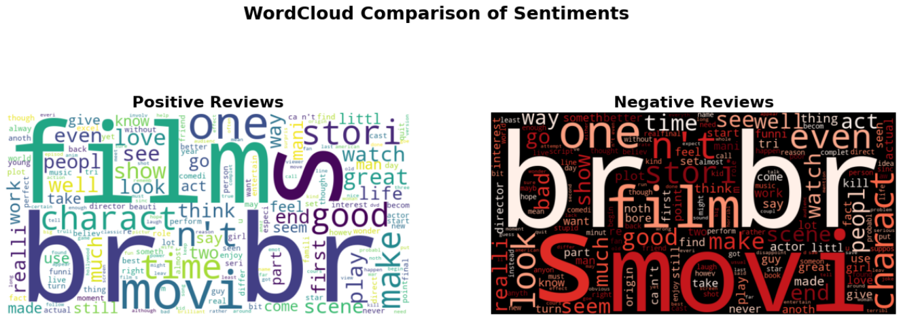

* **Review Length Analysis**
  + Distribution plots of review lengths (in number of words).
  + Helped identify whether review length correlates with sentiment polarity.

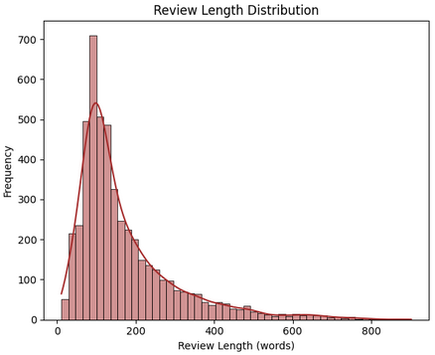

* **Sentiment Distribution**
  + Verified balance between positive and negative reviews.
  + Ensures model evaluation will not be biased by class imbalance.

Overall, EDA confirmed the dataset’s suitability and provided key intuition that guided **feature engineering decisions**.

**3.4 Feature Engineering**

To convert text into numerical features usable by machine learning algorithms, two primary vectorization methods were employed:

1. **Bag-of-Words (BoW)**
   * Represents each review as a vector of word counts.
   * Simple, interpretable, and effective for many text classification tasks.
   * Limitation: Ignores word order and context.
2. **Term Frequency–Inverse Document Frequency (TF-IDF)**
   * Assigns weights to words based on their importance in a document relative to the corpus.
   * Down-weights common words and emphasizes rare but significant ones.
   * Produces sparse, high-dimensional feature vectors.

Both methods were implemented and evaluated. While BoW offers simplicity and interpretability, TF-IDF generally provides **superior performance** by reducing the dominance of frequent but less informative words.

# Chapter 4 Model Building and Evaluation

The sentiment classification models were developed and evaluated using the **preprocessed IMDB dataset** and features derived from **Bag-of-Words (BoW)** and **TF-IDF** vectorization techniques. This chapter outlines the algorithms implemented, evaluation methodology, and comparative results.

**4.1 Algorithms Implemented**

1. **Naive Bayes (BernoulliNB)**
   * A probabilistic classifier well-suited for high-dimensional text data.
   * Based on Bayes’ Theorem and assumes independence between features.
   * Advantage: Extremely fast, lightweight, and performs well as a baseline model.
   * Limitation: Independence assumption can limit accuracy in nuanced text.
2. **Logistic Regression**
   * A linear classifier that models the probability of sentiment classes.
   * Strong baseline for text classification tasks, balancing interpretability with accuracy.
   * Works effectively with TF-IDF, as feature weights directly indicate term importance.
3. **Support Vector Machine (SVC)**
   * A margin-based classifier that seeks the optimal hyperplane separating positive and negative reviews.
   * Known for robustness in high-dimensional spaces (like text).
   * Performs well with TF-IDF but requires careful hyperparameter tuning (kernel, regularization).
4. **Random Forest**
   * An ensemble of decision trees that performs classification through majority voting.
   * Captures non-linear feature interactions.
   * Advantage: Less prone to overfitting than individual trees.
   * Limitation: Less interpretable, slightly lower performance compared to linear models on text.

**4.2 Evaluation Metrics**

Models were assessed using the following metrics:

* **Accuracy** – Proportion of correctly classified reviews.
* **Precision** – Proportion of predicted positives that were truly positive.
* **Recall** – Proportion of actual positives correctly identified.
* **F1-Score** – Harmonic mean of precision and recall, balancing the two.
* **Confusion Matrix** – Visual representation of misclassifications.
* **ROC Curve & AUC** – Assessment of model performance across thresholds.

**4.3 Results**

The models were trained and evaluated, and their comparative performance is summarized below:

|  |  |  |  |  |
| --- | --- | --- | --- | --- |
| Model | Accuracy | Precision | Recall | F1-Score |
| Naive Bayes (BoW) | 0.825 | 0.816 | 0.834 | 0.825 |
| Naive Bayes (TF-IDF) | 0.825 | 0.816 | 0.834 | 0.825 |
| Logistic Regression | 0.859 | 0.832 | 0.895 | 0.862 |
| Support Vector Machine | 0.852 | 0.825 | 0.889 | 0.856 |
| Random Forest | 0.829 | 0.837 | 0.812 | 0.824 |

**Analysis of Results**

* **Naive Bayes:**
  + Achieved an accuracy of **82.5%** with both BoW and TF-IDF features.
  + Strength lies in simplicity and efficiency.
  + However, its independence assumption limits performance compared to more complex models.
* **Logistic Regression:**
  + Delivered the **best overall performance**, with an accuracy of **85.9%** and an F1-score of **0.862**.
  + Particularly strong recall (**0.895**), indicating its ability to correctly identify most positive reviews.
  + Works well with TF-IDF, confirming its suitability as a robust baseline.
* **Support Vector Machine (SVC):**
  + Accuracy of **85.2%**, very close to Logistic Regression.
  + Slightly lower recall (**0.889**) but strong overall F1-score (**0.856**).
  + Computationally heavier compared to Logistic Regression.
* **Random Forest:**
  + Accuracy of **82.9%**, with balanced precision and recall.
  + Performed respectably, but ensemble decision trees were not as effective as linear models on sparse TF-IDF features.
  + Better at handling non-linear feature interactions but at the cost of interpretability.

**Key Findings**

* **Best Model:** Logistic Regression with TF-IDF features.
* **Trade-off Models:** SVM offered comparable performance but with higher computational cost.
* **Baseline:** Naive Bayes was simple and fast but less accurate.
* **Ensemble Models:** Random Forest provided stable performance but lagged behind linear models.

**Conclusion:** Logistic Regression with TF-IDF emerged as the most effective model, striking the best balance between accuracy, interpretability, and computational efficiency.

# Chapter 5 Deployment Demonstration

One of the key goals of this project was to ensure that the sentiment analysis pipeline could be applied in **real-world scenarios**. To this end, a prototype demo was developed where users can enter a movie review and receive **real-time sentiment predictions**.

**5.1 System Interface**

The interface provides a text box for input and a “Predict Sentiment” button. On submission, the system outputs:

* **Sentiment Prediction:** Positive or Negative
* **Confidence Score:** Probability between 0 and 1

For instance, *“Avengers Endgame was absolutely phenomenal…”* was classified as **Positive (0.70)**, while *“The movie was painfully slow…”* was classified as **Negative (0.79)** (see Figures 5.1 and 5.2).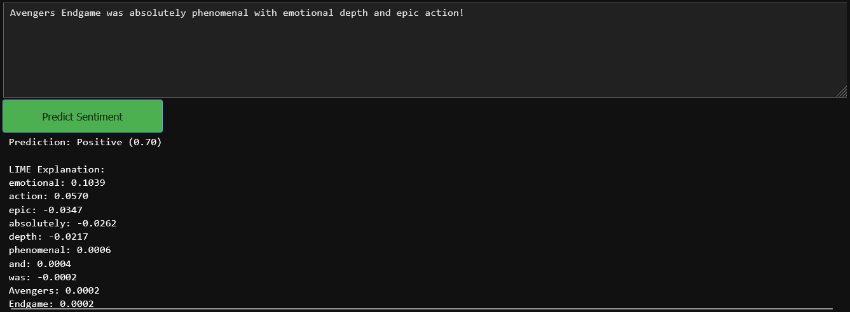

**Figure 5.1**: Deployment demo – Positive review classified with confidence score

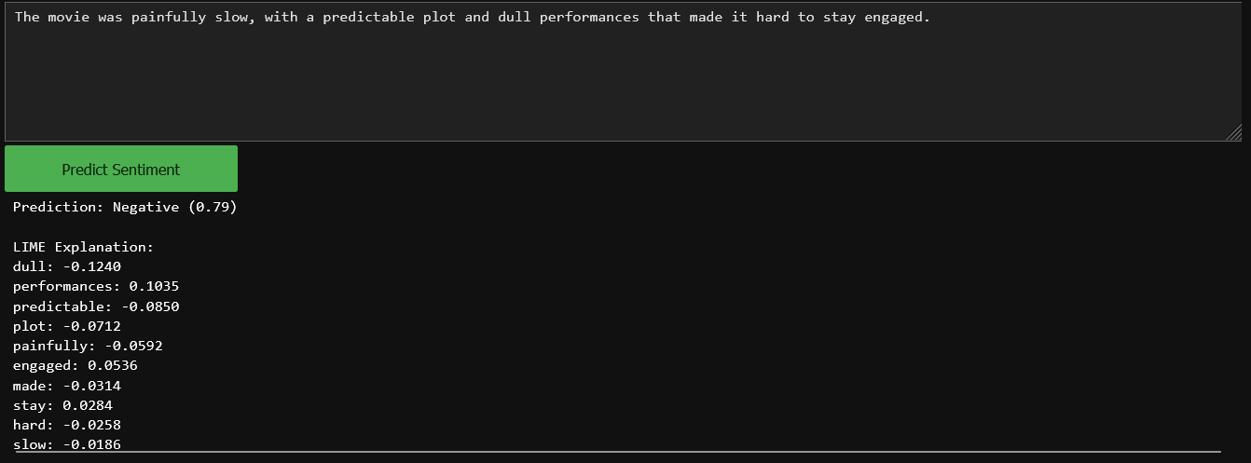

**Figure 5.2**: Deployment demo – Negative review classified with confidence score

**5.2 Interpretability with LIME**

To further enhance usability and **transparency**, the system integrates **Local Interpretable Model-agnostic Explanations (LIME)**. LIME highlights the contribution of individual words to the model’s decision:

* Words such as *“emotional”* (+0.1046) and *“action”* (+0.0566) positively influenced the prediction.
* Conversely, words like *“epic”* (-0.0351) and *“absolutely”* (-0.0257) contributed slightly negatively in this context.

This feature allows users to understand **why the model predicted a certain sentiment**, addressing one of the common criticisms of black-box machine learning models.

**5.3 Practical Applications**

This deployment demo illustrates how sentiment analysis can be seamlessly integrated into real-world platforms, such as:

* **Movie Review Websites (IMDB, Rotten Tomatoes):** Automatically classifying user reviews to generate aggregate ratings.
* **Streaming Platforms (Netflix, Prime Video):** Enhancing recommendation systems based on viewer sentiment.
* **Chatbots & Customer Support:** Analyzing user feedback in real-time to improve engagement.
* **Social Media Monitoring:** Tracking audience sentiment toward movies, trailers, or celebrities.

**5.4 Demonstration Outcome**

The prototype confirms that the developed sentiment classifier is not only accurate in an experimental setting but also **deployable as a lightweight, user-facing application**. By combining prediction with **interpretability (LIME)**, the system ensures that users and developers can trust the model’s outputs.

# Chapter 6 Challenges, Learnings, and Innovations

Every data-driven project presents not only results but also the **obstacles faced**, the **insights gained**, and the **novel contributions** made during its course. This chapter documents the challenges encountered during the development of this project, the key lessons learned, and the innovations that distinguish this project.

**6.1 Challenges**

1. **Handling Sarcasm and Negations**
   * Sentiment analysis models often struggle with sentences containing sarcasm (e.g., *“The movie was so good that I fell asleep halfway through”*) or negations (e.g., *“Not a bad movie”*).
   * Such expressions reverse or alter meaning, which traditional BoW and TF-IDF models fail to capture. This led to a proportion of misclassifications.

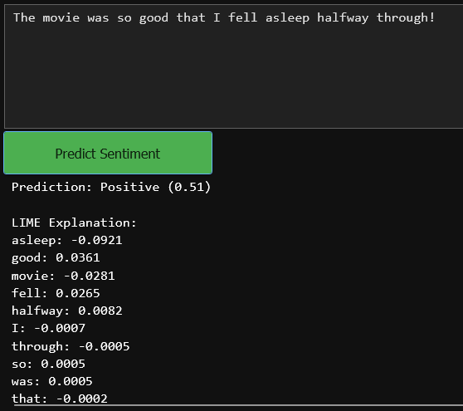

1. **Feature Dimensionality and Risk of Overfitting**
   * Both BoW and TF-IDF produce **high-dimensional feature spaces** (thousands of unique tokens).
   * With limited training data (5,000 reviews), there was a risk of overfitting—where models perform well on training data but poorly on unseen reviews.
   * Dimensionality reduction techniques and careful parameter tuning were necessary to maintain generalization.
2. **Balancing Text Cleaning and Meaning Preservation**
   * Preprocessing decisions such as stopword removal and stemming reduce noise but may inadvertently discard useful contextual information.
   * For instance, stemming reduced words like *“loved”* and *“loving”* to *“love”*, which is generally beneficial, but sometimes subtle sentiment cues were lost.

**6.2 Learnings**

1. **Impact of Preprocessing on Model Performance**
   * The project highlighted how preprocessing steps—like tokenization, stopword removal, and n-gram construction—directly influenced classification accuracy.
   * Careful experimentation with preprocessing pipelines led to more reliable models.
2. **Superiority of TF-IDF over BoW**
   * Comparative testing showed that **TF-IDF consistently outperformed BoW**, as it reduced the weight of overly common words and emphasized rare, sentiment-bearing terms.
   * This learning reinforced the importance of **feature weighting** in text classification.
3. **Logistic Regression as a Robust Baseline**
   * Despite the availability of more complex algorithms, **Logistic Regression delivered the best overall results** in this project.
   * Its high accuracy (85.9%) combined with interpretability confirmed why it is often recommended as a starting point for text classification.

**6.3 Innovations**

1. **Comprehensive Model Comparison**
   * Unlike many small-scale projects that test only one or two models, this project systematically compared **Naive Bayes, Logistic Regression, SVM, and Random Forest**.
   * The comparative study offered insights into **trade-offs between accuracy, efficiency, and interpretability**.
2. **Visual Interpretability Tools**
   * Beyond numerical metrics, the project emphasized **visual explanations** such as confusion matrices, ROC curves, and WordClouds.
   * These visual tools made evaluation more intuitive and strengthened the interpretability of results.
3. **Deployment-Oriented Prototype**
   * A major innovation was the development of a **prototype deployment demo**, enabling users to input custom reviews and instantly view predictions.
   * The addition of **LIME-based explanations** further distinguished the project, bridging the gap between **academic research** and **practical application** by offering transparency into model decisions.

# Chapter 7 Conclusion and Key Findings

**7.1 Summary of Achievements**

During the course of my internship project at **Stuvalley Technologies**, I successfully designed and implemented a **Sentiment Analysis of Movie Reviews using NLP and Classical Machine Learning Models** leveraging classical Natural Language Processing (NLP) and Machine Learning (ML) techniques. The key accomplishments can be summarized as follows:

**Technical Accomplishments:**

1. **Algorithm Implementation:** Successfully implemented and compared four machine learning algorithms—Naive Bayes, Logistic Regression, Support Vector Machine (SVM), and Random Forest.
2. **Feature Engineering:** Applied and evaluated two major text representation techniques—Bag-of-Words (BoW) and Term Frequency–Inverse Document Frequency (TF-IDF).
3. **Deployment Demo:** Developed an interactive prototype allowing real-time user input and prediction, demonstrating practical usability.
4. **Visualization and Interpretability:** Incorporated interpretability tools such as WordClouds, Confusion Matrices, ROC curves, and LIME explanations.

**Performance Highlights:**

* **Logistic Regression with TF-IDF** achieved the best results, with **85.9% accuracy** and **0.862 F1-score**.
* **SVM** closely followed with 85.2% accuracy, confirming its robustness in high-dimensional text data.
* **Naive Bayes** provided an efficient baseline with ~82.5% accuracy, while **Random Forest** offered competitive results at 82.9%.
* The system was able to generalize well across unseen reviews, validating its effectiveness.

**7.2 Research Impact and Significance**

**Academic Contributions:**

1. **Comparative Analysis:** Conducted a systematic comparison of multiple machine learning algorithms on the same dataset and features.
2. **Empirical Benchmarking:** Established benchmarks for performance of classical ML models in sentiment classification tasks.
3. **Practical Implementation:** Demonstrated the integration of academic NLP methods into a deployment-ready prototype.
4. **Visualization as Insight:** Highlighted the role of visual tools in understanding both model performance and dataset characteristics.

**Industry Relevance:**

1. **Commercial Viability:** Validated the use of lightweight, resource-efficient models like Logistic Regression and Naive Bayes for real-world platforms.
2. **User Engagement:** The deployment demo demonstrates how sentiment analysis can enhance user experience on movie review sites, streaming platforms, and chatbots.
3. **Scalability:** Approach can scale to large datasets and multi-class classification tasks with modest modifications.
4. **Business Applications:** Potential applications extend beyond movie reviews to **e-commerce, customer feedback systems, and social media monitoring**.

**7.3 Technical Insights**

**Key Technical Findings:**

1. **TF-IDF Superiority:** TF-IDF features consistently outperformed BoW, proving their effectiveness in weighting discriminative terms.
2. **Model Performance Hierarchy:** Logistic Regression > SVM > Random Forest > Naive Bayes in terms of overall balance between accuracy and interpretability.
3. **Error Patterns:** Sarcasm, negations, and mixed opinions were the primary causes of misclassification.

**Algorithmic Insights:**

1. **Logistic Regression:** Provided the best trade-off between accuracy, simplicity, and interpretability.
2. **Naive Bayes:** Despite lower accuracy, it remained useful due to its efficiency on sparse text data.
3. **SVM:** Strong performer but computationally heavier compared to Logistic Regression.
4. **Random Forest:** Stable but less suited for sparse, high-dimensional representations compared to linear models.

**7.4 Personal Learning and Growth**

**Research and Technical Skills Developed:**

1. **Data Preprocessing:** Gained practical expertise in cleaning, tokenizing, stemming, and preparing text for ML pipelines.
2. **Feature Engineering:** Developed strong understanding of BoW vs TF-IDF trade-offs in text classification.
3. **Model Evaluation:** Learned to interpret results beyond accuracy using precision, recall, F1, confusion matrices, and ROC curves.
4. **Deployment:** Hands-on experience in building a simple but effective prototype that connects research with application.

**Professional and Academic Growth:**

1. **NLP Expertise:** Strengthened my foundation in natural language processing and machine learning for text analytics.
2. **Problem-Solving:** Learned how to handle challenges like overfitting, class balance, and misclassification patterns.
3. **Critical Analysis:** Ability to critically evaluate models, methods, and their suitability for real-world scenarios.
4. **Communication:** Improved in documenting technical findings, explaining algorithms, and presenting insights through visuals.

# Chapter 8 References

* Pang, B., & Lee, L. (2008). *Opinion Mining and Sentiment Analysis*. Foundations and Trends in Information Retrieval.
* Pang, B., Lee, L., & Vaithyanathan, S. (2002). *Thumbs up? Sentiment Classification using Machine Learning Techniques*. Proceedings of EMNLP.
* Maas, A. L., Daly, R. E., Pham, P. T., Huang, D., Ng, A. Y., & Potts, C. (2011). *Learning Word Vectors for Sentiment Analysis*. Proceedings of ACL.
* IMDB Dataset: [https://ai.stanford.edu/~amaas/data/sentiment/](https://ai.stanford.edu/~amaas/data/sentiment/?utm_source=chatgpt.com)
* Manning, C. D., Raghavan, P., & Schütze, H. (2008). *Introduction to Information Retrieval*. Cambridge University Press.
* Jurafsky, D., & Martin, J. H. (2021). *Speech and Language Processing* (3rd ed.). Pearson.
* Kim, Y. (2014). *Convolutional Neural Networks for Sentence Classification*. Proceedings of EMNLP.
* Devlin, J., Chang, M. W., Lee, K., & Toutanova, K. (2019). *BERT: Pre-training of Deep Bidirectional Transformers for Language Understanding*. Proceedings of NAACL.
* Mikolov, T., Chen, K., Corrado, G., & Dean, J. (2013). *Efficient Estimation of Word Representations in Vector Space*. arXiv preprint arXiv:1301.3781.
* Pennington, J., Socher, R., & Manning, C. (2014). *GloVe: Global Vectors for Word Representation*. Proceedings of EMNLP.
* Bird, S., Klein, E., & Loper, E. (2009). *Natural Language Processing with Python: Analyzing Text with the Natural Language Toolkit*. O’Reilly Media.
* Breiman, L. (2001). *Random Forests*. Machine Learning, 45(1), 5–32.
* Cortes, C., & Vapnik, V. (1995). *Support-Vector Networks*. Machine Learning, 20(3), 273–297.
* Domingos, P., & Pazzani, M. (1997). *On the Optimality of the Simple Bayesian Classifier under Zero-One Loss*. Machine Learning, 29, 103–130.

*“Sentiment Analysis of Movie Reviews using NLP and Classical Machine Learning Models” was developed during a coursework internship at Stuvalley Technologies (May–July 2025), in partial fulfillment of the requirements for the Bachelor of Technology in Computer Science & Engineering at KIIT, Bhubaneswar. The author sincerely thanks the organization for providing an opportunity to gain hands-on experience in real-world NLP and Machine Learning applications, and acknowledges the mentorship of Mr. Abhaya Kumar Sahoo for his academic guidance.*