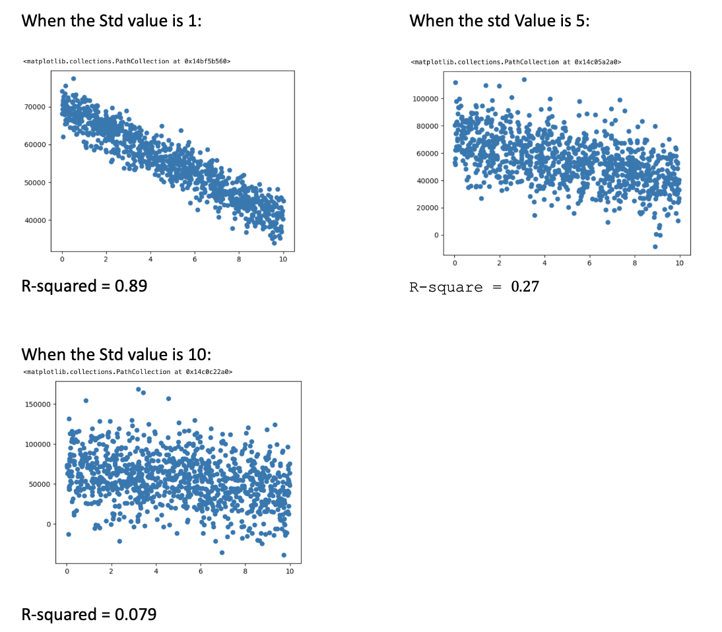

OBSERVATION:

As we know R-square equals to 1 is a very good fit and R-squared equals to 0 is a very bad fit.

From the graph and values of the R-squared above we can see that, as we increase the standard deviation value to 1, 5 and 10 the value of R-squared changes to 0.89, 0.27 and 0.08 respectively. We can tell as the std deviation is increased the noise or scatter of the data in the graph also increases which means the model is less fit to the data and it is less useful for making predictions.