Django Notes

----------------------

Static Collection

i.e. use bootstrap without the CDN

django-admin startproject adminLoginPage

cd adminLoginPage

Now create four(04) directories inside the adminLoginPage Project Directory

mkdir {static,static_cdn,media,media_cdn}

now create an app

python3 manage.py startapp check

Now open the settings.py

Add -> at line 14

import os

INSTALLED_APPS = [check’]

‘

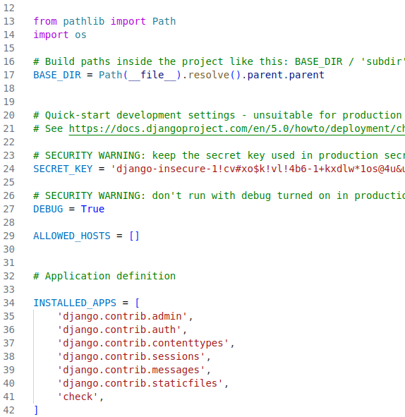

Now create a templates directory inside the adminLoginPage project Directory

path --> /home/reddragon/work/django/adminLoginPage/adminLoginPage/

Now add This templates directory inside the settings.py file

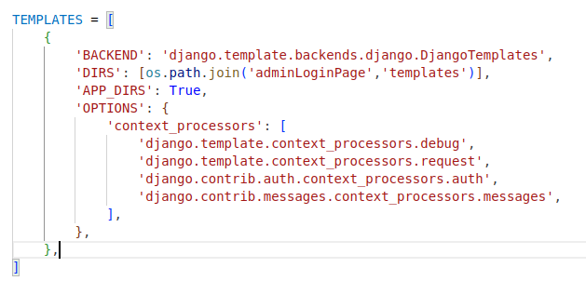

Now Add those lines for static directory Configuration

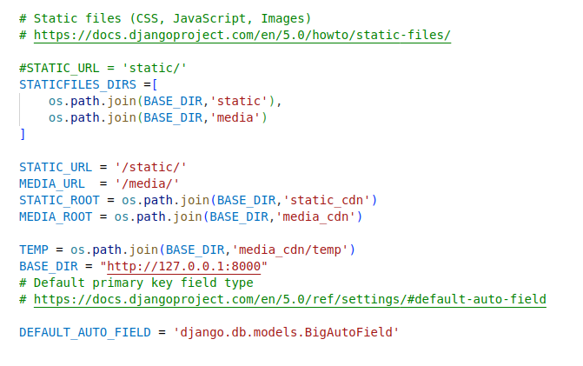

Now open the urls.py in the adminLoginPage directory

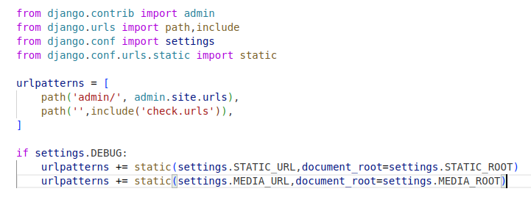

Now Download the bootstrap

link --> https://github.com/twbs/bootstrap/releases/download/v5.3.3/bootstrap-5.3.3-dist.zip

After downloading the bootstrap extract and copy the css/ and js/ directory ,

Now open a directory inside the static directory name it bootstrap, and paste the css/ and js/ directory inside the bootstrap/ directory.

Now run the command

=====================

python3 manage.py collectstatic

Now inside the check directory

the viwes.py file should look like this

from django.shortcuts import render

# Create your views here.

def index(request):

return render(request,'home.html',context={})

Now create a urls.py inside the check directory

------------------------------------------------------------

from django.urls import path

from .views import index

urlpatterns = [

path('',index,name='index')

]

Now inside the mail templates directory

create 3 files -> base.html , footer.html , navbar.html

base.html

-------------------

{% load static %}

<!doctype html>

<html lang="en">

<head>

<meta charset="utf-8">

<meta name="viewport" content="width=device-width, initial-scale=1, shrink-to-fit=no">

<meta name="description" content="">

<title>{% block title %}

{% endblock title %}</title>

<!-- Bootstrap core CSS -->

<link href="{% static 'bootstrap/css/bootstrap.css' %}" rel="stylesheet">

<!-- Custom styles for this template -->

<!-- <link href="starter-template.css" rel="stylesheet">-->

</head>

<body>

<!--including navbar-->

{% include "navbar.html" %}

<br/>

<main role="main" class="container">

<div class="container">

{% block content %}

{% endblock content %}

</div>

</main><!-- /.container -->

<!--including footer-->

{% include "footer.html" %}

<!-- Bootstrap core JavaScript

================================================== -->

<!-- Placed at the end of the document so the pages load faster -->

<script src="{% static 'bootstrap/js/jquery.min.js' %}" ></script>

<script src="{% static 'bootstrap/js/bootstrap.min.js' %}"></script>

</body>

</html>

navbar.html

=================

<div class="container">

<nav class="navbar navbar-expand-md navbar-light bg-light">

<a class="navbar-brand" href="{% url 'index' %}">Project XXX</a>

<button class="navbar-toggler" type="button" data-toggle="collapse" data-target="#navbarsExampleDefault" aria-controls="navbarsExampleDefault" aria-expanded="false" aria-label="Toggle navigation">

<span class="navbar-toggler-icon"></span>

</button>

<div class="collapse navbar-collapse" id="navbarsExampleDefault">

<ul class="navbar-nav mr-auto">

<li class="nav-item active">

<a class="nav-link" href="{% url 'index' %}">Home <span class="sr-only">(current)</span></a>

</li>

</ul>

</div>

</nav>

</div>

footer.html

-----------------------

<footer class="text-muted">

<div class="container text-center">

<p>Have a Happy {% now "Y" %}</p>

</div>

</footer>

Now create a directory called templates inside the created application dirctory check

now create a home.html file

home.html

-=============

{% extends "base.html" %}

{% block content %}

Home Page!

{% load static %}

<div class="container">

<div class="imgcontainer">

<img src="{% static 'img/Untitled.jpeg'%}" alt="Bird">

</div>

</div>

{% endblock content %}

To add an image first move the image in the media directory

i.e.

first create a img directory inside the media directory , and paste the image

python3 manage.py collectstatic

Now to add custome css

inside the static directory create another directory call custom_css

inside this directory create the css file for example my.css

h1{

color:navy;

margin-left: 20px;

}

now run the command

python3 manage.py collectstatic

Now add the my.css in the base.htnl

<link href="{% static 'custom_css/my.css' %}" rel="stylesheet">