

**1.What is Programming language ?**

=>A programming language is a computer language that is used by programmers to communicate with computers. It is a set of instruction that instruct to a computer how to carry out or perform a task is the process of program.

**2. Why do we need a programming language?**

=>Programming Language is important in our daily life to enhance and increase the power of computers, mobile solutions, and the internet. There are numerous examples you may come to know when you are going to learn a programming language.

* Not just for academics, but for the real world as well, all programming is done.
* Due to programmes developed by computer programming, you can conduct online banking and purchase your ticket while travelling by train or aeroplane. It's true that your washing machine has a few different kinds of computer programmes. Programming makes it possible for all of these things and many more.

**3.What is the features of java?**

=>**Features Of Java**

* **Object-Oriented -** The features of object-oriented programming are supported by Java. Its object model is straightforward and flexible.
* **Platform independent -** Because Java and C++ are platform independent, application programs created in one Operating system can run on any other Operating system. C and C++, however, are platform dependent languages, making it impossible for application programs created in one Operating system to run in any other Operating system.
* **Simple -** Because Java incorporates many C/C++ capabilities, it is simple to understand.
* **Secure -** Java offers a variety of defences against malware and viruses. It guarantees that neither damage nor security will be compromised.
* **Portable -** We have the idea of portability in Java. Java allows the same software to run on various platforms.
* **Robust -** It assists us in identifying potential errors as soon as feasible during program development.
* **Multi-threaded -** Java's multithreading programming capability enables you to create a program that executes multiple tasks concurrently.
* **Distributed -**Java maintains the TCP/IP protocol and is therefore suitable for distributed Internet environments.

**4.What is Object?**

=>An object is an entity with state and behaviour, such as a chair, bike, marker, pen, table, or car. It could be intellectual or physical (tangible and intangible). The banking system is an illustration of an intangible entity.

An object has three characteristics

* **State:** represents an object's data (value)
* **Behaviour :** represents how an object behaves (or how it functions), such as when you deposit or withdraw money
* **Identity:** Usually, a distinct ID is used to implement an object's identification. The external user cannot see the value of the ID. However, the JVM uses it internally to uniquely identify each object.

Pen, for instance, is an object. Reynolds is its name; its state is noted as being white. Writing is its behaviour because it is utilized for writing.

A class's instances are objects. A class serves as a model or blueprint from which new objects can be made. Therefore, a class's instance (or result) is an object.

**5.What is Class?**

=>A class is a collection of items with similar characteristics. It serves as a model or blueprint from which things can be made. It makes sense as a whole. It cannot be bodily.

**6.Explain About Main Method in Java?**

=>**The main** () is the starting point for JVM to start execution of a Java program. Without the main () method, JVM will not execute the program. The syntax of the main () method is: public: It is an access specifier. We should use a public keyword before the main () method so that JVM can identify the execution point of the program.

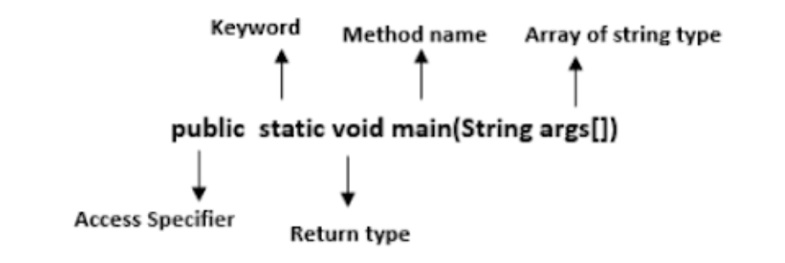

* **public:** An access specifier, that is. Before calling the main() method, we need to use the public keyword to let the JVM know where the programme is actually being executed. Before the main() method, if we use private, protected, and default, the JVM won't be able to see it.
* **static:** You can make a method static by using the keyword static. We should call the main() method without creating an object. Static methods are the method which is invoked without creating the objects, so we do not need any object to call the main() method.
* **void:** In Java, every method has the return type. Void keyword acknowledges the compiler that the main() method does not return any value.
* **main():** It is a default signature which is predefined in the JVM. It is called by JVM to execute a program line by line and end the execution after completion of this method. We can also overload the main() method.
* **String args[]:** The main() method also accepts some data from the user. It accepts a group of strings, which is called a string array. It is used to hold the command line arguments in the form of string values.

main(String args[])

Here, **agrs[]** is the array name, and it is of String type. It means that it can store a group of strings. Remember, this array can also store a group of numbers but in the form of string only. Values passed to the main() method are called arguments. These arguments are stored into an args[] array, so the name args[] is generally used for it.