

**1.Write a Program(WAP) to print Alphabets A, B, C, D, E, F, G, H, using pattern programming logic.**

=> Here's a program in Java that prints Alphabets A, B, C, D, E, F, G, H, using pattern programming logic:

public class Print_A_To_H {  
 public static void main(String[] args) {  
 Scanner sc = new Scanner(System.*in*);  
 System.*out*.print("Please row number greater than or equal 7 : ");  
 int n = sc.nextInt();  
 if (n >= 7) {  
 for (int i = 1; i <= n; i++) {  
  
 for (int j = 1; j <= n * 8; j++) {*/* Here define column upto n*8 beacause "A to H" Alphabets holds 8 number of place*/* if ((0 < j && j <= n) && ((i > 1 && j == 1) || ((j > +1 && j < n) && (i == 1)) || (j == n && 1 < i) || (i == n / 2 + 1))*/* printing A */* || ((n * 1 < j && j <= n * 2) && ((j == n + 1) || ((i == 1 || i == n / 2 + 1 || i == n) && (j < n * 2)) || (((i > 1 && i < n / 2 + 1) || (i > n / 2 + 1 && i < n)) && (j == n * 2))))*/* printing B */*

|| ((n * 2 < j && j <= n * 3) && (((i > 1 && i < n) || (j > n * 2 + 1 && j < n * 3)) && (i == 1 || i == n || j == n * 2 + 1) || ((i == 2 || i == n - 1) && (j == n * 3))))*/* printing C */*

|| ((n * 3 < j && j <= n * 4) && ((j == n * 3 + 2) || (j >= n * 3 + 2 && j < n * 4 && i == 1) || ((j == n * 4) && (i > 1 && i < n)) || (i == n && j >= n * 3 + 2 && j < n * 4)))*/* printing D */*

|| ((n * 4 < j && j <= n * 5) && ((j == n * 4 + 1) || ((i == 1 || i == n / 2 + 1 || i == n) && (j < n * 5))))*/* printing E */*

|| ((n * 5 < j && j <= n * 6) && ((j == n * 5 + 1) || ((i == 1 || i == n / 2 + 1) && (j < n * 6))))*/* printing F */*

|| ((n * 6 < j && j <= n * 7) && (((i > 1 && i < n) || (j > n * 6 + 1 && j < n * 7)) && ((i == 1 || i == n || j == n * 6 + 1) || (i == 2 || (i <= n - 1 && i > n / 2 + 1)) && (j == n * 7)) || (i == n / 2 + 1 && (j > n * 6 + 2))))*/* printing G */*

|| ((n * 7 < j && j <= n * 8) && (j == n * 7 + 2 || j == n * 8 || (i == n / 2 + 1 && j >= n * 7 + 2)))) {*/* printing H */*

System.*out*.print("* ");  
 } else System.*out*.print(" ");  
 }System.*out*.println();  
 }  
 } else System.*out*.println("Alphabet printing is not possible,please enter row number greater than or equal 7 !");  
 }  
}

**2. Write a program to print triangle using star pattern programming logic.**

=> Here's a program in Java that prints triangle using star pattern programming logic:

public class PrintTringle {  
 public static void main(String[] args) {  
  
 int n = 15;  
  
 for (int i = 1; i <= n; i++) {  
 for (int j = 1; j <= n; j++) {  
 if (i + j == (n - 1) / 2 + 2 || j - i == n / 2 || i == n / 2 + 1) {  
 System.*out*.print("* ");  
 } else System.*out*.print(" ");  
 }  
 System.*out*.println();  
 }  
 }  
}

**3. WAP to print**

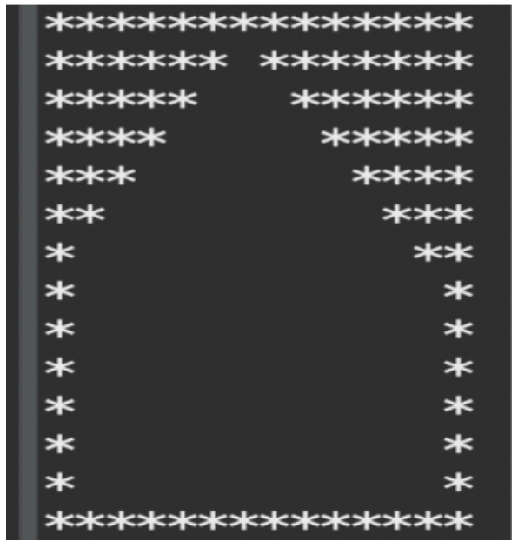

=> Here's a program in Java that prints the following pattern:

public class PrintPattern {  
 public static void main(String[] args) {  
 int n = 14;  
 for (int i = 1; i <= n; i++) {  
 for (int j = 1; j <= n; j++) {  
 if (i + j <= (n - 1) / 2 + 2 || j - i >= n / 2 || i == n || (i > n / 2 && (j == 1 || j == n))) {  
 System.*out*.print("* ");  
 } else System.*out*.print(" ");  
 }  
 System.*out*.println();  
 }  
 System.*out*.println();  
 }  
}

**4. Write a program to print PWSKILLS using pattern programming logic.**

=> Here's a program in Java that prints PWSKILLS using pattern programming logic:

public class PrintPW_SKILLS {  
 public static void main(String[] args) {  
 Scanner sc = new Scanner(System.*in*);  
 System.*out*.print("Please row number greater than or equal 7 : ");  
 int n = sc.nextInt();  
 if (n >= 7) {  
 for (int i = 1; i <= n; i++) {  
  
 for (int j = 1; j <= n * 9; j++) {*/* Here define column upto n*9 beacause "PW SKILLS" holds 8 charecter and adding space after first name ,its become 9 */  
  
 /* printing First Word "PW" */* if ((0 < j && j <= n) && ((j == 1) || (j < n && i == 1) || ((j == n) && (i > 1 && i < n / 2 + 1)) || (i == n / 2 + 1 && j < n))*/* printing P */* || ((n * 1 < j && j <= n * 2) && ((j == n + 1) || (i > n / 2 && (i + j == n * 2 + 1 || i == j - n)) || (j == n * 2)))*/* printing W */  
  
 /* Here skipped column no 3 beacause of printing "SPACE" after printing first Word*/  
  
 /* printing Last Word "SKILLS" */* || ((n * 3 < j && j <= n * 4) && (((i == 1 || i == n / 2 + 1 || i == n) && (j > n * 3 + 1 && j < n * 4)) || ((i > 1 && i < n / 2 + 1) && (j == n * 3 + 1)) || (i < n && i > n / 2 + 1) && (j == n * 4) || ((i == 2 || i == n - 1) && (j == n * 3 + 1 || j == n * 4))))*/* printing S */* || ((n * 4 < j && j <= n * 5) && ((((j == n * 4 + 1) || ((i < n - 1 && j < n * 5) && (j + i == n * 4 + n))) || (i > n / 2 && j - i == n * 4 - 1)) || ((i == 1 || i == n) && (j == n * 5))))*/* printing K */* || ((n * 5 < j && j <= n * 6) && ((i == 1 && (j > n * 5 + 1 && j < n * 6) || i == n && (j > n * 5 + 1 && j < n * 6) || (j == n * 5 + n / 2 + 1))))*/* printing I */* || ((n * 6 < j && j <= n * 7) && ((j == n * 6 + 1) || (i == n && j < n * 7)))*/* printing L */* || ((n * 7 < j && j <= n * 8) && ((j == n * 7 + 1) || (i == n && j < n * 8)))*/* printing L */* || ((n * 8 < j && j <= n * 9) && (((i == 1 || i == n / 2 + 1 || i == n) && (j > n * 8 + 1 && j < n * 9)) || ((i > 1 && i < n / 2 + 1) && (j == n * 8 + 1)) || (i < n && i > n / 2 + 1) && (j == n * 9) || ((i == 2 || i == n - 1) && (j == n * 8 + 1 || j == n * 9))))) {*/* printing S */* System.*out*.print("* ");  
 } else System.*out*.print(" ");  
 }  
 System.*out*.println();  
 }  
 } else System.*out*.println("printing is not possible,please enter row number greater than or equal 7 !");  
  
 }  
}

**5. Write a program to print your Full Name using pattern programming logic.**

=> Here's a program in Java that prints my Full Name(“DIPAYAN RANA”) using pattern programming logic:

public class PrintMyName {  
 public static void main(String[] args) {  
 Scanner sc = new Scanner(System.*in*);  
 System.*out*.print("Please row number greater than or equal 7 : ");  
 int n = sc.nextInt();  
 if (n >= 7) {  
 for (int i = 1; i <= n; i++) {  
  
 for (int j = 1; j <= n * 12; j++) {*/* Here define column upto n*12 beacause my name "DIPAYAN RANA" holds 11 charecter and adding space after first name ,its become 12 */  
  
 /* printing First Name "DIPAYAN" */* if ((0 < j && j <= n) && ((j == 1) || (j < n && i == 1) || ((j == n) && (i > 1 && i < n)) || (i == n && j < n)) */* printing D */* || ((n * 1 < j && j <= n * 2) && ((n * 1 < j && j <= n * 2) && ((i == 1 && (j > n * 1 + 1 && j < n * 2) || i == n && (j > n * 1 + 1 && j < n * 2) || (j == n * 1 + n / 2 + 1)))))*/* printing I */* || ((n * 2 < j && j <= n * 3) && ((j == n * 2 + 1) || (j < n * 3 && i == 1) || ((j == n * 3) && (i > 1 && i < n / 2 + 1)) || (i == n / 2 + 1 && j < n * 3)))*/* printing P */* || ((n * 3 < j && j <= n * 4) && ((i > 1 && j == n * 3 + 1) || ((j > n * 3 + 1 && j < n * 4) && (i == 1)) || (j == n * 4 && 1 < i) || (i == n / 2 + 1)))*/* printing A */* || ((n * 4 < j && j <= n * 5) && ((j + i == n * 4 + n + 1) || (i <= n / 2 && j - i == n * 4)))*/*printing Y */* || ((n * 5 < j && j <= n * 6) && ((i > 1 && j == n * 5 + 1) || ((j > n * 5 + 1 && j < n * 6) && (i == 1)) || (j == n * 6 && 1 < i) || (i == n / 2 + 1)))*/* printing A */* || ((n * 6 < j && j <= n * 7) && ((j - i == n * 6) || (j == n * 6 + 1) || (j == n * 7))) */* printing N */  
  
 /* Here skipped column no 8 beacause of printing "SPACE" after printing first name*/  
  
 /* printing Last Name "RANA" */* || ((n * 8 < j && j <= n * 9) && ((j == n * 8 + 1) || (i == 1 && j < n * 9) || (i == n / 2 + 1 && j < n * 9) || (j == n * 9 && (i > 1 && i <= n / 2)) || (j >= n * 8 + n / 2 + 1 && j - i == n * 8)))*/* printing R */* || ((n * 9 < j && j <= n * 10) && ((n * 9 < j && j <= n * 10) && (i > 1 && j == n * 9 + 1) || ((j > n * 9 + 1 && j < n * 10) && (i == 1)) || (j == n * 10 && 1 < i) || (i == n / 2 + 1)))*/* printing A */* || ((n * 10 < j && j <= n * 11) && ((j - i == n * 10) || (j == n * 10 + 1) || (j == n * 11)))*/* printing N */* || ((n * 11 < j && j <= n * 12) && ((n * 11 < j && j <= n * 12) && (i > 1 && j == n * 11 + 1) || ((j > n * 11 + 1 && j < n * 12) && (i == 1)) || (j == n * 12 && 1 < i) || (i == n / 2 + 1))*/* printing A */*)) {  
 System.*out*.print("* ");  
 } else System.*out*.print(" ");  
 }  
 System.*out*.println();  
 }  
 } else System.*out*.println("Name printing is not possible,please enter row number greater than or equal 7 !");  
  
 }  
}