

**1.What is the default value of Array for different data types?**

=> java will assign the default value 0 to each element of the array in the case of an int array. Similarly, in the case of a float array, it will be 0.0 ,in the case of a boolean array, it will be false, in the case of a String and reference array the default value is null in java, and in the case of a char array, the default value is Unicode (\u0000).

**Example:**

class ArrayDemo {

public static void main(String[] args)

{

System.out.println("String array default values:");

String str[] = new String[5];

for (String s : str)

System.out.print(s + " ");

System.out.println(

"\n\nInteger array default values:");

int num[] = new int[5];

for (int val : num)

System.out.print(val + " ");

System.out.println(

"\n\nDouble array default values:");

double dnum[] = new double[5];

for (double val : dnum)

System.out.print(val + " ");

System.out.println(

"\n\nBoolean array default values:");

boolean bnum[] = new boolean[5];

for (boolean val : bnum)

System.out.print(val + " ");

System.out.println(

"\n\nReference Array default values:");

ArrayDemo ademo[] = new ArrayDemo[5];

for (ArrayDemo val : ademo)

System.out.print(val + " ");

}

}

**Output**

String array default values:

null null null null null

Integer array default values:

0 0 0 0 0

Double array default values:

0.0 0.0 0.0 0.0 0.0

Boolean array default values:

false false false false false

Reference Array default values:

null null null null null

**2.Can you pass the negative number in Array size?**

=>No, you cannot use a negative integer as size, the size of an array represents the number of elements in it, –ve number of elements in an array makes no sense.

Still if you do so, the program gets compiled without issues but, while executing it generates a runtime exception of type ***NegativeArraySizeException***

Example

In the following Java program, we are trying to create an array with a negative value as size.

public class Test {

   public static void main(String[] args) {

      int[] intArray = new int[-5];

   }

}

## Run time exception

On executing, this program generates a run time exception as shown below.

Exception in thread "main" java.lang.NegativeArraySizeException

at myPackage.Test.main(Test.java:6)

**3. Where does Array stored in JVM memory ?**

=>The reference types in Java are stored in heap area. Since arrays are reference types (we can create them using the new keyword) these are also stored in heap area. and stack memory contains the reference to it.

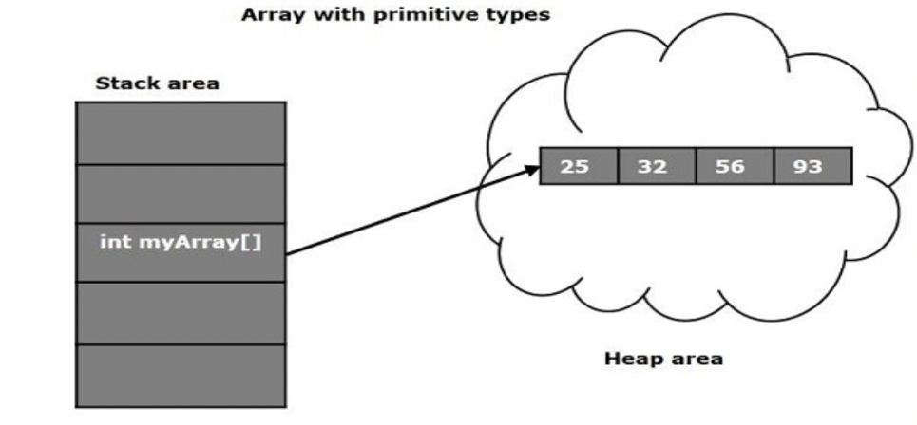

**4.What are the disadvantages of Array?**

* once we create the size cannot be increased/decreased.
* It stores only homogeneous data elements.

**5. What is an Anonymous Array in Java ? Give an example?**

=>An array in Java without any name is known as an anonymous array. It is an array just for creating and using instantly. Using an anonymous array, we can pass an array with user values without the referenced variable.

The main purpose of an anonymous array is just for instant use (just for one-time usage). An anonymous array is passed as an argument of a method.

**Example**

public class Demo{

public static void main(String... args){

add(new int[]{10,20,30,40});

add(new int[]{10,20});

add(new int[]{});

}

public static void add(int[] a){

sum+=0;

for(int i=0;i<=a.length;i++){

sum+=a[i];

}

System.out.println("The sum is ::"+sum);

}

}

**Output**

The sum is 100

The sum is 30

The sum is 0

**6.What are the different ways to traverse an Array in java?**

# =>Here is the different ways to traverse an Array in java:-

# **1. for loop**

The most classic way of  traverse in the array.

class Main {

public static void main(String[] args) {

// create an array

int[] numbers = {3, 9, 5, -5};

// for loop

for (int i=0;i<numbers.length;i++) {

System.out.println(number[i]);

}

}

}

# **2. for-each loop**

In Java ,It’a is also known as enhanced for loop in java, and good to loop over collections.

class Main {

public static void main(String[] args) {

// create an array

int[] numbers = {3, 9, 5, -5};

// for each loop

for (int number: numbers) {

System.out.println(number);

}

}

}

**3. while loop**

class Main {

public static void main(String[] args) {

// createan array

int[] numbers = {3, 9, 5, -5};

// while loop

int i=0;

while (i<numbers.length) {

System.out.println(number[i]);

i++;

}

}

}

# **4. do-while loop**

class Main {

public static void main(String[] args) {

// create an array

int[] numbers = {3, 9, 5, -5};

//do while loop

int i=0;

do {

System.out.println(number[i]);

i++;

} while (i<numbers.length)

}

}

**7. What is the difference between length and length() method Give an Examples?**

=> **length**   
It is a property of the Array type class.

**length()**   
It is a method of String class.

**Example**

int[] a= {10,20,30};   
System.out.println(a);//[I@...

System.out.println(a.length);//3

System.out.println(a.length());//CE::symbol not found

String[] names={"sachin","saurav","dhoni","yuvi"};

System.out.println(names); //[I@....

System.out.println(names[0]);//sachin

System.out.println(names.length);//4

System.out.println(names[0].length());6

int[] a[] ={{10,20,30},{100,200},{1000},{40,50,60,70}};

System.out.println(a);//[[I@...

System.out.println(a[0]);//[I@...

System.out.println(a.length);//4

System.out.println(a[0].length);3