Configure first time

git config --global user.name "dipbanik"

get config --global user.email "dip.banik@live.com"

Here are the git commands:

**To set up your Git repository:**

<https://help.github.com/articles/set-up-git/>

Nice Intro Videos on Git :

<https://www.youtube.com/playlist?list=PL4cUxeGkcC9goXbgTDQ0n_4TBzOO0ocPR>

**The life cycle of a git flow**

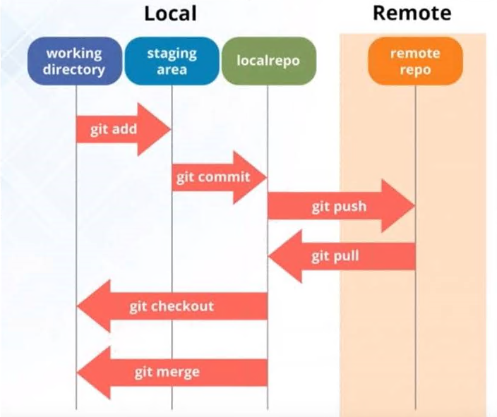

**$git status**

To see what if there are mismatched files in your Gt branch

**$git add .**

**$git add -A**

To stage all your new files to Git repository

**$git reset <*filename*>**

This will remove all files from your staging area, unless you specify the filenames

**$git commit**

**$git commit -m "*your commit message*"**

Does a local commit

**$git diff**

This will show you the changes you have made to your code

**$git log**

This will show you the commit you just made showing its hash, author name, timestamp and the commit message

**$git clone <url> *<where to clone>***

Cloning a remote repository to your local machine

**Git clone --branch <tag> <url>**

Clone a specific branch from a git repo

**$git remote -v**

Lists the info about the repository

**$git branch -a**

List all remote and local branches in the repository

**Syncing to the remote repository**

Always do a git pull first before doing a push

**$git pull <repo> <branch>**

To sync to the latest. Open "Git Shell" and go to the project folder and your latest

**$git push <repo> <branch>**

Pushes the changes and your latest commit to GitHub

**Setting an upstream**

git remote add upstream <https://github.com/Microsoft/AI.git>

**Syncing a Fork** <<https://help.github.com/en/articles/syncing-a-fork>>

Fetch the branches and their respective commits from the upstream repository.

**$git fetch upstream**

Check out your fork's local master branch

**$git checkout master**

Merge the changes from upstream/master into your local master branch. This brings your fork's master branch into sync with the upstream repository, without losing your local changes.

**$git merge upstream/master**

Update your origin with the changes

**$git push**

**Branching in Git**

**$git branch <branch name>**

Creates a branch

**$git branch**

Will list all local branches. The one with * is the current one you are working on

**$git checkout <branch name>**

This will switch your working branch

**$git checkout -b <branch name>**

This will create a new branch and checkout that branch

**$git -push -u <repo> <branch name>**

This will push your branch to the remote repository and map it to the local branch you have already created

**$ git branch -d <branch name>**

This will remove the branch locally but it still remains in the remote repo

**$ git push <repo> --delete <branch>**

This will delete the branch from the remote repo

**Merging branch changes to master**

**$git checkout master**

Switch to master branch

**$git pull <repo> <branch>**

Sync the local with remote master

**$git branch --merged**

Will show all branches that was merged with master

**$git merge <branch name>**

This will now merge the branch into master

**$git push <repo> <branch>**

Will push the merged changes into the remote repo

**Syncing forked repo**

git remote -v

git remote add upstream <https://github.com/dipbanik/MyTectraAugust>

git remote -v

git fetch upstream

provide password if necessary

this will store the changes in a branch called "upstream/master"

now you need to merge the changes.

git merge upstream/master

git push origin master