Version Control System – This is the system that allow the users to work together on same project and helps to maintain the history of changes.

This is of two types –

Centralized version control system - > this is having single server setup, if server failure all data lost.

Decentralized VCS - >GIT -> In distributed system, mirror images of repository created and if server down or any other issue it copy back to server.

Advantages GIT –

1. Free and Open source
2. Fast speed
3. Easy backup
4. No powerful h/w required
5. Easy branching

Work flow –

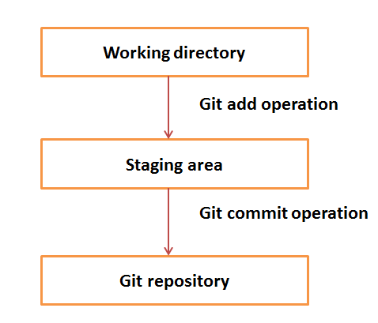

1. Working dir - Checkout data in to the particular directory.
2. Modify changes in the file and move in to staging area
3. By Push operation, commit the changes in to GIT.

Termology - Commit, branch[can be specific for one feature] , tag[specific version in repository],PULL,PUSH,HEAD[point to the latest commit]