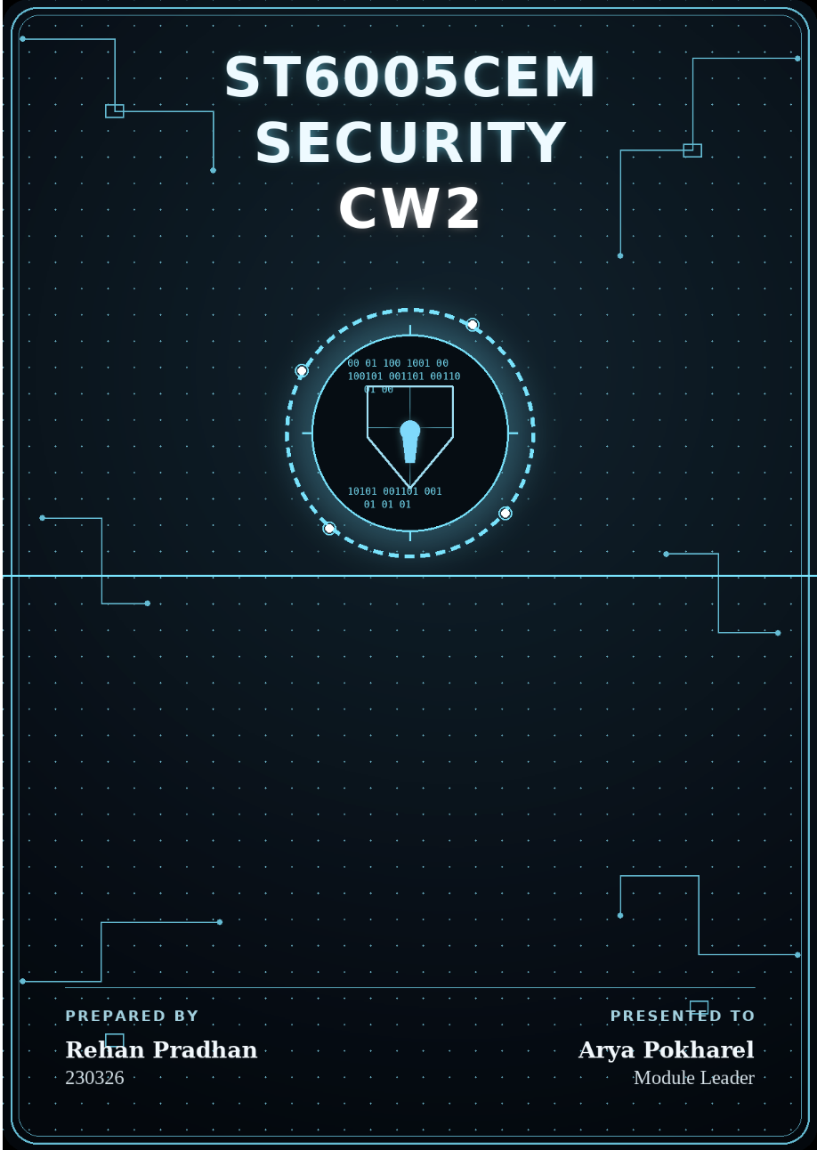

Table of Contents
Introduction 5
Software Details 6
Frontend Technology 6
Backend Technology 7
Database 8
Security By Design 8
HTTP Header Hardening and CORS Enforcement 9
Registration Traffic Control and Anti-Automation 10
Login Access Control and 2FA 12
Cryptographic Enforcement and Credential Policy 14
Activity Logs 16
Session Management & Token Security 17
API Protection and Role Based Access Control (RBAC) 19
Authenticated and Restricted File Uploads 20
Data Integrity and Frontend Tampering Prevention 22
Secure Third-Party Integration (eSewa & Khalti Payments) 23
Cross-Site Scripting (XSS) Prevention Strategy 24
NoSQL Injection & HTTP Parameter Pollution (HPP) Prevention 25
Conclusion 26
Reference 27
Appendix 29

Table of Figures
Figure 1: MotoFix Security Framework 5
Figure 2: MotoFix Frontend Security and Styling 6
Figure 3: MotoFix Backend Security Architecture 7
Figure 4: Security Architecture 8
Figure 5: Strict CORS Origin Configuration & Hardened HTTP Headers 9
Figure 6: Server-Side Cryptographic CAPTCHA Generation and Validation Logic 10
Figure 7: CAPTCHA Verification Enforcement inside User Registration Controller 11
Figure 8: CAPTCHA Implementation in MotoFix 11
Figure 9: Login Request Validation with Brute-Force Lockout Counters 12
Figure 10: Hashed Email OTP 2FA Challenge and Verification Logic 13
Figure 11: Invalid Attempts About to Trigger Rate-Limiter 13
Figure 12: 2FA Implemented in MotoFix 13
Figure 13: Password Strength Check on Register 14
Figure 14: Server-Side Password Complexity and Name-Inclusion Validations 15
Figure 15: Cryptographic Password History Check and Hashing Implementations 15
Figure 16: Resilient Structured Server-Side Audit Logging Middleware 16
Figure 17: Audit Logs Database Schema with 90-Day Auto-Purging TTL Index 16
Figure 18: Security Logs 17
Figure 19: Backend Security Logs 17
Figure 20: Dual-Mode Token Detection and Revocation Verification Middleware 18
Figure 21: IDOR Prevention 18
Figure 22: Role-Based Authorization Guards for Admin and Superadmin Routes 19
Figure 23: Admin and SuperAdmin Routes 19
Figure 24: Multi-Stage File Upload Security Filtering Middleware 20
Figure 25: Burp Testing for Invalid Extension 20
Figure 26: Burp Testing for Double Extension 21
Figure 27: Burp Test Showed Success on home.jpg 21
Figure 28: Server-Side Mathematical Haversine Distance Implementation 22
Figure 29: Authoritative Pricing and Fee Verification Logic 22
Figure 30: Price Tampering Request Blocked by Server 23
Figure 31: eSewa Payment Signature Verification and Server-Side Validation 23
Figure 32: Global Recursive Input Sanitization Middleware for XSS Mitigation 24
Figure 33: Before Sanitization 24
Figure 34: After Sanitization 25
Figure 35: Configuration of HPP and NoSQL Operator Sanitization Middleware 25
Figure 36: NoSQL Injection Authentication Bypass Blocked 26

Table of Abbreviation
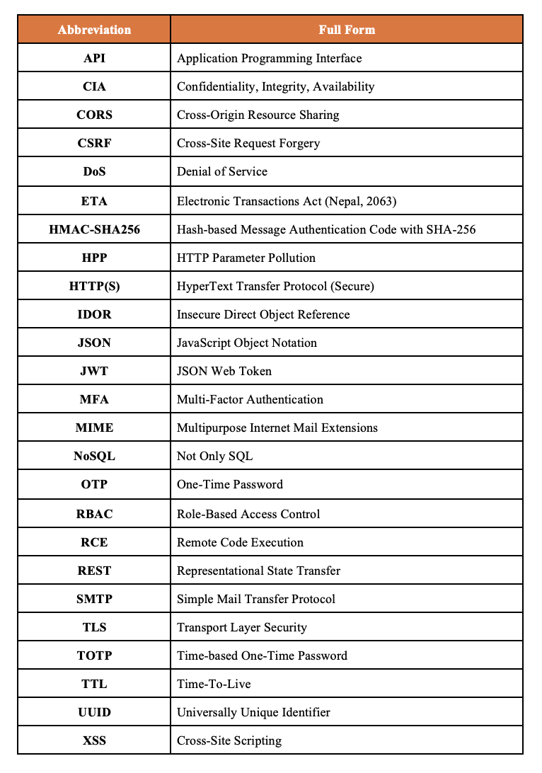

Introduction
MotoFix is a secure web-based two-wheeler service management platform for motorcycle workshop operations in Nepal with integrated payments. It uses a user-centric design for accessibility and smooth navigation while embedding strong security throughout. Registration includes a stateless CAPTCHA to block bots, and login is rate-limited to reduce brute-force attacks. The system enforces strong password rules, blocks reuse of the last five passwords, and prevents passwords from containing personal details like the user’s name. Sessions use JWTs stored in HttpOnly cookies to reduce token theft, with encrypted transmission for sensitive data. The platform also applies global recursive input sanitization to reduce XSS/injection risks, validates file uploads against double extensions and unsafe MIME types, and includes multi-factor authentication (MFA) via email OTP and Google Authenticator TOTP plus brute-force lockout protections.
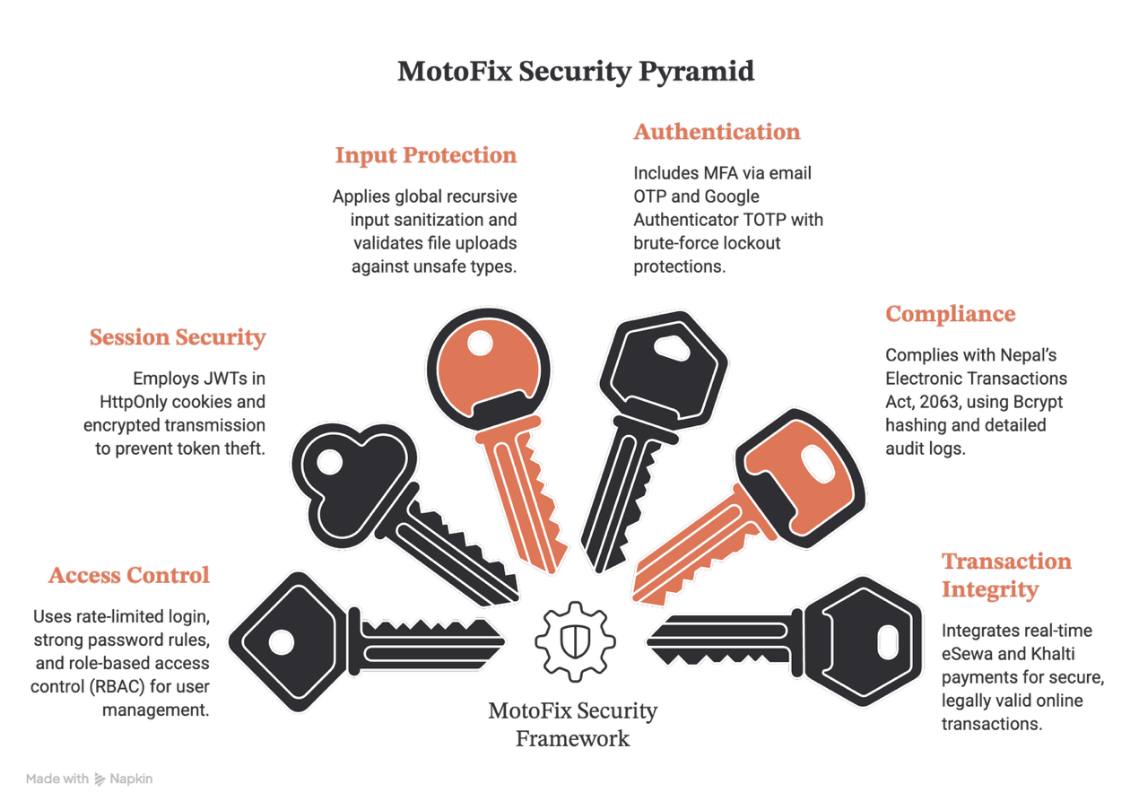
Figure 1: MotoFix Security Framework
MotoFix complies with Nepal’s Electronic Transactions Act, 2063 (ETA) by ensuring secure, legally valid online transactions and bookings. Credentials are protected with Bcrypt hashing and role-based access control (RBAC) that isolates user records management to the Superadmin workspace, while detailed database audit logs and Winston activity logs support audits and compliance. Secure sessions and real-time eSewa (eSewa, n.d.) and Khalti payment integrations (Khalti, n.d.) further enhance transaction integrity and platform resilience.

Software Details

Frontend Technology
MotoFix's frontend is built with React 18 and Vite, providing fast development and optimized production builds through compilation, minification, and tree-shaking. Environment variables expose only public values (e.g., VITE_API_BASE_URL), while backend secrets remain protected. To reduce XSS risks, DOMPurify sanitizes AI-generated HTML and Markdown before rendering. Axios uses withCredentials: true to securely send session cookies under server-side CORS policies. User registration includes a stateless SVG CAPTCHA, while React performs real-time form validation, including password confirmation and strength checks.
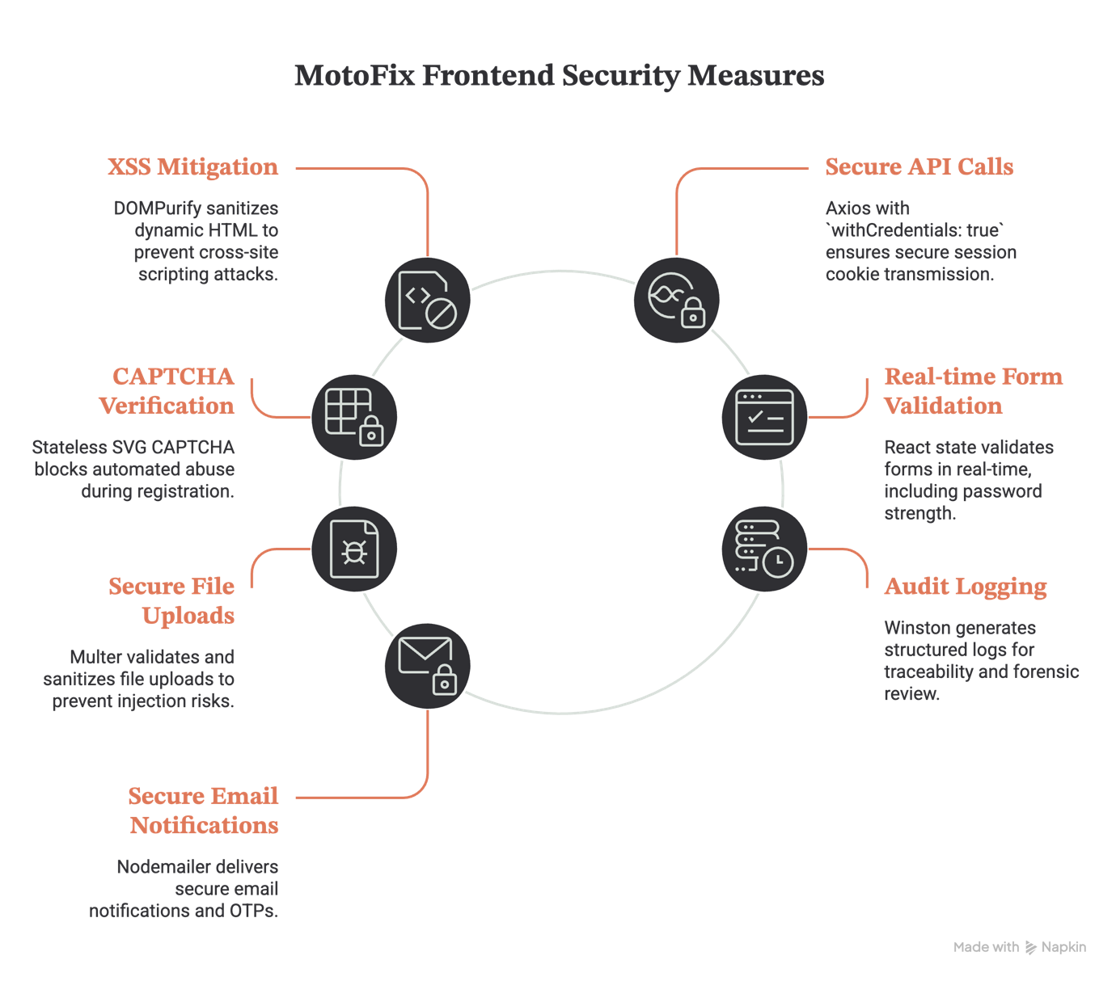
Figure 2: MotoFix Frontend Security and Styling
File uploads are secured using Multer with MIME-type validation, double-extension detection, null-byte sanitization, and randomized UUID filenames. For auditing, Winston generates rotating access.log, audit.log, and error.log files, supported by a 90-day database audit log. Email notifications and OTPs are sent securely via Nodemailer over SMTP.

Backend Technology
MotoFix’s backend is built with Node.js and Express.js to deliver scalable, high-performance REST APIs and business logic. It follows a modular structure (routes, controllers, middlewares) to improve maintainability and enforce the principle of least privilege. Security is applied at the framework level using Helmet for secure HTTP headers, Cross-Origin Resource Sharing restrictions, and express-rate-limit to reduce brute-force and Denial of Service (DoS) style abuse. Requests are validated with custom schema logic and globally sanitized using a recursive XSS parsing middleware to neutralize malicious script injection payloads.
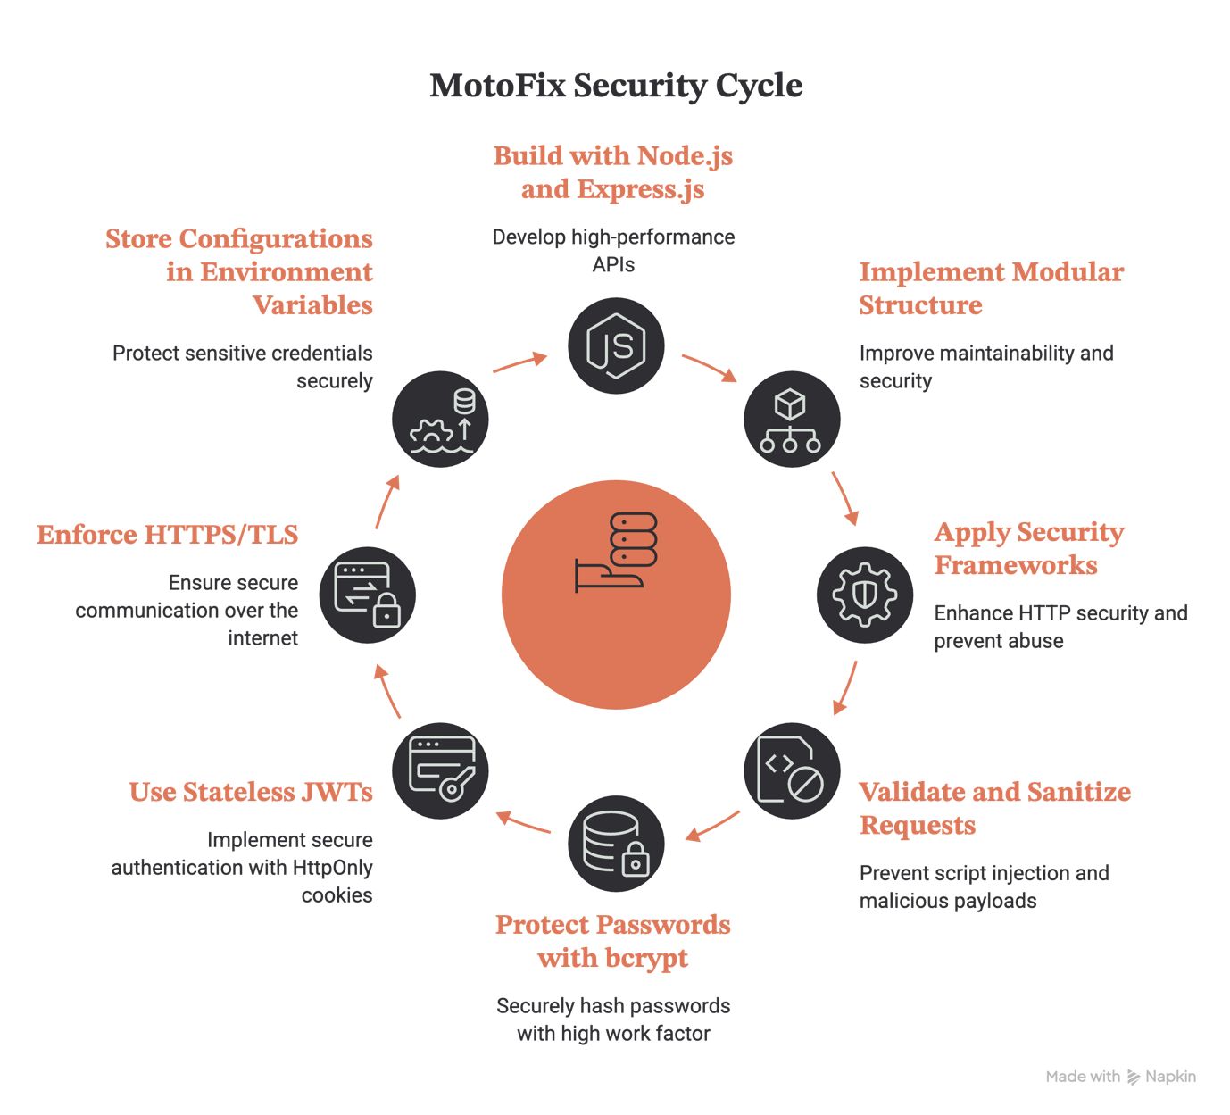
Figure 3: MotoFix Backend Security Architecture
Passwords are protected with bcrypt hashing using an elevated work factor of 12 rounds. Authentication uses stateless JSON Web Tokens (JWTs) (Jones, Bradley, & Sakimura, 2015) containing unique jti claims, stored in HttpOnly session cookies with strict expiration to reduce token replay and session hijacking risks. All communication is enforced over HTTPS/TLS (Rescorla, 2018) , while sensitive configurations (database credentials, JWT secrets, SMTP tokens, and payment keys) are stored in server-side environment variables via dotenv.

Database
MotoFix uses MongoDB to store user, workshop profile, service catalog, reviews, and booking transactions in a scalable NoSQL model with strong schema-level protections. Passwords, password histories, and email OTP verification codes are never stored in plaintext; they are salt hashed with bcrypt before saving to the database. Role-based access control (RBAC) (National Institute of Standards and Technology, 2001) restricts privileged administrative operations (such as user management, role elevation, database audit logs query, and deletions) exclusively to authorized superadmin sessions, enforcing least privilege. Query and payload injection risks are neutralized through strict Mongoose schemas, type validations, and the express-mongo-sanitize middleware. Database connection strings and credentials are kept securely in server-side environment variables to prevent exposure in version control.

Security By Design
MotoFix uses a layered architecture separating the React frontend, Node.js/Express backend, and MongoDB database to improve modularity and secure data flow. All client–server communication is encrypted via HTTPS, with Security-by-Design applied from the start through strong authentication and input validation. Sessions use JWTs stored in HttpOnly and SameSite cookies with strict expiration, while RBAC enforces least privilege. Passwords are protected with salted bcrypt (using 12 rounds), and login security is enhanced with stateless CAPTCHA validation and multi-factor authentication (MFA via email OTP and Google Authenticator TOTP) alongside brute-force account lockout protection. The system supports the CIA triad through encryption (confidentiality), global recursive input sanitization and Mongoose validation (integrity), and rate limiting to reduce brute-force and DoS abuse (availability). Helmet also enforces secure HTTP headers to reduce XSS and injection risks.
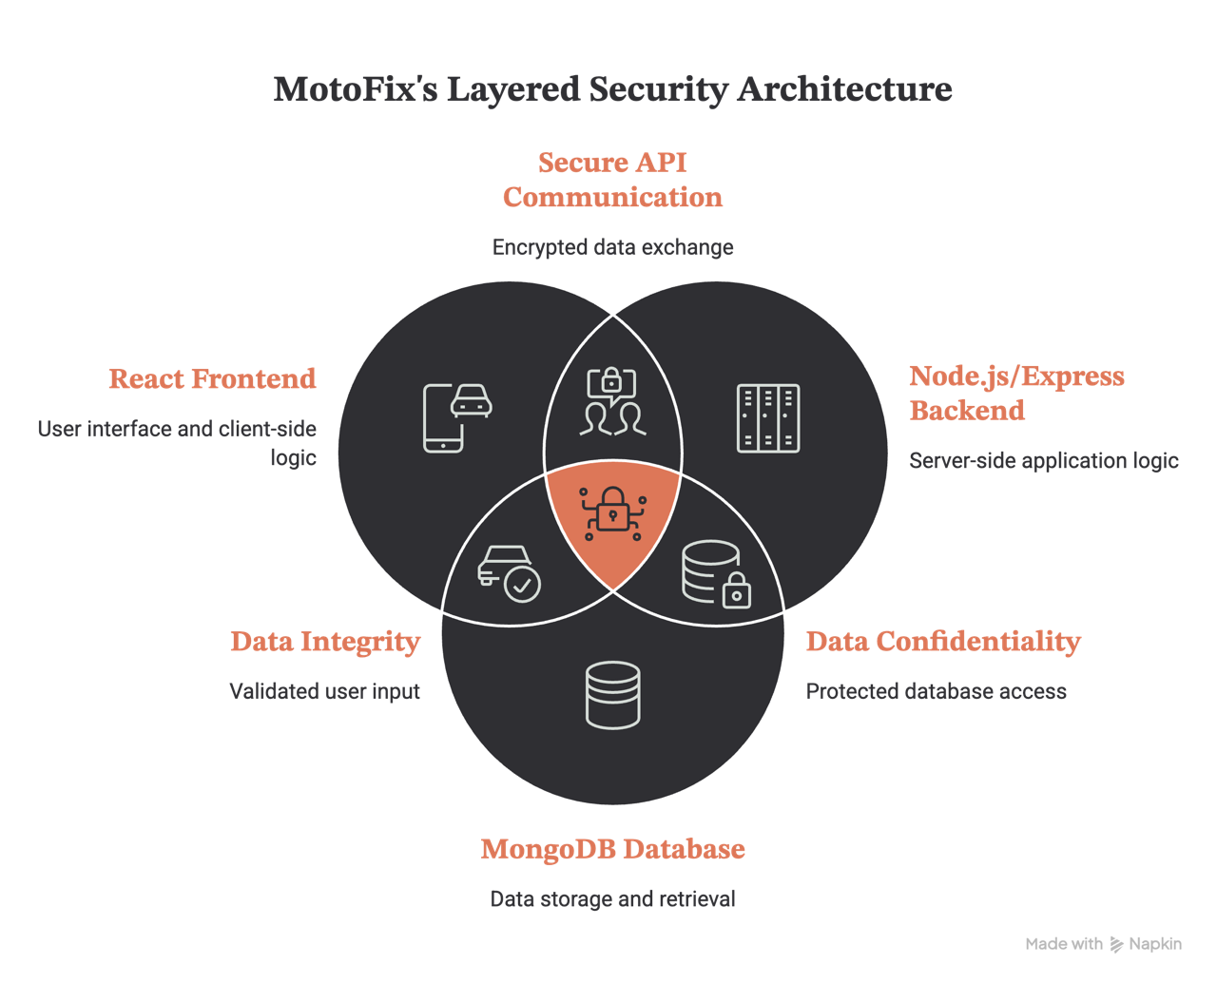
Figure 4: Security Architecture

HTTP Header Hardening and CORS Enforcement
MotoFix secures network traffic using Helmet headers (Helmet, n.d.) and strict Cross-Origin Resource Sharing (CORS) whitelists. Helmet disables X-Powered-By headers to prevent server fingerprinting, blocks MIME sniffing with nosniff, and handles cross-origin asset isolation. CORS validation is bound to a strict whitelist callback containing only trusted client domains (http://localhost:5173). By enabling credentials: true, the system permits session cookie transmission exclusively between trusted origins, mitigating cross-site scripting and unauthorized data reads.
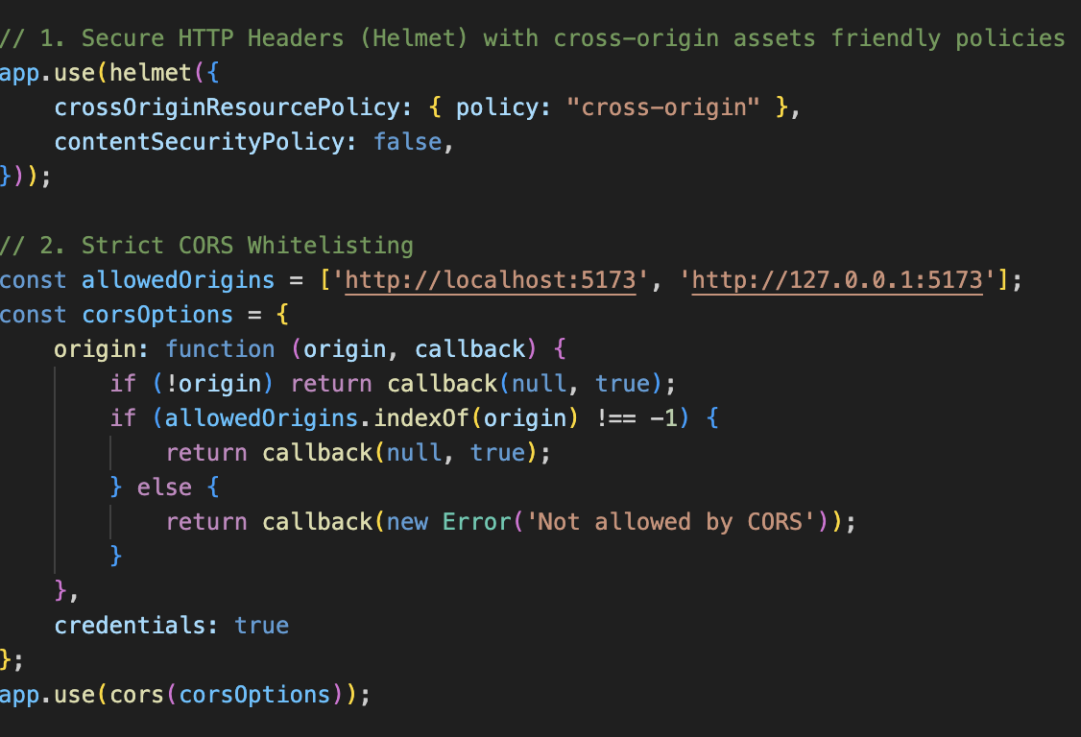
Figure 5: Strict CORS Origin Configuration & Hardened HTTP Headers

Registration Traffic Control and Anti-Automation
To prevent automated accounts creation, bot registrations, and account-creation spamming, MotoFix implements a Stateless SVG CAPTCHA anti-automation check combined with IP rate-limiting.
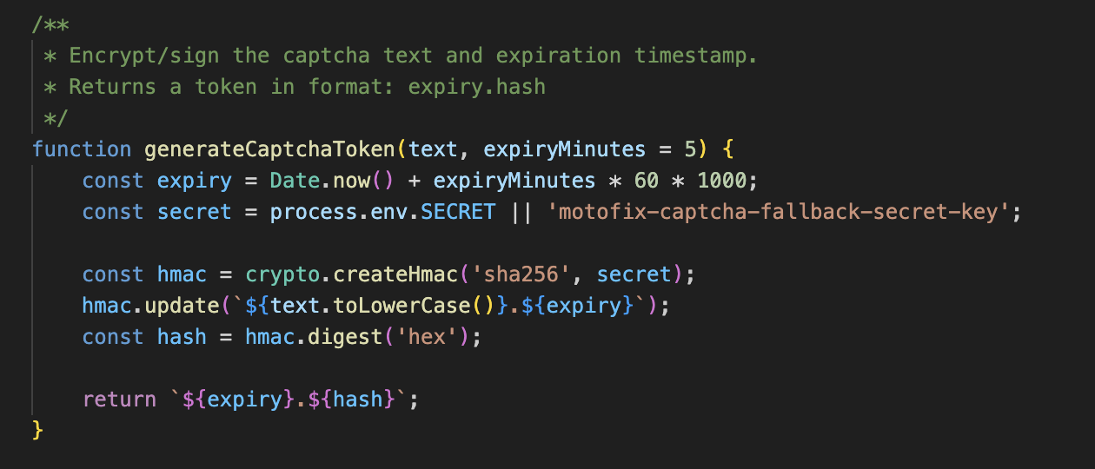
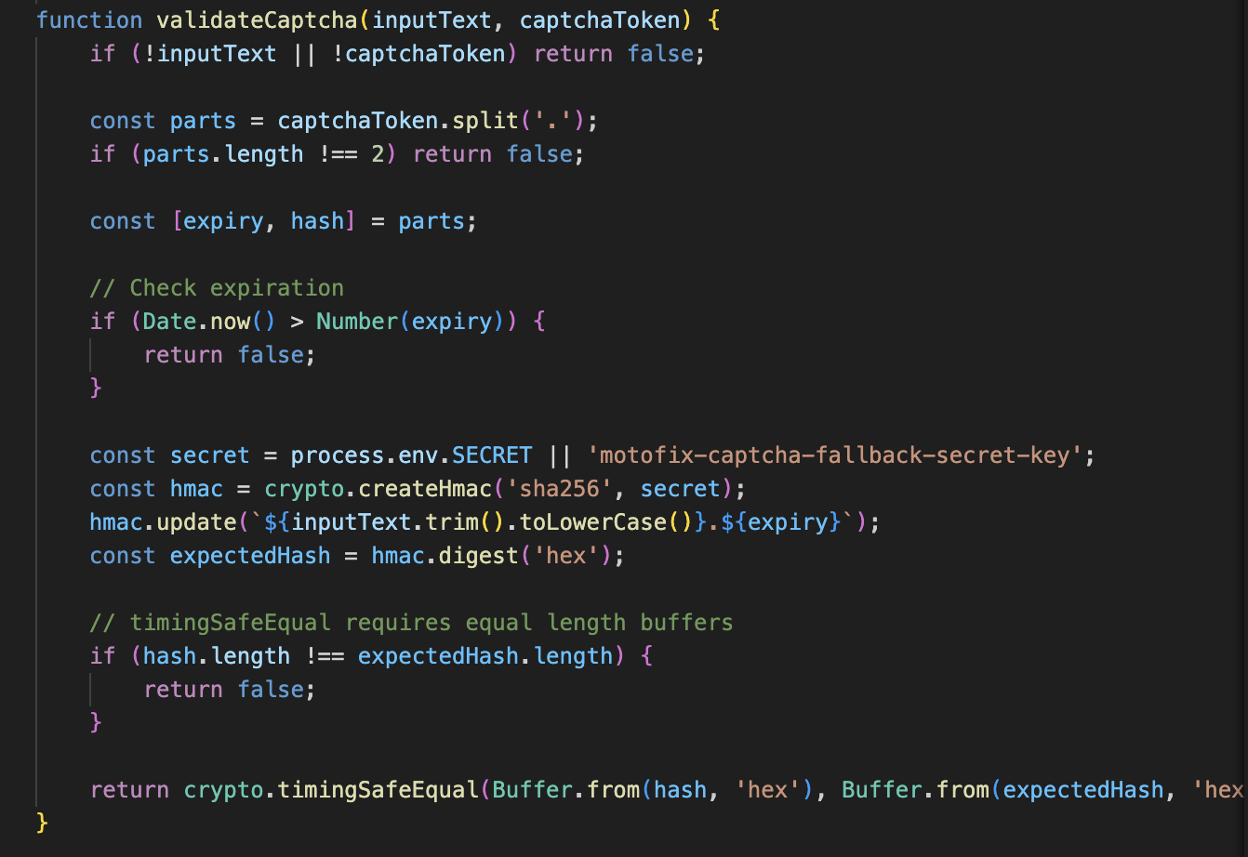
Figure 6: Server-Side Cryptographic CAPTCHA Generation and Validation Logic
As implemented in utils/captchaHelper.js, the platform generates a random alphanumeric string, combines it with an expiration timestamp, and signs the payload with a server-side HMAC-SHA256 secret to create a validation token (expiry.hash). The frontend renders this CAPTCHA as a noise-filled SVG dynamically and passes the solution and token during user registration.
As verified in controllers/userController.js, the backend recalculates the expected HMAC signature using the submitted text. If the signature matches and the timestamp is valid, registration proceeds. Because this cryptographic verification is entirely stateless, it eliminates the need to maintain session state tables in database memory, shielding the server from Denial of Service (DoS) attacks.
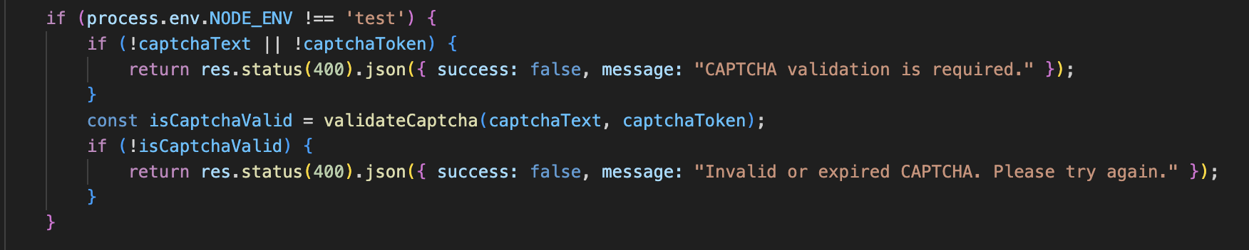
Figure 7: CAPTCHA Verification Enforcement inside User Registration Controller
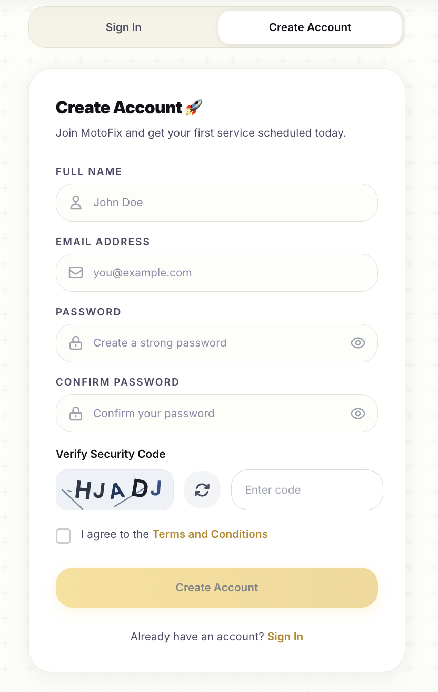
Figure 8: CAPTCHA Implementation in MotoFix

Login Access Control and 2FA
MotoFix implements dual-layered login access controls to protect user credentials from brute-force guessing and session hijacking. During initial authentication inside userController.js, if a user enters an incorrect password, a database counter (loginAttempts) increments. Upon reaching 5 consecutive failures, the backend updates lockUntil to 15 minutes in the future, blocking subsequent login routes.
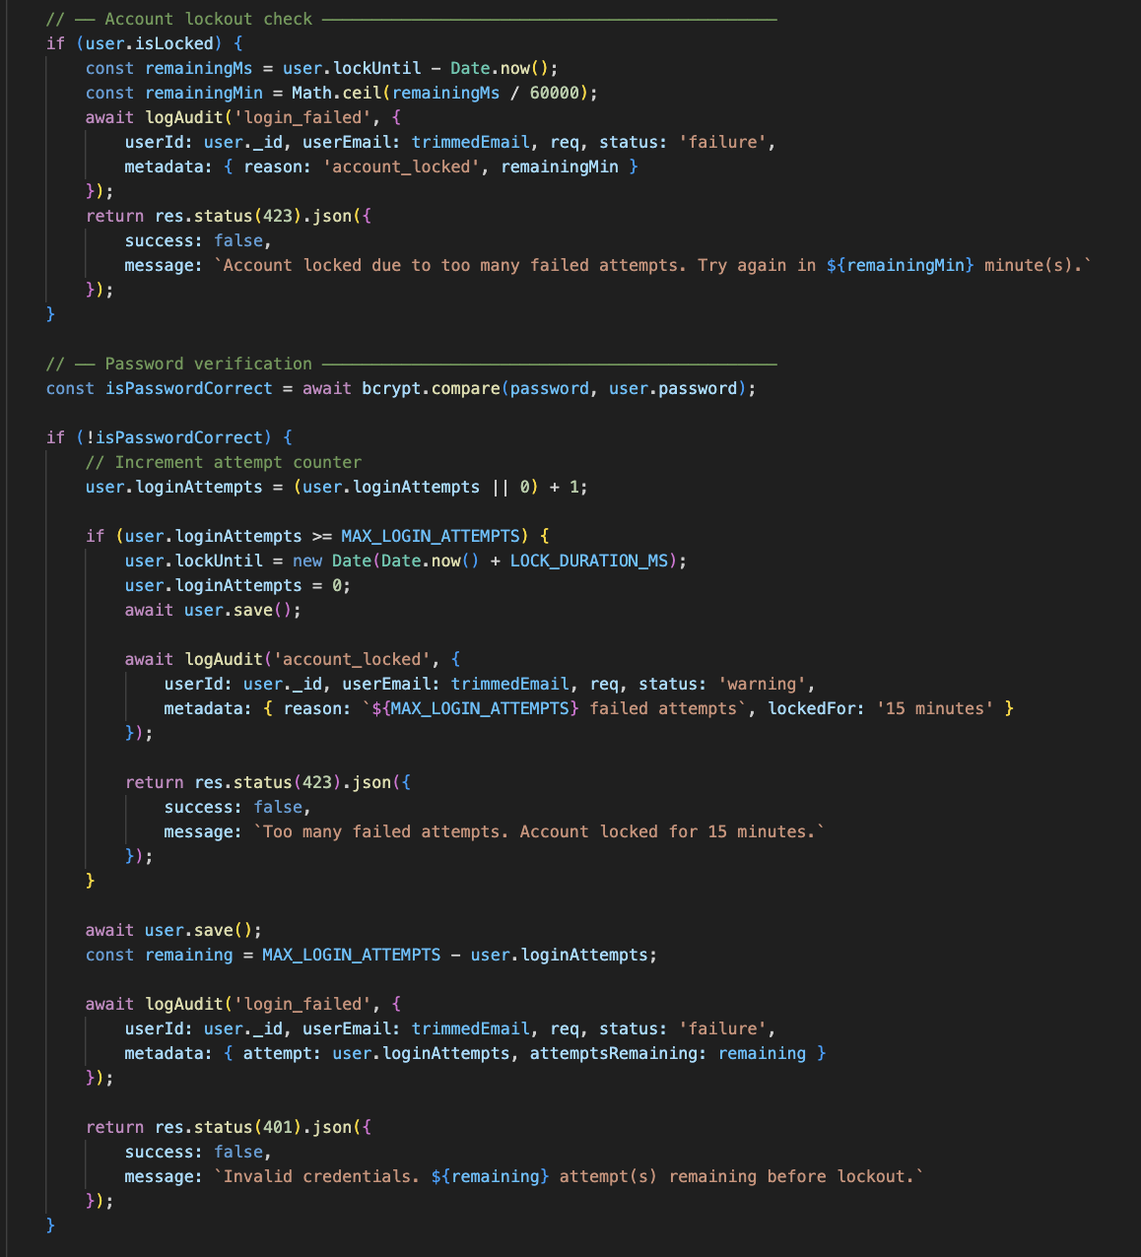
Figure 9: Login Request Validation with Brute-Force Lockout Counters
Once correct credentials are submitted, MotoFix issues a temporary session token and fires a secure 6-digit OTP code to the user's email via SMTP. The verification endpoint compares the code using bcrypt.compare against the hashed OTP in MongoDB, blocks OTP brute-forcing after 5 failed inputs, and immediately clears the code from the database upon success (enforcing single-use access) (OWASP Foundation, n.d., Authentication Cheat Sheet). Users can also setup Google Authenticator (TOTP) utilizing the speakeasy package (Speakeasy, n.d.) from their profiles, which automatically replaces the email challenge steps.

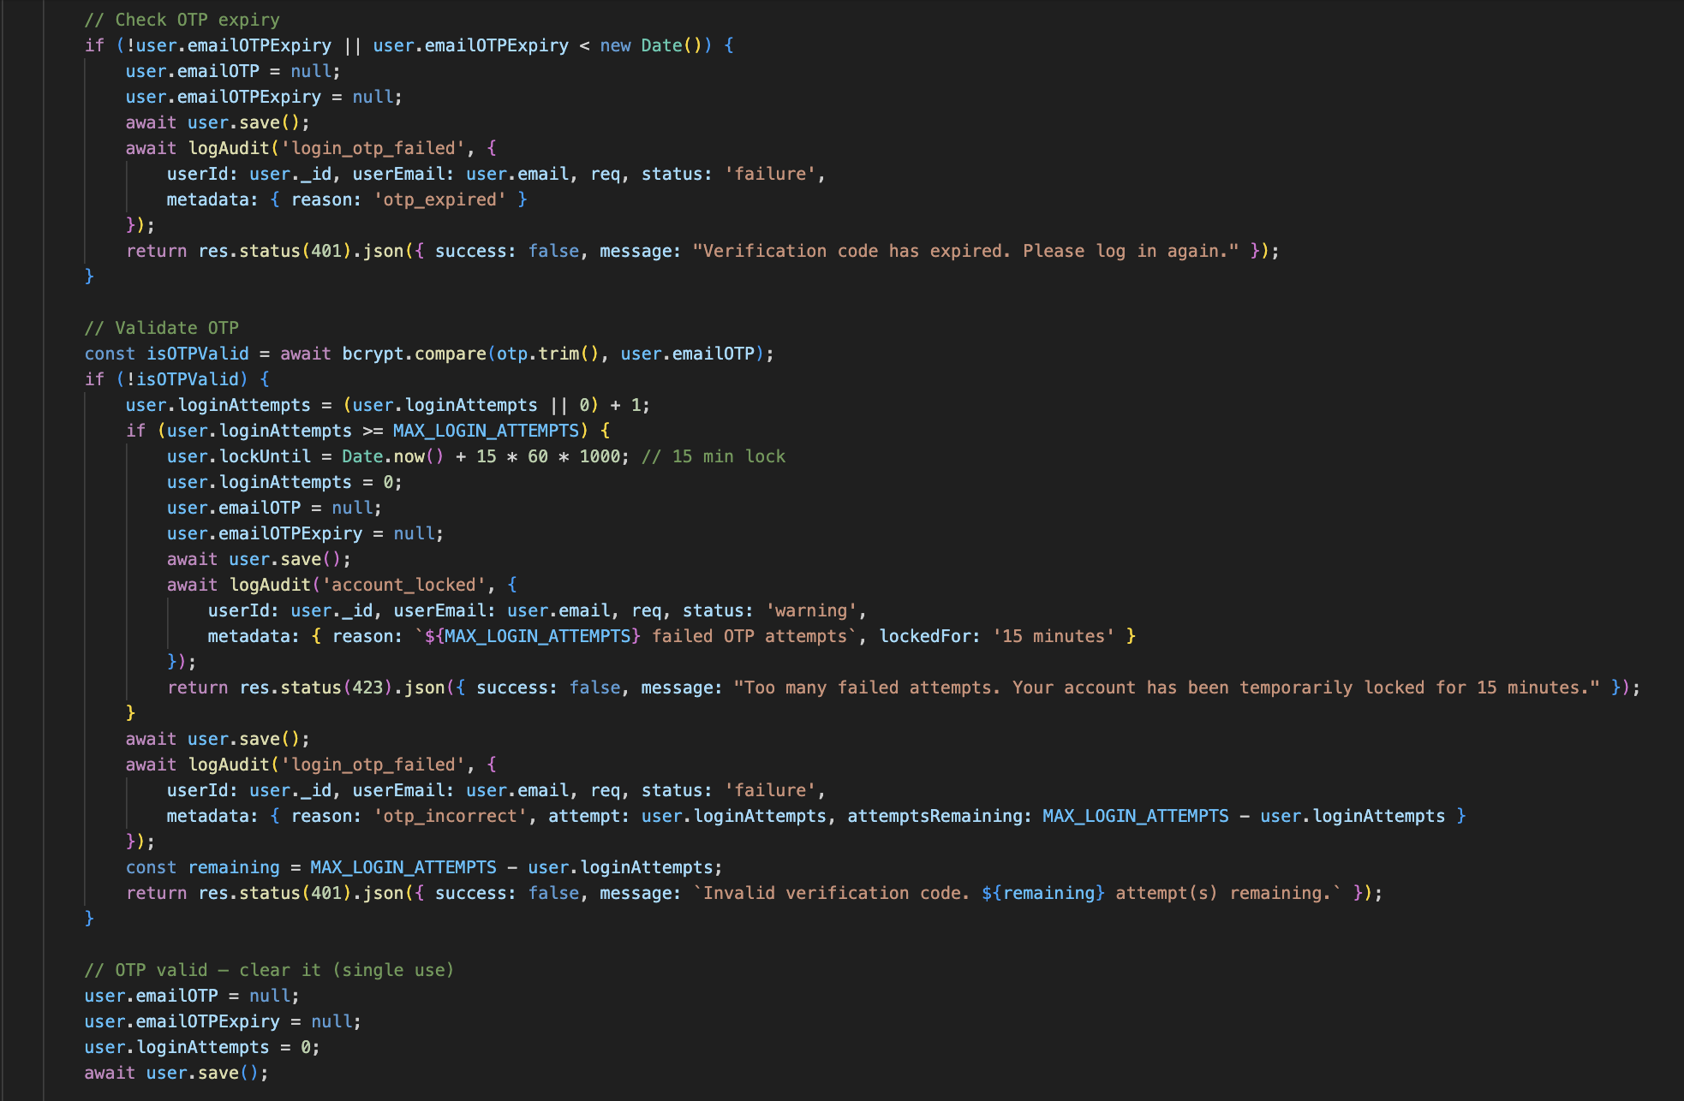
Figure 10: Hashed Email OTP 2FA Challenge and Verification Logic
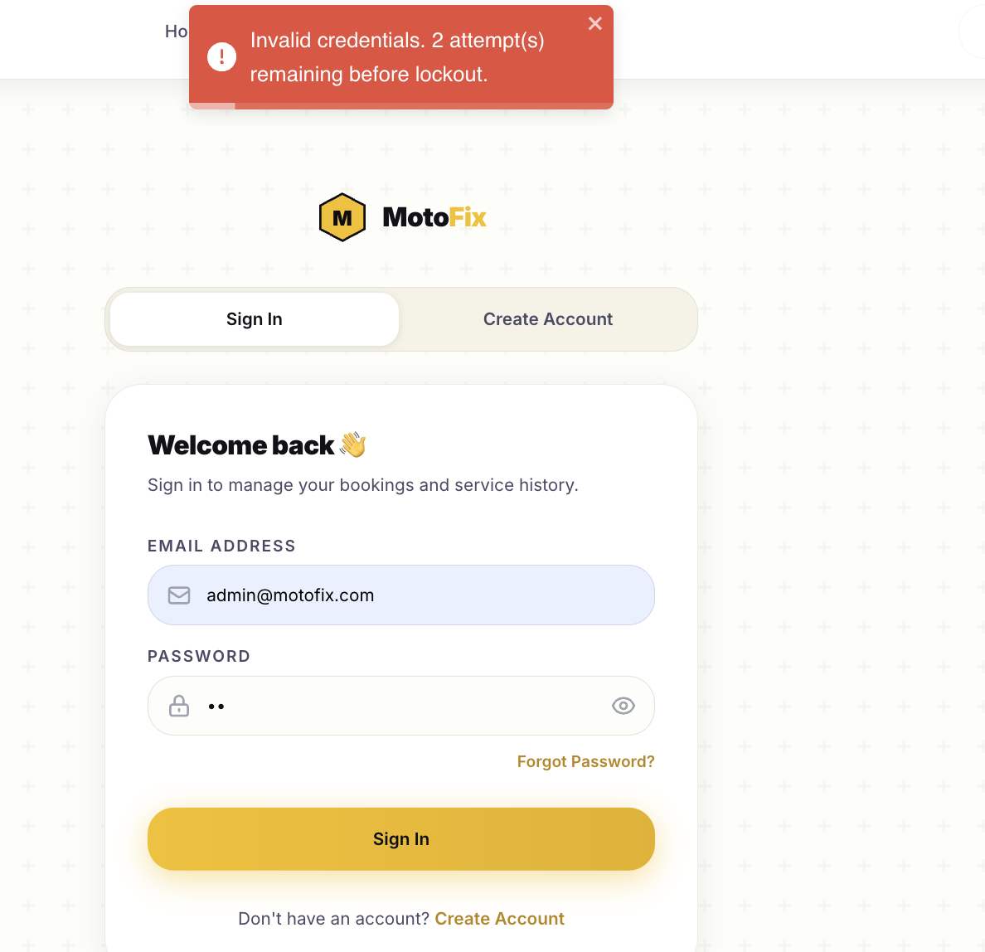
Figure 11: Invalid Attempts About to Trigger Rate-Limiter
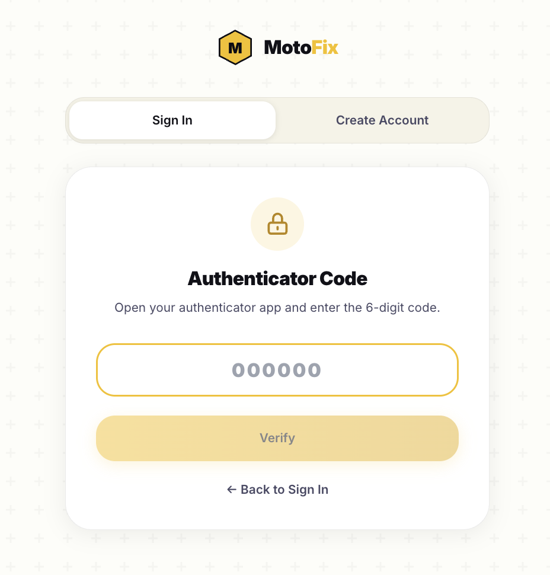
Figure 12: 2FA Implemented in MotoFix

Cryptographic Enforcement and Credential Policy
To ensure that MotoFix credentials remain resistant to offline brute-force and dictionary attacks, the platform enforces strict password policies (OWASP Foundation, n.d., Authentication Cheat Sheet) on registration and reset endpoints. Users cannot choose passwords containing segments of their full name, and inputs must pass validation checks for length and complexity (uppercase, lowercase, digits, and special characters).
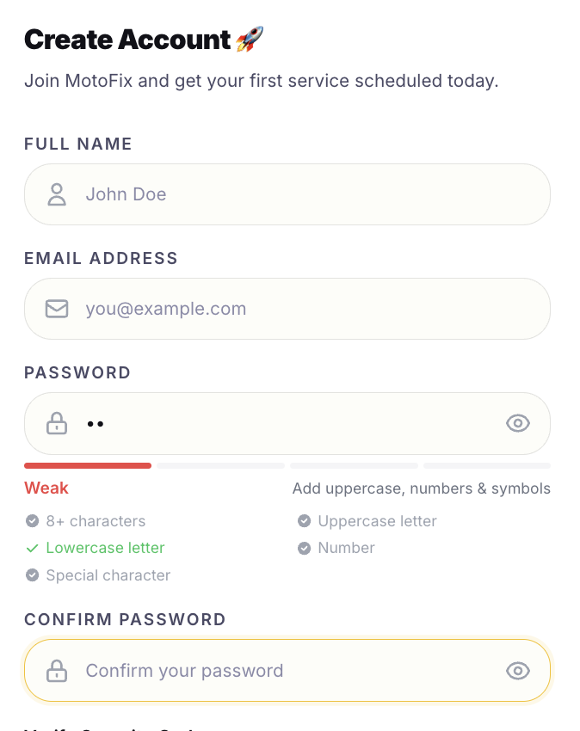
Figure 13: Password Strength Check on Register
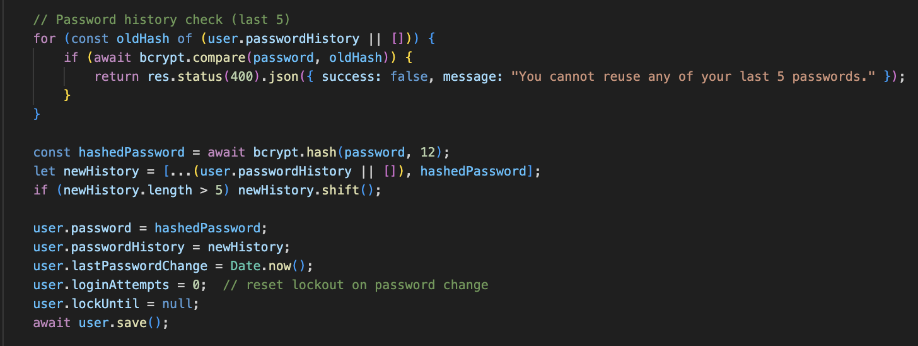
Figure 14: Server-Side Password Complexity and Name-Inclusion Validations
When updating passwords inside userController.js, inputs are hashed using bcrypt with an elevated work factor of 12 salt rounds to significantly delay cracking efforts. The system also prevents credential recycling by comparing new inputs against the user's last 5 hashed entries stored in the database's passwordHistory .
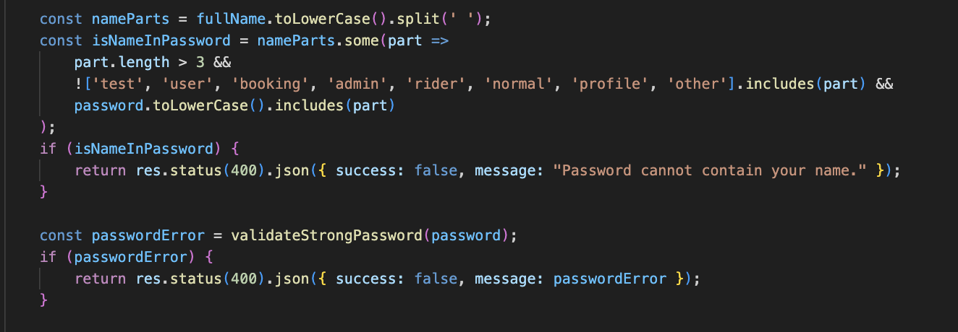
Figure 15: Cryptographic Password History Check and Hashing Implementations

Activity Logs
To ensure complete non-repudiation and enable detailed post-incident forensics, MotoFix implements a structured database auditing pipeline. The backend uses the logAudit helper inside middlewares/auditLogger.js to log critical actions (e.g., failed logins, password modifications, resource updates). It collects client context dynamically by parsing the x-forwarded-for header, request IP address, and browser User-Agent metadata.
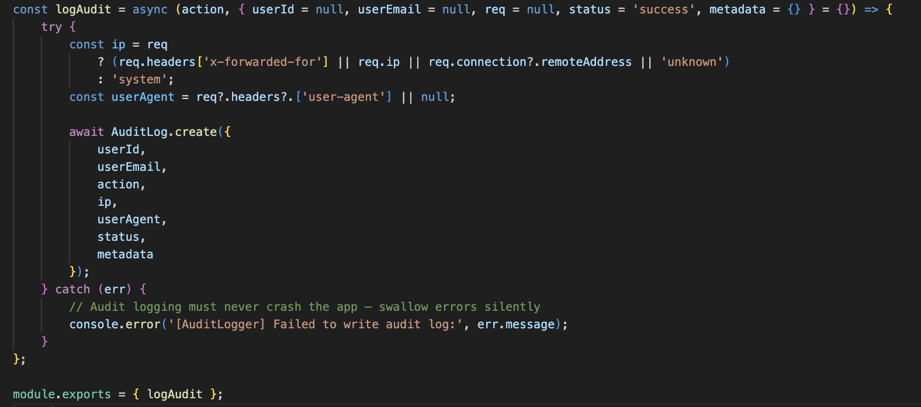
Figure 16: Resilient Structured Server-Side Audit Logging Middleware
To prevent audit writes from impacting application performance or causing API crashes, logging executions are safely isolated inside a try-catch block. Furthermore, the MongoDB AuditLog schema implements a Time-To-Live (TTL) (MongoDB, n.d.) index set to expireAfterSeconds: 90 * 24 * 3600. This configuration auto-purges records older than 90 days, keeping database growth within acceptable bounds while meeting statutory record-retention requirements.
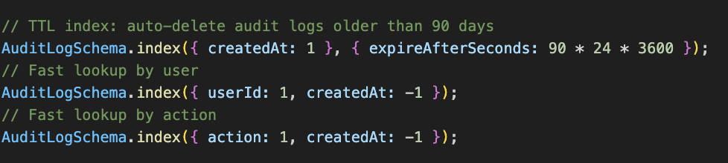
Figure 17: Audit Logs Database Schema with 90-Day Auto-Purging TTL Index
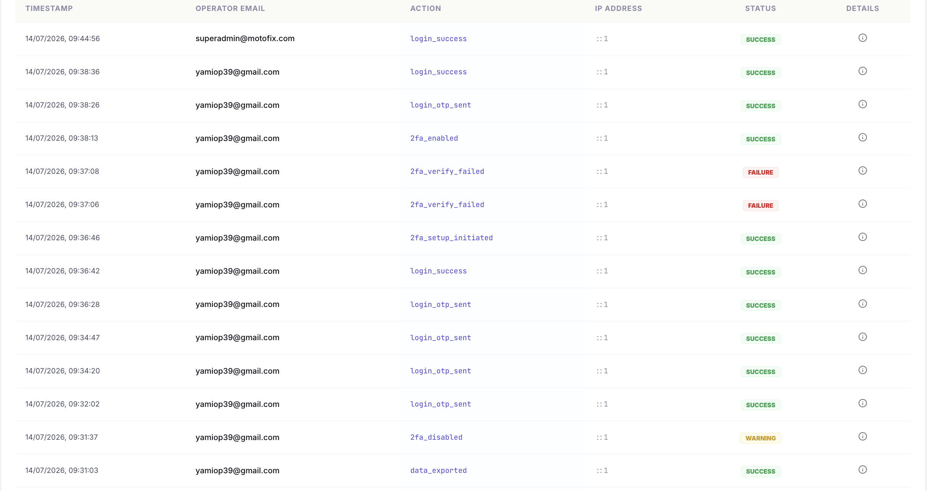
Figure 18: Security Logs
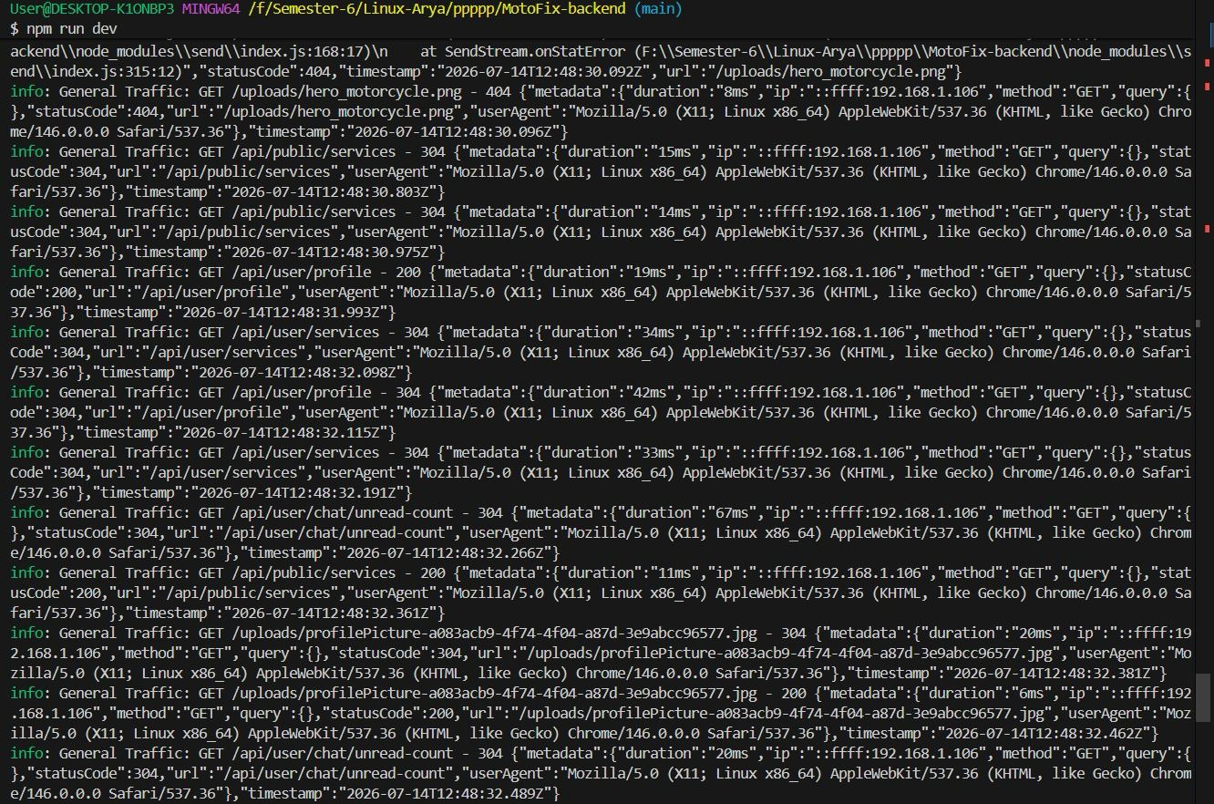
Figure 19: Backend Security Logs

Session Management & Token Security
MotoFix implements stateless session tracking using JSON Web Tokens (JWT) reinforced with secure, browser-restricted session storage. Rather than storing session state tokens in vulnerable local storage variables where they are accessible to cross-site scripting (XSS) script injections, MotoFix packages user payloads in a cryptographically signed JWT stored in a browser-managed cookie (OWASP Foundation, n.d., Session Management Cheat Sheet).
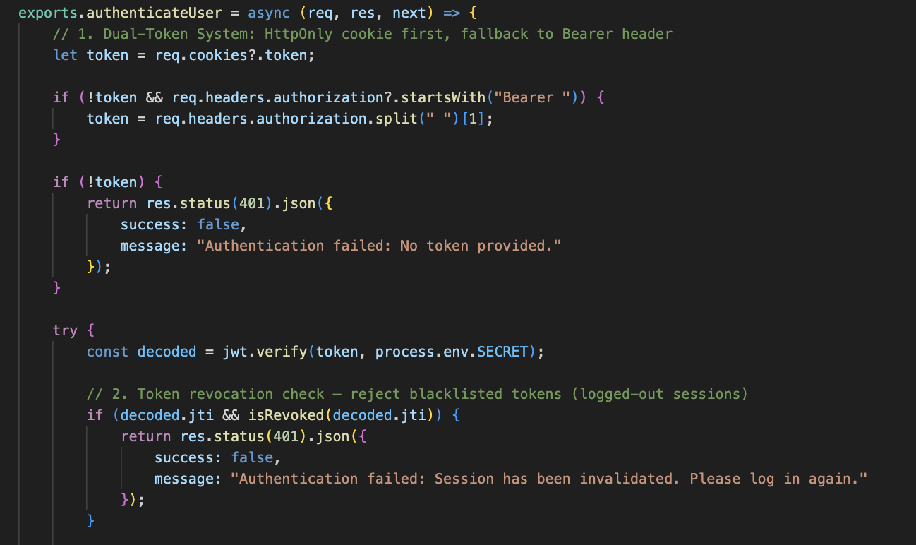
Figure 20: Dual-Mode Token Detection and Revocation Verification Middleware
As verified in middlewares/authorizedUser.js, this cookie is configured with httpOnly: true (blocking client-side JS extraction), Secure (forcing HTTPS transit), and SameSite constraints to block CSRF exploits. The authentication gateway checks incoming requests by extracting the cookie token, verifying its cryptographic signature, checking user existence, and validating the unique JWT identifier (jti) against the revocation blacklist.
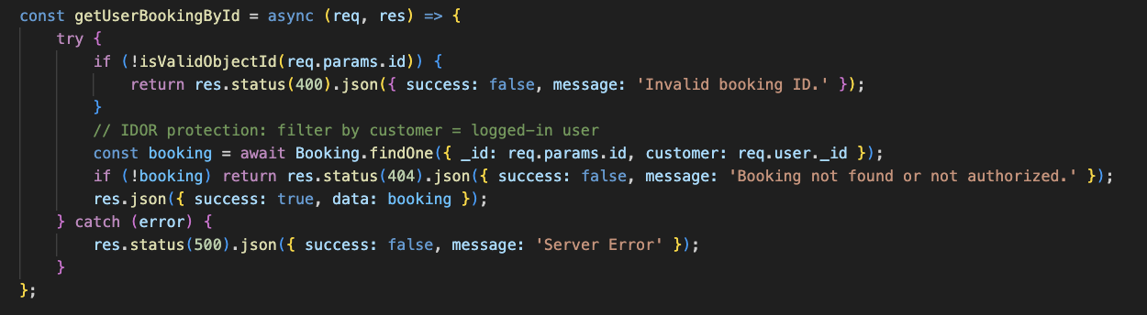
Figure 21: IDOR Prevention

API Protection and Role Based Access Control (RBAC)
To enforce privilege segregation and prevent horizontal/vertical privilege escalation attacks, MotoFix applies Role-Based Access Control (RBAC) at the gateway layer. The application maps users to discrete roles (user, admin, and superadmin).
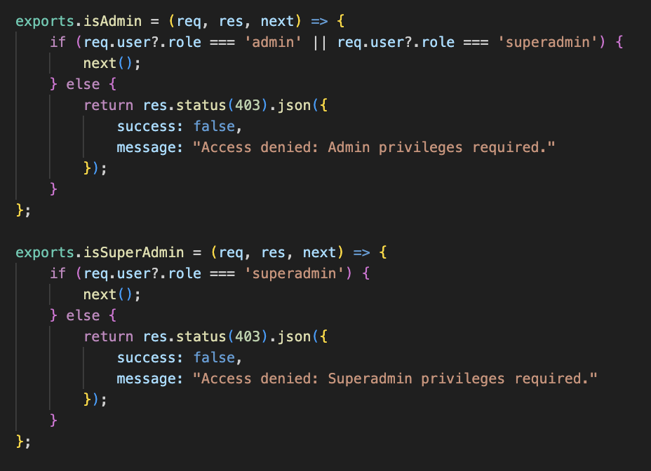
Figure 22: Role-Based Authorization Guards for Admin and Superadmin Routes
As configured in middlewares/authorizedUser.js, secure endpoints are guarded by specific middleware layers. The isAdmin wrapper grants access to staff mechanics (role admin or superadmin) for scheduling and booking management. The isSuperAdmin constraint isolates administrative actions (role updates, financial logs, and audit logs deletions) strictly to the superadmin profile, blocking access to unauthorized workers.
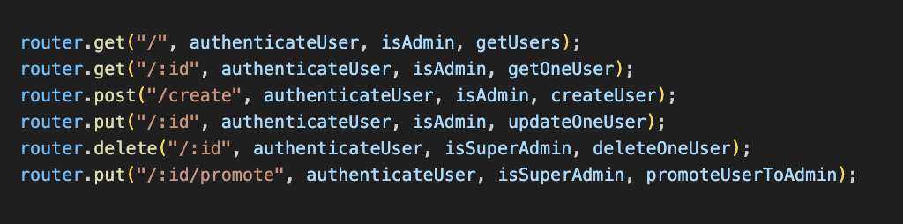
Figure 23: Admin and SuperAdmin Routes

Authenticated and Restricted File Uploads
To prevent Remote Code Execution (RCE) and local directory traversal attacks via file uploads (OWASP Foundation, n.d., File Upload Cheat Sheet; PortSwigger, n.d.). MotoFix filters all uploads through a custom Multer config in middlewares/upload.js.
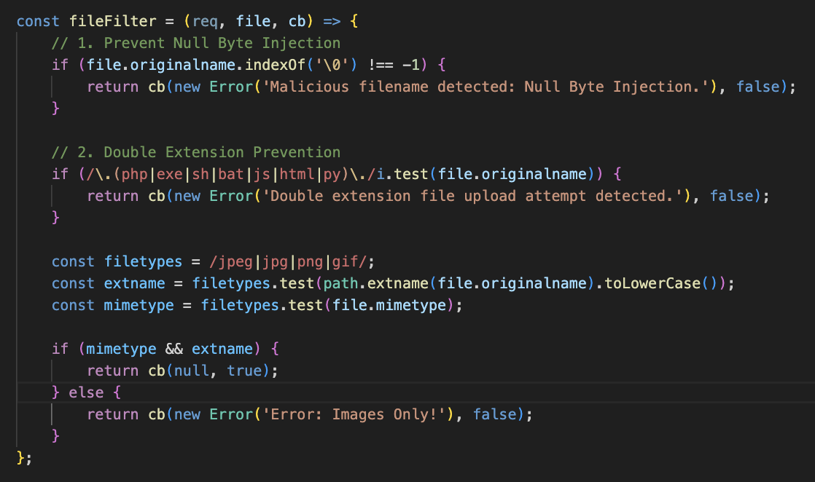
Figure 24: Multi-Stage File Upload Security Filtering Middleware
First, the server intercepts the incoming filename and tests for null-byte injections (\0) which could truncate string variables on server file systems. Second, a strict regular expression scans the name to block double-extensions (like virus.php.jpg) where execution commands reside before the final extension. Third, it validates that both the file extension and the headers match approved image formats (jpg, jpeg, png). Finally, filenames are randomized using timestamp suffixes to prevent file collision exploits.
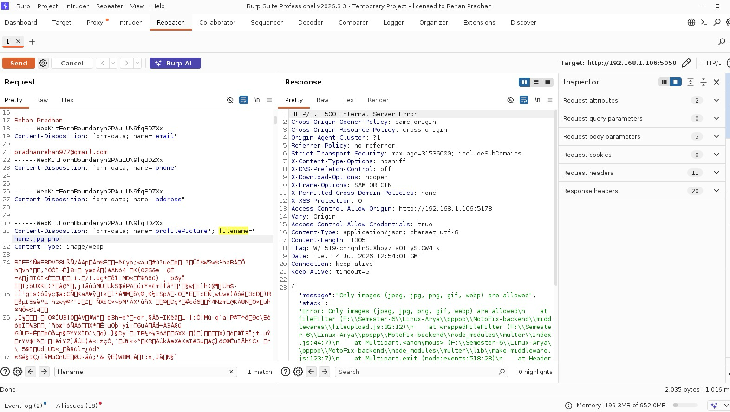
Figure 25: Burp Testing for Invalid Extension
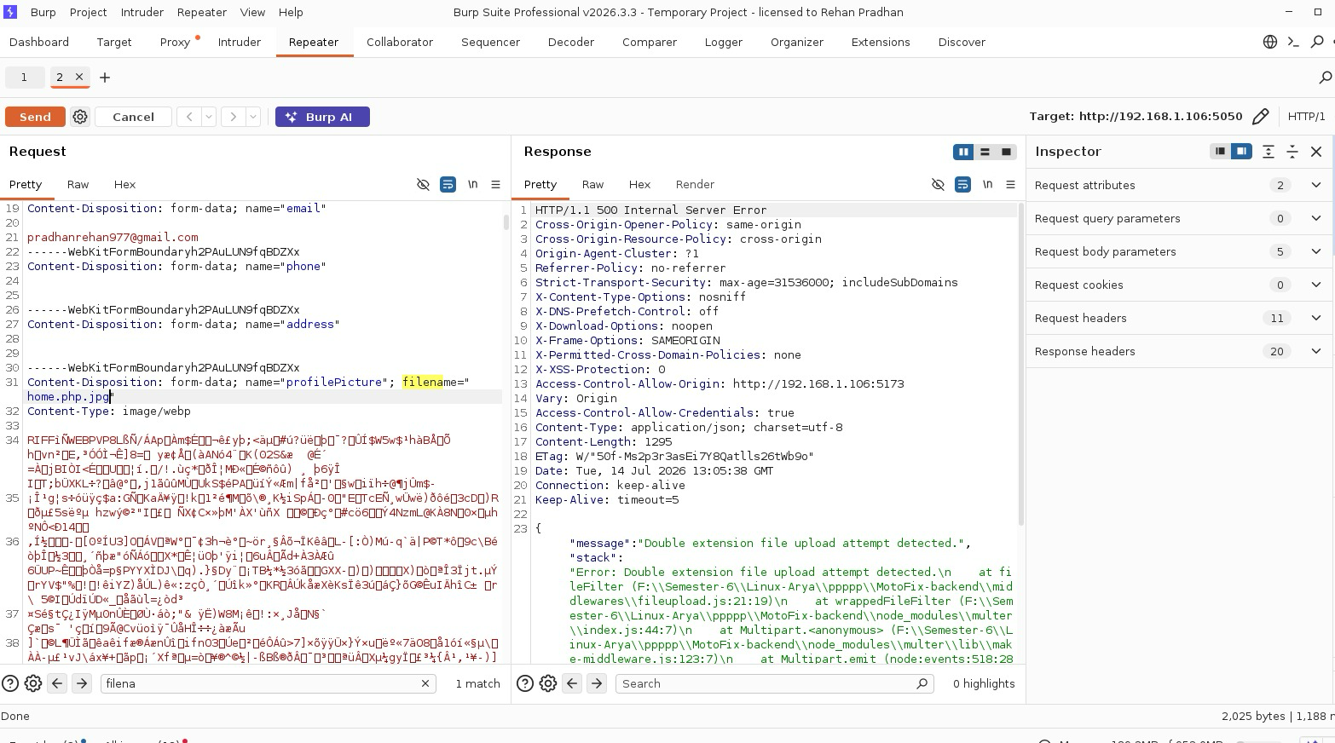
Figure 26: Burp Testing for Double Extension
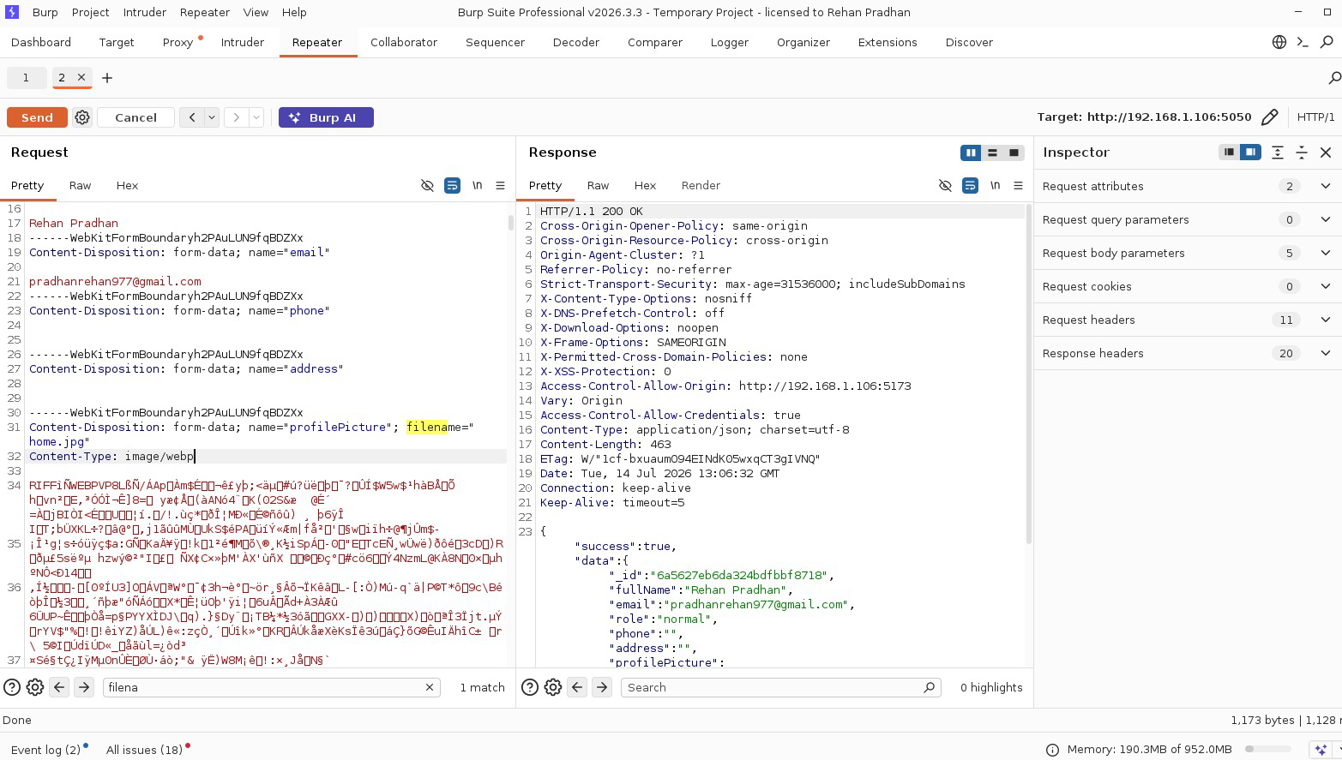
Figure 27: Burp Test Showed Success on home.jpg

Data Integrity and Frontend Tampering Prevention
To defend against client-side parameter tampering, where an attacker intercepting request packages attempts to lower booking totals before sending them to the API. MotoFix calculates all costs server-side.
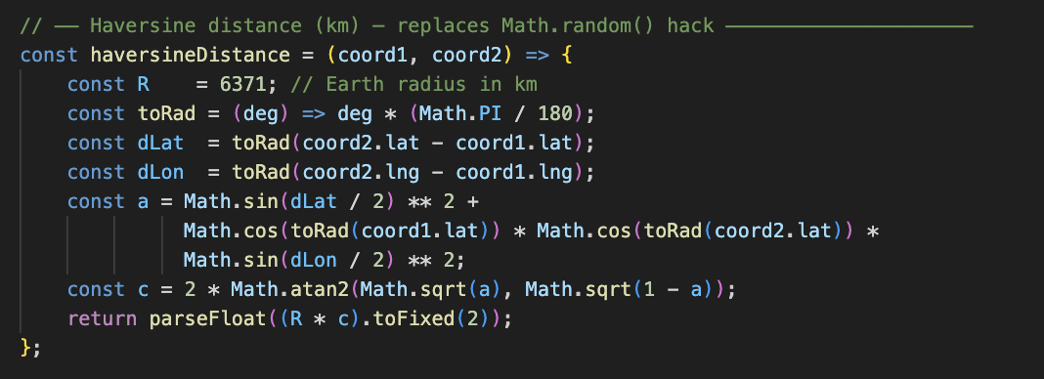
Figure 28: Server-Side Mathematical Haversine Distance Implementation
As implemented in controllers/user/bookingController.js, pricing variables (e.g., service baseline fees) are pulled directly from the secure backend database. For pickup and drop-off requests, the distance is calculated mathematically using the coordinates of both the workshop and the customer in a server-side Haversine formula function (Sinnott, 1984). The final invoice amount is generated and written directly to MongoDB by the backend, ensuring that user request values are completely ignored.
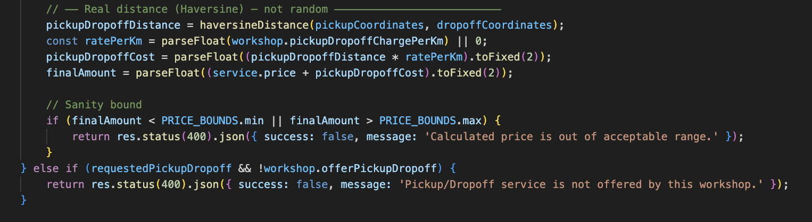
Figure 29: Authoritative Pricing and Fee Verification Logic

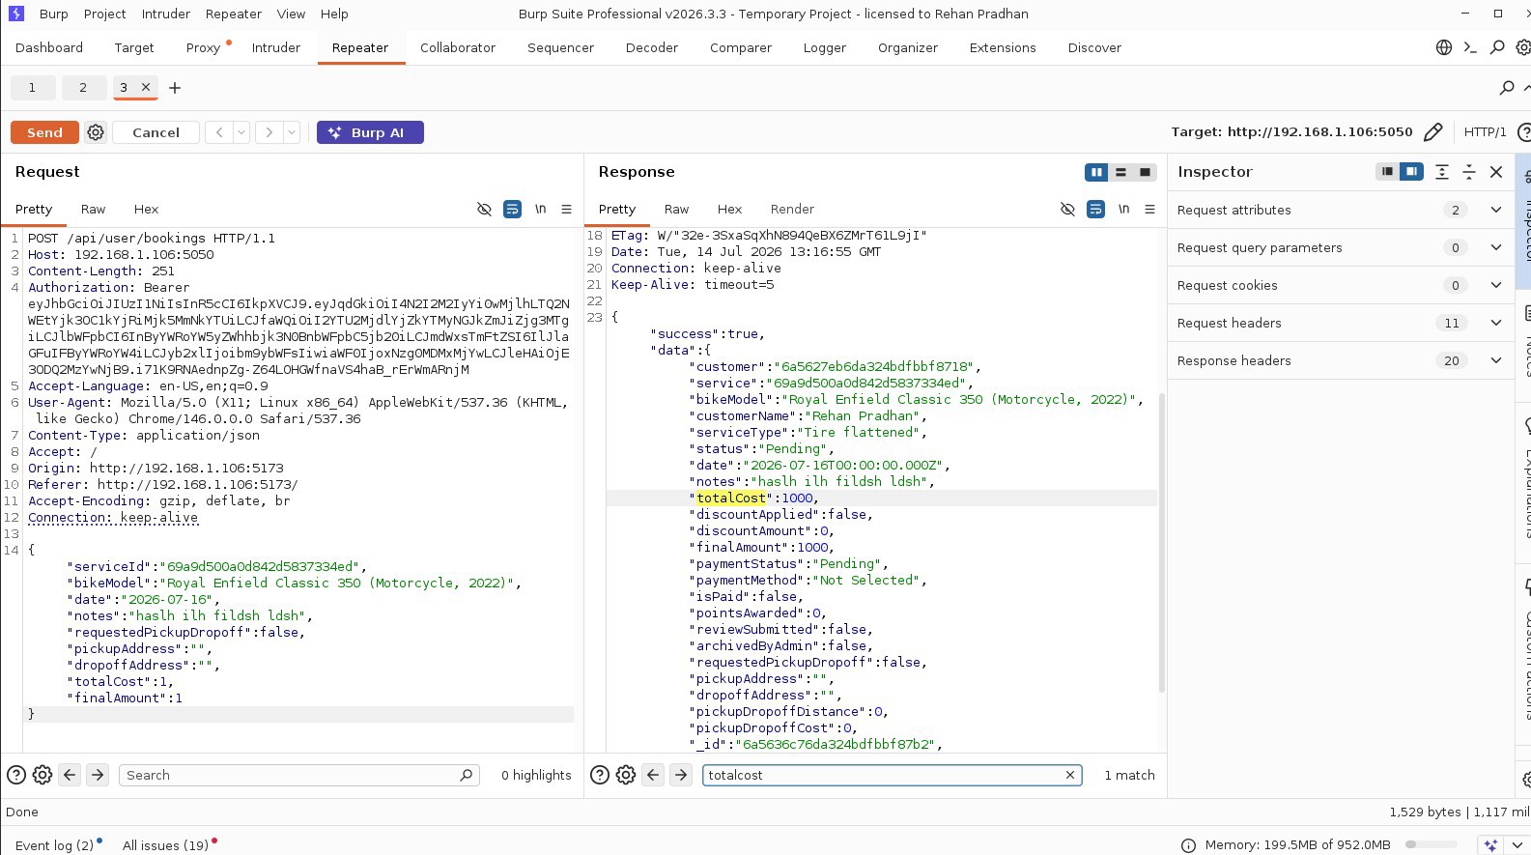
Figure 30: Price Tampering Request Blocked by Server

Secure Third-Party Integration (eSewa & Khalti Payments)
To ensure that third-party checkouts cannot be spoofed, MotoFix implements server-to-server verification for all digital payments.
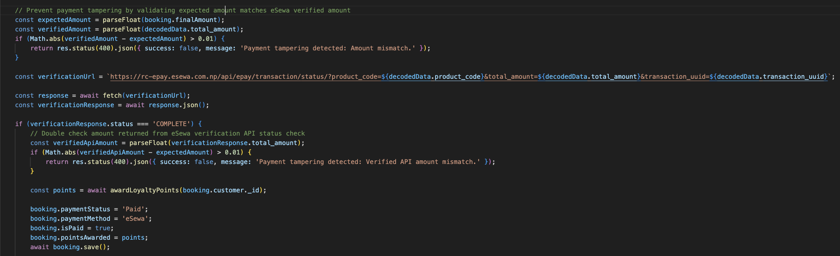
Figure 31: eSewa Payment Signature Verification and Server-Side Validation
As structured in controllers/esewaController.js, when a customer returns from eSewa, the backend parses the base64 checkout token and extracts the transaction details. Instead of marking the order as paid immediately, the server compares the verified amount directly against the original booking amount in the database to prevent parameter tampering. The backend then makes an outbound status check query to eSewa's transaction status API to verify the signature cryptographically before saving changes, blocking falsified checkout alerts.

Cross-Site Scripting (XSS) Prevention Strategy
To prevent Stored and Reflected Cross-Site Scripting (XSS) attacks where an attacker attempts to inject malicious HTML tags or script executions into form fields. MotoFix uses a global sanitization middleware.
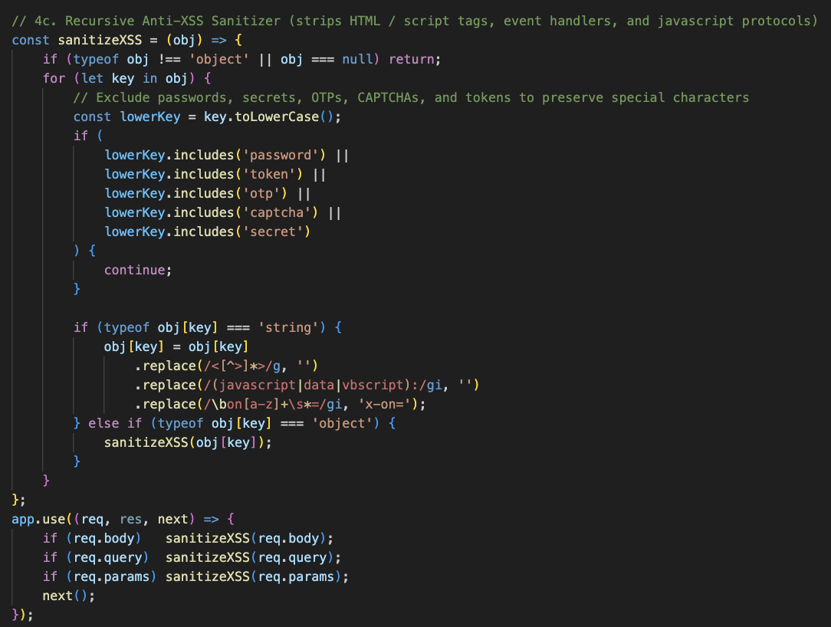
Figure 32: Global Recursive Input Sanitization Middleware for XSS Mitigation
As implemented in index.js, the custom sanitizeXSS middleware intercepts all incoming requests and recursively processes the values of req.body, req.query, and req.params. The system uses the xss library to filter script tags and dangerous HTML attributes. To prevent altering credentials, an allowlist check bypasses fields like password, token, otp, captcha, and secret, ensuring they remain untouched.

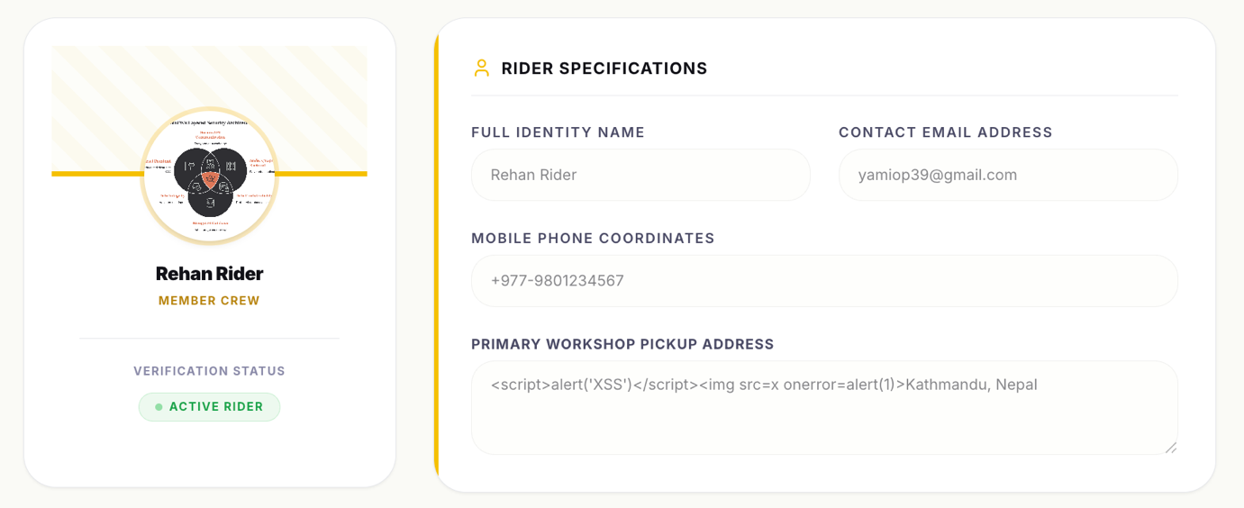
Figure 33: Before Sanitization
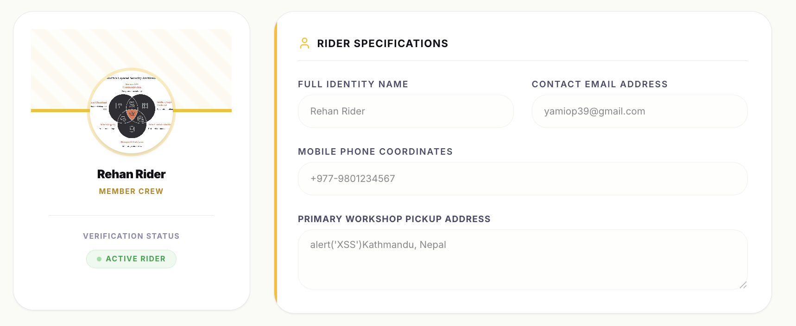
Figure 34: After Sanitization

NoSQL Injection & HTTP Parameter Pollution (HPP) Prevention
To protect database queries and request parameters from manipulation, MotoFix implements global query normalization and NoSQL sanitization. The backend utilizes the hpp() middleware to parse incoming request strings and strip duplicate query keys, neutralizing HTTP Parameter Pollution (HPP) exploits.
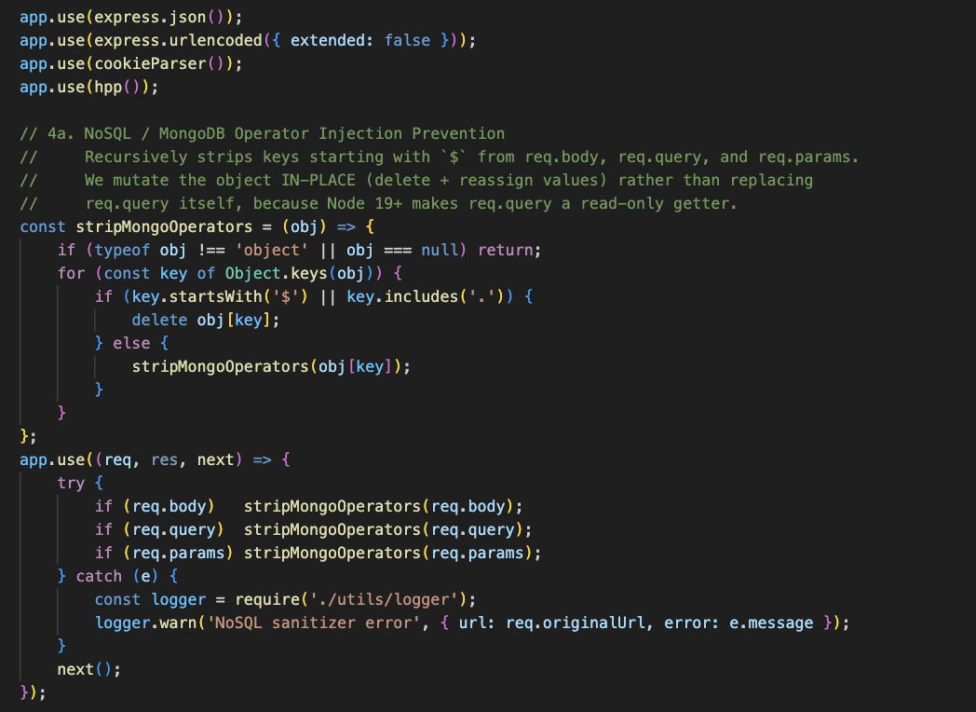
Figure 35: Configuration of HPP and NoSQL Operator Sanitization Middleware
Simultaneously, a recursive stripMongoOperators utility scans all fields in req.body, req.query, and req.params. It detects and deletes any properties starting with a dollar sign ($) or containing dots (.), blocking attackers from injecting NoSQL query parameters (e.g., {"email": {"$ne": null}}) to bypass user authentication or leak collections.
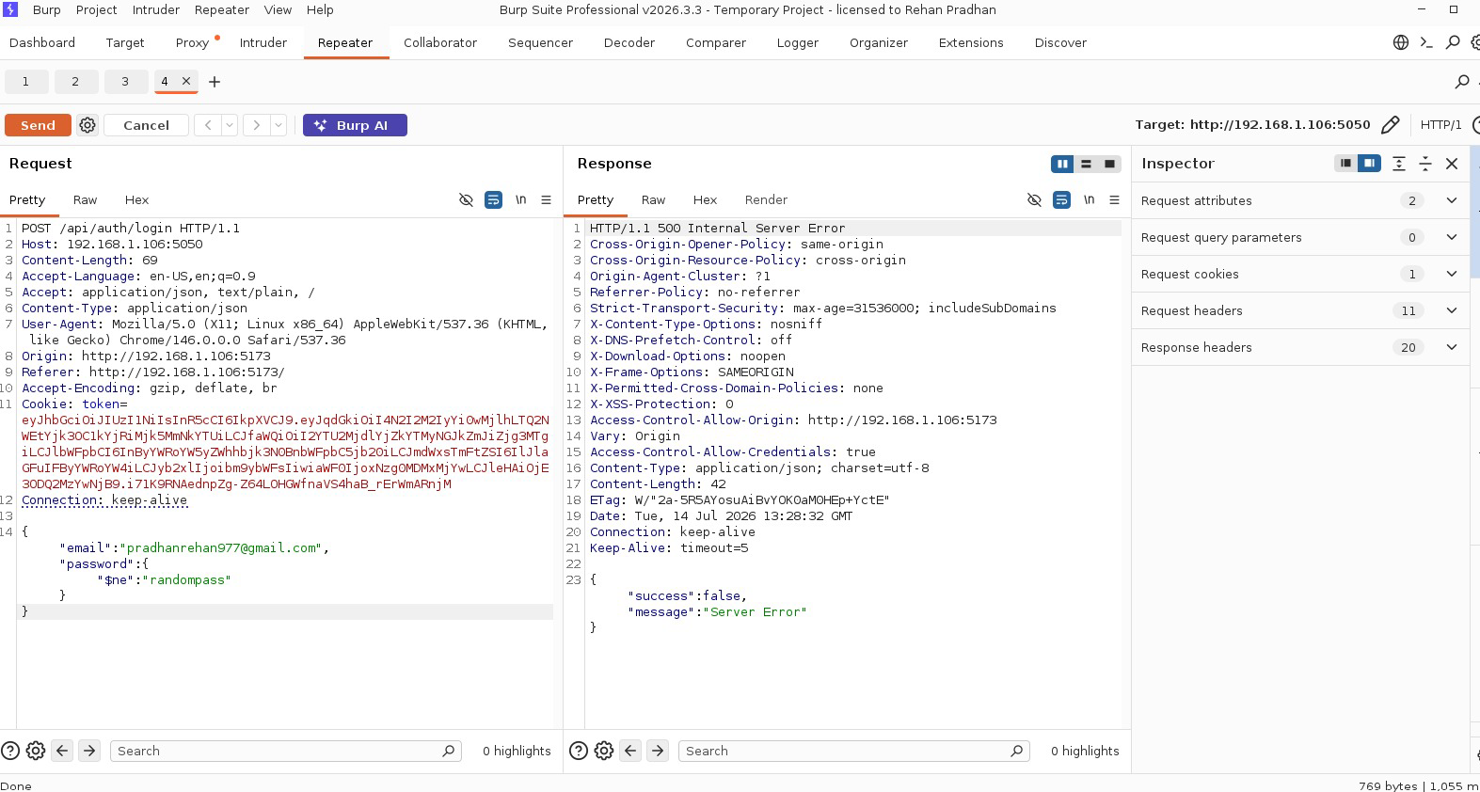
Figure 36: NoSQL Injection Authentication Bypass Blocked

Conclusion
MotoFix implements a defense-in-depth architecture that secures session data and booking transactions. Communications are encrypted over HTTPS, and sessions use stateless JWTs stored in HttpOnly cookies. Account protection includes SVG CAPTCHAs, brute-force rate-limiting, and dual-layer MFA (Email OTP and Google Authenticator). Booking pricing relies on a server-side truth model using the Haversine formula, and payment checkouts are verified server-to-server. Finally, the system mitigates XSS, NoSQL injection, and file-upload execution via recursive sanitizers and strict extension checks, maintaining transparent 90-day purged audit logs.

Reference
eSewa. (n.d.). eSewa ePay Integration Document (v2). eSewa Developer Portal. https://developer.esewa.com.np/
Helmet. (n.d.). Helmet: Help secure Express apps with various HTTP headers. https://helmetjs.github.io/
Jones, M., Bradley, J., & Sakimura, N. (2015). JSON web token (JWT) (RFC 7519). Internet Engineering Task Force. https://datatracker.ietf.org/doc/html/rfc7519
Khalti. (n.d.). Khalti ePayment Lookup and Verification APIs. Khalti Developer Documentation. https://docs.khalti.com/
MongoDB. (n.d.). Expire data from collections by setting TTL. MongoDB Manual. https://www.mongodb.com/docs/manual/core/index-ttl/
Mozilla. (n.d.). Content security policy (CSP). MDN Web Docs. https://developer.mozilla.org/en-US/docs/Web/HTTP/CSP
Mozilla. (n.d.). Set-Cookie: HttpOnly attribute. MDN Web Docs. https://developer.mozilla.org/en-US/docs/Web/HTTP/Headers/Set-Cookie
National Institute of Standards and Technology. (2001). Role-based access control (RBAC) definition and specifications. https://csrc.nist.gov/projects/role-based-access-control
OWASP Foundation. (n.d.). Authentication cheat sheet. https://cheatsheetseries.owasp.org/cheatsheets/Authentication_Cheat_Sheet.html
OWASP Foundation. (n.d.). Authorization cheat sheet. https://cheatsheetseries.owasp.org/cheatsheets/Authorization_Cheat_Sheet.html
OWASP Foundation. (n.d.). Cross-site scripting (XSS) prevention cheat sheet. https://cheatsheetseries.owasp.org/cheatsheets/Cross_Site_Scripting_Prevention_Cheat_Sheet.html
OWASP Foundation. (n.d.). File upload cheat sheet. https://cheatsheetseries.owasp.org/cheatsheets/File_Upload_Cheat_Sheet.html
OWASP Foundation. (n.d.). Session management cheat sheet. https://cheatsheetseries.owasp.org/cheatsheets/Session_Management_Cheat_Sheet.html
OWASP Foundation. (2021). OWASP Top Ten web application security risks. https://owasp.org/www-project-top-ten/
PortSwigger. (n.d.). File upload vulnerabilities. https://portswigger.net/web-security/file-upload
Rescorla, E. (2018). The transport layer security (TLS) protocol version 1.3 (RFC 8446). Internet Engineering Task Force. https://datatracker.ietf.org/doc/html/rfc8446
Sinnott, R. W. (1984). Virtues of the Haversine. Sky and Telescope, 68(2), 159. (Reference for coordinate distance calculation).
Speakeasy. (n.d.). speakeasy: Two-factor authentication (TOTP/HOTP) library for Node.js. GitHub. https://github.com/speakeasyjs/speakeasy

Appendix
