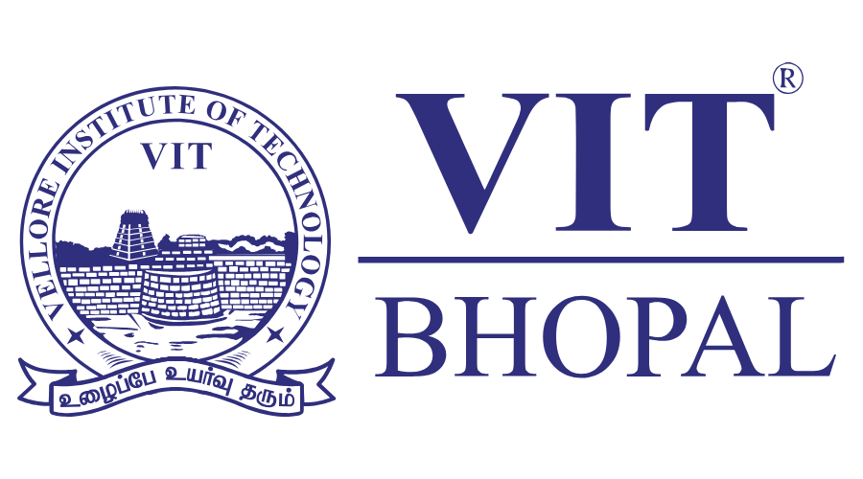
Course: CSE0001 || Date: 29th March 2026
DIGITAL LITERACY PROJECT REPORT

Name: Dipen
Reg. No: 25BAI10284
Branch: CSE (AI & ML)
Year: First Year B.Tech

INTRODUCTION

This report provides an overview of the project completed as part of CSE0001 Digital Literacy Course for the students enrolled in the first year of B.Tech across all branches at VIT Bhopal University. The project was designed with the student digital ambassador theme. The digital ambassador is responsible for assisting other students in becoming more digitally literate and navigating the digital world safely, professionally, and effectively. The portfolio (work product) includes five projects, each assigned to one of the digital literacy learning outcomes.
The projects include: Making an infographic that promotes digital literacy; putting together a digital portfolio as a student; looking at platforms that offer coding and collaboration; practising writing professional emails; and researching information about cybercrime. Each of these projects has been posted to a GitHub repository. Each of the projects did not require any prior knowledge of coding. All of the tools used in completing the projects are free and browser based. Therefore, all students have access to the tools, regardless of their level of digital literacy knowledge.

TASK1: INFOGRAPHIC

For the first task, I created a "Digital Literacy Awareness Infographic" using Canva. The goal was to provide a visual summary of the four pillars of digital literacy: functional skills, critical thinking, safe online behaviour, and professional etiquette. I designed the infographic with a clean blue-and-white colour scheme to keep a professional appearance, while using bold icons to highlight sections like "Multi-Factor Authentication" and "Phishing Awareness."

Reflection: Making this infographic taught me about information structure. I realized that as a Student Ambassador, my goal isn't just to have knowledge but to present it in a way that is easy for someone who may not be tech-savvy to understand. The hardest part was narrowing down the broad topic of cyber security into three simple steps. This task helped me improve my graphic design skills and showed me how to use visual hierarchy to direct a reader's attention to important safety warnings.

TASK 2: DIGITAL PORTFOLIO

In Task 2, I created professional profiles on GitHub, Kaggle, and Stack Overflow.

GitHub: I set this up as a version-control repository to host my project code.

Kaggle: I created this to take part in data science competitions and access datasets related to my AI and ML work.

Stack Overflow: I made this to connect with a global developer community for troubleshooting and technical discussions.

Purpose and Future Plans: These platforms act as my digital resume. While a traditional CV lists skills, these sites show them through my contributions and commit histories. In the future, I plan to add every major academic project to my GitHub repository and keep a "Green Wall" of contributions. For Kaggle, I aim to finish at least three data analysis certifications by the end of my second year. By building these profiles now, I am making sure that when I reach campus placements, recruiters will see a clear four-year record of my development and growth as a data scientist.

TASK 3: PLATFORM &COLLBORATION

This task focused on using coding and collaboration tools. I used HackerRank to solve a basic coding challenge, which confirmed my ability to manage standard input/output and algorithm logic. For the collaboration part, I created a "Digital Literacy Awareness Quiz" using Google Forms. This quiz aimed to test peers on their ability to identify secure websites (HTTPS) and understand password strength.

Practice & Learnings: Through HackerRank, I practiced turning logical ideas into executable code while under time pressure. Using Google Forms taught me how to gather and analyze data effectively. I learned to apply "Conditional Logic" in forms to give different feedback based on a user's answer. These tools are crucial for any modern engineer, as they support both personal technical growth and group data collection. This task connected solo coding with engaging a digital audience.

TASK 4: COMMUNICATION

For Task 4, I practiced professional communication in two different scenarios. The first was an academic extension request to a professor, and the second was a formal internship inquiry to an HR manager. These drafts aimed to strike a balance between being concise and respectful.

Key Learnings: The key lesson was the "Subject Line" rule. A clear subject line can decide whether an email gets opened or ignored. I also learned about the importance of "Digital Etiquette" (Netiquette), such as avoiding slang and using proper grammar. In a professional setting, your email is usually the first impression you make. Mastering the tone of a "professional inquiry" is a skill I will use throughout my career for networking and formal project submissions.

TASK 5: CYBERCRIME AWARENESS

I researched the "Request Money" Trap, a common UPI-based scam where attackers misuse the "Collect" feature of payment apps.

What Surprised Me: I was shocked to find out how attackers use simple psychological tactics like "urgency" to make victims forget a basic rule. They often tell the victim that the "payment link will expire," which prompts the victim to rush and enter their PIN without checking the screen.

Habit Change: I will change my notification management for payment apps right away. I will double-check the "Merchant Name" on every UPI notification before clicking it. I have also decided to never enter my UPI PIN while "receiving" money, as I've learned that receiving funds does not require any authentication from the recipient.

CONCLUSION

Overall, this project has changed how I view "digital literacy." It involves more than just using a computer. It also includes managing a professional identity, communicating clearly, and staying safe in a complicated online world. As a Student Digital Ambassador, I learned that keeping safe online is a shared responsibility. By creating a secure portfolio and learning about how modern scams work, I feel more ready for my B.Tech journey. The biggest takeaway for me was that a well-managed digital presence can help with career growth and community safety.

REFERENCE

- National Cyber Crime Reporting Portal – cybercrime.gov.in
- GitHub Documentation – docs.github.com
- HackerRank – hackerrank.com
- Google Workspace Learning Centre – workspace.google.com/learning-center
- Canva Design School – canva.com/learn
- Kaggle – kaggle.com
- VIT Bhopal University – vitbhopal.ac.in

