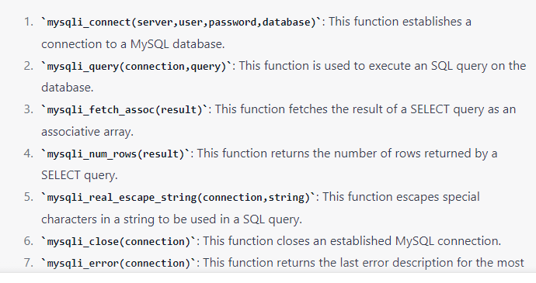

**EDITING the database with php**

To edit the contents of a database with PHP, you need to perform the following steps:

Connect to the database: You need to establish a connection to the database using the PHP function mysqli_connect() or PDO::__construct(). You will need to pass the hostname, username, password, and database name as parameters.

Select the data you want to edit: You can use the SELECT statement in a SQL query to retrieve the data that you want to edit. You can then use PHP functions like mysqli_query() or PDO::query() to execute the query.

Modify the data: Once you have retrieved the data, you can modify it using PHP variables. You can then use an UPDATE statement in a SQL query to save the changes to the database.

Execute the query: You can execute the query to update the database using the PHP function mysqli_query() or PDO::exec().

Close the connection: Finally, you should close the connection to the database using the PHP function mysqli_close() or PDO::close().

Here is a simple example of how to edit data in a database using PHP and SQL:

php

Copy code

<?php

// Connect to the database

$conn = mysqli_connect("hostname", "username", "password", "database_name");

// Check the connection

if (!$conn) {

die("Connection failed: " . mysqli_connect_error());

}

// Retrieve the data

$sql = "SELECT * FROM table_name WHERE id = '1'";

$result = mysqli_query($conn, $sql);

// Modify the data

if (mysqli_num_rows($result) > 0) {

$row = mysqli_fetch_assoc($result);

$row['field_name'] = "new_value";

}

// Update the database

$sql = "UPDATE table_name SET field_name='" . $row['field_name'] . "' WHERE id='1'";

if (mysqli_query($conn, $sql)) {

echo "Record updated successfully";

} else {

echo "Error updating record: " . mysqli_error($conn);

}

// Close the connection

mysqli_close($conn);

?>

Q.Why setcookie( ) and session_start( ) Want to Be at the Top of the Page.

1. **setcookie()**: This function must be called before any output is sent to the browser, as the cookie needs to be sent as part of the HTTP header. If any data, including whitespace, is sent to the browser before calling **setcookie()**, the cookie will not be sent and an error may occur.
2. **session_start()**: This function must also be called before any output is sent to the browser, as it initializes a session or resumes an existing one. When a session is started, a session ID is sent to the browser as a cookie. Like **setcookie()**, if any data is sent to the browser before calling **session_start()**, the session ID cookie will not be sent and the session will not be started. Additionally, if **session_start()** is called after any data has been sent to the browser, an error may occur.

Therefore, it's best practice to place both **setcookie()** and **session_start()** at the very top of a PHP page, before any other data is sent to the browser, to ensure they work properly.

Top of Form