Parsing a Date or Time

The date_format() function returns a date formatted according to the specified format.

Syntax:

date_format(datetime object,datetime format);

datetime object can obtain by date_create() function

syntax:

date_create(string);

example:

*<?php*

*//creating datetime object form given string*

*$date=date_create('2015-3-10');*

*//formating the date*

*$date1=date_format($date,'y/m/d');*

*echo "<br> After Format:&nbsp;".$date1;*

*?>*

Displaying Date and Time in HTML Form

The **<input type="time">** allows the user to select a time (no time zone).

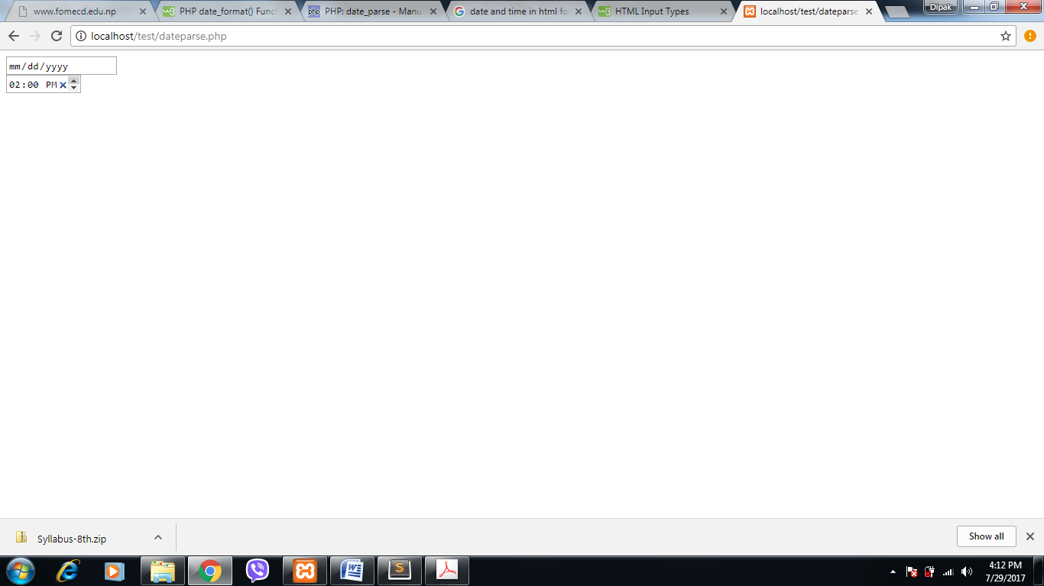

The **<input type="date">** is used for input fields that should contain a date.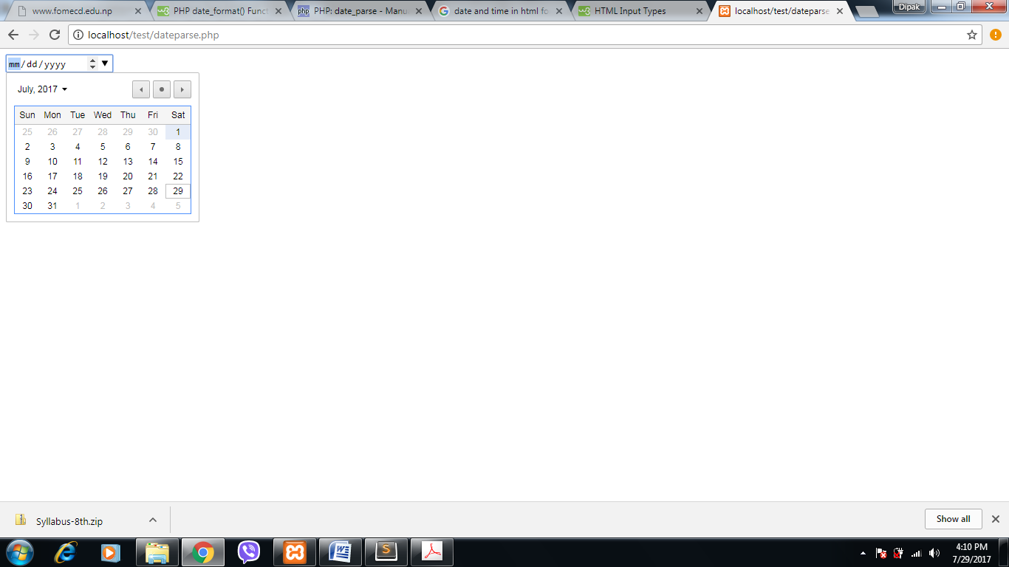

Displaying calendar using php

cal_days_in_month() function is used to get total days of given month and year.

Syntax:

cal_days_in_month(calendar,month,year);

calendar=CAL_GREGORIAN

month=month in digit ex: 1,7 or 10

year=year in four digit ex: 2017 or 1999

Example:

*<?php*

*$year=2017;*

*$month=07;*

*$days_in_month=cal_days_in_month(CAL_GREGORIAN,$month,$year);*

*$obj=date_create($year."/".$month."/1");*

*$heading=date_format($obj,'F Y');*

*echo $heading;*

*echo "<table style='border-collapse:collapse;' border=1>";*

*echo "<tr>";*

*echo "<th> SUN </th>";*

*echo "<th> MON </th>";*

*echo "<th> TUE </th>";*

*echo "<th> WED </th>";*

*echo "<th> THU </th>";*

*echo "<th> FRI </th>";*

*echo "<th> SAT </th>";*

*echo "</tr>";*

*echo "<tr>";*

*$obj=date_create($year."/".$month."/1");*

*$firstDay=date_format($obj,'N');*

*$week=$firstDay;*

*echo "<td colspan=".$week."</td>"; //starting from correct day.*

*for($day=1;$day<=$days_in_month;$day++)*

*{*

*if($week==8)*

*{*

*echo "</tr><tr>";*

*$week=1;*

*}*

*$week++;*

*echo "<td>".$day."</td>";*

*}*

*echo "</table>";*

*?>*