AI-Based smart PDF Summarizer & Auto Highlighter
A Minor Project


SANGAM UNIVERSITY, BHILWARA
Bachelors of Technology
Submitted By:-
Dipendra Kumar Chaudhary
(2023BTCS063)
Zafran Tariq
(2023BTCS021)

Department of Computer Science and Engineering,
Sangam University,
National Highway-79, Chittor By-Pass, Atoon, Bhilwara, Rajasthan

Guided by:-
Session:- 2025-2026 Prof. Dr. Vikas Somani

Candidate’s Declaration
I hereby declare that the work, which is being presented in the Minor Project Report, entitled “AI-Based Smart PDF Summarizer And Auto Highlighter ” in partial fulfillment for the award of Degree of “Bachelor of Technology” in CSE. Submitted to the Department of Computer Science Engineering, Sangam University. The project is a record of my investigations carried out under the guidance of Prof(Dr.) Vikas Somani HOD, Sangam University, Bhilwara, Rajasthan, India.
I have not submitted the matter presented in this dissertation anywhere for any other Degree.

Students Name:
1. Dipendra Kumar Chaudhary
(2023SUBTCS063)
2.Zafran Tariq
(2023SUBTCS021)
Date: 17/12/2025
Counter Signed by Prof(Dr.) Vikas Somani
HOD School of Engineering & Technology
Department of Computer Science & Engineering
Sangam University, Bhilwara

CERTIFICATE

This is to certify that the Minor Project entitled “AI-Based PDF Summarizer and Auto Highlighter” submitted by Mr. Dipendra Kumar Chaudhary (Enrollment No.: 2023BTCS063) And by Mr. Zafran Tariq (Enrollment No.: 2023BTCS0021) of B.Tech (Computer Science & Engineering) at Sangam University, Bhilwara, Rajasthan is a bonafide record of the work carried out by him under my supervision for the partial fulfillment for the award of the degree of Bachelor of Technology in Computer Science & Engineering.
This work has not been submitted for the award of any other degree.
Project Guide:
(Prof. Dr. Vikas Somani)
Department of Computer Science & Engineering

Head of Department:
(Prof. Dr. Vikas Somani)
Department of Computer Science & Engineering
Sangam University, Bhilwara

Examiner:____________
Date:________________

ACKNOWLEDGMENT
I would like to express my sincere gratitude to my project guide Prof. Dr. Vikas Som,
Department of Computer Science & Engineering, Sangam University, Bhilwara, for his
valuable guidance, continuous encouragement, and constant support throughout the
development of this Minor Project titled “AI-Based PDF Summarizer and Auto Highlighter.”
His insightful suggestions, technical expertise, and motivation played a crucial role in
helping me overcome challenges and successfully complete this project.
I am also thankful to the faculty members of the Department of Computer Science & Engineering
for providing the necessary resources, technical assistance, and a supportive academic
environment during the course of this project work.
I would like to extend my sincere thanks to my friends and classmates for their cooperation,
constructive feedback, and encouragement throughout the project development process.
Finally, I express my heartfelt gratitude to my parents for their unconditional support,
constant encouragement, and motivation, without which the successful completion of this
project would not have been possible.

Abstract
This project report presents the design, development, and implementation of an advanced document summarization system capable of handling multiple document formats, including PDF, DOCX, and PPTX. In today’s fast-paced digital environment, both organizations and individuals frequently deal with large volumes of documents, reports, research papers, and presentations. Manually reading, understanding, and summarizing these documents is a time-consuming process and often prone to human error. The need for efficient, automated solutions to extract and highlight important information from documents has therefore become increasingly critical. This system addresses that need by providing an automated platform that can process diverse document formats, extract relevant content, and produce concise, structured summaries in a user-friendly format. The goal is to reduce the manual effort required for document comprehension while ensuring that critical information is preserved and presented effectively.
A key feature of this system is its ability to support both typed and handwritten documents, thanks to the integration of Optical Character Recognition (OCR) technology. Typed documents can often be processed using standard text extraction tools, but handwritten or scanned documents require OCR to recognize and convert images of text into machine-readable formats. The system employs a multi-tier OCR pipeline to ensure high accuracy across different document types. Initially, PyMuPDF is used for native text extraction from digital documents, providing a fast and reliable method for PDFs that contain embedded text. For scanned or handwritten content, EasyOCR is utilized to recognize and extract text from images. EasyOCR employs deep learning-based models capable of detecting text in various fonts, orientations, and handwriting styles. In cases where EasyOCR fails to produce accurate results, pytesseract serves as a fallback mechanism. This layered approach enhances the robustness and reliability of text extraction, allowing the system to handle a wide range of document qualities and formats.
Once the text has been extracted, the system applies an extractive summarization algorithm to generate concise summaries. Unlike abstractive summarization, which generates new sentences and paraphrases, extractive summarization selects the most important sentences directly from the original text. This ensures that the factual accuracy of the content is preserved, a critical consideration for professional, legal, academic, or technical documents. The algorithm is based primarily on term frequency analysis, which evaluates the importance of each word based on its frequency within the document. To improve the relevance of selected sentences, the system applies entity boosting, giving higher scores to sentences containing important entities such as dates, numerical values, and proper nouns. This ensures that the final summary highlights key events, measurements, and individuals mentioned in the document, providing readers with a focused overview of the content.
The system also incorporates section detection and heading-based summarization, which allows it to maintain the structural integrity of the original document. Headings are detected using multiple heuristics, including all-caps lines, numbered headings, and markdown-style headers. Text between headings is aggregated and summarized independently, producing section-wise summaries that preserve the logical flow of the original document. This approach is particularly useful for documents such as research papers, reports, and theses, where content is organized into sections and sub-sections. By maintaining the original structure, users can quickly locate and comprehend the key points of each section without losing context.
In addition to summarization, the system implements a keyword extraction feature that highlights the main topics and entities within a document. Keywords are identified using frequency analysis, combined with entity detection to include important dates, locations, and names. These keywords are displayed in a dedicated “Key Points” section at the end of the summary PDF, providing readers with a quick reference to the document’s primary themes. This feature enhances usability by allowing users to grasp the central concepts of a document at a glance, which is especially valuable for long or complex files.
The output of the system is a professionally formatted PDF document, generated using the ReportLab library. The summary is presented in a clean and readable layout, with highlighted headings, important dates, numerical values, and keywords to improve comprehension. The use of color coding—such as red for dates, orange for numbers, and green for section headings—further enhances readability and makes critical information stand out. Paragraph formatting, justified alignment, and appropriate line spacing contribute to a polished and professional appearance, making the output suitable for academic, corporate, and professional environments.
From a technical perspective, the system is built using the Django web framework, which provides a scalable and secure platform for development and deployment. The web interface is designed to be intuitive and user-friendly, featuring drag-and-drop file uploads, responsive design, and real-time feedback. This ensures that users, regardless of their technical expertise, can easily upload documents, initiate processing, and download the resulting summaries. The use of Django also enables robust handling of file uploads, security measures, and user session management, which are critical for maintaining data privacy and system reliability.
Security and data privacy have been considered throughout the system’s design. Uploaded files are validated for type and size, sanitized to prevent directory traversal attacks, and stored in a dedicated media directory outside the web root. The system processes documents locally, without uploading them to the cloud, ensuring that sensitive information remains secure. Users can request deletion of uploaded files, and automatic cleanup routines are implemented to prevent unnecessary storage of processed documents. For production deployment, additional security measures such as HTTPS, authentication, logging, and database encryption are recommended, ensuring compliance with modern security standards and regulations.
Performance optimization is another key aspect of the system. Processing times vary depending on document type and size: a 10-page typed PDF typically takes 2–3 seconds, whereas OCR-intensive documents such as handwritten PDFs may take 30–60 seconds. To address performance bottlenecks, the system implements model caching, batching, GPU acceleration, and lazy loading techniques. Large documents are processed using chunk-based strategies to reduce memory overhead and improve efficiency. These optimizations ensure that the system can handle large-scale documents while maintaining responsiveness and reliability.
Testing and validation are integral to the system’s development. Unit tests cover core functionalities, including text extraction, summarization, keyword extraction, section detection, and PDF generation. Integration testing ensures that the entire workflow—from file upload to PDF download—operates seamlessly. Summarization quality is evaluated through human review, fact preservation checks, and OCR accuracy metrics such as word error rate (WER). These practices ensure that the system produces high-quality, reliable summaries across diverse document types.
Looking to the future, the system can be further enhanced by integrating abstractive summarization models, supporting multi-language documents, and providing user-configurable preferences such as summary length, output format, and highlighting options. Exposing RESTful API endpoints for programmatic access, enabling batch processing of multiple documents, and implementing advanced analytics for readability and complexity analysis are additional potential improvements. Fine-tuning OCR and summarization models on domain-specific corpora can further increase accuracy and relevance for specialized fields such as legal, medical, and technical documents.
In conclusion, this project demonstrates a comprehensive and practical approach to automated document summarization. By combining OCR, extractive summarization, keyword extraction, structured PDF generation, and a user-friendly web interface, the system provides a reliable, efficient, and professional solution for processing documents of various formats and types. It addresses the challenges of manual summarization, improves accessibility of key information, and offers a scalable platform for future enhancements. Overall, the system exemplifies how modern technologies can be integrated to create intelligent tools that save time, reduce human effort, and improve the accessibility of complex textual information.

Table of Contents
1. Introduction ……….9-12
2. Related Work ………13-16
3. System Requirements & Environment Setup……17-19
4. Architecture & System Design……19-23
5. File Handling & Data Pipeline ……..23-26
6. Text Extraction from Multiple Formats ……..26-28
7. OCR & Handwritten Document Support ………29-30
8. Summarization Algorithm & Implementation …….31-34
9. Section Detection & Heading-Based Summaries ……..34-37
10. PDF Generation & Styling …….37-38
11. Keyword Extraction & Entity Detection……39-40
12. Security & Data Privacy ……40-41
13. Testing & Validation ……..41-42
14. Performance Metrics & Optimization…….42-43
15. Deployment & Maintenance ………43-44
16. Future Enhancements …….44-45
17. References …….45-47
18. Appendice ……..49

1.Introduction
1.1 Problem Statement
In the modern digital era, the rapid growth of information has made document processing and information extraction a significant challenge for organizations, institutions, and individuals. Every day, large volumes of documents are created and shared in various formats such as PDFs, Word documents, and PowerPoint presentations. These documents often contain a combination of digitally typed text, scanned pages, and even handwritten content, which makes automated analysis and summarization complex and unreliable. As the diversity and size of documents increase, traditional text-processing systems struggle to handle this heterogeneity effectively.
Manual reading and summarization of documents is a time-consuming and resource-intensive task. Professionals in academic, corporate, legal, and administrative environments are often required to analyze lengthy reports, research papers, policies, and records within limited time frames. This manual approach not only reduces productivity but also increases the likelihood of human error, such as overlooking critical details or misinterpreting important information. Consequently, the need for an automated and reliable summarization solution becomes increasingly important.
Although several document summarization tools are available, many existing systems suffer from notable limitations. Most tools are designed to work only with digitally typed text and fail to process scanned or handwritten documents accurately. In addition, many systems support only a single file format, which limits their practical usability in real-world scenarios where documents are commonly exchanged in multiple formats. Another major drawback is the lack of structured output, as generated summaries often ignore document sections, headings, and essential entities such as dates and numerical values.
To overcome these challenges, this project proposes an integrated document summarization system capable of handling multiple document formats while incorporating robust OCR techniques for scanned and handwritten content. The system automatically extracts text, detects document structure, summarizes important content, and highlights key elements such as keywords, dates, and numbers. By automating the entire workflow, the proposed solution significantly reduces manual effort, enhances efficiency, and delivers accurate, well-structured summaries, making it highly suitable for real-world academic, professional, and administrative applications.

1.2 Objectives
Primary Objectives
- Develop a system that processes PDF, DOCX, and PPTX files with high accuracy
The primary objective is to build a unified system capable of handling multiple document formats commonly used in academic, corporate, and professional environments. By supporting PDF, Word, and PowerPoint files, the system ensures wide applicability and accurate text extraction across different file structures and layouts.
- Implement extractive summarization with intelligent sentence scoring
The system aims to generate summaries using an extractive approach, where important sentences are selected directly from the original document. Intelligent sentence scoring based on word frequency, relevance, and entity presence ensures that the most meaningful and informative content is included in the final summary.
- Support optical character recognition (OCR) for handwritten and image-based documents
To handle scanned documents and handwritten content, the system integrates OCR technologies. This objective ensures that information embedded in images or handwritten pages is not ignored and can be accurately converted into machine-readable text for further processing.
- Generate professionally formatted summary PDFs with section-wise organization
Another key objective is to produce visually appealing and well-structured output documents. The generated summary PDFs preserve section-wise organization with clear headings, consistent formatting, and highlighted information, making the summaries easy to read and understand.
- Provide a user-friendly web interface for easy document upload and processing
The system focuses on usability by offering an intuitive web interface that allows users to upload documents with minimal effort. Features such as drag-and-drop upload and simple download options ensure accessibility for both technical and non-technical users.
- Extract and highlight keywords and important entities (dates, numbers, proper nouns)
The system aims to identify and emphasize key information such as keywords, dates, numerical values, and named entities. Highlighting these elements improves the usefulness of the summary by allowing users to quickly locate critical facts and concepts.
- Ensure robustness through a multi-tier text extraction and OCR pipeline
To handle documents of varying quality, structure, and complexity, the system employs a multi-tier extraction strategy. If one extraction or OCR method fails or produces poor results, alternative methods are automatically applied, ensuring reliable performance across diverse document types.
- Reduce manual effort and processing time through automation
A fundamental objective of the system is to minimize the time and effort required for document analysis. By automating text extraction, summarization, and PDF generation, the system improves efficiency, reduces human intervention, and enables faster access to essential information.
1.3 Scope and Limitations
The system is designed around an extractive summarization approach, which involves selecting the most relevant and informative sentences directly from the original document rather than generating new content, as is done in abstractive summarization. This design choice provides several key advantages. First, it ensures factual accuracy, as the summarized sentences remain verbatim from the source, eliminating the risk of introducing errors or misinterpretations that can occur with automatically generated text. Second, extractive summarization offers simplicity and reliability, since the algorithm primarily relies on measurable features such as term frequency, sentence structure, and entity importance to determine which sentences should be included in the summary. By prioritizing sentences containing critical elements such as dates, numerical values, and proper nouns, the system is able to highlight essential information efficiently, making the summary concise yet comprehensive. This approach is particularly suitable for professional, academic, and technical documents, where preserving the integrity of the information is crucial.
Currently, the system supports English language text processing, which encompasses tokenization, stopword removal, frequency analysis, and named entity recognition. While English is the primary language, the architecture is designed to be extensible, allowing future integration of additional languages. Expanding to multilingual support would require updating the preprocessing pipelines, stopword lists, and possibly retraining entity detection modules to handle language-specific nuances. Such enhancements would broaden the system’s applicability, enabling organizations and users in different regions to process and summarize documents in their native languages without compromising performance or accuracy.
A significant feature of the system is its ability to process handwritten or scanned documents using Optical Character Recognition (OCR). OCR allows the conversion of image-based text into machine-readable formats, which can then be summarized using the extractive approach. The system employs multiple OCR engines to improve reliability, typically using deep learning-based models that can detect text from various fonts and handwriting styles. However, OCR accuracy is influenced by several factors, including image resolution, quality of document scans, and clarity of handwriting. Poor-quality scans, faded ink, or highly cursive handwriting can reduce recognition performance, potentially leading to incomplete or partially inaccurate summaries. Mitigating these challenges often involves preprocessing steps such as image enhancement, noise reduction, and text alignment before OCR is applied.

Another core design principle is local processing without cloud integration, which enhances data privacy and security. By ensuring that all text extraction, OCR, and summarization occur on the user’s machine or on a dedicated server, sensitive information remains under the user’s control and is not transmitted over external networks. This approach is particularly valuable when processing confidential documents in domains such as healthcare, legal services, and finance. While local processing improves security, it also introduces some limitations. Handling large or complex documents can be computationally intensive, particularly when OCR is involved, requiring sufficient memory and processing power to maintain responsiveness and accuracy. Additionally, the lack of cloud integration reduces remote accessibility, meaning users cannot easily process documents from multiple devices or locations without a centralized server setup.
In summary, the system prioritizes accuracy, reliability, and data security through extractive summarization and local processing. While English language support and OCR capabilities enable a wide range of document types to be summarized, future enhancements could focus on multilingual support, improved OCR accuracy, and optimized processing for large documents, further increasing the system’s versatility and usability in diverse real-world scenarios.

2. Related Work

2.1 Document Summarization Approaches
Automatic document summarization has been a key focus of research for several decades, driven by the ever-increasing volume of digital information and the need to efficiently extract meaningful content from large textual datasets. With the proliferation of digital documents—ranging from academic papers and business reports to news articles and technical manuals—manual reading and summarization have become time-consuming, labor-intensive, and prone to errors. Automatic summarization addresses these challenges by generating condensed representations of documents, allowing users to quickly grasp the main ideas without reading the entire content. Broadly, document summarization techniques can be categorized into two main approaches: extractive summarization and abstractive summarization.
Extractive summarization involves identifying and selecting the most important sentences or phrases directly from the source document, without altering the original wording. This method relies on measurable criteria such as term frequency, sentence position, keyword density, and named entity presence to score and rank sentences. High-scoring sentences are then combined to form a coherent summary. Extractive summarization is valued for its computational efficiency and reliability, as it does not attempt to generate new content that could introduce inaccuracies or distort factual information. These characteristics make extractive methods particularly well-suited for academic, technical, and professional documents, where preserving the integrity of the original data is critical. For example, in legal or medical documents, extractive summarization ensures that key facts, dates, measurements, and terminology remain unchanged, maintaining the accuracy required for professional decision-making.
In contrast, abstractive summarization generates new sentences that may not explicitly appear in the original text, aiming to produce summaries that are more concise, coherent, and human-like. Abstractive methods require advanced natural language understanding and often rely on deep learning models such as transformers (e.g., BART, T5, GPT). These models can paraphrase, rephrase, and synthesize information across sentences to generate summaries that are conceptually faithful but syntactically new. While abstractive summarization has the advantage of producing more fluent and readable outputs, it also introduces challenges related to system complexity, computational resource requirements, and the risk of factual inaccuracies. Additionally, training such models typically requires large annotated datasets, significant GPU resources, and sophisticated model optimization.
Our system adopts the extractive summarization approach for several practical reasons. By leveraging frequency-based sentence scoring and entity recognition, the system can efficiently identify sentences that carry the most critical information, such as numerical values, dates, proper nouns, and domain-specific terms. This methodology is inspired by classical TF-IDF (Term Frequency–Inverse Document Frequency) techniques, which prioritize words and sentences based on their prominence within the document relative to the entire corpus. Extractive summarization allows the system to function offline without relying on large-scale neural models or cloud-based APIs, ensuring faster processing, lower computational overhead, and greater reliability for factual content. By combining sentence scoring with entity detection, the system ensures that the summary is not only concise but also highlights key entities and structured information, providing a practical, accurate, and user-friendly solution for automated document summarization.

2.2 OCR Technologies
The project makes use of multiple OCR technologies to ensure accurate text extraction from different types of documents:
- Multiple OCR Tools Integration:
The system uses several OCR technologies in combination to ensure accurate text extraction from typed, scanned, and handwritten documents.
- Tesseract OCR:
  - Open-source OCR engine developed by Google.
  - Reliable for document image analysis and scanned text recognition.
  - Supports multiple languages with training data.
  - Requires system-level installation and configuration.
- EasyOCR:
  - Python-based modern OCR library using deep learning models (CRAFT for text detection, CRNN for recognition).
  - Provides high accuracy for handwritten text and diverse fonts.
  - Easier to integrate into Python/Django applications compared to traditional OCR engines.
- PyMuPDF OCR:
  - Provides native text extraction for PDFs.
  - Efficient for digitally generated PDFs with embedded text.
  - Faster and more accurate than image-based OCR for PDFs with machine-readable content.
- Multi-tier OCR Strategy:
  - The system applies OCR tools in a tiered manner based on document type and quality.
  - For example, PyMuPDF is used first for digital PDFs, EasyOCR for scanned or handwritten content, and Tesseract as a backup.
- Fallback Mechanism:
  - If one OCR engine fails or produces poor-quality text, the system automatically switches to another OCR tool.
  - Ensures robustness and reliability in text extraction across different document conditions.
- Flexibility and Coverage:
  - Supports typed, scanned, and handwritten documents efficiently.
  - Handles different resolutions, fonts, layouts, and handwriting styles.
  - Ensures high-quality text for downstream tasks like preprocessing, summarization, and keyword extraction.
- Key Advantages:
  - Accuracy: Tiered approach maximizes correct text extraction.
  - Reliability: Fallback mechanism prevents failures.
  - Scalability: Can process multiple document types in a consistent manner.

2.3 Document Processing Libraries
1. PyMuPDF (fitz):
- Handles PDFs for text extraction, image processing, and layout analysis.
- Supports both digitally generated and scanned PDFs (when combined with OCR).
2. python-docx:
- Official Python library for DOCX files.
- Extracts paragraph text, tables, and structured content.
3. python-pptx:
- Processes PowerPoint presentations.
- Extracts text from slides, notes, and presentation elements.
4. ReportLab:
- Generates professionally formatted PDF summaries.
- Supports headings, justified text, line spacing, and highlights for keywords, dates, and numbers.
5. Format Independence:
- Libraries enable uniform processing of PDF, DOCX, and PPTX documents.
- Ensures consistent output regardless of input format.
6. Advantages:
- Accurate extraction across multiple document types.
- Supports structured summarization workflows.
- Facilitates professional PDF generation for user-friendly outputs.

3. System Requirements & Environment Setup
3.1 Hardware Requirements
- Minimum Requirements
  - A dual-core processor is sufficient to run the basic document processing and summarization tasks.
  - 4GB RAM allows the system to handle small to medium-sized documents, including text extraction and basic OCR operations.
  - 2GB disk space is required to store the application files, uploaded documents, processed summaries, and temporary data during execution.
  - These minimum specifications ensure that the system can run on standard personal computers without specialized hardware.
- Recommended Requirements
  - A quad-core processor improves overall performance by enabling faster execution of text extraction, summarization, and PDF generation tasks.
  - 8GB RAM is recommended for handling large documents, multi-page PDFs, and OCR-heavy workloads without performance degradation.
  - GPU support significantly accelerates OCR processing, especially when using EasyOCR with CUDA. GPU acceleration reduces processing time for scanned and handwritten documents and improves system responsiveness.
Operating System Compatibility
  - The system is designed to be cross-platform, supporting Windows, macOS, and Linux operating systems.
  - It has been tested on Windows 10 and Windows 11 to ensure stability and compatibility.
  - The application runs on Python 3.13.5, which provides access to the latest language features, performance improvements, and library support.

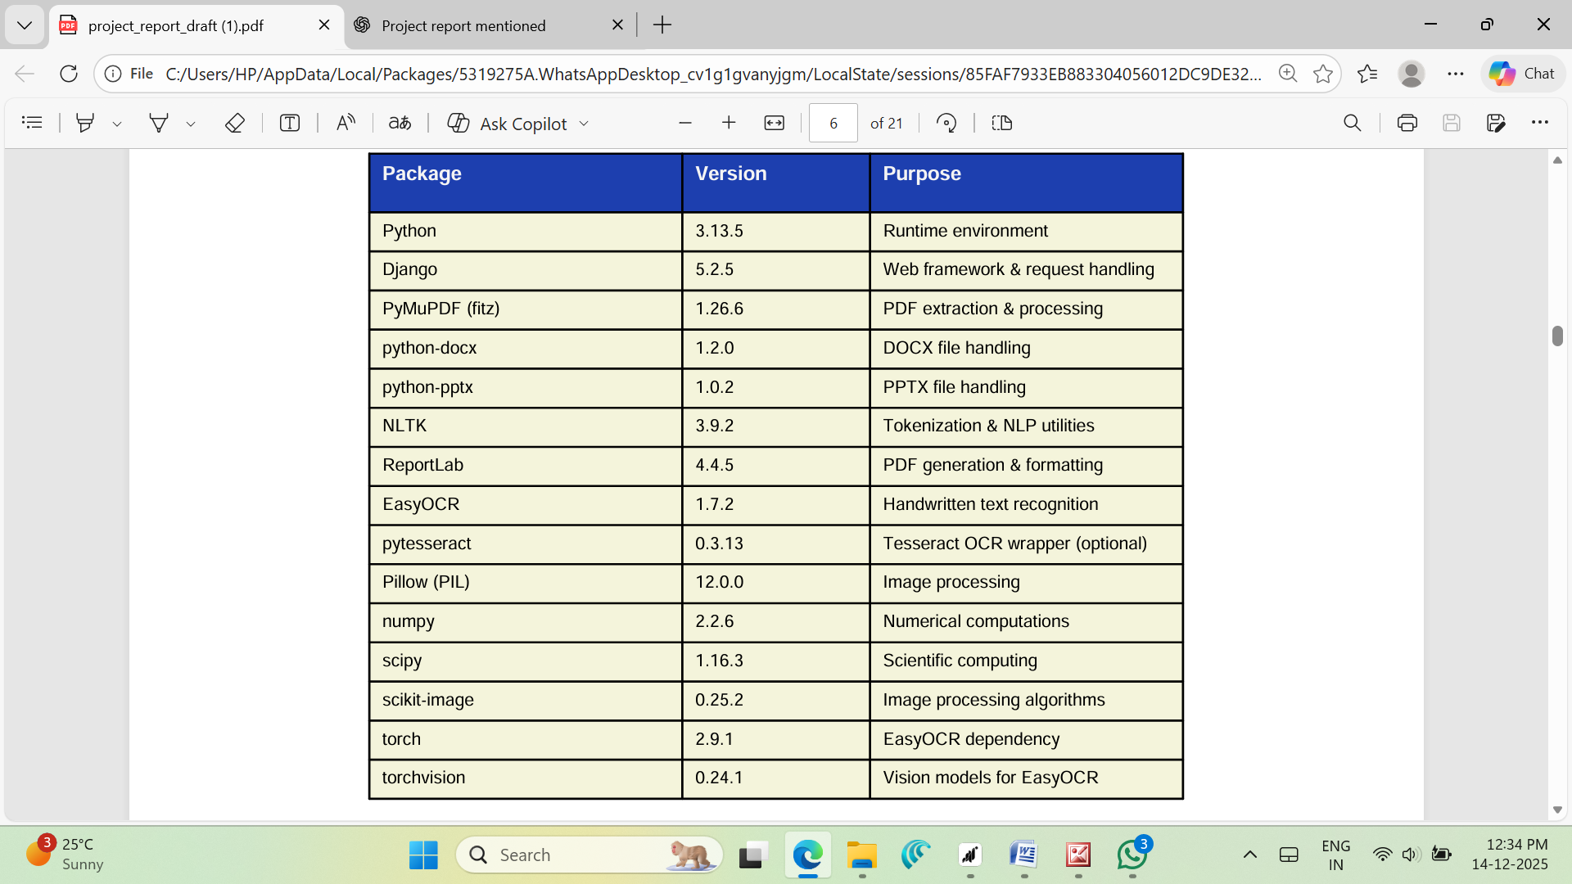

3.3 Installation & Environment Setup
• Tesseract OCR wrapper (optional)
• Image processing libraries for handling scanned documents
• Numerical computation libraries for text analysis and scoring
• Scientific computing tools for efficient data processing
• Image processing algorithms for OCR pre-processing
• EasyOCR dependency for handwritten text recognition
• Vision models required by EasyOCR for deep learning inference
• Virtual environment tools (venv) for dependency isolation
• Package manager (pip) for installing Python libraries
• Database drivers for SQLite and optional production databases
• GPU drivers and CUDA toolkit (optional) for accelerated OCR
Clone the project repository and navigate to the project directory to begin setup. A Python virtual environment is created using venv to isolate project dependencies and avoid version conflicts. After activating the virtual environment, all required libraries are installed using pip based on the project’s requirements file. The application uses Django’s built-in SQLite database for development and testing purposes due to its simplicity and ease of configuration.
For production deployment, more scalable databases such as PostgreSQL or MySQL are recommended to handle larger workloads and concurrent users. Installation of the Tesseract OCR engine is optional but strongly recommended to enable fallback OCR support through pytesseract. Proper environment setup ensures stable performance, easier maintenance, and smoother deployment across different operating systems.

4. Architecture & System Design

4.1 System Overview
The Document Summarizer is designed based on a classical three-tier architecture, which separates the system into the Presentation Layer, Application Layer, and Data Layer. This architecture provides a clear modular structure, enhancing maintainability, scalability, and ease of development. By isolating concerns into distinct layers, each component can be independently developed, tested, and maintained, allowing for more efficient troubleshooting, updates, and feature enhancements. The three-tier design also facilitates clear communication interfaces between layers, ensuring that each module interacts with others in a well-defined and organized manner.
The Presentation Layer forms the user-facing part of the system and is implemented using HTML, CSS, and JavaScript, providing a responsive and interactive web interface. This layer allows users to easily upload documents, configure summarization settings, and download the resulting summaries. Features such as drag-and-drop file uploads, progress indicators, and visual feedback enhance usability, making the system accessible to both technical and non-technical users. The presentation layer does not directly handle any business logic or data storage, which ensures that the interface remains lightweight, responsive, and easily adaptable to changes in design or user experience requirements.
The Application Layer acts as the core of the system, handling all business logic, document processing workflows, and request management. Built using the Django web framework, this layer orchestrates the sequence of operations necessary to process each uploaded document. These operations include document validation, text extraction, optical character recognition (OCR), entity detection, sentence scoring, extractive summarization, and PDF generation. The application layer ensures that each step in the processing pipeline executes correctly and efficiently, while also managing error handling, logging, and system-level configurations. By centralizing all processing logic in this layer, the system can maintain consistent behavior and performance across different document types and formats.
The Data Layer is responsible for persistent storage and document management. It uses an SQLite database for storing metadata, user information, and processing records, while uploaded and processed documents are stored in a dedicated file storage system. This separation of structured data (database) and unstructured data (documents) allows the system to efficiently retrieve, update, and manage files without impacting the performance of the application. Data access is performed through well-defined interfaces, ensuring security, integrity, and controlled access to sensitive documents.

The system processes user-uploaded documents through a structured and modular pipeline, starting with validation to ensure supported file types and sizes, followed by text extraction and OCR for image-based content, summarization using frequency-based and entity-aware scoring, and finally PDF generation with structured sections, headings, and highlighted keywords. Each component in the pipeline is modular, allowing developers to enhance, replace, or optimize individual functionalities without affecting the overall workflow. For example, improvements in OCR accuracy, summarization algorithms, or PDF formatting can be incorporated independently, demonstrating the flexibility and robustness of the three-tier design.
Overall, the three-tier architecture ensures that the Document Summarizer is scalable, maintainable, and efficient, providing a solid foundation for future enhancements such as multilingual support, advanced analytics, or abstractive summarization capabilities, while maintaining reliable performance and a user-friendly experience.
.

4.2 Data Flow Diagram

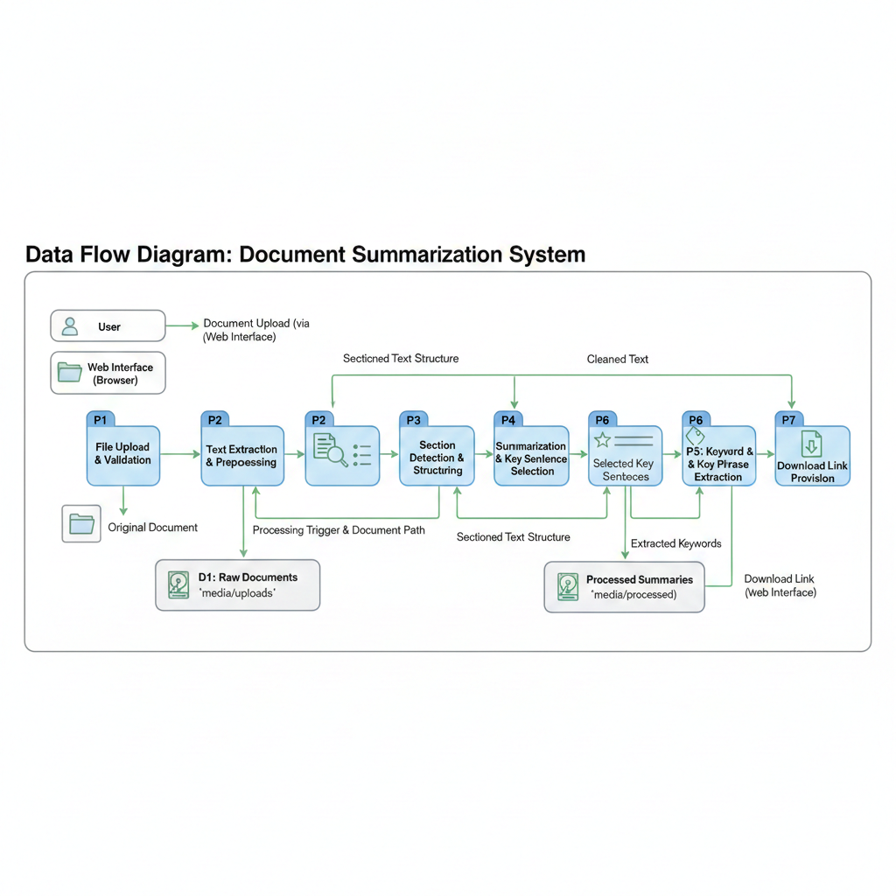
The data flow in the Document Summarizer system follows a well-structured and sequential pipeline, ensuring efficient processing of user-uploaded documents while maintaining accuracy, security, and usability. The process begins when a user interacts with the web interface to upload a document in one of the supported formats, including PDF, DOCX, or PPTX. The user-friendly interface, implemented using HTML, CSS, and JavaScript, provides options for drag-and-drop uploads and visual feedback, allowing users to easily select files for summarization. Once a document is uploaded, the Django view layer performs validation checks to ensure that the file type is supported and the size does not exceed the system constraints. These checks prevent unsupported or excessively large files from entering the processing pipeline, thereby safeguarding system performance and stability. After validation, the document is securely stored in the media/uploads directory, serving as a staging area for subsequent processing.
Following storage, the system’s extraction engine determines the format of the uploaded document and applies the appropriate text extraction method. For PDFs containing embedded text, PyMuPDF is used to extract content directly. For scanned or handwritten documents, OCR engines such as EasyOCR or, as a fallback, pytesseract are employed to recognize and convert image-based text into machine-readable formats. This multi-tiered approach ensures high reliability across different document qualities and formats. Once the raw text is extracted, it undergoes preprocessing, which includes tokenization, lowercasing, stopword removal, and filtering of non-alphabetic tokens. These preprocessing steps normalize the text and prepare it for further analysis.
After preprocessing, section detection is performed to organize the content based on headings. The system identifies headings using multiple heuristics, including all-caps lines, numbered headings, and markdown-style headers, which helps to segment the document into logical sections. This segmentation is essential for producing section-wise summaries, preserving the structure of the original document and enabling users to navigate the summary more efficiently. The summarization algorithm then scores each sentence using a combination of term frequency and entity-based boosting, selecting the most relevant sentences that capture the core information of each section. In parallel, keyword extraction is performed using frequency analysis and regular expressions to identify important terms, dates, numerical values, and named entities. These keywords provide users with a concise overview of the main topics discussed in the document.
Finally, the processed content is rendered into a professionally formatted PDF using the ReportLab library. The PDF maintains a clean layout with green section headings, justified body text, and colored highlights for dates, numbers, and keywords to enhance readability and visual appeal. The completed summary is saved in the media/processed directory, and a download link is provided to the user via the web interface. This data flow ensures that each step—from upload to summarization to PDF generation—is handled in a modular, secure, and efficient manner, enabling users to quickly obtain structured summaries while preserving the integrity and accuracy of the original documents.

  - Component Architecture
- Django Views (core/views.py)
This component handles all incoming HTTP requests from the user interface. It manages file upload validation, invokes the appropriate processing functions, and coordinates the complete document processing pipeline from upload to summary generation and download.
- Extraction Engine (core/utils.py)
The extraction engine is responsible for format-specific text extraction. It detects whether the uploaded file is a PDF, DOCX, or PPTX and applies the corresponding extraction method to retrieve textual content accurately from each format.
- OCR Pipeline (core/utils.py)
This component implements a multi-tier OCR strategy to process scanned and handwritten documents. It uses primary OCR methods and automatically switches to fallback mechanisms when initial extraction results are insufficient, ensuring robust text recognition across varying document qualities.
- Summarization Engine (core/utils.py)
The summarization engine applies a frequency-based extractive summarization algorithm. It intelligently scores sentences and boosts the importance of key entities such as dates, numbers, and proper nouns to preserve critical information in the final summary.
- Section Detector (core/utils.py)
This module analyzes the extracted text to identify document headings using heuristic rules. Based on detected headings, it organizes content into sections and generates section-wise summaries, preserving the original document structure.
- PDF Generator (core/utils.py)
The PDF generator uses the ReportLab library to create professionally styled summary PDFs. It applies consistent formatting, green section headings, highlighted entities, and readable layouts to enhance clarity and presentation quality.
- Web UI (templates/core/upload.html)
The web interface provides a modern and user-friendly experience. It supports drag-and-drop document uploads and allows users to easily download the generated summary PDFs after processing is complete.
- Validation Module
This component ensures that uploaded files comply with system constraints such as supported file types and maximum file size. It prevents invalid or potentially harmful files from entering the processing pipeline.
- Storage Manager
The storage manager organizes and manages uploaded and processed files within the media directory. It maintains a clear separation between raw uploads and generated summaries, simplifying file management and maintenance.
- Logging Module
This module records processing steps, warnings, and errors during execution. Logging supports debugging, performance monitoring, and system auditing, improving overall reliability and maintainability.
- Configuration Handler
The configuration handler manages environment-specific settings such as file paths, OCR parameters, summarization ratios, and security-related options. This enables easy customization and smooth deployment across development and production environments.

PDF Uploading
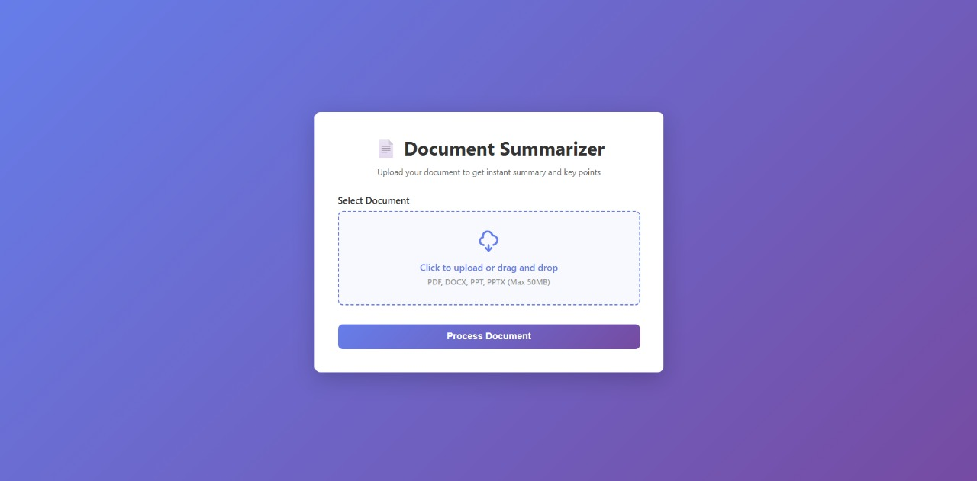

5. File Handling & Data Pipeline
5.1 Supported Document Formats
- PDF (.pdf)
Portable Document Format files are supported using the PyMuPDF library. The system extracts native text directly from digitally created PDFs and converts pages to images when OCR is required, ensuring accurate processing of both text-based and scanned PDFs.
- DOCX (.docx)
Microsoft Word documents are processed using the python-docx library. This allows the system to extract structured content such as paragraphs, headings, and formatted text while preserving the logical flow of the document.
- PPTX (.pptx)
Microsoft PowerPoint presentations are handled using the python-pptx library. Text content is extracted from individual slides, enabling the system to summarize presentation material effectively.
- Scanned PDFs
Image-based or scanned PDFs are automatically detected by the system. When native text extraction is not possible, the document is routed through the OCR pipeline to recognize and extract text from images.
- Mixed-Content Documents
Documents containing both textual content and embedded images are processed using hybrid extraction methods. The system combines direct text extraction with OCR to ensure no important information is missed.
- Multi-page Documents
The system supports documents with a large number of pages or slides. It efficiently processes lengthy files while maintaining performance and summary quality.
- Font and Layout Variations
Diverse fonts, sizes, and layout styles commonly found in professional and academic documents are handled effectively. This ensures consistent extraction across different document designs.
- Section-Based Processing
Extracted content is organized into sections based on detected headings. This structured approach improves summarization quality and helps preserve the original document hierarchy in the final output.

5.2 File Storage & Organization
The Document Summarizer system implements a structured and organized approach to file storage, ensuring both traceability and ease of maintenance. Uploaded documents are stored in the media/uploads directory using their original filenames. Preserving the original filenames provides familiarity for users and allows for easy identification of uploaded files, which is particularly useful in scenarios involving multiple uploads or repeated interactions with the system. Once a document has been processed, the resulting summary PDF is saved in the media/processed directory. To maintain clarity and prevent filename conflicts, a standardized naming convention is employed, such as highlighted_[original_name].pdf. This approach not only distinguishes processed files from raw uploads but also provides immediate context regarding the content and processing status of each file.
Beyond basic storage, the system manages metadata related to each processing job. The database tracks information including the file name, upload time, processing status, and output location. This structured metadata facilitates efficient retrieval, reporting, and auditing of system operations. In addition to automatic storage, the system provides options for manual file deletion, allowing users or administrators to remove documents that are no longer needed. To maintain optimal disk usage, automated cleanup tasks can be scheduled to periodically purge older or unused files. Furthermore, storage quotas are enforced to prevent disk space exhaustion and to ensure that the system continues to operate efficiently, even under heavy usage. Proper organization of uploaded and processed files not only simplifies ongoing maintenance but also supports the scalability of the application, making it easier to introduce new features or expand system capacity in the future.
5.3 Error Handling & Validation
Robust error handling and validation mechanisms are integral to maintaining system reliability and ensuring a positive user experience. The system implements file size validation to prevent extremely large documents from being processed, which could otherwise lead to memory overflows or degraded performance. Similarly, file type validation restricts uploads to supported formats such as PDF, DOCX, and PPTX, ensuring that the system only processes documents it is designed to handle. When an error occurs, whether due to invalid input or processing failures, user-friendly error messages are displayed. These messages provide clear guidance to users while avoiding exposure of sensitive system information, thereby maintaining security and transparency.
The system’s multi-tier OCR pipeline acts as a key fallback mechanism, improving robustness and reliability. If the primary text extraction method fails—such as PyMuPDF for PDFs or EasyOCR for scanned documents—the system automatically switches to alternative extraction methods like pytesseract, ensuring that processing can continue without interruption. Additionally, the system maintains comprehensive log files to record processing errors, warnings, and execution details. These logs serve multiple purposes: they facilitate debugging, allow system administrators to monitor performance, and provide insights for future optimizations. By combining proactive validation with structured error handling and fallback strategies, the system minimizes failures, ensures consistent operation, and enhances the overall user experience, making the summarization workflow reliable and seamless.
Collectively, the file storage, organization, and error management mechanisms of the system provide a robust foundation for scalability, maintenance, and operational reliability. They ensure that documents are stored securely and consistently, processing workflows are resilient to errors, and users can interact with the system confidently, knowing that their data is handled carefully and that errors are managed gracefully. These design considerations are critical for the practical deployment of the system in real-world environments, where stability, reliability, and maintainability are paramount.
6. Text Extraction from Multiple Formats
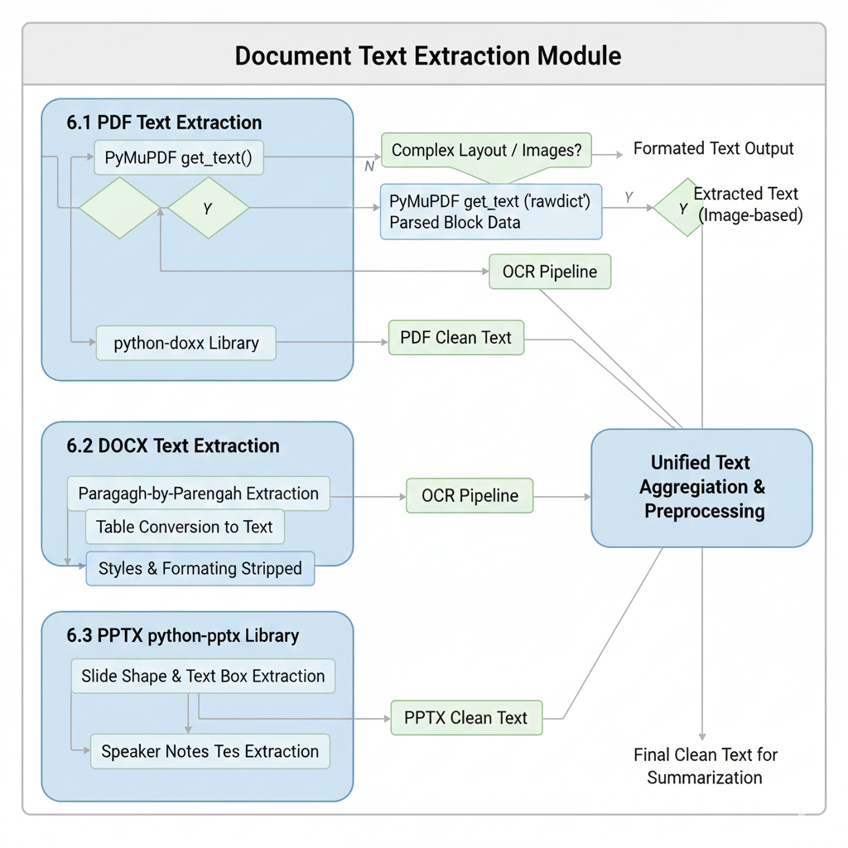

6.1 PDF Text Extraction
PDF text extraction in the system is primarily performed using PyMuPDF’s get_text() method, which efficiently retrieves textual content from PDF documents. This method preserves important formatting features such as line breaks, spacing, and paragraph structure, allowing the extracted text to closely resemble the original document. Maintaining this structural information is essential for accurate preprocessing, section detection, and summarization in later stages of the pipeline.
For PDF files that contain complex layouts, such as multi-column text, tables, or embedded images, the system employs advanced extraction techniques to improve accuracy. The get_text('rawdict') method is used to obtain structured, block-level information, including text positions and layout metadata. This structured representation enables better parsing of complex document structures and helps in correctly reconstructing the logical reading order of the content.
In scenarios where standard text extraction yields little or no readable text, the system automatically classifies the PDF as image-heavy or scanned. Such documents are then routed through the OCR pipeline, where text is extracted directly from images using optical character recognition technologies. This adaptive strategy ensures that both digitally generated PDFs and scanned or image-based documents are processed reliably. By dynamically selecting the most suitable extraction method, the system achieves consistent and accurate text extraction across a wide range of PDF formats and quality levels, forming a strong foundation for subsequent summarization and analysis tasks.

6.2 DOCX Text Extraction
DOCX text extraction in the system is carried out using the python-docx library, which provides direct programmatic access to the internal structure of Microsoft Word documents. The library allows text to be extracted in a paragraph-by-paragraph manner, helping to preserve logical paragraph boundaries, sentence flow, and overall document structure. This structured extraction is important for maintaining contextual relationships between sentences, which directly improves the quality of summarization and section detection.
In addition to paragraphs, tables embedded within DOCX files are also processed. Table contents are converted into a textual representation so that valuable information stored in rows and columns is not ignored during summarization. This ensures that key data, figures, or descriptive content contained within tables contributes to the final summary.
Although python-docx allows access to formatting details such as font styles, sizes, and alignment, the system intentionally converts most content into plain text before further processing. This design choice simplifies the summarization pipeline, reduces computational complexity, and ensures consistent handling across different document types. By focusing on semantic content rather than visual styling, the system achieves reliable and efficient text extraction from DOCX files while preserving essential meaning and structure for downstream analysis.
6.3 PPTX Text Extraction
PPTX text extraction in the system is performed using the python-pptx library, which enables direct access to the internal elements of Microsoft PowerPoint presentations. The system extracts text from various slide components, including shapes, text boxes, and placeholders, ensuring that all visible textual content on each slide is captured accurately. This comprehensive extraction approach prevents the loss of important information such as titles, bullet points, and explanatory text commonly used in presentations.
To maintain the logical structure of the presentation, the extracted text from each slide is treated as a separate section during summarization. This slide-wise organization helps preserve the natural flow and progression of ideas across the presentation. Additionally, if speaker notes are available, they can also be extracted and included to provide deeper context and supporting explanations that may not appear directly on the slides.
After processing individual slides, the system aggregates text from all slides to generate an overall summary of the presentation. This ensures that both high-level themes and detailed points are represented in the final output. By combining slide-level summarization with document-wide aggregation, the system delivers a comprehensive and structured summary of PPTX files, making presentation content easier to review and understand.

7. OCR & Handwritten Document Support

7.1 Multi-Tiered OCR Pipeline
The system uses a multi-tiered OCR pipeline to ensure accurate and reliable text extraction from documents that contain typed, scanned, or handwritten content. Instead of relying on a single OCR method, the system applies multiple extraction techniques in a sequential manner. This layered approach improves robustness and allows the system to handle documents with varying quality, layouts, and content types.
In the first tier, PyMuPDF Native Extraction is used to perform standard text extraction through the get_text() method. This method is fast and highly efficient for digitally generated PDFs that contain selectable text. However, if the document is image-only or scanned, this tier returns little or no text, indicating the need for OCR-based processing.
The second tier uses PyMuPDF RawDict Parsing, which extracts structured block-level data from PDFs. This method is useful for documents with mixed content, such as text combined with images or complex layouts. By analyzing block information, the system can recover text that may be missed by basic extraction techniques.
When the first two tiers fail to produce sufficient results, the system moves to EasyOCR, which serves as the primary OCR engine. EasyOCR is a deep learning–based OCR library that converts each PDF page into an image using a pixmap and then processes it through trained neural models. This tier provides excellent accuracy for handwritten text and low-quality scanned documents, although it requires more processing time and computational resources.
As a final fallback, pytesseract is used as an alternative OCR solution. It is a lightweight wrapper around the open-source Tesseract OCR engine and requires system-level installation. While it may offer lower accuracy compared to EasyOCR for handwritten text, it provides a reliable backup mechanism to ensure that text extraction is attempted even in challenging cases.
Overall, this multi-tiered OCR strategy ensures maximum coverage, improved accuracy, and dependable performance across diverse document types and quality levels.

7.2 EasyOCR Implementation Details
EasyOCR is integrated into the system in a way that ensures both stability and efficiency during execution. The library is lazy-loaded, meaning it is imported only when OCR processing is actually required. This approach helps avoid import-time errors related to heavy dependencies such as Torch and CUDA, and also reduces initial application startup time when OCR is not needed.
The EasyOCR reader is initialized only once with English language support to maintain consistency and reduce repeated overhead. GPU support is deliberately disabled by default to ensure wider compatibility across systems that may not have dedicated graphics hardware. Before OCR processing begins, each document page is converted into an image and then transformed into PIL (Python Imaging Library) format, which is compatible with the EasyOCR processing pipeline.
After text recognition, the OCR results are filtered using a confidence score threshold of 0.5. This filtering step removes low-confidence detections, improving the overall accuracy and readability of the extracted text. During the first execution, EasyOCR automatically downloads its required pre-trained models, which are approximately 100MB in size. This initial download may take several minutes depending on internet speed, but it occurs only once and is cached for subsequent runs, ensuring smoother and faster OCR performance thereafter.

7.3 OCR Quality & Limitations
The accuracy of Optical Character Recognition in the system is influenced by several external and document-specific factors. Image resolution plays a crucial role, as low-resolution scans often lack the detail required for accurate character recognition. Documents scanned at a resolution below 150 DPI may produce incomplete or inaccurate OCR results due to blurred or pixelated text.
Image contrast and lighting conditions also affect OCR performance. Poor contrast between text and background, uneven lighting, or shadows in scanned documents can reduce recognition accuracy. Handwriting clarity is another important factor; cursive or highly stylized handwriting is more difficult for OCR engines to interpret compared to clean, printed text, leading to a higher probability of recognition errors.
Documents containing mixed languages or multiple writing styles within the same page may further reduce OCR accuracy, especially if the OCR model is optimized for a single language. To address reliability concerns, the system generates confidence scores for extracted text segments. These scores can be used to identify uncertain or unreliable extractions, allowing users or developers to flag, review, or reprocess low-confidence OCR results for improved accuracy.

8. Summarization Algorithm & Implementation
8.1 Extractive Summarization Overview
The Document Summarizer system employs an extractive summarization approach, a widely adopted technique in automatic text summarization. Extractive summarization works by selecting the most important sentences directly from the original document to create a concise, informative summary. Unlike abstractive summarization, which generates new sentences or rephrases content using advanced natural language generation models, extractive summarization preserves the original wording of sentences. This ensures that the factual accuracy and meaning of the content remain intact, making it particularly suitable for documents where precision and terminology are critical, such as scientific research papers, legal documents, technical manuals, and corporate reports. By retaining exact sentences, extractive summarization avoids introducing potential errors or ambiguities that may arise from rephrased or synthesized content.
The algorithm used in this system is deterministic, which means it produces consistent results for the same input each time it is executed. This predictability is important in professional and academic settings where reproducibility and reliability are required. Additionally, the system is designed to run offline without depending on external APIs or large-scale language models. This makes the summarization process faster and more resource-efficient, allowing it to operate on devices with limited computational capacity or be integrated seamlessly into larger software systems without introducing significant overhead.
The extractive summarization process works by analyzing sentence importance through measurable criteria. Key metrics used for scoring sentences include word frequency, sentence position, and the presence of relevant keywords or named entities. Sentences containing frequently occurring terms, domain-specific keywords, or entities such as dates and proper nouns are considered more important. Sentence position is also taken into account, as introductory or concluding sentences often contain essential information in structured documents. Each sentence is assigned a score based on these factors, and the top-ranking sentences are selected to form the final summary. By combining multiple metrics, the system ensures that the selected sentences effectively capture the core information of the document.
The computational simplicity of extractive summarization is another advantage. Since it relies on deterministic scoring and selection mechanisms rather than deep neural networks or large pretrained models, it requires minimal processing power and memory resources. This allows the system to handle a wide range of document sizes and types efficiently, from short reports to lengthy academic papers. Furthermore, its lightweight nature makes it suitable for offline applications, enabling organizations or individuals to process sensitive documents securely without uploading them to cloud services.
Overall, extractive summarization offers a balanced combination of accuracy, reliability, and efficiency. It ensures that key information is captured in a concise format while maintaining the integrity of the original text. The approach is particularly valuable for practical applications where precision and interpretability are critical, and computational resources may be limited. By focusing on measurable sentence importance and retaining the original wording, the system provides a robust, consistent, and practical solution for automated document summarization, capable of meeting the needs of diverse professional and academic environments.

8.2 Algorithm Steps
Step 1: Tokenization
- The text is first split into sentences using NLTK's sent_tokenize() function.
- Each sentence is then further split into words using word_tokenize().
- Tokenization allows the algorithm to process the text at both the sentence and word levels, which is essential for scoring and analysis.
- This step ensures that punctuation, special characters, and sentence boundaries are correctly handled.
Step 2: Preprocessing
- All words are converted to lowercase to maintain consistency.
- Stopwords (common words like "and", "the", "is") are removed as they do not contribute to sentence importance.
- Non-alphabetic tokens (numbers, punctuation, symbols) are excluded unless specifically needed for scoring.
- Preprocessing cleans the text, reducing noise and improving the accuracy of frequency and scoring calculations.
Step 3: Frequency Analysis
- A word frequency counter is created for the entire document.
- Frequent words indicate the main topics and important terms in the text.
- This step helps in identifying which sentences carry significant content based on word occurrence.

Step 4: Sentence Scoring
- Each sentence is assigned a base score calculated as the sum of the frequencies of its constituent words.
- Higher-scoring sentences are likely to contain more important information.
- This approach prioritizes content-rich sentences while ignoring trivial or redundant ones.
Step 5: Entity Boosting
- Additional points are added to sentence scores to emphasize important entities:
  - +50 for dates
  - +20 for numbers
  - +15 for proper nouns
- Entity boosting ensures that sentences containing critical information such as events, statistics, or names are more likely to be included in the summary.

Step 6: Selection
- Top N sentences are selected based on their scores.
- N is calculated as: max(int(total_sentences * ratio), min_sentences)
- This step ensures that the summary is concise but still contains enough information to represent the original text effectively.
Step 7: Assembly
- selected sentences are returned in the original document order to maintain context and readability.
- The final summary preserves the logical flow of the original text while significantly The reducing length.
- This structured approach allows the system to create accurate and coherent summaries consistently.

8.3 Parameters & Configuration
The summarization system allows customization through several key parameters that influence the quality, length, and relevance of the generated summaries. Proper configuration ensures that the summaries are concise yet informative, and adaptable to different types of documents.
- ratio = 0.35 – This parameter retains 35% of the original sentences in the summary. It strikes a balance between brevity and informativeness, ensuring that the most important content is preserved without making the summary too long. Adjusting the ratio can either condense the summary further (lower ratio) or include more content (higher ratio) based on user requirements.
- min_sentences = 3 – This ensures that the summary contains a minimum of 3 sentences, even for very short documents. This prevents generating trivially short summaries that might omit crucial information. It also guarantees that the summary has a coherent structure and sufficient context for understanding.
- Stopwords Removal – The system uses NLTK’s English stopwords list to filter out common words like "the", "is", "and", etc., which do not contribute to the overall meaning of the text. Removing stopwords reduces noise and ensures that the sentence scoring focuses on content-rich words. This improves the accuracy of the frequency analysis and the selection of important sentences.
- Additional Considerations – Depending on the document type, other parameters such as entity boosting values (for dates, numbers, proper nouns) and sentence selection ratio can be tuned to optimize performance. These parameters allow the summarizer to emphasize specific types of information that are critical for the context, such as statistics in reports or names and dates in news articles.

9. Section Detection & Heading-Based Summaries
9.1 Heading Detection Heuristics
The system uses heading detection heuristics to identify the structure of a document and divide it into meaningful sections. Detecting headings accurately allows the summarization system to generate section-wise summaries, which helps in preserving the context and logical flow of the document. The system applies multiple patterns to detect headings:
- Pattern 1: ALL CAPS Lines – Lines written entirely in uppercase letters are assumed to be headings. For example, a line like ‘INTRODUCTION’ would trigger the creation of a new section. This pattern is effective for documents that follow traditional formatting rules, such as reports, manuals, or academic papers.
- Pattern 2: Numbered Headings – Lines starting with a digit followed by a period or parenthesis are considered section headings. Examples include ‘1. Introduction’ or ‘2) Methods’. This heuristic captures structured documents that use numbered outlines or lists to organize content, which is common in scientific and technical writing.
- Pattern 3: Markdown Headers – Lines beginning with # symbols are interpreted as headers in markdown-formatted documents. For instance, ‘## Section Title’ denotes a subheading under the main header. This method is particularly useful for web-based documents, notes, or software documentation that uses markdown formatting.
Once a heading is detected, it triggers the formation of a new section. The text between consecutive headings is aggregated as the section content, which can later be summarized independently. This approach ensures that each section summary focuses on its respective topic, preserving both context and hierarchy within the document. By leveraging multiple heuristics, the system achieves robust heading detection, capable of handling different document styles, including formal reports, markdown notes, and structured outlines.

9.2 Per-Section Summarization
Once the document sections are identified using the heading detection heuristics, each section is summarized independently using the extractive summarization algorithm. This ensures that the context and main points of each section are preserved, rather than producing a single generic summary for the entire document. By handling sections individually, the system can provide more accurate and focused summaries, capturing the essence of each topic.
- Each section’s summary appears in the output PDF immediately after its corresponding heading. The headings are formatted to appear GREEN and BOLD, making it easy for readers to navigate through the document and distinguish sections at a glance.
- The extractive summarization algorithm considers word frequencies, entity boosting, and sentence scoring within the scope of the section, rather than the entire document. This localized scoring ensures that important points within smaller sections are not overlooked, even if they are less frequent in the overall document.
- This method is particularly useful for structured documents such as reports, theses, research papers, technical manuals, or academic assignments, where maintaining the hierarchy and context of each section is crucial.
- Per-section summarization also facilitates modular reading, allowing users to quickly access summaries of specific sections without having to read the full document. This improves usability for large documents, enabling faster comprehension and decision-making.
- Additionally, this approach helps in generating consistent formatting and readability in the final summarized document. Each section maintains its original structure while reducing verbosity, which enhances clarity for the reader.

9.3 Limitations & Edge Cases
While the Document Summarizer provides robust section detection and per-section summarization, several limitations and edge cases must be acknowledged to understand the system’s boundaries and areas for improvement. One limitation arises with short sections: if a section contains fewer than three sentences, the system outputs the entire section due to the minimum sentence constraint. This ensures that very short sections are not underrepresented, but it may result in summaries that are slightly longer than necessary for small sections. Another challenge occurs with documents that lack detectable headings. If the text does not match any of the predefined heading patterns—such as ALL CAPS lines, numbered headings, or markdown-style headers—the system defaults to whole-document summarization. Although this produces a usable summary, it fails to maintain the original document’s section-wise structure and hierarchy, which may reduce readability and organization.
Inconsistent heading formatting is another limitation. Documents with mixed capitalization, irregular styles, or unconventional heading patterns may cause the system to miss certain headings, resulting in merged or skipped sections in the final summary. Similarly, the system does not currently support multi-line headings; only the first line is recognized as a heading, which can affect section segmentation and the completeness of the summary. Other potential edge cases include documents containing embedded images, tables, or non-text elements. Since the current summarization approach is primarily text-based, these elements are ignored, which may reduce the informativeness of summaries for content-heavy technical or visually rich documents.
Despite these constraints, the system is designed to handle the majority of structured and semi-structured documents effectively. The inclusion of fallback mechanisms, minimum sentence enforcement, and robust text processing ensures that summaries remain informative and coherent even when ideal conditions are not present. Future enhancements could address these limitations by incorporating support for multi-line headings, improved detection for irregular heading formats, and context-aware algorithms capable of processing more complex document structures, tables, and embedded visuals. These improvements would further enhance the system’s adaptability and effectiveness across a wider range of documents.

- Short Sections: Sections with fewer than three sentences are fully output due to min_sentences enforcement. Ensures completeness but may slightly lengthen summaries.
- Documents Without Detectable Headings: Defaults to whole-document summarization if no headings match predefined patterns. Section granularity is lost.
- Inconsistent Heading Formatting: Mixed capitalization, unusual punctuation, or unconventional styles may cause some headings to be missed.
- Multi-line Headings: Only the first line of multi-line headings is detected, which can affect section segmentation accuracy.
- Non-text Elements: Images, tables, and embedded media are ignored, which may reduce summary quality for content-heavy or technical documents.
- System Robustness: Fallback mechanisms and minimum sentence constraints maintain informative and coherent summaries despite edge cases.
- Future Improvements: Include support for multi-line headings, better handling of irregular formats, and context-aware algorithms for complex document structures.
10. PDF Generation & Styling
10.1 ReportLab Framework
The system leverages ReportLab, a powerful Python library designed for programmatic PDF generation. ReportLab allows developers to create well-formatted, professional-quality PDF documents directly from Python code without relying on external tools or manual editing.
- The system specifically uses ReportLab’s Platypus layout engine, which provides high-level abstractions for building documents. Platypus simplifies complex tasks such as text flow management, page breaks, and element positioning, allowing developers to focus on content rather than low-level formatting.
- SimpleDocTemplate is used to manage page setup, including margins, page size, and automatic page breaks. This ensures that the generated PDF maintains consistent formatting and readability across multiple pages.
- Paragraph objects handle text wrapping, alignment, font styles, and other typographic features. This allows headings, summaries, and section text to be displayed clearly and attractively. For example, section headings can be displayed in bold and green, while body text remains standard, improving visual hierarchy and readability.
- Tables are supported for tabular data, which is useful for reports containing statistical information, comparison charts, or structured lists. Tables can be styled with borders, shading, and alignment options to maintain a professional appearance.
- Using ReportLab, the system can assemble complex documents that include multiple sections, headings, summaries, and optional images or tables. The approach ensures that the final output is print-ready and suitable for academic, professional, or presentation purposes.
- Additionally, ReportLab’s flexibility allows for custom styling and branding, such as adding logos, page numbers, headers/footers, and custom fonts, providing a polished, publication-quality PDF output.

10.2 Styling & Visual Design
- Title – Displayed in 20pt, bold, blue (#1e40af) to immediately capture attention and clearly indicate the document’s main subject.
- Subtitle – Shown in 10pt, light gray, italic, providing secondary context without overpowering the main title.
- Section Headings – Rendered in 13pt, bold, GREEN (#16a34a) to make sections easily scannable and distinguishable. This enhances navigation and readability, especially in multi-section documents.
- Body Text – Standard content is displayed in 11pt, with justified alignment and 18pt line height to optimize readability and prevent visual clutter. This ensures a smooth reading experience across pages.
- Highlights – Important entities are color-coded for emphasis: dates in RED (#dc2626) and numbers in ORANGE (#ea580c). This makes key information stand out for faster comprehension.
- Footer – Includes page numbers or additional metadata in 8pt, gray, centered style, maintaining a professional look without distracting from the main content.

10.3 Error Handling & Fallbacks
To ensure robustness, the system includes error handling and fallback mechanisms for potential issues during PDF generation:
- Paragraph Rendering Failures – If a paragraph fails to render due to problematic HTML tags or unsupported formatting, the system strips the HTML and falls back to plain text. This prevents errors from breaking the document creation process.
- Full Document Build Failures – If the entire PDF build fails for any reason, the system generates a minimal fallback PDF containing only the document title and plain text summary. This guarantees that users always receive a usable output, even under error conditions.
- These mechanisms maintain reliability and user trust, ensuring that the system provides consistent results without abrupt failures.
- Additional logging can be incorporated to record the cause of failures, enabling future improvements and debugging while maintaining uninterrupted service for end users.

11. Keyword Extraction & Entity Detection
11.1 Frequency-Based Keyword Extraction
The system incorporates keyword extraction to identify the most important and frequently discussed concepts within a document. This process enhances the overall summarization by highlighting key terms that represent the core content.
- The system uses a term frequency-based approach to identify keywords. After the text is tokenized, it is lowercased and filtered to remove stopwords such as "the", "is", "and", etc., which do not contribute meaningfully to content analysis.
- A word count is maintained for the entire document, tallying how many times each term occurs. Words with higher frequency are considered more relevant to the document’s main topics.
- The system then selects the top N keywords (default N=10), representing the most-discussed concepts. These keywords provide a concise overview of the document’s subject matter, which is particularly useful for indexing, search optimization, or highlighting important content for readers.
- Frequency-based extraction is simple yet effective, especially for documents where key terms are repeated frequently. It also allows users to quickly grasp the main topics without reading the full text.
- This method can be combined with entity detection to enhance insight. For example, important names, dates, locations, or numerical data can be identified and prioritized alongside high-frequency keywords, providing a more comprehensive understanding of the document.
11.2 Entity Detection via Regex
Date Detection: Match DD/MM/YYYY, DD-MM-YYYY, YYYY, Month Year formats.
- Place Detection: Capitalized multi-word sequences (e.g., ‘New York’) as locations.
- Name Detection: Capitalized sequences (e.g., ‘John Smith’) as person names.
- Detected entities are boosted during sentence scoring to appear in summaries.
- Regex-based detection is lightweight and offline-friendly, suitable for most structured documents.

11.3 Keyword Display in Output
In the system, extracted keywords are presented in a dedicated “Key Points” section at the end of the summary PDF. This section serves as a quick reference for readers, allowing them to grasp the main themes and important concepts of the document without having to read the entire summary. The keywords are derived from both frequency-based analysis and entity detection, ensuring comprehensive coverage of the most relevant terms, including high-frequency words, important dates, names, and locations. By combining these two methods, the system highlights not only the most-discussed topics but also the critical entities that provide context and meaning. This approach enhances the usability of the summary, enabling readers to quickly identify the document’s core content, important events, key people, and locations. Overall, the “Key Points” section makes the summarized PDF more informative and reader-friendly, especially for large documents where skimming for essential information is often necessary.

12. Security & Data Privacy
12.1 File Upload Security
The system implements strict file upload security measures to ensure that only safe and valid documents are processed. Uploaded files are validated by type, allowing only PDF, DOCX, and PPTX formats, and size restrictions are enforced to prevent excessively large files from being uploaded. To enhance security, all files are stored in a dedicated media/uploads directory outside the web root, which prevents direct access through the web server and minimizes the risk of unauthorized file execution. Additionally, filename sanitization is performed to remove any potentially harmful characters or patterns, effectively preventing directory traversal attacks and other common file-based exploits. For production deployments, it is highly recommended to integrate virus scanning tools to detect and block any malicious content before it is processed by the system. These measures collectively ensure that the file upload feature is secure, reliable, and safe for handling sensitive user documents.

12.2 Data Privacy Considerations
The system is designed with strong data privacy principles in mind. All document processing occurs locally on the server or user’s machine, without uploading files to external cloud services. This ensures that sensitive information remains under the control of the user or organization. To further protect data, uploaded files are automatically deleted after processing or immediately upon user request, minimizing the risk of unauthorized access. For highly sensitive documents, such as medical, legal, or financial records, additional safeguards like access controls and encryption are recommended to ensure that only authorized personnel can view or process the files. By maintaining local processing and secure deletion protocols, the system reduces exposure to potential data breaches and reinforces user trust.
12.3 Recommendations
To enhance security and privacy further, several best practices and recommendations are suggested. All communications should be encrypted using HTTPS, ensuring data in transit is secure. Implementing user authentication and authorization ensures that only authorized users can upload, view, or process documents. Comprehensive logging of file access and processing activities is recommended for audit trails and compliance purposes. For users in the European Union, adherence to GDPR requirements should be considered, including proper consent and data handling procedures. Additionally, data retention policies should be enforced, with automatic cleanup of old or processed files to maintain minimal storage of sensitive information. Collectively, these recommendations provide a robust framework for maintaining security, privacy, and regulatory compliance within the document summarization system.

13. Testing & Validation
13.1 Unit Testing
The system emphasizes rigorous unit testing to ensure the reliability and correctness of its core functionalities. Unit tests are designed to cover critical components, including text extraction accuracy, summarization quality, keyword extraction, section detection, and PDF generation. A variety of test inputs are employed to evaluate system performance across different scenarios. These include small documents to verify basic functionality, large documents to assess scalability and performance, documents with no headings to test fallback mechanisms, mixed-format documents to ensure compatibility with varying file structures, and image-heavy PDFs to validate OCR and content extraction processes. By thoroughly testing these components, the system can detect and correct errors early, maintain consistent output quality, and ensure that the summarization process remains reliable across diverse document types and formats.

13.2 Integration Testing
The system undergoes comprehensive integration testing to ensure that all components work seamlessly together in an end-to-end workflow. Tests simulate real-world usage, starting from file upload via the web interface, followed by document processing, PDF generation, and finally downloading the output. Various file formats and sizes are tested to verify compatibility and performance under different conditions. Integration testing also evaluates the system’s error handling mechanisms, ensuring that invalid inputs, unsupported file types, or corrupted documents are gracefully managed without disrupting the workflow. This process ensures that all modules—upload, processing, summarization, and output—function cohesively and reliably in a production-like environment.
13.3 Quality Evaluation
To maintain high standards, the quality of summarization is systematically evaluated using both automated and manual methods. Human review is conducted to verify that the summaries preserve the key facts, main ideas, and logical flow of the original document. Additionally, checks are performed to ensure that critical entities such as dates, numbers, and proper nouns are correctly included in the summaries. For documents containing images or scanned text, OCR accuracy is measured by comparing the extracted text with a ground truth, and calculating metrics such as Word Error Rate (WER). These evaluations provide quantitative and qualitative feedback, enabling continuous refinement of the system to produce summaries that are both informative and reliable across different document types and formats.
14. Performance Metrics & Optimization
14.1 Processing Time Analysis
The system’s performance has been analyzed to provide insights into processing time for different document types and sizes. For a typical typed PDF of around 10 pages, text extraction is highly efficient, taking approximately 2–3 seconds. However, documents requiring OCR, such as handwritten PDFs of 5 pages, take significantly longer, around 30–60 seconds, due to the additional time needed for EasyOCR model loading and text recognition. For DOCX or PPTX files of comparable size, processing is relatively fast, taking 1–2 seconds, since these formats allow direct extraction of textual content without the need for OCR. It is important to note that OCR is the primary bottleneck in the system, with the initial EasyOCR model download (~100MB) occurring only on the first run, which can take several minutes. Once the model is loaded, subsequent OCR operations are much faster. Understanding these processing times helps in optimizing workflow, managing user expectations, and identifying areas where further performance improvements can be applied, such as model caching or parallel processing for large or OCR-heavy documents.
14.2 Optimization Strategies
To improve the system’s performance and efficiency, several optimization strategies have been implemented. Caching is employed to store the EasyOCR model after the first download, preventing repeated downloads and significantly reducing initialization time for OCR-heavy documents. Similarly, NLTK data is cached to speed up text processing tasks. Batching allows multiple pages to be processed in parallel, leveraging multi-threading for I/O-bound operations and reducing overall processing time for large documents. Where available, GPU acceleration can be utilized by running EasyOCR on the GPU (using gpu=True during reader initialization), providing substantial speedups for OCR tasks. Additionally, lazy loading defers the import of EasyOCR until it is actually needed, minimizing startup time and conserving system resources during the processing of non-OCR documents. Collectively, these strategies enhance system responsiveness, reduce delays for users, and make the summarization pipeline more scalable and efficient for documents of varying sizes and formats.
14.3 Memory Considerations
Processing large documents, such as PDFs exceeding 100 pages, can consume a significant amount of system memory. Memory usage typically scales to approximately 2–3 times the file size, accounting for the original document, extracted text, and intermediate data structures used during summarization and PDF generation. For very large documents, this can lead to high memory consumption and potential slowdowns or system instability. To mitigate these issues, streaming or chunk-based processing is recommended, where the document is processed in smaller segments rather than loading the entire file into memory at once. This approach not only reduces memory overhead but also enables more efficient handling of large-scale documents while maintaining processing speed and system stability. Careful memory management is therefore critical to ensure that the system remains responsive and scalable when dealing with extensive documents, especially in production environments.
15. Deployment & Maintenance
15.1 Development Deployment
For development purposes, the system is deployed using Django’s built-in development server by running the command python manage.py runserver. This setup provides a simple and convenient environment for testing and debugging the application locally. The SQLite database is used during development, as it is lightweight, easy to configure, and sufficient for testing functionality without the overhead of a full-scale database server. Static files, such as CSS, JavaScript, and images, are served using Django’s built-in static file handler, allowing developers to quickly observe changes in styles and scripts without additional configuration. This development deployment approach facilitates rapid iteration, troubleshooting, and testing of new features in a controlled environment before moving to production.

15.2 Production Deployment
For production deployment, the system requires a robust and secure setup to ensure reliability, scalability, and data protection. Unlike the development environment, which uses Django’s built-in server, production deployment should utilize a production-grade WSGI server such as Gunicorn or uWSGI. These servers efficiently handle multiple concurrent requests and provide better performance under load.
The database should also be upgraded from SQLite to a full-fledged relational database like PostgreSQL or MySQL, which can manage larger datasets, support concurrent access, and ensure data integrity for multiple users. To enhance performance and security, Nginx can be configured as a reverse proxy, handling incoming HTTP requests, serving static files efficiently, and forwarding dynamic requests to the WSGI server.
Sensitive configurations, such as secret keys, database credentials, and API tokens, should be stored as environment variables rather than hardcoded in the application, reducing the risk of exposure. Additionally, HTTPS should be enabled using services like Let’s Encrypt, ensuring encrypted communication between the server and clients and safeguarding user data in transit.
To streamline updates and maintain continuous reliability, it is recommended to implement a CI/CD (Continuous Integration/Continuous Deployment) pipeline, which automates testing, deployment, and rollback processes. This ensures that new features or bug fixes are safely deployed without downtime or errors. Collectively, these measures create a secure, scalable, and maintainable production environment, capable of handling real-world traffic while protecting user data and ensuring consistent performance.
15.3 Maintenance & Monitoring
Effective maintenance and monitoring are essential for ensuring the long-term stability, performance, and security of the deployed system. Regularly monitoring disk space is critical, especially for media storage, to prevent storage exhaustion that could disrupt file uploads or PDF generation. Log aggregation, using tools such as the ELK stack (Elasticsearch, Logstash, Kibana), allows centralized collection and analysis of logs, helping administrators detect errors, performance bottlenecks, or unusual activities.
Automated backups of both the database and processed files should be scheduled to safeguard against data loss due to hardware failures, accidental deletions, or security incidents. Additionally, all system dependencies and packages should be periodically updated, ensuring that security patches are applied promptly to protect against vulnerabilities. For OCR-intensive documents, it is important to track OCR accuracy metrics, and if a decline in accuracy is observed, the OCR models should be retrained or reconfigured to maintain reliable text extraction. These maintenance practices collectively ensure that the system remains secure, reliable, and efficient over time, providing consistent performance and minimizing downtime or errors in production environments.
16. Future Enhancements
The system is designed with scalability and continuous improvement in mind, and several future enhancements are planned to increase functionality, usability, and intelligence. One major enhancement is abstractive summarization, which would integrate transformer-based models such as BART, T5, or GPT to generate summaries in natural, human-like language, going beyond extractive methods to provide more fluent and context-aware outputs.
Another key improvement is multi-language support, enabling the system to perform summarization and OCR for documents in multiple languages. This would expand usability for global users and support cross-lingual applications. User preferences can also be incorporated, allowing users to adjust summary ratios, output formats, and highlighting options, providing a personalized summarization experience tailored to individual needs.
The system could further expose RESTful API endpoints, enabling programmatic access for integration with other applications, workflow automation, or enterprise systems. Batch processing would allow multiple documents to be processed in a single request, improving efficiency for large-scale usage scenarios.
Additionally, advanced analytics can be implemented to generate document statistics, readability metrics, and complexity analysis, offering users deeper insights into the structure and content of their documents. Finally, machine learning model training can be leveraged to fine-tune OCR and summarization models on domain-specific corpora, improving accuracy and relevance for specialized fields such as legal, medical, or technical documents. Collectively, these enhancements will make the system more intelligent, flexible, and powerful, capable of meeting the evolving needs of users and supporting a wide range of real-world applications.
17. References & Bibliography
The development of this document summarization and PDF generation system draws upon a combination of academic research, official documentation, and open-source resources. Key references include foundational works on natural language processing, such as Bird, Klein, and Loper (2009), whose book Natural Language Processing with Python provides comprehensive guidance on text processing and analysis using Python libraries. For PDF handling and manipulation, the PyMuPDF documentation serves as a critical resource, offering detailed instructions for extracting and processing text from PDF files.
OCR functionality is built upon EasyOCR, an open-source Python library, with implementation details and usage guidelines available on its GitHub repository. Similarly, ReportLab documentation provides in-depth information on programmatically generating PDFs, including layout, styling, and table handling using the Platypus engine. Django documentation is referenced for best practices in web application development, deployment, and security measures.
For summarization techniques, foundational research by Nenkova and McKeown (2011) on automatic summarization has been consulted to guide the design of extractive summarization algorithms and evaluation metrics. OCR theory and engine implementation are informed by Smith (2007), which provides an overview of the Tesseract OCR engine and principles for accurate text recognition.
Additionally, official documentation for Python libraries such as python-docx and python-pptx is used for handling DOCX and PPTX files, respectively, while NLTK documentation provides guidelines for tokenization, stopwords, and text preprocessing required for keyword extraction and summarization.
Collectively, these references ensure that the system is grounded in both research and practical implementation standards, providing a reliable foundation for text processing, summarization, PDF generation, and web deployment functionalities.

References
The project draws upon a variety of academic books, official documentation, and open-source resources to ensure the use of reliable and well-established methodologies. Key references include Bird, Klein, and Loper (2009) for foundational concepts in Natural Language Processing (NLP) with Python, which underpin the text processing and summarization modules. For PDF handling, PyMuPDF documentation provides detailed guidance on text extraction and manipulation, while EasyOCR GitHub repository offers insights into deep learning-based OCR for handwritten and scanned documents. ReportLab’s user guide is used for PDF generation and formatting, enabling professional output with structured headings and highlights. The Django documentation supports the development of the web interface, request handling, and backend integration. Research studies such as Nenkova & McKeown (2011) provide theoretical grounding on automatic summarization approaches, while Smith (2007) offers technical details on the Tesseract OCR engine. Additional references include python-docx and python-pptx documentation for handling Word and PowerPoint documents, as well as NLTK documentation for text preprocessing, tokenization, and frequency-based analysis. Collectively, these sources ensure that the system leverages proven algorithms, reliable libraries, and best practices, forming a solid foundation for accurate and efficient document summarization.

- Bird, S., Klein, E., & Loper, E. (2009) – Natural Language Processing with Python, O'Reilly Media.
  - Foundation for NLP techniques used in text preprocessing and summarization.
- PyMuPDF Documentation – https://pymupdf.readthedocs.io/
  - Guidance for PDF text extraction and document handling.
- EasyOCR GitHub – https://github.com/JaidedAI/EasyOCR
  - Deep learning-based OCR library for handwritten and scanned text recognition.
- ReportLab Documentation – https://www.reportlab.com/docs/reportlab-userguide.pdf
  - Used for PDF generation, formatting, and professional output layout.
- Django Documentation – https://docs.djangoproject.com/
  - Supports web application development, request handling, and backend integration.
- Nenkova, A., & McKeown, K. (2011) – Automatic summarization, Foundations and Trends in Information Retrieval, 5(2-3), 103–233.
  - Provides theoretical foundation and evaluation metrics for automatic summarization.
- Smith, R. (2007) – An Overview of the Tesseract OCR Engine, ICDAR 2007.
  - Reference for traditional OCR techniques and Tesseract engine functionality.
- python-docx Documentation – https://python-docx.readthedocs.io/
  - Guidance for Word document processing and text extraction.
- python-pptx Documentation – https://python-pptx.readthedocs.io/
  - Guidance for PowerPoint file handling and content extraction.
- NLTK Documentation – https://www.nltk.org/
  - Provides tools for tokenization, frequency analysis, and NLP preprocessing.

18. Appendices
A. Installation & Setup Commands
To set up the Document Summarizer system locally, a series of installation and configuration steps must be followed. First, the project repository is cloned from the version control system using the git clone command. After navigating into the project directory, a Python virtual environment is created using python -m venv .venv. The virtual environment isolates project dependencies from the system Python installation, ensuring compatibility and preventing conflicts with other Python projects. Once the virtual environment is created, it must be activated using .venv\Scripts\activate on Windows or source .venv/bin/activate on Mac/Linux systems.
With the virtual environment activated, all required Python dependencies are installed using pip install -r requirements.txt. This command reads the requirements.txt file and installs all libraries and modules needed for document processing, OCR, summarization, and PDF generation. After installing dependencies, the development server can be started using python manage.py runserver. This launches the Django web application locally, allowing users to access the interactive web interface at http://127.0.0.1:8000. The web interface supports features such as drag-and-drop file upload, document processing, and summary download. These setup steps provide a straightforward way to deploy the system for testing, development, or demonstration purposes, ensuring that the application runs in a controlled and reproducible environment.
- Clone Repository:
  - git clone <repository-url>
  - Retrieves the project code from version control.
- Navigate to Project Directory:
  - cd doc_summarizer
  - Moves into the project folder to execute setup commands.
- Create Virtual Environment:
  - python -m venv .venv
  - Isolates project dependencies from the system Python installation.
- Activate Virtual Environment:
  - Windows: .venv\Scripts\activate
  - Mac/Linux: source .venv/bin/activate
  - Ensures that all Python commands use the project-specific environment.
- Install Dependencies:
  - pip install -r requirements.txt
  - Installs all required libraries for OCR, text processing, summarization, and PDF generation.
- Run Development Server:
  - python manage.py runserver
  - Starts the Django development server for local access.
- Access Web Interface:
  - Open http://127.0.0.1:8000 in a web browser.
  - Enables drag-and-drop uploads, document processing, and summary downloads.
B. Key Source Files
- core/utils.py:
  - Contains the main processing functions of the system.
  - Handles text extraction, summarization, keyword extraction, and PDF generation.
  - Central module that implements the core algorithms for document processing.
- core/views.py:
  - Django view module responsible for handling user requests.
  - Orchestrates the entire processing pipeline from file upload to PDF summary generation.
  - Ensures smooth interaction between frontend and backend.
- core/forms.py:
  - Defines the Django form used for file uploads.
  - Provides validation for file type and size before processing.
- templates/core/upload.html:
  - HTML template for the web interface.
  - Supports drag-and-drop file upload, upload buttons, and download functionality for processed summaries.
  - Provides a user-friendly interface for interacting with the system.
- manage.py:
  - Standard Django command-line utility.
  - Used for running the development server, executing management commands, database migrations, and other administrative tasks.
C. Sample Processing Workflow
- File Upload:
  - User uploads annual_report.pdf (20 pages) via the web interface.
  - The system validates file type and size before processing.
- File Storage:
  - Django view stores the uploaded file in the media/uploads directory for processing.
- Text Extraction:
  - extract_text_from_pdf() function is called.
  - PyMuPDF successfully extracts textual content from the PDF.

- Section Detection & Summarization:
  - extract_sections_with_summaries() detects 5 major sections: Introduction, Methods, Results, Discussion, Conclusion.
  - Each section is summarized to 35% of its original content, preserving key sentences.
- Keyword Extraction:
  - Important keywords such as 'revenue', '2024', 'growth', and 'Q4' are identified.
  - Combines frequency-based analysis and entity recognition for comprehensive coverage.
- PDF Generation:
  - ReportLab generates a professional PDF summary.
  - Green section headings and colored highlights (dates in red, numbers in orange) improve readability.
- Summary Storage:
  - Final summary saved as highlighted_annual_report.pdf in the media/processed directory.
  - Summary size is 4–5 pages, significantly reduced from the original 20 pages.
- User Access:
  - User can download the processed summary directly from the web interface.

