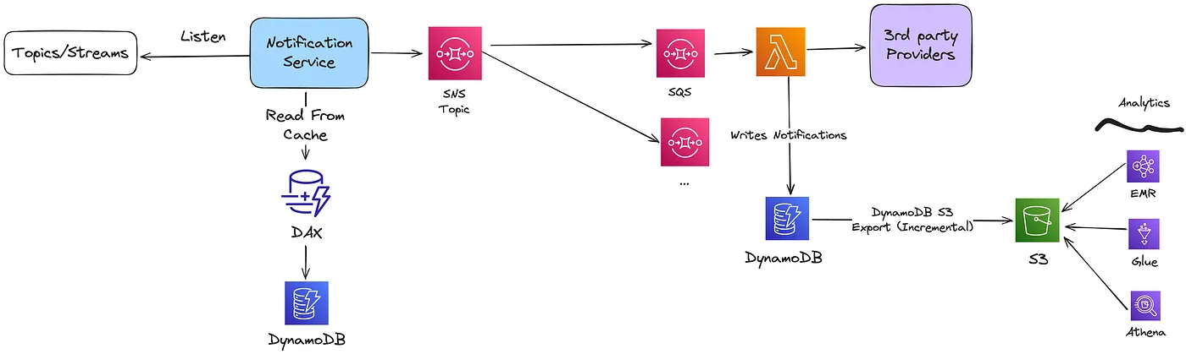

# High-Level System Design

To understand the high-level design of our notification system, we need to clarify its core responsibilities:

1. ****Event Invocation****  
   The notification service must be triggered by the relevant events generated within the system.
2. ****Event Type Processing and User Preferences****  
   For each event, the service should determine the notification type and fetch the user’s preferences for that type of notification. This ensures that notifications align with the user’s opt-in/opt-out choices.
3. ****Fan-out to Notification Providers****  
   The service must handle the distribution (fan-out) of notifications to the appropriate notification providers, such as push notifications, SMS gateways, or email services.
4. ****Durable Storage for Notifications****  
   Notifications should be preserved in durable storage until they are successfully processed. If a notification fails to be processed, it must remain in storage and be retried until successfully delivered.

With these requirements in mind, the architecture could be visualized as follows:

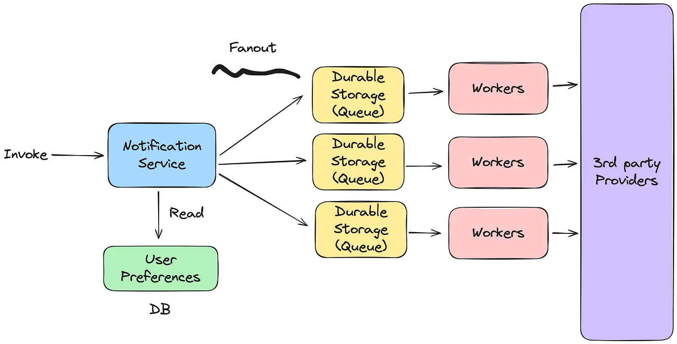

# Different types of notifications

We start by looking at each notification type at a high level.

## i**OS push notification**

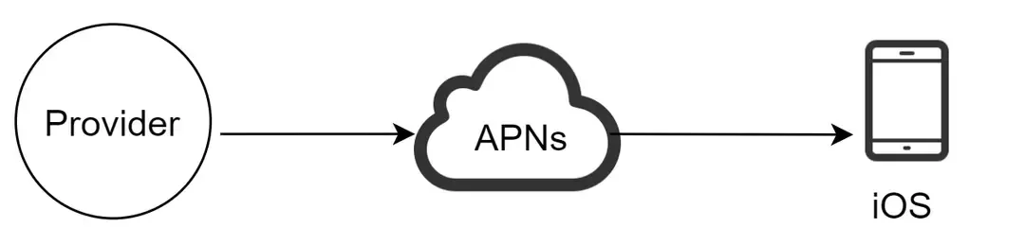

We primarily need three components to send an iOS push notification:

* Provider: A provider builds and sends notification requests to Apple Push Notification Service (APNS). To construct a push notification, the provider provides the following data:
* Device token: This is a unique identifier used for sending push notifications.
* Payload: This is a JSON dictionary that contains a notification’s payload.

## **Android push notification**

Android adopts a similar notification flow. Instead of using APNs, Firebase Cloud Messaging (FCM) is commonly used to send push notifications to Android devices.

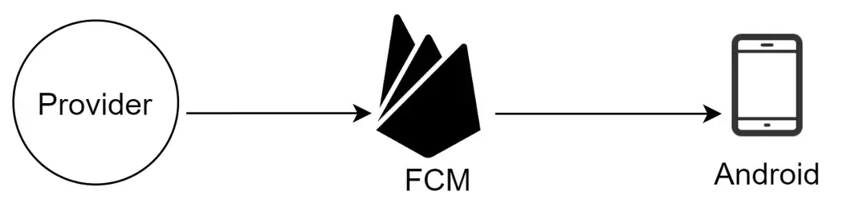

## **SMS message**

For SMS messages, third-party SMS services like Twilio, Nexmo, and many others are commonly used. Most of them are commercial services.

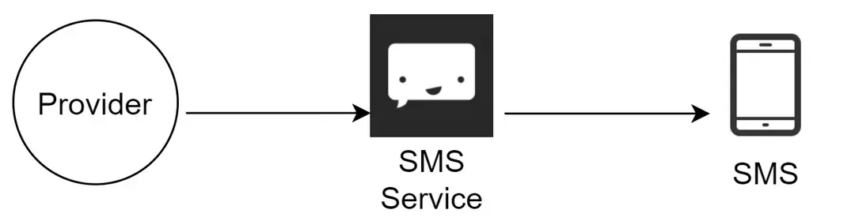

## **Email**

Although companies can set up their own email servers, many of them opt for commercial email services. Sendgrid and Mailchimp are among the most popular email services, which offer a better delivery rate and data analytics.

