JavaScript Function
A function is a block of code that performs a specific task.
Dividing a complex problem into smaller chunks makes your program easy to understand and reusable.
JavaScript also has a huge number of inbuilt functions. For example, Math.sqrt() is a function to calculate the square root of a number.
In this tutorial, you will learn about user-defined functions.

Declaring a Function
The syntax to declare a function is:

Declaring a Function
The syntax to declare a function is:
function nameOfFunction () {
// function body
}
- A function is declared using the function keyword.
- The basic rules of naming a function are similar to naming a variable. It is better to write a descriptive name for your function. For example, if a function is used to add two numbers, you could name the function add or addNumbers.
- The body of function is written within {}.
For example,
// declaring a function named greet()
function greet() {
console.log("Hello there");
}

Calling a Function
In the above program, we have declared a function named greet(). To use that function, we need to call it.
Here's how you can call the above greet() function.
// function call
greet();

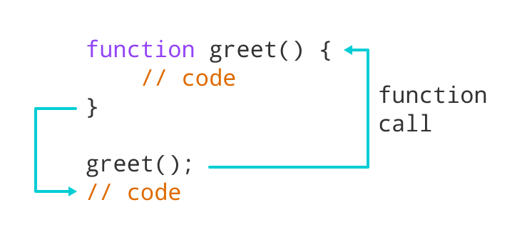Working of a Function in JavaScript

Benefits of Using a Function
- Function makes the code reusable. You can declare it once and use it multiple times.
- Function makes the program easier as each small task is divided into a function.
- Function increases readability.

Function Expressions
In Javascript, functions can also be defined as expressions. For example,
// program to find the square of a number
// function is declared inside the variable
let x = function (num) { return num * num };
console.log(x(4));

// can be used as variable value for other variables
let y = x(3);
console.log(y);
Output
16
9
In the above program, variable x is used to store the function. Here the function is treated as an expression. And the function is called using the variable name.
The function above is called an anonymous function.

JavaScript Recursion

JavaScript Variable Scope
Scope refers to the availability of variables and functions in certain parts of the code.
In JavaScript, a variable has two types of scope:
- Global Scope
- Local Scope
- The value of a global variable can be changed inside a function. For example,
- // program to show the change in global variable
- let a = "hello";

- function greet() {
- a = 3;
- }

- // before the function call
- console.log(a);

- //after the function call
- greet();
- console.log(a); // 3
- In the above program, variable a is a global variable. The value of a is hello. Then the variable a is accessed inside a function and the value changes to 3.

JavaScript Array
You can create an array using two ways:
1. Using an array literal
The easiest way to create an array is by using an array literal []. For example,
const array1 = ["eat", "sleep"];
2. Using the new keyword
You can also create an array using JavaScript's new keyword.
const array2 = new Array("eat", "sleep");
In both of the above examples, we have created an array having two elements.
Here are more examples of arrays:
// empty array
const myList = [ ];

// array of numbers
const numberArray = [ 2, 4, 6, 8];

// array of strings
const stringArray = [ 'eat', 'work', 'sleep'];

// array with mixed data types
const newData = ['work', 'exercise', 1, true];

Access Elements of an Array
You can access elements of an array using indices (0, 1, 2 …). For example,
const myArray = ['h', 'e', 'l', 'l', 'o'];

// first element
console.log(myArray[0]); // "h"

// second element
console.log(myArray[1]); // "e"

Change the Elements of an Array
You can also add elements or change the elements by accessing the index value.
let dailyActivities = [ 'eat', 'sleep'];

// this will add the new element 'exercise' at the 2 index
dailyActivities[2] = 'exercise';

console.log(dailyActivities); // ['eat', 'sleep', 'exercise']
Suppose, an array has two elements. If you try to add an element at index 3 (fourth element), the third element will be undefined. For example,
let dailyActivities = [ 'eat', 'sleep'];

// this will add the new element 'exercise' at the 3 index
dailyActivities[3] = 'exercise';

console.log(dailyActivities); // ["eat", "sleep", undefined, "exercise"]

Remove an Element from an Array
You can use the pop() method to remove the last element from an array. The pop() method also returns the returned value. For example,
let dailyActivities = ['work', 'eat', 'sleep', 'exercise'];

// remove the last element
dailyActivities.pop();
console.log(dailyActivities); // ['work', 'eat', 'sleep']

// remove the last element from ['work', 'eat', 'sleep']
const removedElement = dailyActivities.pop();

//get removed element
console.log(removedElement); // 'sleep'
console.log(dailyActivities); // ['work', 'eat']
If you need to remove the first element, you can use the shift() method. The shift() method removes the first element and also returns the removed element. For example,

Topic's Covered: Session No:2 - >
- Function Declaration, body ,calling , parameters and return values.
- Use of Let and Var with respect to function block.
- How execution control passing from one function to another and return control to calling environment after completion.
- Same function returning different type of values on different situation
- Recursive Function
- Array Declaration and Memory Allocation
- Const Array
- Value type and reference type variables
- Accession Array values using loop
- Changing the array values by index

