DOM Properties:-
With the Document Object Model (DOM), we can create and build documents, add, modify, or delete elements and content. Anything found in an HTML document can be accessed, changed, deleted, or added using the Document Object Model, with a few exceptions. The syntax for accessing the DOM properties is:
document.property_name
Copy
Here are some of the most common properties of the document object model.
Property | Description
document.anchors | It will return all <a> elements that have a name attribute
document.baseURI | It will return the absolute base URI of the document
document.body | It will return the <body> element
document.cookie | It will return the document's cookie
document.doctype | It will return the document's doctype
document.documentElement | It will return the <html> element
document.documentMode | It will return the mode used by the browser
document.documentURI | It will return the URI of the document
document.embeds | It will return all HTML <embed> elements
document.forms | It will return all HTML <form> elements
document.head | It will return the HTML <head> element
document.images | It will return all HTML <img> elements
document.implementation | It will return the DOM implementation
document.links | It will return all HTML <area> and <a> elements that have a href attribute
document.scripts | It will return all HTML <script> elements
document.title | It will return the <title> element
document.URL | It will return the complete URL of the document
Note that: The DOM is a representation of the various components of the browser and the current Web document that can be accessed or manipulated using JavaScript.

What is the difference between a HTMLCollection and a NodeList?
A HTMLCollection contains only element nodes (tags) and a NodeList contains all nodes.
Most important node types:
- element node
- attribute node
- text node
- comment node
node types
Whitespace inside elements is considered as text, and text is considered as nodes.
Consider the following:
<ul id="myList">
<!-- List items -->
<li>List item 1</li>
<li>List item 2</li>
<li>List item 3</li>
<li>List item 4</li>
<li>List item 5</li>
</ul>
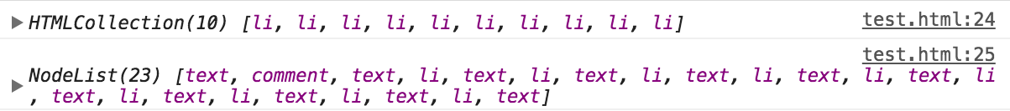

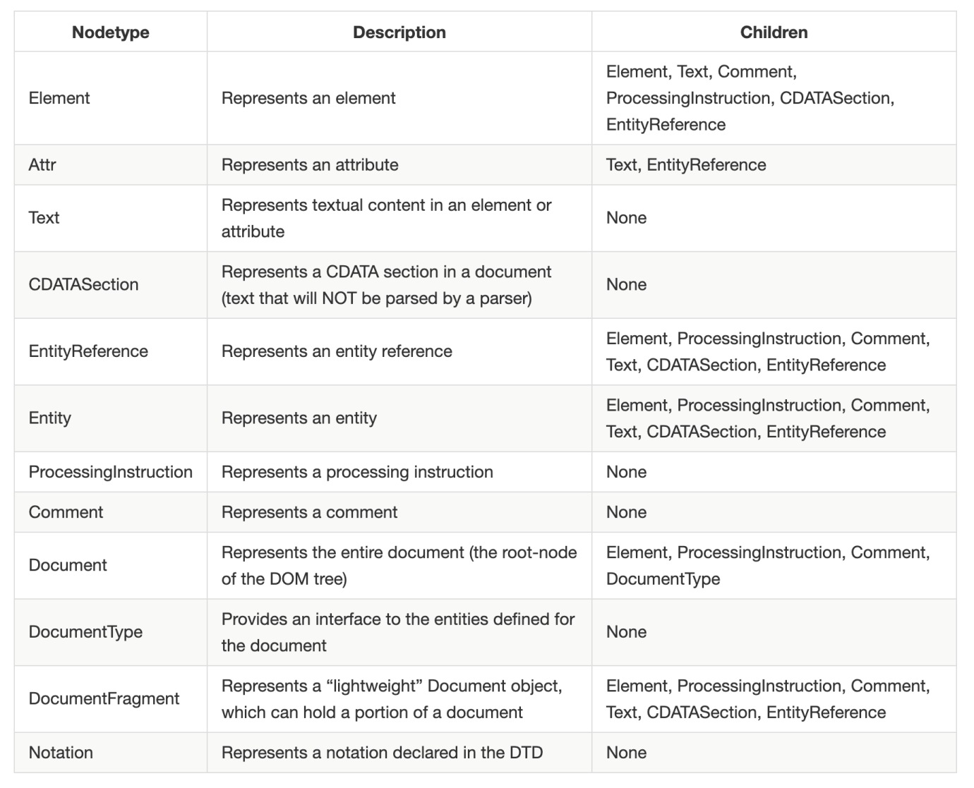

- We can use the following three properties to inspect and inquire about nodes in DOM:
  - nodeType Property
  - nodeName Property
  - nodeValue Property
- The nodeType property returns the node type, as a number, of the specified node.
  - If the node is an element node, the nodeType property will return 1.
  - If the node is an attribute node, the nodeType property will return 2.
  - If the node is a text node, the nodeType property will return 3.
  - If the node is a comment node, the nodeType property will return 8.
  - This property is read-only.

HTMLCollection vs NodeList
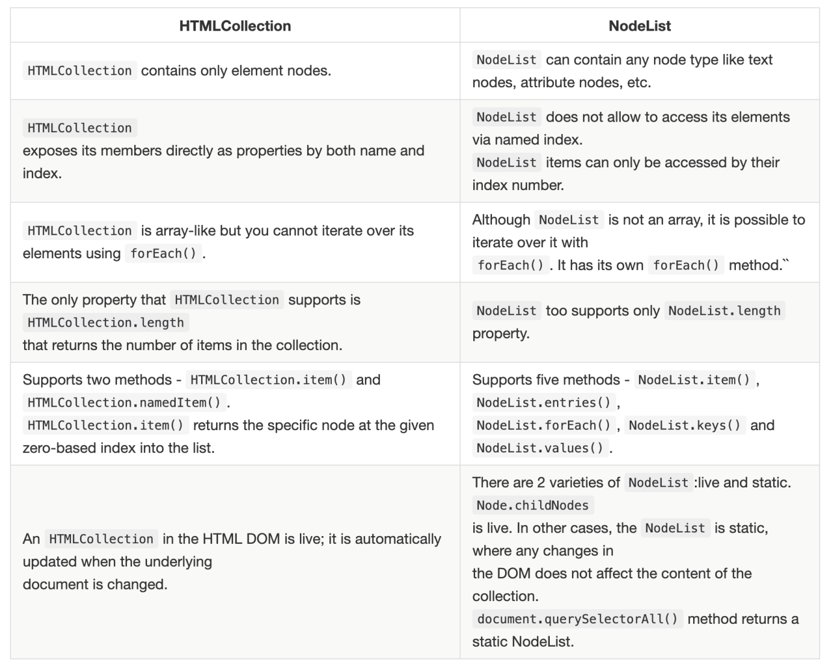
Node= Node { ELEMENT_NODE=1, ATTRIBUTE_NODE=2, TEXT_NODE=3, more...}

