Multiline Strings Using Template Literals
const message1 = `This is a long message
that spans across multiple lines
in the code.`

console.log(message1)

Expression Interpolation
const name = 'Jack';
console.log(`Hello ${name}`);

// template literals used with expressions

const result = `The sum of 4 + 5 is ${4 + 5}`;
console.log(result);

console.log(`${result < 10 ? 'Too low': 'Very high'}`)

Tagged Templates
function tagExample(strings) {
return strings;
}

// creating tagged template
const result = tagExample`Hello Jack`;

console.log(result);
const name = 'Jack';
const greet = true;

function tagExample(strings, nameValue) {
let str0 = strings[0]; // Hello
let str1 = strings[1]; // , How are you?

if(greet) {
return `${str0}${nameValue}${str1}`;
}
}

// creating tagged literal
// passing argument name
const result = tagExample`Hello ${name}, How are you?`;

console.log(result);

JavaScript Spread Operator
const arrValue = ['My', 'name', 'is', 'Jack'];

console.log(arrValue); // ["My", "name", "is", "Jack"]
console.log(...arrValue); // My name is Jack

Copy Array Using Spread Operator
const arr1 = ['one', 'two'];
const arr2 = [...arr1, 'three', 'four', 'five'];

console.log(arr2);
// Output:
// ["one", "two", "three", "four", "five"]

Clone Array Using Spread Operator
let arr1 = [ 1, 2, 3];
let arr2 = arr1;

console.log(arr1); // [1, 2, 3]
console.log(arr2); // [1, 2, 3]

// append an item to the array
arr1.push(4);

console.log(arr1); // [1, 2, 3, 4]
console.log(arr2); // [1, 2, 3, 4]

Spread Operator with Object
const obj1 = { x : 1, y : 2 };
const obj2 = { z : 3 };

// add members obj1 and obj2 to obj3
const obj3 = {...obj1, ...obj2};

console.log(obj3); // {x: 1, y: 2, z: 3}

Rest Parameter
When the spread operator is used as a parameter, it is known as the rest parameter.
You can also accept multiple arguments in a function call using the rest parameter. For example,
let func = function(...args) {
console.log(args);
}

func(3); // [3]
func(4, 5, 6); // [4, 5, 6]

Array forEach() Method
var fruits = ["apple", "orange", "cherry"];
fruits.forEach(myFunction);
function myFunction(item, index) {
document.getElementById("demo").innerHTML += index + ":" + item + "<br>";
}

Syntax
array.forEach(function(currentValue, index, arr), thisValue)

Parameter Values
Parameter | Description
function(currentValue, index, arr) | Required. A function to be run for each element in the array.  Function arguments:
  Argument | Description
  currentValue | Required. The value of the current element
  index | Optional. The array index of the current element
  arr | Optional. The array object the current element belongs to
thisValue | Optional. A value to be passed to the function to be used as its "this" value.  If this parameter is empty, the value "undefined" will be passed as its "this" value

var sum = 0;
var numbers = [65, 44, 12, 4];
numbers.forEach(myFunction);
function myFunction(item) {
sum += item;
document.getElementById("demo").innerHTML = sum;
}

Example
For each element in the array: update the value with 10 times the original value:
var numbers = [65, 44, 12, 4];
numbers.forEach(myFunction)
function myFunction(item, index, arr) {
arr[index] = item * 10;
}

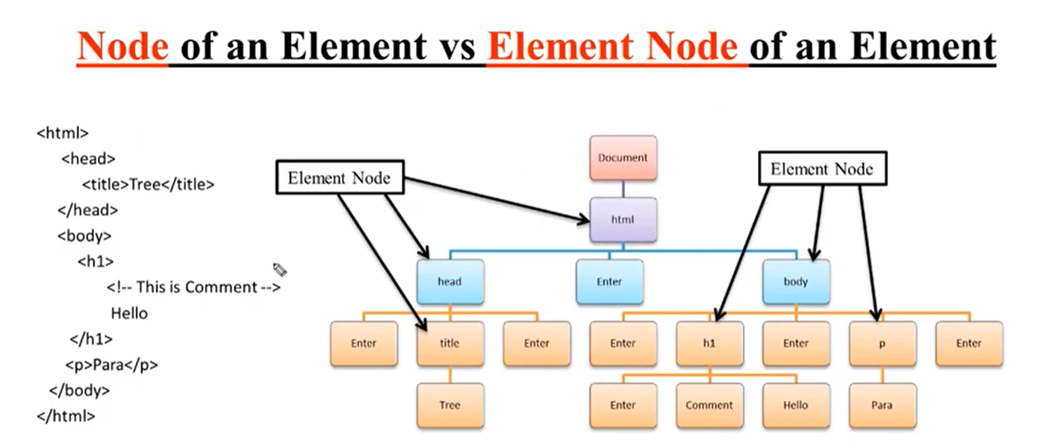

Construtor Shortcut:
class Person {
constructor(private firstName, private lastName) {
}
}
interface Human {
firstName: string;
lastName: string;
}
Sometimes however we might want an interface to describe an optional contract. We can append ? to the name of the property or function to mark it as optional, like so:
TypeScript
interface Human {
firstName: string;
lastName: string;
name?: Function;
isLate?(time: Date): Function;
}
interface Human {
firstName: string;
lastName: string;
name?: Function;
isLate?(time: Date): Function;
}

class Person implements Human {
constructor(public firstName, public lastName) {
}

public name() {
return `${this.firstName} ${this.lastName}`;
}

protected whoAreYou() {
return `Hi i'm ${this.name()}`;
}
}

class Student extends Person {
constructor(public firstName, public lastName, public course) {
super(firstName, lastName);
}

whoAreYou() {
return `${super.whoAreYou()} and i'm studying ${this.course}`;
}
}

let asim = new Student("Asim", "Hussain", "typescript");
console.log(asim.whoAreYou());

Map & Set

