1. Write a program that will use bitwise & operator to perform bitwise AND operation,bitwise operator to perform bitwise inclusive OR operation ans bitwise ^ operator to perform bitwise exclusive OR operation

Program:-

class bitwiseOps

{

public static void main(String argv[])

{

int a=13,b=25;

System.out.println("a = "+a);

System.out.println("b = "+b);

System.out.println("(a & b) = "+(a&b));

System.out.println("(a | b) = "+(a|b));

System.out.println("(a ^ b) = "+(a^b));

}

}

Output:-

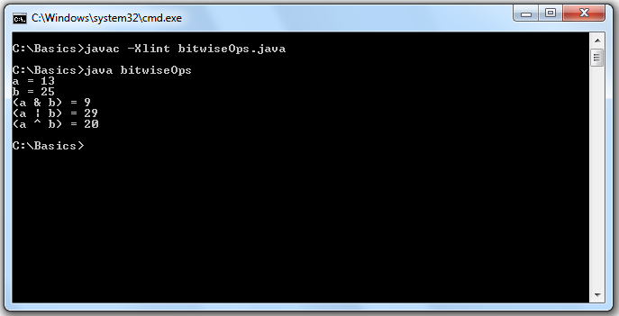

1. Write a program to demonstrate Boolean variable in JAVA and also show that they are compatible with relational operators

Program:-

class boolen

{

public static void main(String argv[])

{

boolean state;

state=false;

System.out.println("The state now is "+state);

state=true;

System.out.println("The state now is "+state);

System.out.println("A boolean variable can contain the branching statement");

if(state)

System.out.println("TRUE");

System.out.println("Outcome of Relational Operator is boolean");

System.out.println("12>9\t"+(12>9));

System.out.println("12<9\t"+(12<9));

}

}

Output:-

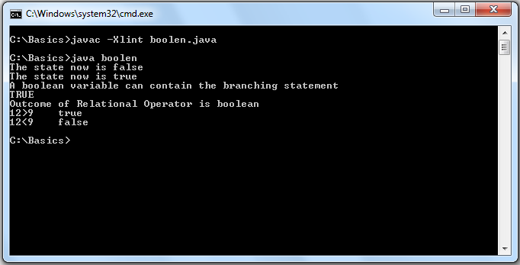

1. Write a program to to demonstrate character variables in JAVA also show that in ceratin situations they behave like integers

Program:-

class chrctr

{

public static void main(String argv[])

{

char a1='a',a2=65;

System.out.println("The value of a1 is = "+a1);

System.out.println("The value of a2 is = "+a2);

System.out.println("Character variables sometimes behaves like Integers = ");

a1++;

a2++;

System.out.println("The value of a1++ is = "+a1);

System.out.println("The value of a2++ is = "+a2);

}

}

Output:-

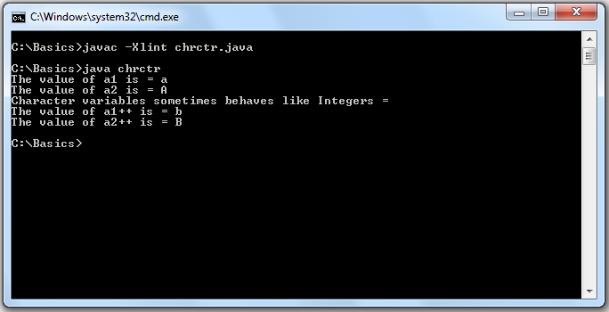

1. Write a program to demonstrate comand line arguments

Program:-

class cmdLn

{

public static void main(String argv[])

{

int n=0;

if(argv.length == 0)

System.out.println("No arguments passed");

for(int i=0;i<argv.length;i++)

{

n=Integer.parseInt(argv[i]);

System.out.println("argv["+i+"]="+n);

}

}

}

Output:-

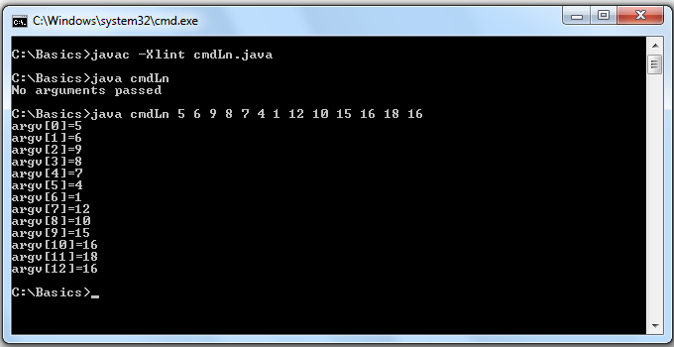

1. Write a program to to demonstrate the working of conditional operators in JAVA

Program:-

class conditionalOp

{

public static void main(String argv[])

{

int a,b;

a=98786;

b=756757;

System.out.println("a = "+a+"\nb = "+b);

System.out.println("a > b ? (True = a) ? (False = b) :---------> "+(a>b?a:b));

System.out.println("a < b ? (True = a) ? (False = b) :---------> "+(a<b?a:b));

}

}

Output:-

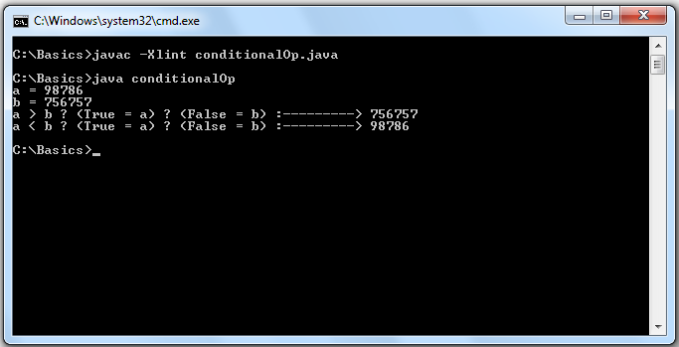

1. To demonstrate all the Float(float,double) types available in JAVA

Program:-

class flot

{

public static void main(String args[])

{

float a1,a2;

double b1,b2;

a1=5e+17f;

a2=6e+20f;

System.out.println("FLOAT\na1 = "+a1+"\na2="+a2+"\na1 * a2 = "+a1*a2);

b1=3e+150;

b2=4e+157;

System.out.println("DOUBLE\nb1 = "+b1+"\nb2="+b2+"\nb1 * b2 = "+b1*b2);

}

}

Output:-

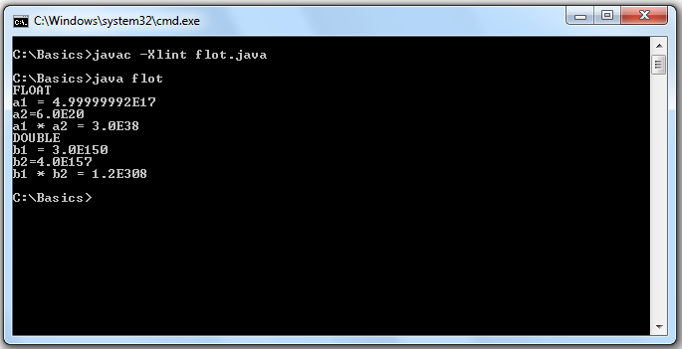

1. Write a program to to demonstrate the Float arithmetic operations performed in JAVA

Program:-

import java.util.Scanner;

class flotArth

{

public static void main(String argv[])

{

Scanner in = new Scanner(System.in);

float r=0.0f;

double pi=3.142857142857,cir=0.0f,area=0.0f;

System.out.print("Enter Radius of circle in float: ");

r=in.nextFloat();

cir=2*pi*r;

area=pi*r*r;

System.out.println("Circumference of circle = "+cir+"\nArea of circle = "+area);

}

}

Output:-

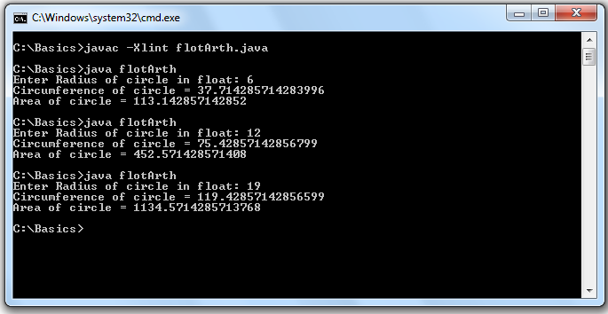

1. Write a program to demonstrate the Integer arithmetic operations performed in JAVA

Program:-

import java.util.Scanner;

class intArth

{

public static void main(String args[])

{

Scanner in = new Scanner(System.in);

int lengthr=0,breadthr=0,lengths=0,areas,arear,peris,perir;

System.out.print("Enter length of square in integer: ");

lengths=in.nextInt();

System.out.print("Enter length of rectangle in integer: ");

lengthr=in.nextInt();

System.out.print("Enter breadth of rectangle in integer: ");

breadthr=in.nextInt();

areas=lengths*lengths;

arear=lengthr*breadthr;

peris=4*lengths;

perir=2*(lengthr+breadthr);

System.out.println("Square\nPerimeter = "+peris+"\nArea = "+areas);

System.out.println("Rectangle\nPerimeter = "+perir+"\nArea = "+arear);

}

}

Output:-

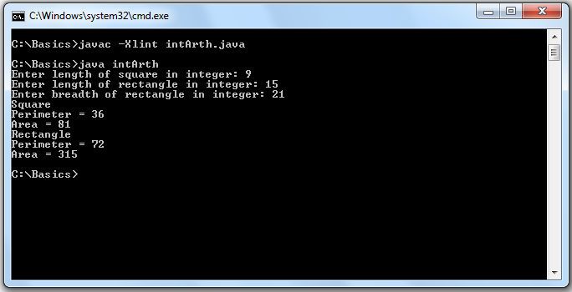

1. To demonstrate all the Integer(short,int,long,byte) types available in JAVA

class integr

{

public static void main(String args[])

{

int a1,a2;

long b1,b2;

short c1,c2;

byte d1,d2;

a1=46340;

a2=46341;

System.out.println("INT\na1 = "+a1+"\na2="+a2+"\na1 * a2 = "+a1*a2);

b1=303700049;

b2=303700050;

System.out.println("LONG\nb1 = "+b1+"\nb2="+b2+"\nb1 * b2 = "+b1*b2);

c1=181;

c2=182;

System.out.println("SHORT\nc1 = "+c1+"\nc2="+c2+"\nc1 * c2 = "+c1*c2);

d1=11;

d2=11;

System.out.println("BYTE\nd1 = "+d1+"\nd2="+d2+"\nd1 * d2 = "+d1*d2);

}

}

Output:-

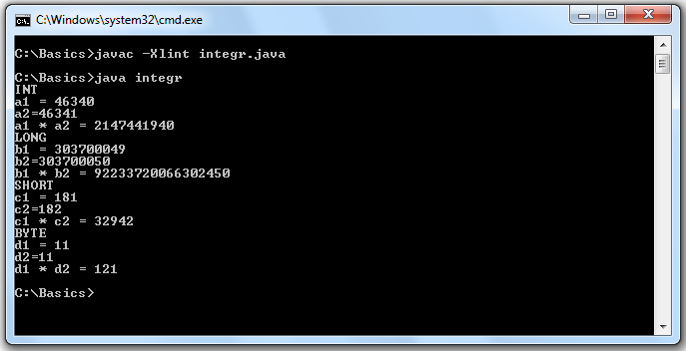

1. Write a program that will take int,float and double values given by user and display them

Program:-

import java.util.Scanner;

class intfltdbl

{

public static void main(String argv[])

{

Scanner in = new Scanner(System.in);

int intNumber=0;

float floatNumber=0.0f;

double doubleNumber=0.0;

System.out.print("Enter Integer Value: ");

intNumber=in.nextInt();

System.out.print("Enter Float Value: ");

floatNumber=in.nextFloat();

System.out.print("Enter Double Value: ");

doubleNumber=in.nextDouble();

System.out.println("intNumber = "+intNumber);

System.out.println("floatNumber = "+floatNumber);

System.out.println("doubleNumber = "+doubleNumber);

}

}

Output:-

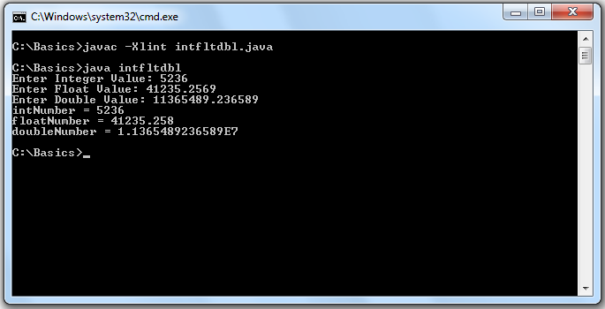

1. Write a program that will demonstrate arithmetic operations performed with int,float and double values given by user

Program:-

import java.util.Scanner;

class intfltdblArth

{

public static void main(String argv[])

{

Scanner in = new Scanner(System.in);

int resulti=0,intNumber1=0,intNumber2=0;

float resultf=0.0f,floatNumber1=0.0f,floatNumber2=0.0f;

double resultd=0.0,doubleNumber1=0.0,doubleNumber2=0.0;

System.out.print("Integer\nEnter Number 1: ");

intNumber1=in.nextInt();

System.out.print("Enter Number 2: ");

intNumber2=in.nextInt();

System.out.print("Float\nEnter Number 1: ");

floatNumber1=in.nextFloat();

System.out.print("Enter Number 2: ");

floatNumber2=in.nextFloat();

System.out.print("Double\nEnter Number 1: ");

doubleNumber1=in.nextDouble();

System.out.print("Enter Number 2: ");

doubleNumber2=in.nextDouble();

resulti=intNumber1+intNumber2;

System.out.println("Integer-------\n"+intNumber1+" + "+intNumber2+" = "+resulti);

resulti=intNumber1-intNumber2;

System.out.println(intNumber1+" - "+intNumber2+" = "+resulti);

resulti=intNumber1*intNumber2;

System.out.println(intNumber1+" * "+intNumber2+" = "+resulti);

resulti=intNumber1/intNumber2;

System.out.println(intNumber1+" / "+intNumber2+" = "+resulti);

resultf=floatNumber1+floatNumber2;

System.out.println("Float-------\n"+floatNumber1+" + "+floatNumber2+" = "+resultf);

resultf=floatNumber1-floatNumber2;

System.out.println(floatNumber1+" - "+floatNumber2+" = "+resultf);

resultf=floatNumber1*floatNumber2;

System.out.println(floatNumber1+" * "+floatNumber2+" = "+resultf);

resultf=floatNumber1/floatNumber2;

System.out.println(floatNumber1+" / "+floatNumber2+" = "+resultf);

resultd=doubleNumber1+doubleNumber2;

System.out.println("Double-------\n"+doubleNumber1+" + "+doubleNumber2+" = "+resultd);

resultd=doubleNumber1-doubleNumber2;

System.out.println(doubleNumber1+" - "+doubleNumber2+" = "+resultd);

resultd=doubleNumber1*doubleNumber2;

System.out.println(doubleNumber1+" * "+doubleNumber2+" = "+resultd);

resultd=doubleNumber1/doubleNumber2;

System.out.println(doubleNumber1+" / "+doubleNumber2+" = "+resultd);

}

}

Output:-

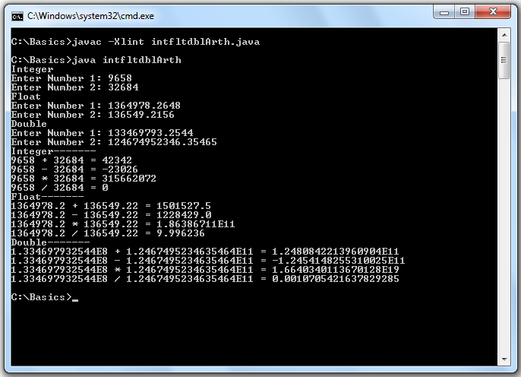

1. Write a program to demonstrate the Mixed mode arithmetic operation performed inJAVA

Program:-

import java.util.Scanner;

class mixdArth

{

public static void main(String argv[])

{

Scanner in = new Scanner(System.in);

int intNumber=0;

float floatNumber=0.0f;

System.out.print("Enter Integer Value: ");

intNumber=in.nextInt();

System.out.print("Enter Float Value: ");

floatNumber=in.nextFloat();

System.out.println("Mixed Mode Arithmetic\n"+intNumber+" * "+floatNumber+" = "+(intNumber*floatNumber)+"\n"+intNumber+" / "+floatNumber+" = "+(intNumber/floatNumber));

}

}

Output:-

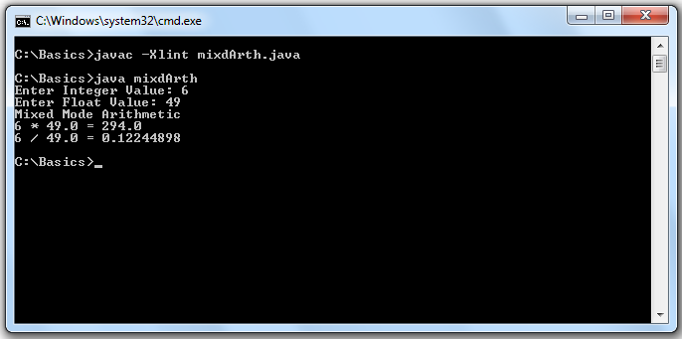

1. Write a program to demonstrate pre-increment and post-increment operation with an integer.Also perform decrement operation in the same way

Program:-

class postpreInDe

{

public static void main(String argv[])

{

int intNumber;

intNumber=198236;

System.out.println("Before Post-Increment --- "+intNumber+"\nAfter Post-Increment --- "+(intNumber++));

System.out.println("Before Pre-Increment --- "+intNumber+"\nAfter Pre-Increment --- "+(++intNumber));

intNumber=937464;

System.out.println("Before Post-Decrement --- "+intNumber+"\nAfter Post_Decrement ---"+(intNumber--));

System.out.println("Before Pre-Decrement --- "+intNumber+"\nAfter Pre_Decrement ---"+(--intNumber));

}

}

Output:-

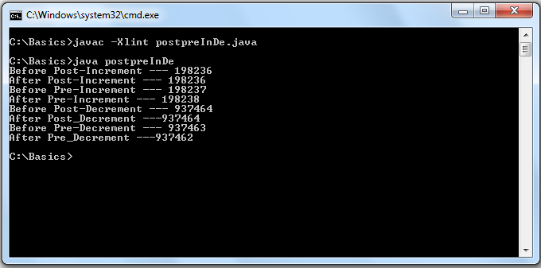

1. Write a program to demonstrate the printing facility provided by JAVA(use of print,printf,println)

Program:-

class printing

{ public static void main(String args[])

{

System.out.println("----------This line is printed using PRINTLN-----------");

System.out.print("****************This line is printed using PRINT***************");

System.out.printf("===============This line is printed using PRINTF==============");

System.out.println("----------This line is printed using 2nd PRINTLN-----------");

}

}

Output:-

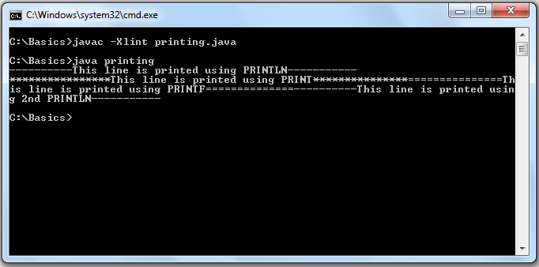

1. Write a program to demonstrate the working of relational operators and their evaluation as Boolean in JAVA

Program:-

class relationalOp

{

public static void main(String args[])

{

double a=19e199,b=48e150,c=19e199;

System.out.println("a = "+a+"\nb = "+b+"\nc = "+c);

System.out.println("a < b = "+(a<b));

System.out.println("c > b = "+(c>b));

System.out.println("a == c = "+(a==c));

System.out.println("a >= c = "+(a>=c));

System.out.println("a <= b = "+(a<=b));

System.out.println("a != c = "+(a!=c));

}

}

Output:-

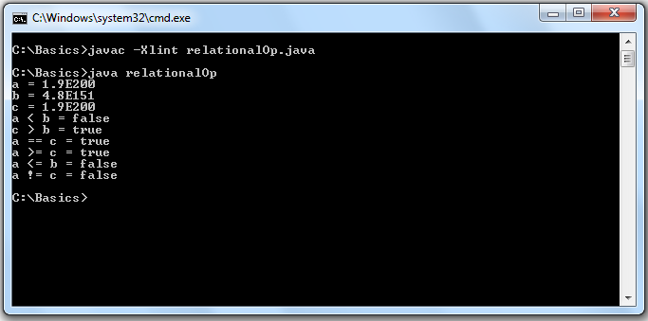

1. Write a program that will declare an integer type of array and display its values initialized at compiled time individually

Program:-

class runTimeArrIn

{

public static void main(String argv[])

{

int []a = {3,1,4,1,5,9};

int b[] = {78,98,63,25,54,49};

System.out.println("\nUsing enhanced for loop feature");

for(int i:a)

System.out.print(i+"\t");

System.out.println("\nUsing .length feature");

for(int i=0;i<b.length;i++)

System.out.println("b["+i+"] = "+b[i]);

}

}

Output:-

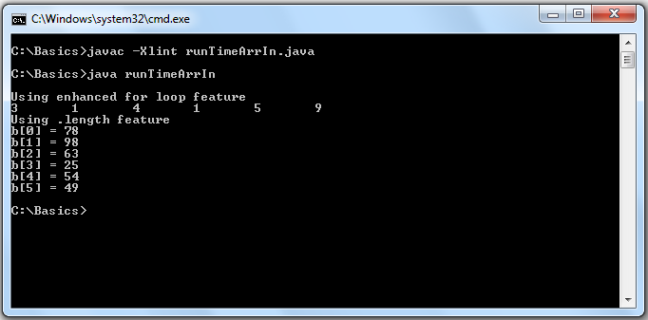

1. Write a program that will perform concatenation of two strings

Program:-

import java.io.DataInputStream;

class strCat

{

public static void main(String argv[])

{

DataInputStream in = new DataInputStream(System.in);

String str1="",str2="";

try

{

System.out.print("Enter a string1 : ");

str1=in.readLine();

System.out.print("Enter a string2 : ");

str2=in.readLine();

}

catch(Exception E)

{

}

System.out.println("After concatenation:-\n"+str1+" "+str2);

}

}

Output:-

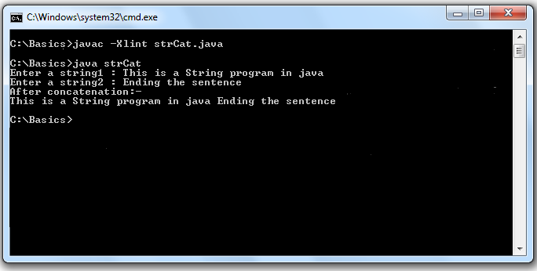

1. Write a program that will demonstrate initialization of string by user input

Program:-

import java.io.DataInputStream;

class strUserIn

{

public static void main(String argv[])

{

DataInputStream in = new DataInputStream(System.in);

String str="";

try

{

System.out.println("Enter a string: ");

str=in.readLine();

}

catch(Exception E)

{

}

System.out.println("Read string = "+str);

}

}

Output:-

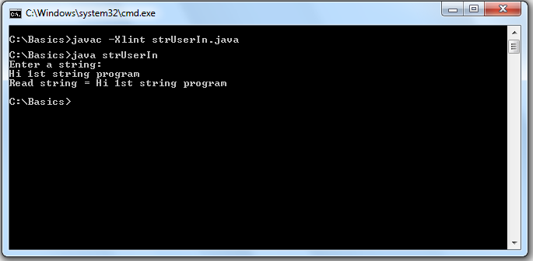

1. Write a program that will take two numbers from the user and check whether they are Amicable numbers or not

Program:-

import java.util.Scanner;

class amicablNo

{

public static void main(String argv[])

{

Scanner in = new Scanner(System.in);

int intNumber1=0,intNumber2=0,div1=0,div2=0,n=0;

System.out.print("Enter Number 1: ");

intNumber1=in.nextInt();

System.out.print("Enter Number 2: ");

intNumber2=in.nextInt();

n=intNumber1;

for(int i=1;i<=n/2;i++)

{

if(n % i == 0)

div1=div1+i;

}

n=intNumber2;

for(int i=1;i<=n/2;i++)

{

if(n % i == 0)

div2=div2+i;

}

if(intNumber1 == div2 && intNumber2 == div1)

System.out.println(intNumber1+" and "+intNumber2+" are Amicable Numbers");

else

System.out.println(intNumber1+" and "+intNumber2+" are Not Amicable Numbers");

}

}

OutPut:-

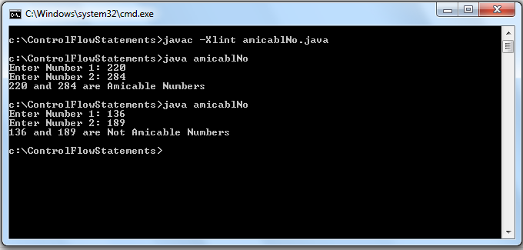

1. Write a program that will check whether a number is Armstrong number or not

Program:-

import java.util.Scanner;

class armstrng

{

public static void main(String argv[])

{

Scanner in = new Scanner(System.in);

int s=0,intNumber=0,n,b=0,x=0,a=1;

System.out.print("Enter Integer Value: ");

intNumber=in.nextInt();

n=intNumber;

while(n >= 1)

{

n=n/10;

x++;

}

n=intNumber;

while(n >= 1)

{

b=n%10;

n=n/10;

a=1;

for(int i=1;i<=x;i++)

a=a*b;

s=s+a;

}

if(s == intNumber)

System.out.println(intNumber+" is an Armstromg Number");

else

System.out.println(intNumber+" is Not an Armstromg Number");

}

}

Output:-

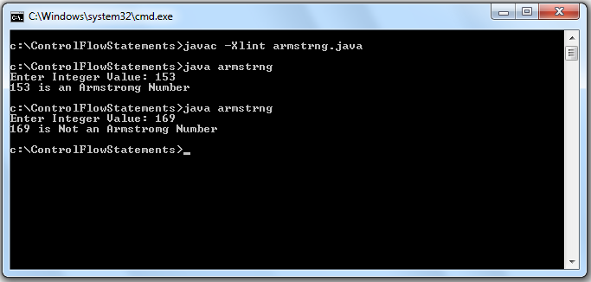

1. Write a program to demonstrate the Enhanced For Loop in JAVA

Program:-

class enForLoop

{

public static void main(String argv[])

{

int x=0;

int arr[]={49,93,85,73,82,8,27};

System.out.println("Displaying Array elements using Enhanced For Loop:--------");

for(int i:arr)

{

++x;

System.out.println("array["+x+"] = "+i);

}

}

}

Output:-

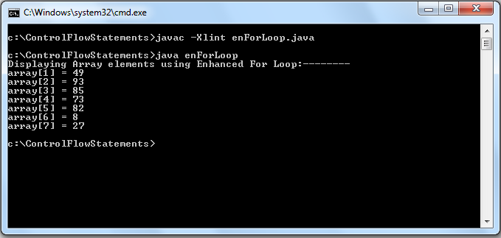

1. Write a program that will demonstrate instanceOf operator in JAVA

class x

{

x()

{

}

}

class y

{

y()

{

}

}

class instanceF

{

public static void main(String argv[])

{

x ob1 = new x();

y ob2 = new y();

if( ob1 instanceof x)

System.out.println("ob1 is instance of x ");

if( ob2 instanceof y)

System.out.println("ob2 is instance of y ");

}

}

Output:-

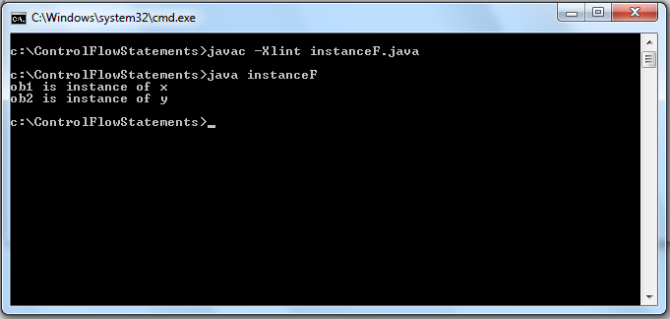

1. Write a program that will find sum of all the positive integers upto a specified range

Program:-

import java.util.Scanner;

class intRange

{

public static void main(String argv[])

{

Scanner in = new Scanner(System.in);

int i=0,n=0,s=0;

do

{

System.out.print("Enter Range(Positive Integer): ");

n=in.nextInt();

}while(n <= 0);

System.out.println("Intergers upto "+n+" are:-");

for(i=1;i<=n;i++)

s=s+i;

System.out.print("sum till "+i+" = "+s);

}

}

Output:-

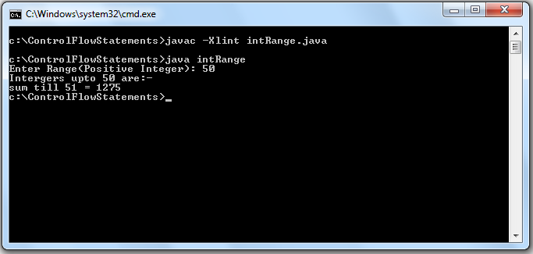

1. Write a program that will generate Lucas sequence up to certain range specified by user

Program:-

import java.util.Scanner;

class lucasNo

{

public static void main(String args[])

{

Scanner in = new Scanner(System.in);

int range=0,a=2,b=1,c=0;

System.out.print("Enter the range:- ");

range=in.nextInt();

System.out.println("The sequence is as follows : ");

System.out.print(a+"\t"+b);

for(int i=2;i<=range;i++)

{

c=a+b;

System.out.print("\t"+c);

a=b;

b=c;

}

}

}

Output:-

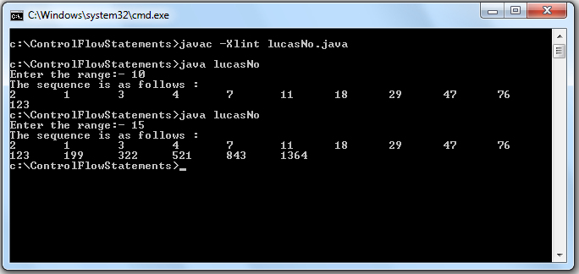

1. Write a program that will generate all prime numbers with in Fibonacci series up to certain range

Program:-

import java.util.Scanner;

class primeFibo

{

public static void main(String argv[])

{

Scanner in = new Scanner(System.in);

int a=0,b=1,c=0,n=0,x=0;

System.out.print("Enter Range: ");

n=in.nextInt();

System.out.print("All prime numbers that are also fibonacci numbers:\n1\t");

for(int i=2;i<n;i++)

{

x=0;

c=a+b;

a=b;

b=c;

for(int j=1;j <= c/2;j++)

{

if(c % j == 0)

x++;

}

if(x == 1)

System.out.print(c+"\t");

}

}

}

Output:-

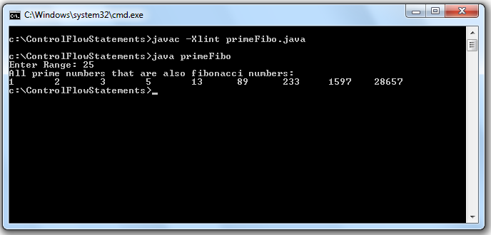

1. Write a program that will take an integer from the user amd check whether it is perfect number or not

Program:-

import java.util.Scanner;

class perfectNo

{

public static void main(String argv[])

{

Scanner in = new Scanner(System.in);

int intNumber=0,n=0,s=0,j;

System.out.print("Enter Number: ");

intNumber=in.nextInt();

n=intNumber;

for(int i=1;i<=n/2;i++)

{

if(n % i == 0)

s=s+i;

}

if(s == intNumber)

System.out.println(intNumber+" is a Perfect Number");

else

System.out.println(intNumber+" is Not a Perfect Number");

}

}

Output:-

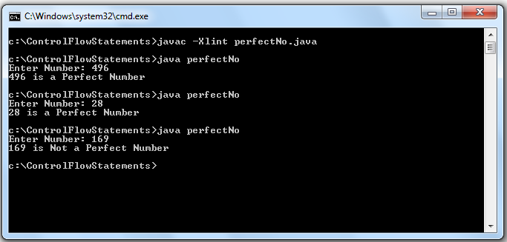

1. Write a program to check whether a number is even or odd.Put proper restrictions on the values given by the user

Program:-

import java.util.Scanner;

class oddOReven

{

public static void main(String argv[])

{

Scanner in = new Scanner(System.in);

int intNumber=0,f=1;

do

{

if(f == 0)

System.out.println("Wrong Entry:-ReEnter ");

System.out.print("Enter a Positive Number: ");

intNumber=in.nextInt();

f=0;

}while(intNumber <= 0);

if(intNumber % 2 == 0)

System.out.println(intNumber+" is Even");

else

System.out.println(intNumber+" is Odd");

}

}

Output:-

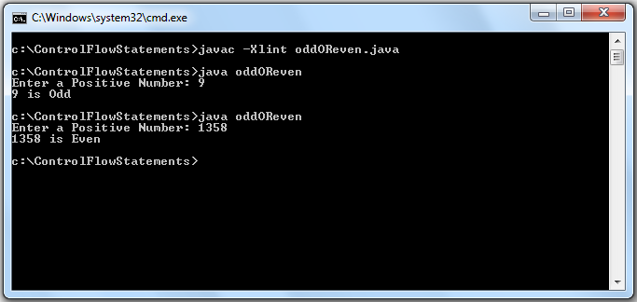

1. Write a program that will display modulo value (|x|) of a number taken from the user

Program:-

import java.util.Scanner;

class modulo

{

public static void main(String argv[])

{

Scanner in = new Scanner(System.in);

int intNumber=0;

System.out.print("Enter a Number: ");

intNumber=in.nextInt();

System.out.print("| "+intNumber+" | = ");

if(intNumber < 0)

intNumber*=(-1);

System.out.println(intNumber);

}

}

Output:-

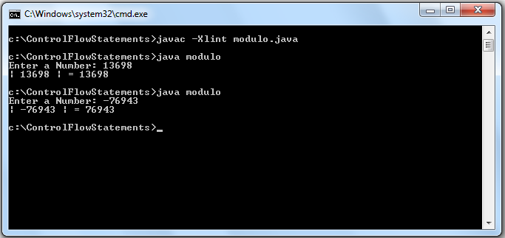

1. Write a menu driven program that will perform arithmetic operation on two numbers

Program:-

import java.util.Scanner;

class menu

{

public static void main(String argv[])

{

Scanner in = new Scanner(System.in);

int resulti=0,intNumber1=0,intNumber2=0,c=0,cc=0;

float resultf=0,floatNumber1=0.0f,floatNumber2=0.0f;

System.out.println("\tMENU");

System.out.println("1.Integer");

System.out.println("2.Float");

System.out.print("Enter Choice :- ");

c=in.nextInt();;

switch(c)

{

case 1:

System.out.print("Enter Number 1: ");

intNumber1=in.nextInt();

System.out.print("Enter Number 2: ");

intNumber2=in.nextInt();

System.out.println("\tINTEGER-MENU");

System.out.println("1.ADDITION");

System.out.println("2.SUBTRACTION");

System.out.println("3.MULTIPLICATION");

System.out.println("4.DIVISION");

System.out.print("Enter Choice :- ");

cc=in.nextInt();

switch(cc)

{

case 1:

resulti=intNumber1+intNumber2;

System.out.println("ADDITION:----\n"+intNumber1+" + "+intNumber2+" = "+resulti);

break;

case 2:

resulti=intNumber1-intNumber2;

System.out.println("SUBTRACTION:----\n"+intNumber1+" - "+intNumber2+" = "+resulti);

break;

case 3:

resulti=intNumber1*intNumber2;

System.out.println("MULTIPLITION:----\n"+intNumber1+" * "+intNumber2+" = "+resulti);

break;

case 4:

resulti=intNumber1/intNumber2;

System.out.println("DIVISION:----\n"+intNumber1+" / "+intNumber2+" = "+resulti);

break;

default:

System.out.println("Wrong Input Int");

break;

}

break;

case 2:

System.out.print("Enter Number 1: ");

floatNumber1=in.nextFloat();

System.out.print("Enter Number 2: ");

floatNumber2=in.nextFloat();

System.out.println("\tFLOAT-MENU");

System.out.println("1.ADDITION");

System.out.println("2.SUBTRACTION");

System.out.println("3.MULTIPLICATION");

System.out.println("4.DIVISION");

System.out.print("Enter Choice :- ");

cc=in.nextInt();

switch(cc)

{

case 1:

resultf=floatNumber1+floatNumber2;

System.out.println("ADDITION:----\n"+floatNumber1+" + "+floatNumber2+" = "+resultf);

break;

case 2:

resultf=floatNumber1-floatNumber2;

System.out.println("SUBTRACTION:----\n"+floatNumber1+" - "+floatNumber2+" = "+resultf);

break;

case 3:

resultf=floatNumber1*floatNumber2;

System.out.println("MULTIPLITION:----\n"+floatNumber1+" * "+floatNumber2+" = "+resultf);

break;

case 4:

resultf=floatNumber1/floatNumber2;

System.out.println("DIVISION:----\n"+floatNumber1+" / "+floatNumber2+" = "+resultf);

break;

default:

System.out.println("Wrong Input Float");

break;

}

break;

default:

System.out.println("Wrong Input");

break;

}

}

}

Output:-

