Multimedia Assignment
Roll_no: 91/CIS/091024
Registration_no: 0028619 OF 2006-2007
Examination: MSc. 3rd SEMESTER EXAMINATION 2010
IN COMPUTER AND INFORMATION
SCIENCE.

ASSIGNMENT:1

- Write C programs to draw some basic shapes such as line, rectangle, ellipse, sector and polygon.

Code:
#include<graphics.h>
#include<stdlib.h>
int xMax,yMax;
void menu();
void choice(int);
void screenInitialize();
void drawCoordinates(char []);

void menu()
{
int c;
do
{
printf("\t\t\t\tDifferent Shapes to Draw\n");
printf("\t\t\t\t\t1.Line\n");
printf("\t\t\t\t\t2.Square\n");
printf("\t\t\t\t\t3.Rectangle\n");
printf("\t\t\t\t\t4.Ellipse\n");
printf("\t\t\t\t\t5.Circle\n");
printf("\t\t\t\t\t6.Sector\n");
printf("\t\t\t\t\t7.Polygon\n");
printf("\t\t\t\t\t8.Exit\n");
printf("\t\t\tEnter choice(1/2/3/4/5/6/7/8) :- ");
scanf("%d",&c);
choice(c);
}while(1);
}

void choice(int c)
{
int x1,y1,x2,y2,a,b,r,sang,eang;
int poly[12]={350,450, 350,410, 430,400, 350,350, 300,430, 350,450 };
switch(c)
{ case 1:
printf("Line\n");
printf("Enter Co-ordinates :- \n");
printf("Enter 1st point :- \n");
printf("X1 = ");
scanf("%d",&x1);
printf("Y1 = ");
scanf("%d",&y1);
printf("Enter 2nd point :- \n");
printf("X2 = ");
scanf("%d",&x2);
printf("Y2 = ");
scanf("%d",&y2);
screenInitialize();
drawCoordinates("Line");
line(xMax/2+x1,yMax/2-y1,xMax/2+x2,yMax/2-y2);
break;
case 2:
printf("Square\n");
printf("Enter Co-ordinates :- \n");
printf("Enter point :- \n");
printf("X1 = ");
scanf("%d",&x1);
printf("Y1 = ");
scanf("%d",&y1);
printf("Enter Length of sides :- ");
scanf("%d",&a);
screenInitialize();
drawCoordinates("Square");
rectangle(xMax/2+x1,yMax/2-y1,xMax/2+x1+a,yMax/2-y1+a);
break;
case 3:
printf("Rectangle\n");
printf("Enter Co-ordinates :- \n");
printf("Enter point :- \n");
printf("X1 = ");
scanf("%d",&x1);
printf("Y1 = ");
scanf("%d",&y1);
printf("Enter Length :- ");
scanf("%d",&a);
printf("Enter Breath :- ");
scanf("%d",&b);
screenInitialize();
drawCoordinates("Rectangle");
rectangle(xMax/2+x1,yMax/2-y1,xMax/2+x1+a,yMax/2-y1+b);
break;
case 4:
printf("Ellipse\n");
printf("Enter Co-ordinates of Center:- \n");
printf("Enter point :- \n");
printf("X1 = ");
scanf("%d",&x1);
printf("Y1 = ");
scanf("%d",&y1);
printf("Enter X-Radian :- ");
scanf("%d",&a);
printf("Enter Y-Radian :- ");
scanf("%d",&b);
screenInitialize();
drawCoordinates("Ellipse");
ellipse(xMax/2+x1,yMax/2-y1,0,360,a,b);
break;
case 5:
printf("Circle\n");
printf("Enter Co-ordinates of Center:- \n");
printf("Enter point :- \n");
printf("X1 = ");
scanf("%d",&x1);
printf("Y1 = ");
scanf("%d",&y1);
printf("Enter Radius :- ");
scanf("%d",&r);
screenInitialize();
drawCoordinates("Circle");
circle(xMax/2+x1,yMax/2-y1,r);
break;
case 6:
printf("Sector\n");
printf("Enter Co-ordinates of Center:- \n");
printf("Enter point :- \n");
printf("X1 = ");
scanf("%d",&x1);
printf("Y1 = ");
scanf("%d",&y1);
printf("Enter Start-Angle :- ");
scanf("%d",&sang);
printf("Enter End-Angle :- ");
scanf("%d",&eang);
printf("Enter X-Radian :- ");
scanf("%d",&a);
printf("Enter Y-Radian :- ");
scanf("%d",&b);
screenInitialize();
drawCoordinates("Sector");
sector(xMax/2+x1,yMax/2-y1,sang,eang,a,b);
break;
case 7:
printf("Polygon\n");
screenInitialize();
drawCoordinates("Polygon");
drawpoly(6, poly);
break;
case 8:
printf("\nExiting");
cleardevice();
closegraph();
exit(0);
default:
printf("\aWrong Choice-");
delay(200);
printf("\aEnter a valid choice\n");
break;
}
getch();
clrscr();
cleardevice();
}

void screenInitialize()
{
int gdriver = DETECT, gmode, errorcode;
initgraph(&gdriver, &gmode, "C:\\tc\\bgi");
outport(0x0378,0x00);
errorcode = graphresult();
if (errorcode != grOk)
{
printf("Graphics error: %s\n",grapherrormsg(errorcode));
printf("Press any key to halt:");
getch();
exit(0);
}
xMax=getmaxx();
yMax=getmaxy();
}

void drawCoordinates(char a[])
{
char msg[80];
setcolor(20);
sprintf(msg,a);
outtextxy(xMax/2-textwidth(msg)/2,0,msg);
setcolor(255);
line(4,yMax/2,xMax-4,yMax/2);
line(xMax/2,textheight(msg),xMax/2,yMax-2*textheight(msg));
outtextxy(9,yMax/2+5,"X");
gotoxy(3,16);
printf("'");
outtextxy(xMax-textwidth("X")-9,yMax/2+5,"X");
outtextxy(xMax/2,textheight(msg)+5,"Y");
outtextxy(xMax/2,yMax-3*textheight("Y")-4,"Y");
gotoxy(42,29);
printf("'");
setcolor(50);
sprintf(msg,"Press any Key to Continue");
outtextxy(430,470,msg);
setcolor(255);
rectangle(4,textheight(msg),xMax-4,yMax-2*textheight(msg)+1);
setcolor(random(255));
}

int main()
{
clrscr();
menu();
getch();
return 0;
}

Input1
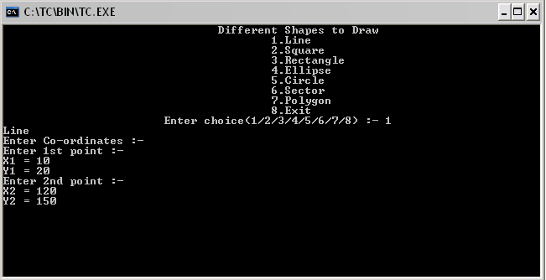
Output1:
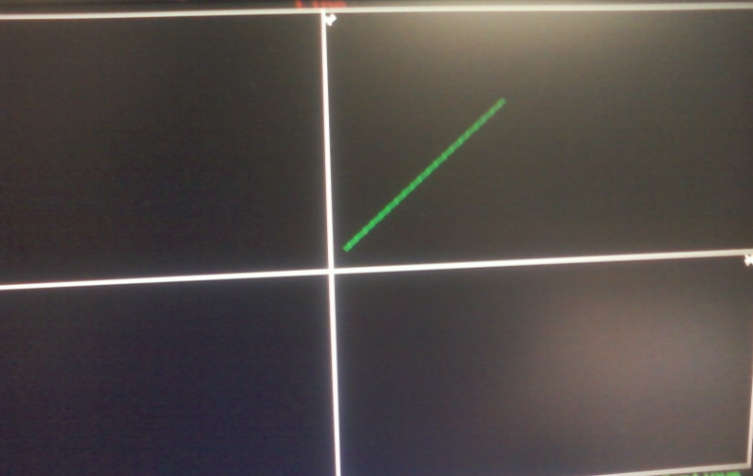
Input2
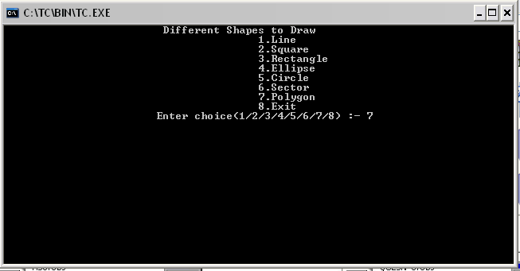
Output2
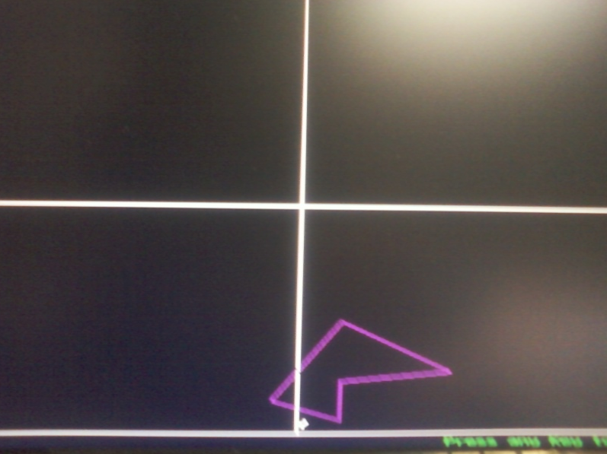

Input3: 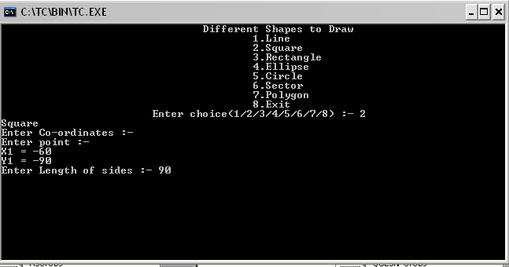Output3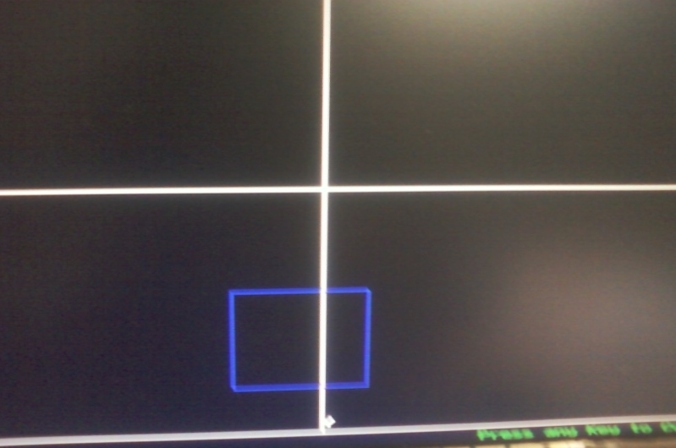

ASSIGNMENT:2
- Write a program with colours, pixels, bar and clear device using random number generation. We have a function random(no), it returns a random number between 0 and no. The effect is by drawing random radius, random colour circles with same center and random pixels. Kbhit() function(define in conio.h) returns a nonzero value when a key is pressed in the keyboard. So, the loop will continue until a key is pressed.

Code:
#include<graphics.h>
#include<stdlib.h>

int xMax,yMax;

void screenInitialize();
void draw();

void screenInitialize()
{
int gdriver = DETECT, gmode, errorcode;
initgraph(&gdriver, &gmode, "C:\\tc\\bgi");
outport(0x0378,0x00);
errorcode = graphresult();
if (errorcode != grOk)
{
printf("Graphics error: %s\n",grapherrormsg(errorcode));
printf("Press any key to halt:");
getch();
exit(0);
}
xMax=getmaxx();
yMax=getmaxy();
}

void draw()
{
setcolor(0);
setfillstyle(1,12);
bar(xMax/2-300,yMax/2-200,xMax/2+300,yMax/2+200);
setfillstyle(1,8);
bar(xMax/2-250,yMax/2-150,xMax/2+250,yMax/2+150);
while(!kbhit())
{
putpixel(random(439)+101,random(279)+101,random(16));
delay(300);
setcolor(random(16));
delay(300);
circle(320,240,random(170));
delay(300);
}
closegraph();
}

int main()
{
screenInitialize();
draw();
return 0;
}

Output:
Pic1
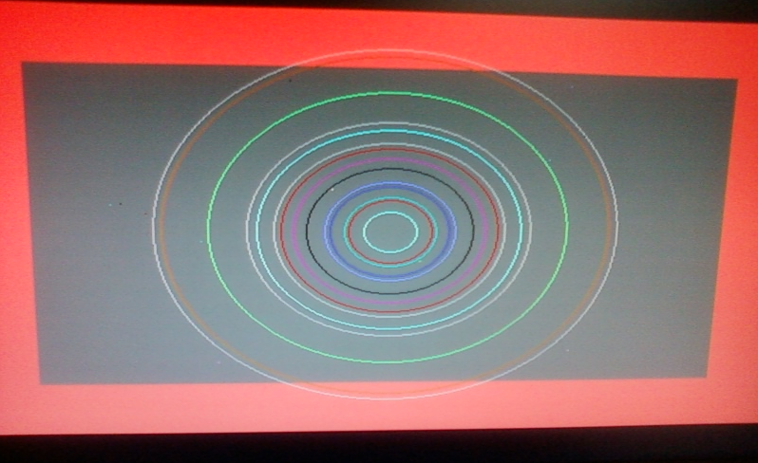

Pic2
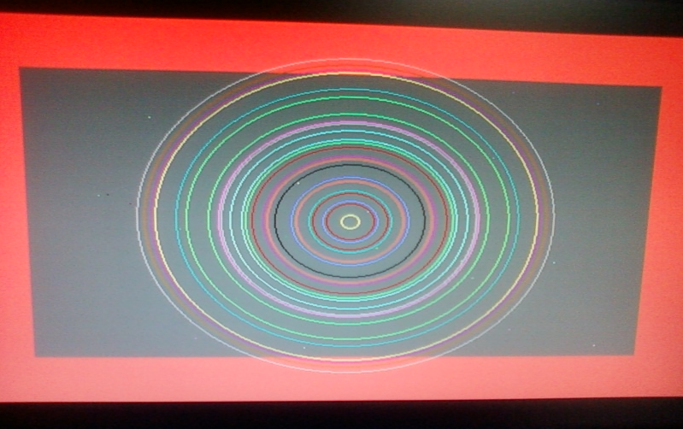

Pic3

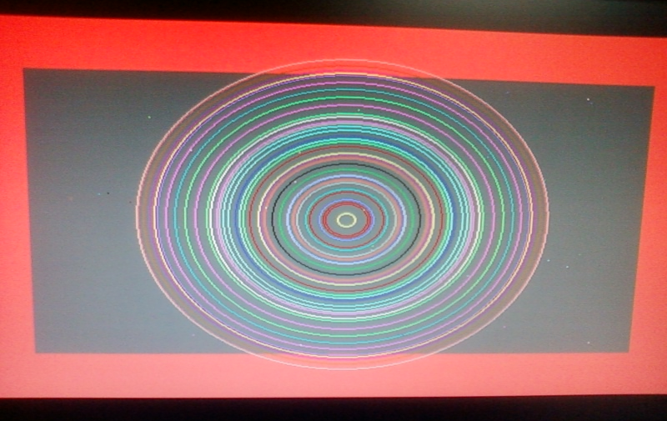

ASSIGNMENT:3
3.Given a finite number of cities (choose cities from 1 to a finite number) along with the distance of travel ( distance between two cities are randomly selected) between each pair of them. The aim is to find the cheapest distance of visiting all the cities and returning to the starting point.

#include <stdio.h>
#define MAX 100
#define INFINITY 999

int tsp_dp (int c[][MAX], int tour[], int start, int n);

int main()
{
int n; /* Number of cities. */
int i, j; /* Loop counters. */
int c[MAX][MAX]; /* Cost matrix. */
int tour[MAX]; /* Tour matrix. */
int cost; /* Least cost. */
clrscr();
printf ("This program demonstrates the TSP problem.");
printf ("\nHow many cities to traverse? ");
scanf ("%d", &n);
printf ("Enter the cost matrix: (999: no connection)\n");
for (i=0; i<n; i++)
for (j=0; j<n; j++)
scanf ("%d", &c[i][j]);

for (i=0; i<n; i++)
tour[i] = i;

cost = tsp_dp (c, tour, 0, n);

printf ("Minimum cost: %d.\nTour: ", cost);
for (i=0; i<n; i++)
printf ("%d ", tour[i]+1);
printf ("1\n");
getch();
return 0;
}

int tsp_dp (int c[][MAX], int tour[], int start, int n)
{
int i, j, k; /* Loop counters. */
int temp[MAX]; /* Temporary during calculations. */
int mintour[MAX]; /* Minimal tour array. */
int mincost; /* Minimal cost. */
int ccost; /* Current cost. */

/* End of recursion condition. */
if (start == n - 2)
return c[tour[n-2]][tour[n-1]] + c[tour[n-1]][0];

/* Compute the tour starting from the current city. */
mincost = INFINITY;
for (i = start+1; i<n; i++)
{ for (j=0; j<n; j++)
temp[j] = tour[j];

/* Adjust positions. */
temp[start+1] = tour[i];
temp[i] = tour[start+1];

/* Found a better cycle? (Recurrence derivable.) */
if (c[tour[start]][tour[i]] +
(ccost = tsp_dp (c, temp, start+1, n)) < mincost) {
mincost = c[tour[start]][tour[i]] + ccost;
for (k=0; k<n; k++)
mintour[k] = temp[k];
}
}

/* Set the minimum-tour array. */
for (i=0; i<n; i++)
tour[i] = mintour[i];

return mincost;
}

Input
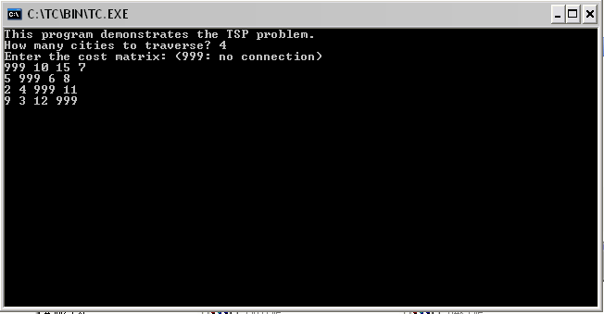

Output:
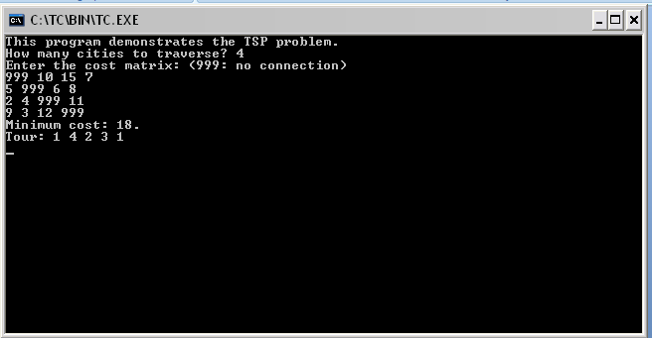

ASSIGNMENT:4
4.Read and display an image. A region of interest (ROI) is a portion of an image to filter or perform some other operation on. You can define ROI by creating a binary mask, which is a binary image that is the same size as the image you want to process with pixels that define the ROI set to 1 and all other pixel set to 0.

Creating a Binary mask

You can use the createMask method of the imroi base class to create a binary mask for any type of ROI object --- impoint, imlime, imrect, imellipse, impoly, or imfreehand. The createMask method returns a binary image the same size as the input image, containing 1s inside the ROI and 0s everywhere else.
For example, suppose you want to filter the grayscale image I, filtering only those pixels whose values are greater than 0.5. You can create the appropriate mask with this command:
BW= (I>0.5).

Code:

%----------- READ THE IMAGE AND DISPLAY IT ------------%
img = imread('cameraman.tif');
h_im = imshow(img);

%-------FIND REGION OF INTEREST(ROI): CREATE MASK & APPLY FILTER ------%
%%%%%%%%%%%%%%%%%%%%%%%%%%%%%%%%%%%%%%%%%%%%%%%%%%%%%%%%%%%%%%%%%%%%%%%%
%---------- ROI OF POINT SHAPE -----------%
e1 = impoint(gca,100,100);
BW1 = createMask(e1,h_im);
figure, imshow(BW1);
H = fspecial('unsharp');
J1 = roifilt2(H,img,BW1);
figure, imshow(J1);
%%%%%%%%%%%%%%%%%%%%%%%%%%%%%%%%%%%%%%%%%%%%%%%%%%%%%%%%%%%%%%%%%%%%%%%%
%---------- ROI OF LINE SHAPE -----------%
e2 = imline(gca,[100 150;170 150]);
BW2 = createMask(e2,h_im);
figure, imshow(BW2);
H = fspecial('unsharp');
J2 = roifilt2(H,img,BW2);
figure, imshow(J2);
%%%%%%%%%%%%%%%%%%%%%%%%%%%%%%%%%%%%%%%%%%%%%%%%%%%%%%%%%%%%%%%%%%%%%%%%
%---------- ROI OF RECTANGLE SHAPE -----------%
e3 = imrect(gca,[10 10 100 100]);
BW3 = createMask(e3,h_im);
figure, imshow(BW3);
H = fspecial('unsharp');
J3 = roifilt2(H,img,BW3);
figure, imshow(J3);
%%%%%%%%%%%%%%%%%%%%%%%%%%%%%%%%%%%%%%%%%%%%%%%%%%%%%%%%%%%%%%%%%%%%%%%%
%---------- ROI OF POLYGON SHAPE -----------%
c = [222 272 300 270 221 194];
r = [21 21 75 121 121 75];
e4 = impoly(gca,[67 47;67 97;121 125;167 95;167 46;121 19]);
BW4 = createMask(e4,h_im);
figure, imshow(BW4);
H = fspecial('unsharp');
J4 = roifilt2(H,img,BW4);
figure, imshow(J4);

%%%%%%%%%%%%%%%%%%%%%%%%%%%%%%%%%%%%%%%%%%%%%%%%%%%%%%%%%%%%%%%%%%%%%%%%
%---------- ROI OF ELLIPSE SHAPE -----------%
e5 = imellipse(gca,[38 30 150 100]);
BW5 = createMask(e5,h_im);
figure, imshow(BW5);
H = fspecial('unsharp');
J5 = roifilt2(H,img,BW5);
figure, imshow(J5);
%%%%%%%%%%%%%%%%%%%%%%%%%%%%%%%%%%%%%%%%%%%%%%%%%%%%%%%%%%%%%%%%%%%%%%%%
%---------- ROI OF FREEHAND SHAPE -----------%
e6 = imfreehand(gca);
% ---- wait on interactive freehand selection window-----%
pos=wait(e6);
%------double click to resume opertion after selection---%
BW6 = createMask(e6,h_im);
figure, imshow(BW6);
H = fspecial('unsharp');
J6 = roifilt2(H,img,BW6);
figure, imshow(J6);

Output:
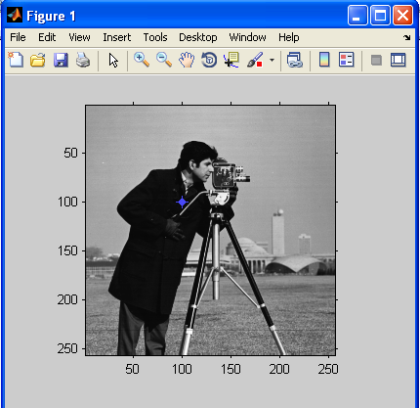

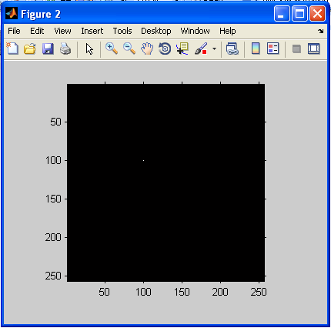

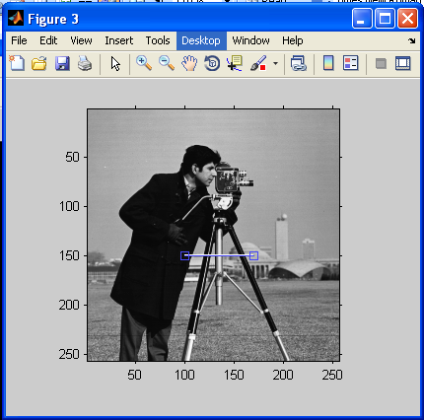

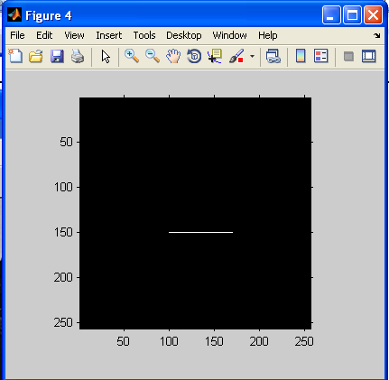

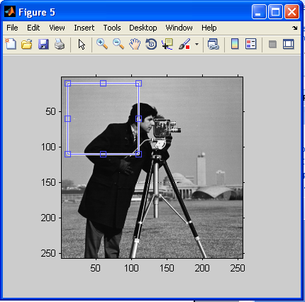

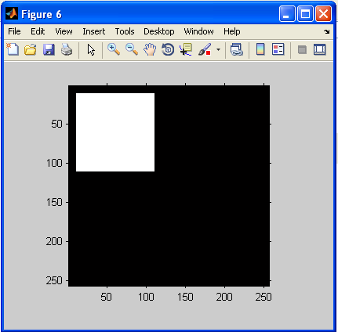

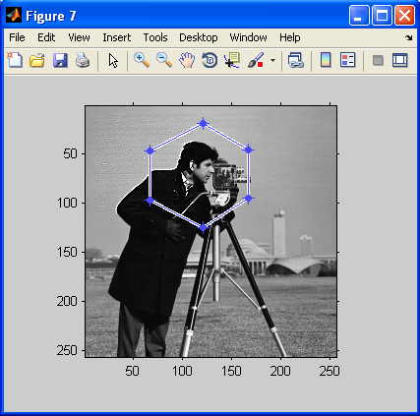

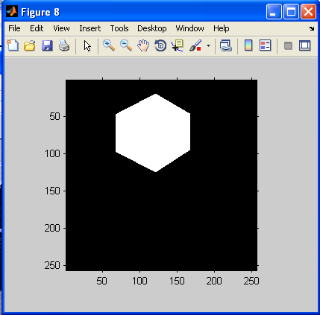

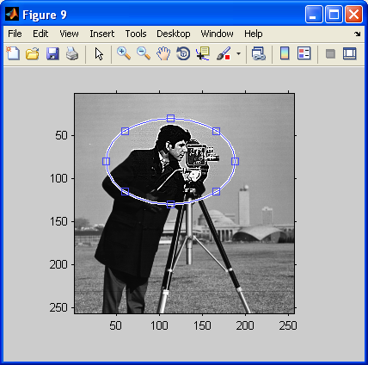

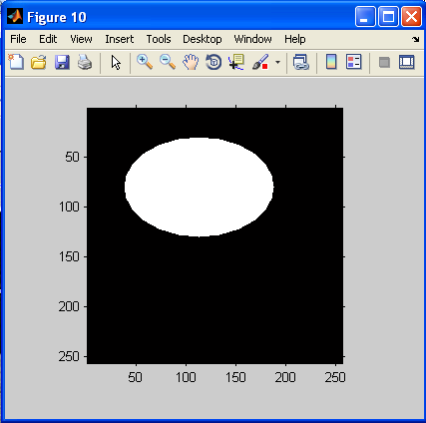

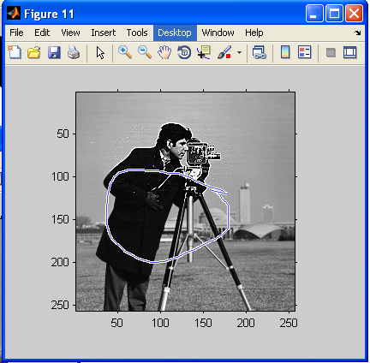

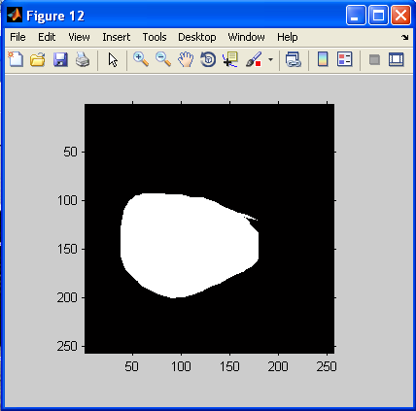

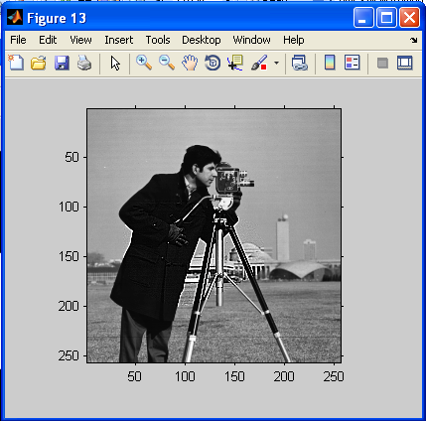

ASSIGNMENT:5
The various mouse functions can be accessed by setting up the AX register with different values (service number) and issuing interrupt number 51. The functions are listed below,
- Reset mouse and get status
- Hide mouse pointer
- Show mouse pointer

Code:
#include<graphics.h>
#include<stdio.h>
#include<conio.h>
#include<dos.h>
union REGS in,out;

int callmouse()
{
in.x.ax=0;
int86(51,&in,&out);
if(out.x.ax==0)
printf("\nmouse not avelable");
else
{
printf("\nmouse avelable");
printf("\npress any key to continue:");
getch();
}
in.x.ax=1;
int86(51,&in,&out);
return 1;
}
void mouseposi(int &xpos,int &ypos,int &click)
{
in.x.ax=3;
int86(51,&in,&out);
click=out.x.bx;
xpos=out.x.cx;
ypos=out.x.dx;
}
int mousehide()
{
in.x.ax=2;
int86(51,&in,&out);
return 1;
}
void setposi(int &xpos,int &ypos)
{
in.x.ax=4;
in.x.cx=xpos;
in.x.dx=ypos;
int86(51,&in,&out);
}
int main()
{
int x,y,cl,a,b;
clrscr();
int g=DETECT,m;
initgraph(&g,&m,"c:\tc\bgi");
a=100;
b=400;
setposi(a,b);
printf("\npress any key to check mouse status...");
getch();
callmouse();
do
{
mouseposi(x,y,cl);
gotoxy(10,9);
printf("\n\tMouse Position is: %d,%d",x,y);
printf("\n\tClick: %d",cl);
printf("\n\tPress any key to hide the mouse");
}while(!kbhit());
getch();
mousehide();
printf("\n\n\tPress any key to Exit");
getch();}
Output: