UNIVERSITY OF CALCUTTA



Roll . 91/CIS/ No. 091028
Reg.no: 0063688 of 2006-2007
M.Sc 3rd Semester, 2010 (Computer & Information Science)

ASSIGNMENT 1

Write C program to draw some basic shapes such as Line, Rectangle, Ellipse, Sector and Polygon.

PROGRAM CODE

//=================ASSIGNMENT 1=========================

#include<stdio.h>
#include<graphics.h>
#include<conio.h>

void main()
{
int gd=DETECT, gm;
int poly[12]={350,450, 350,410, 430,400, 350,350, 300,430, 350,450 };
initgraph(&gd, &gm, "F:\\TC\\BGI");
circle(100,100,50);
outtextxy(75,170, "Circle");
rectangle(200,50,350,150);
outtextxy(240, 170, "Rectangle");
ellipse(500, 100,0,360, 100,50);
outtextxy(480, 170, "Ellipse");
line(100,250,540,250);
outtextxy(300,260,"Line");
sector(150, 400, 30, 300, 100,50);
outtextxy(120, 460, "Sector");
drawpoly(6, poly);
outtextxy(340, 460, "Polygon");
getch();
closegraph();
}

OUTPUT

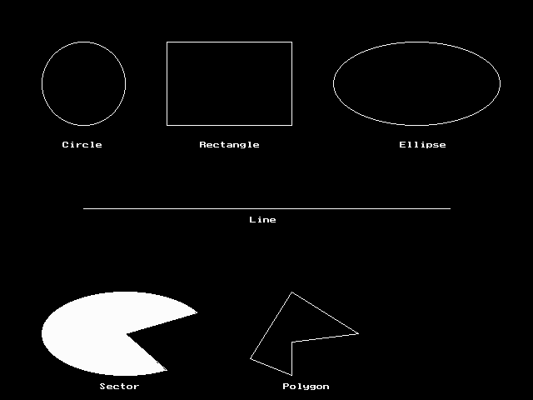

ASSIGNMENT 2

Write a program with colors, pixels, bar and cleardevice using random number generation. We have a function random(no), it returns a random number between 0 and no. The effect is by drawing random radius, random color circles with same center and random pixels. kbhit() function (defined in conio.h) returns a non zero value when a key is pressed in the keyboard. So, the loop will continue until a key is pressed.

PROGRAM CODE

//===================ASSIGNMENT 2===========================

#include<graphics.h>
#include<conio.h>
#include<stdlib.h>

void main()
{
int gd,gm;
gd=DETECT;

initgraph(&gd, &gm, "F:\\TC\\BGI");
setcolor(3);
setfillstyle(SOLID_FILL,RED);
bar(50, 50, 590, 430);

setfillstyle(1, 14);
bar(100, 100, 540, 380);

while(!kbhit())
{
putpixel(random(439)+101, random(279)+101,random(16));
setcolor(random(16));
circle(320,240,random(100));
}
getch();
closegraph();
}

OUTPUT

The output can not be shown as random circles with random radius (same center) and random color pixels are drawn.

ASSIGNMENT 3

Given a finite number of cities (choose cities from 1 to a finite number ) along with the distance of travel ( distance between two cities is randomly selected ) between each pair of them . The aim is to find the cheapest distance of visiting all the cities and returning to the starting point.

PROGRAM CODE

//===================ASSIGNMENT 3===========================

#include <stdio.h>
#define MAX 100
#define INFINITY 999

int tsp_dp (int c[][MAX], int tour[], int start, int n);

int main()
{
int n; /* Number of cities. */
int i, j; /* Loop counters. */
int c[MAX][MAX]; /* Cost matrix. */
int tour[MAX]; /* Tour matrix. */
int cost; /* Least cost. */
clrscr();
printf ("This program demonstrates the TSP problem.");
printf ("\nHow many cities to traverse? ");
scanf ("%d", &n);
printf ("Enter the cost matrix: (999: no connection)\n");
for (i=0; i<n; i++)
for (j=0; j<n; j++)
scanf ("%d", &c[i][j]);

for (i=0; i<n; i++)
tour[i] = i;

cost = tsp_dp (c, tour, 0, n);

printf ("Minimum cost: %d.\nTour: ", cost);
for (i=0; i<n; i++)
printf ("%d ", tour[i]+1);
printf ("1\n");
getch();
return 0;
}

int tsp_dp (int c[][MAX], int tour[], int start, int n)
{
int i, j, k; /* Loop counters. */
int temp[MAX]; /* Temporary during calculations. */
int mintour[MAX]; /* Minimal tour array. */
int mincost; /* Minimal cost. */
int ccost; /* Current cost. */

/* End of recursion condition. */
if (start == n - 2)
return c[tour[n-2]][tour[n-1]] + c[tour[n-1]][0];

/* Compute the tour starting from the current city. */
mincost = INFINITY;
for (i = start+1; i<n; i++)
{ for (j=0; j<n; j++)
temp[j] = tour[j];

/* Adjust positions. */
temp[start+1] = tour[i];
temp[i] = tour[start+1];

/* Found a better cycle? (Recurrence derivable.) */
if (c[tour[start]][tour[i]] +
(ccost = tsp_dp (c, temp, start+1, n)) < mincost) {
mincost = c[tour[start]][tour[i]] + ccost;
for (k=0; k<n; k++)
mintour[k] = temp[k];
}
}

/* Set the minimum-tour array. */
for (i=0; i<n; i++)
tour[i] = mintour[i];

return mincost;
}

OUTPUT

This program demonstrates the TSP problem.

How many cities to traverse? 5
Enter the cost matrix: (999: no connection)

999 4 999 1 2
4 999 5 4 999
999 5 999 999 3
1 4 999 999 999
2 999 3 999 999

Minimum cost: 15.
Tour: 1 4 2 3 5 1

ASSIGNMENT 4

Read and display an image. A region of interest (ROI) is a portion of an image to filter or perform some other operation on. You can define an ROI by creating a binary mask, which is a binary image that is the same size as the image you want to process with pixels that define the ROI set to 1 and all other pixels set to 0.

Creating a Binary Mask
You can use the createMask method of the imroi base class to create a binary mask for any type of ROI object — impoint, imline, imrect, imellipse, impoly, or imfreehand. The createMask method returns a binary image the same size as the input image, containing 1s inside the ROI and 0s everywhere else.

PROGRAM CODE

%----------- READ THE IMAGE AND DISPLAY IT ------------%
img = imread('cameraman.tif');
h_im = imshow(img);

%-------FIND REGION OF INTEREST(ROI): CREATE MASK & APPLY FILTER ------%
%%%%%%%%%%%%%%%%%%%%%%%%%%%%%%%%%%%%%%%%%%%%%%%%%%%%%%%%%%%%%%%%%%%%%%%%
%---------- ROI OF POINT SHAPE -----------%
e1 = impoint(gca,100,100);
BW1 = createMask(e1,h_im);
figure, imshow(BW1);
H = fspecial('unsharp');
J1 = roifilt2(H,img,BW1);
figure, imshow(J1);
%%%%%%%%%%%%%%%%%%%%%%%%%%%%%%%%%%%%%%%%%%%%%%%%%%%%%%%%%%%%%%%%%%%%%%%%
%---------- ROI OF LINE SHAPE -----------%
e2 = imline(gca,[100 150;170 150]);
BW2 = createMask(e2,h_im);
figure, imshow(BW2);
H = fspecial('unsharp');
J2 = roifilt2(H,img,BW2);
figure, imshow(J2);
%%%%%%%%%%%%%%%%%%%%%%%%%%%%%%%%%%%%%%%%%%%%%%%%%%%%%%%%%%%%%%%%%%%%%%%%
%---------- ROI OF RECTANGLE SHAPE -----------%
e3 = imrect(gca,[10 10 100 100]);
BW3 = createMask(e3,h_im);
figure, imshow(BW3);
H = fspecial('unsharp');
J3 = roifilt2(H,img,BW3);
figure, imshow(J3);
%%%%%%%%%%%%%%%%%%%%%%%%%%%%%%%%%%%%%%%%%%%%%%%%%%%%%%%%%%%%%%%%%%%%%%%%
%---------- ROI OF POLYGON SHAPE -----------%
c = [222 272 300 270 221 194];
r = [21 21 75 121 121 75];
e4 = impoly(gca,[67 47;67 97;121 125;167 95;167 46;121 19]);
BW4 = createMask(e4,h_im);
figure, imshow(BW4);
H = fspecial('unsharp');
J4 = roifilt2(H,img,BW4);
figure, imshow(J4);

%%%%%%%%%%%%%%%%%%%%%%%%%%%%%%%%%%%%%%%%%%%%%%%%%%%%%%%%%%%%%%%%%%%%%%%%%---------- ROI OF ELLIPSE SHAPE -----------%
e5 = imellipse(gca,[38 30 150 100]);
BW5 = createMask(e5,h_im);
figure, imshow(BW5);
H = fspecial('unsharp');
J5 = roifilt2(H,img,BW5);
figure, imshow(J5);
%%%%%%%%%%%%%%%%%%%%%%%%%%%%%%%%%%%%%%%%%%%%%%%%%%%%%%%%%%%%%%%%%%%%%%%%
%---------- ROI OF FREEHAND SHAPE -----------%
e6 = imfreehand(gca);
% ---- wait on interactive freehand selection window-----%
pos=wait(e6);
%------double click to resume opertion after selection---%
BW6 = createMask(e6,h_im);
figure, imshow(BW6);
H = fspecial('unsharp');
J6 = roifilt2(H,img,BW6);
figure, imshow(J6);

OUTPUT

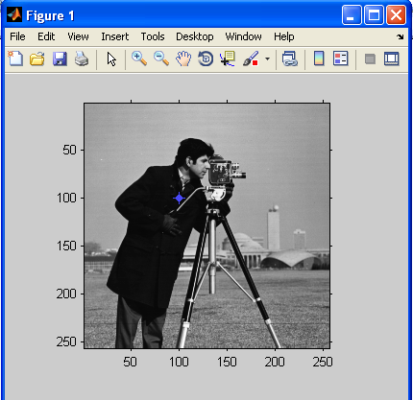

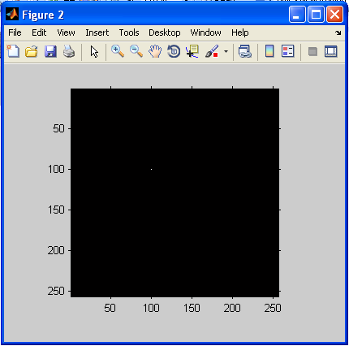

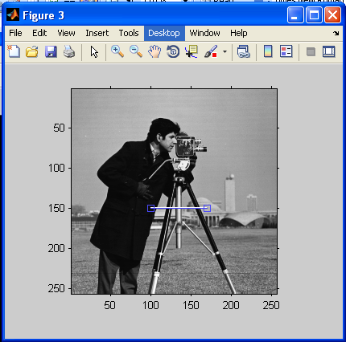

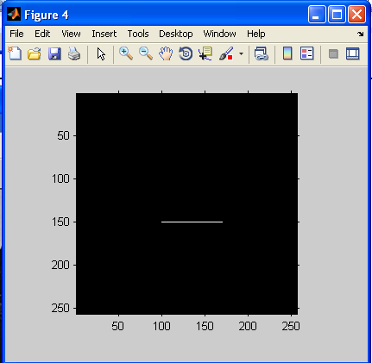

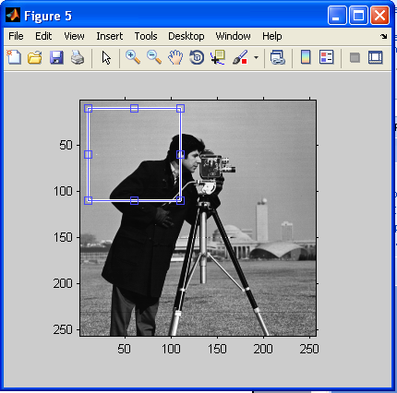

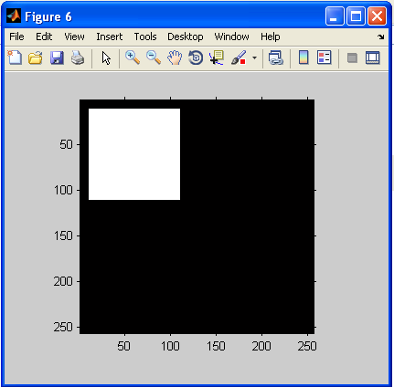

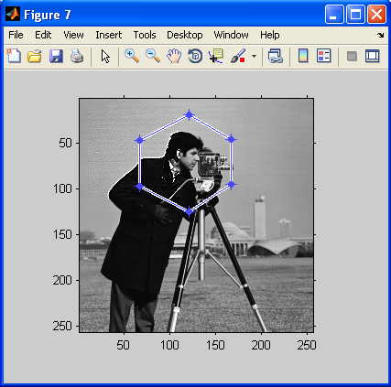

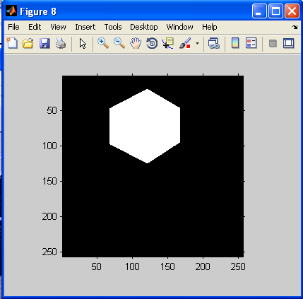

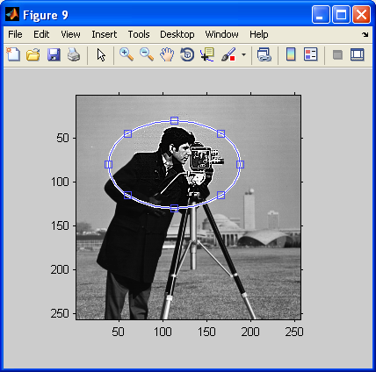

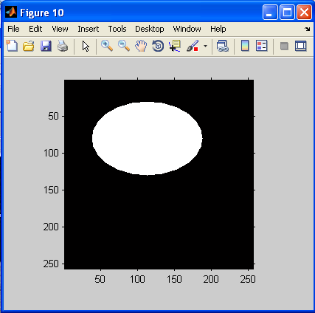

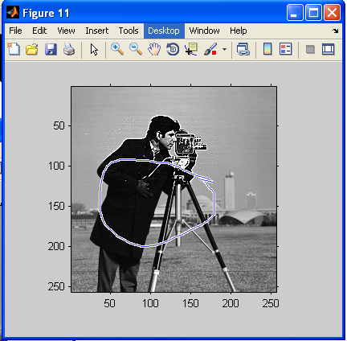

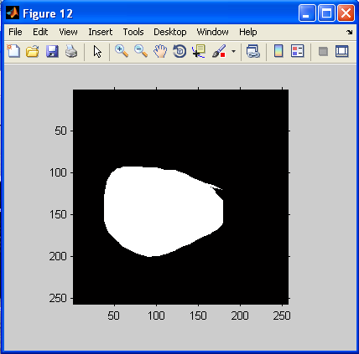

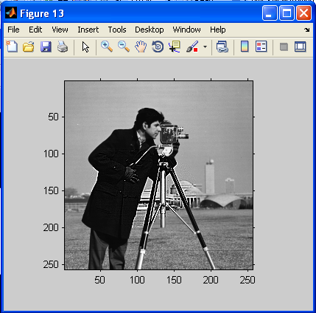

ASSIGNMENT 5

The various mouse functions can be accessed by setting up the AX register with different values (service number) and issuing interrupt number 51. The functions are listed below:

- Reset mouse and get status
- Hide mouse pointer
- Show mouse pointer

PROGRAM CODE

//=====================ASSIGNMENT 5======================

#include<graphics.h>
#include<stdio.h>
#include<conio.h>
#include<dos.h>
union REGS in,out;
int rstmouse()
{
in.x.ax=0;
int86(51,&in,&out);
if(out.x.ax==0xffff)
printf("Mouse support is available in the system\n");
else
printf("Mouse support is not available in the system\n");
return 1;
}
int callmouse()
{
in.x.ax=1;
int86(51,&in,&out);
return 1;
}
void mouseposi(int &xpos,int &ypos,int &click)
{
in.x.ax=3;
int86(51,&in,&out);
click=out.x.bx;
xpos=out.x.cx;
ypos=out.x.dx;
}
int mousehide()
{
in.x.ax=2;
int86(51,&in,&out);
return 1;
}
int main()
{
int x,y,cl,a,b;
clrscr();
int g=DETECT,m;
initgraph(&g,&m,"f:\tc\bgi");
printf("\n\t Resetting mouse and get status: ");
rstmouse();

printf("\n\t Showing mouse pointer");
callmouse();
do
{
mouseposi(x,y,cl);
gotoxy(10,9);
printf("\n\tMouse Position is: %d,%d",x,y);
printf("\n\tPress any key to hide the mouse");
}while(!kbhit());
getch();
mousehide();
printf("\n\n\tPress any key to Exit");
getch();
return 0;
}

OUTPUT

Resetting mouse and get status: Mouse support is available in the system

Showing mouse pointer

Mouse Position is: 368,112

Press any key to hide the mouse

Press any key to Exit

