SUDOKU puzzle has become very popular in recent days and is being published in almost all the News papers now. This program can be used to generate sudoku puzzles of required difficulty level and for solving any given sudoku puzzle.

Logic used for Solution:

The program does not use any extreme graphics functions and still has a good outlook as shown in figure 1. For solving the puzzle, the first vacant box is filled with the first consistent number (which is not present in the same row, column and 3 X 3 matrix) starting from 1 to 9. The filled number might be correct or wrong. Next vacant box is filled using same logic. If the number filled in any box is wrong, there exists a case where a certain box cannot be filled with any number from 1 to 9. In that case present box is made vacant and the number in the previously filled box is incremented to the next consistent number.

Logic used for generation:

For generating a sudoku puzzle we cannot randomly assign consistent numbers to vacant boxes. That may lead to a sudoku puzzle that has no solution. Hence a minimum (10) of locations are filled first with random numbers and a solution is obtained. From the solved puzzle certain randomly selected locations are displayed making others zero.

To enter elements for solving a puzzle, row and column number of corresponding number have to be specified as shown in figure 1. After all the elements are entered, ‘0’ (zero) has to be entered to finish entering. The solved puzzle would look like the one shown in figure 2.

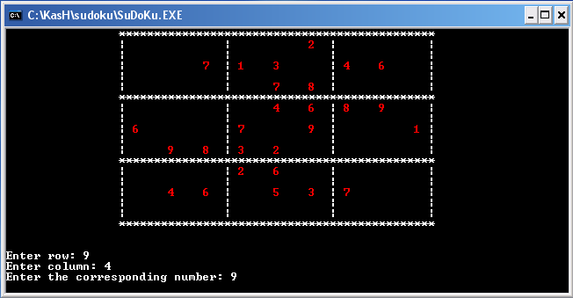

Figure 1.

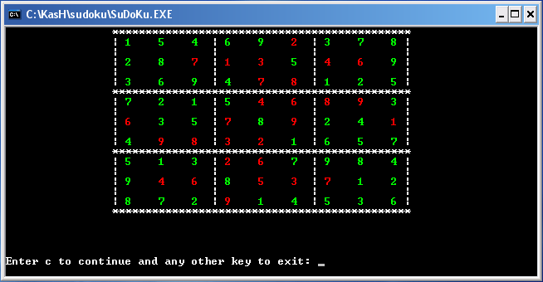

Figure 2.

