1) Write a program that will use bitwise & operator to perform bitwise AND operation,bitwise operator to perform bitwise inclusive OR operation ans bitwise ^ operator to perform bitwise exclusive OR operation
Program:-
class bitwiseOps
{
public static void main(String argv[])
{
int a=13,b=25;
System.out.println("a = "+a);
System.out.println("b = "+b);
System.out.println("(a & b) = "+(a&b));
System.out.println("(a | b) = "+(a|b));
System.out.println("(a ^ b) = "+(a^b));
}
}
Output:-

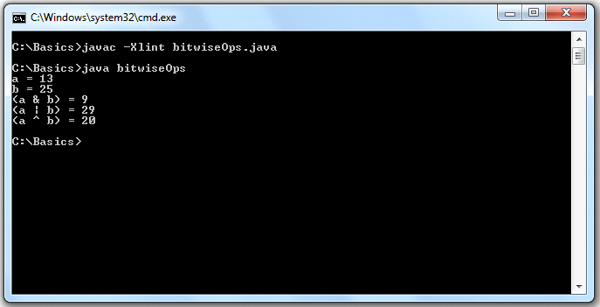

2) Write a program to demonstrate Boolean variable in JAVA and also show that they are compatible with relational operators

Program:-
class boolen
{
public static void main(String argv[])
{
boolean state;
state=false;
System.out.println("The state now is "+state);
state=true;
System.out.println("The state now is "+state);
System.out.println("A boolean variable can contain the branching statement");
if(state)
System.out.println("TRUE");
System.out.println("Outcome of Relational Operator is boolean");
System.out.println("12>9\t"+(12>9));
System.out.println("12<9\t"+(12<9));
}
}
Output:-
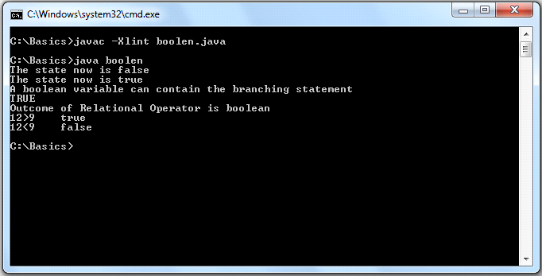

3) Write a program to to demonstrate character variables in JAVA also show that in ceratin situations they behave like integers
Program:-
class chrctr
{
public static void main(String argv[])
{
char a1='a',a2=65;
System.out.println("The value of a1 is = "+a1);
System.out.println("The value of a2 is = "+a2);
System.out.println("Character variables sometimes behaves like Integers = ");
a1++;
a2++;
System.out.println("The value of a1++ is = "+a1);
System.out.println("The value of a2++ is = "+a2);
}
}
Output:-
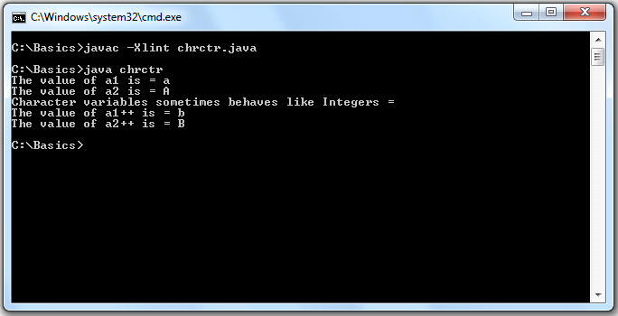

4) Write a program to demonstrate comand line arguments
Program:-
class cmdLn
{
public static void main(String argv[])
{
int n=0;
if(argv.length == 0)
System.out.println("No arguments passed");
for(int i=0;i<argv.length;i++)
{
n=Integer.parseInt(argv[i]);
System.out.println("argv["+i+"]="+n);
}
}
}

Output:-
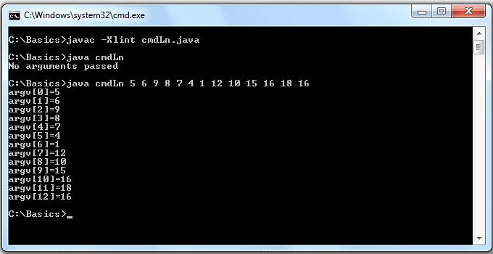

5) Write a program to to demonstrate the working of conditional operators in JAVA
Program:-
class conditionalOp
{
public static void main(String argv[])
{
int a,b;
a=98786;
b=756757;
System.out.println("a = "+a+"\nb = "+b);
System.out.println("a > b ? (True = a) ? (False = b) :---------> "+(a>b?a:b));
System.out.println("a < b ? (True = a) ? (False = b) :---------> "+(a<b?a:b));
}
}

Output:-
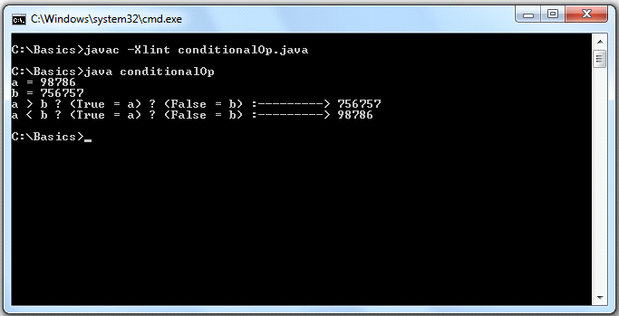

6) To demonstrate all the Float(float,double) types available in JAVA
Program:-
class flot
{
public static void main(String args[])
{
float a1,a2;
double b1,b2;
a1=5e+17f;
a2=6e+20f;
System.out.println("FLOAT\na1 = "+a1+"\na2="+a2+"\na1 * a2 = "+a1*a2);
b1=3e+150;
b2=4e+157;
System.out.println("DOUBLE\nb1 = "+b1+"\nb2="+b2+"\nb1 * b2 = "+b1*b2);
}
}

Output:-
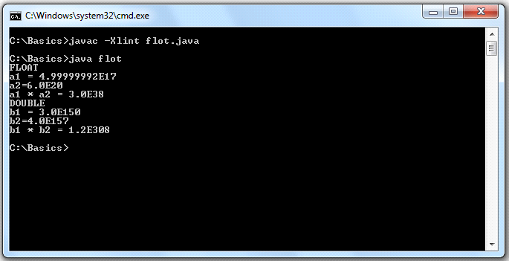

7) Write a program to to demonstrate the Float arithmetic operations performed in JAVA
Program:-
import java.util.Scanner;
class flotArth
{
public static void main(String argv[])
{
Scanner in = new Scanner(System.in);
float r=0.0f;
double pi=3.142857142857,cir=0.0f,area=0.0f;
System.out.print("Enter Radius of circle in float: ");
r=in.nextFloat();
cir=2*pi*r;
area=pi*r*r;
System.out.println("Circumference of circle = "+cir+"\nArea of circle = "+area);
}
}

Output:-
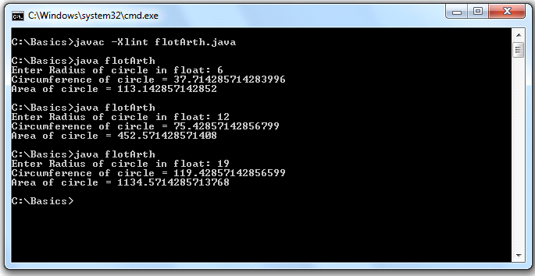

8) Write a program to demonstrate the Integer arithmetic operations performed in JAVA
Program:-
import java.util.Scanner;
class intArth
{
public static void main(String args[])
{
Scanner in = new Scanner(System.in);
int lengthr=0,breadthr=0,lengths=0,areas,arear,peris,perir;
System.out.print("Enter length of square in integer: ");
lengths=in.nextInt();
System.out.print("Enter length of rectangle in integer: ");
lengthr=in.nextInt();
System.out.print("Enter breadth of rectangle in integer: ");
breadthr=in.nextInt();
areas=lengths*lengths;
arear=lengthr*breadthr;
peris=4*lengths;
perir=2*(lengthr+breadthr);
System.out.println("Square\nPerimeter = "+peris+"\nArea = "+areas);
System.out.println("Rectangle\nPerimeter = "+perir+"\nArea = "+arear);
}
}

Output:-
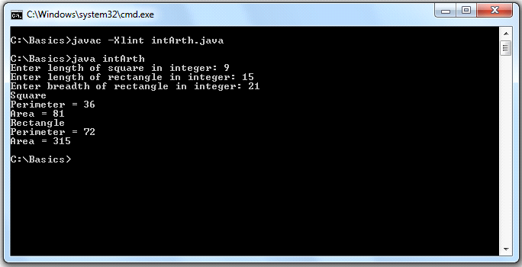

9) To demonstrate all the Integer(short,int,long,byte) types available in JAVA
Program:-
class integr
{
public static void main(String args[])
{
int a1,a2;
long b1,b2;
short c1,c2;
byte d1,d2;
a1=46340;
a2=46341;
System.out.println("INT\na1 = "+a1+"\na2="+a2+"\na1 * a2 = "+a1*a2);
b1=303700049;
b2=303700050;
System.out.println("LONG\nb1 = "+b1+"\nb2="+b2+"\nb1 * b2 = "+b1*b2);
c1=181;
c2=182;
System.out.println("SHORT\nc1 = "+c1+"\nc2="+c2+"\nc1 * c2 = "+c1*c2);
d1=11;
d2=11;
System.out.println("BYTE\nd1 = "+d1+"\nd2="+d2+"\nd1 * d2 = "+d1*d2);
}
}

Output:-
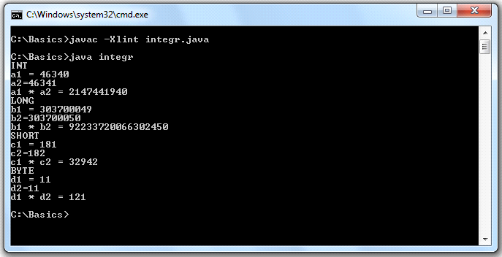

10) Write a program that will take int,float and double values given by user and display them
Program:-
import java.util.Scanner;
class intfltdbl
{
public static void main(String argv[])
{
Scanner in = new Scanner(System.in);
int intNumber=0;
float floatNumber=0.0f;
double doubleNumber=0.0;
System.out.print("Enter Integer Value: ");
intNumber=in.nextInt();
System.out.print("Enter Float Value: ");
floatNumber=in.nextFloat();
System.out.print("Enter Double Value: ");
doubleNumber=in.nextDouble();
System.out.println("intNumber = "+intNumber);
System.out.println("floatNumber = "+floatNumber);
System.out.println("doubleNumber = "+doubleNumber);
}
}

Output:-

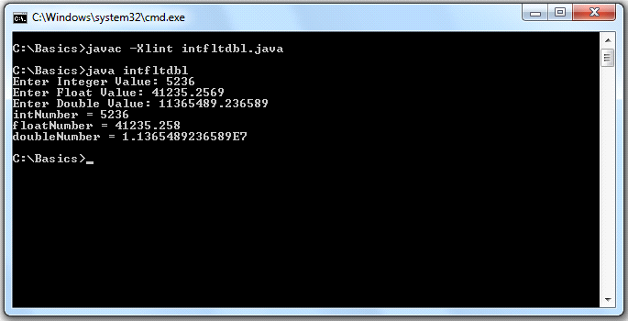

11) Write a program that will demonstrate arithmetic operations performed with int,float and double values given by user
Program:-
import java.util.Scanner;
class intfltdblArth
{
public static void main(String argv[])
{
Scanner in = new Scanner(System.in);
int resulti=0,intNumber1=0,intNumber2=0;
float resultf=0.0f,floatNumber1=0.0f,floatNumber2=0.0f;
double resultd=0.0,doubleNumber1=0.0,doubleNumber2=0.0;
System.out.print("Integer\nEnter Number 1: ");
intNumber1=in.nextInt();
System.out.print("Enter Number 2: ");
intNumber2=in.nextInt();
System.out.print("Float\nEnter Number 1: ");
floatNumber1=in.nextFloat();
System.out.print("Enter Number 2: ");
floatNumber2=in.nextFloat();
System.out.print("Double\nEnter Number 1: ");
doubleNumber1=in.nextDouble();
System.out.print("Enter Number 2: ");
doubleNumber2=in.nextDouble();

resulti=intNumber1+intNumber2;
System.out.println("Integer-------\n"+intNumber1+" + "+intNumber2+" = "+resulti);
resulti=intNumber1-intNumber2;
System.out.println(intNumber1+" - "+intNumber2+" = "+resulti);
resulti=intNumber1*intNumber2;
System.out.println(intNumber1+" * "+intNumber2+" = "+resulti);
resulti=intNumber1/intNumber2;
System.out.println(intNumber1+" / "+intNumber2+" = "+resulti);

resultf=floatNumber1+floatNumber2;
System.out.println("Float-------\n"+floatNumber1+" + "+floatNumber2+" = "+resultf);
resultf=floatNumber1-floatNumber2;
System.out.println(floatNumber1+" - "+floatNumber2+" = "+resultf);
resultf=floatNumber1*floatNumber2;
System.out.println(floatNumber1+" * "+floatNumber2+" = "+resultf);
resultf=floatNumber1/floatNumber2;
System.out.println(floatNumber1+" / "+floatNumber2+" = "+resultf);

resultd=doubleNumber1+doubleNumber2;
System.out.println("Double-------\n"+doubleNumber1+" + "+doubleNumber2+" = "+resultd);
resultd=doubleNumber1-doubleNumber2;
System.out.println(doubleNumber1+" - "+doubleNumber2+" = "+resultd);
resultd=doubleNumber1*doubleNumber2;
System.out.println(doubleNumber1+" * "+doubleNumber2+" = "+resultd);
resultd=doubleNumber1/doubleNumber2;
System.out.println(doubleNumber1+" / "+doubleNumber2+" = "+resultd);
}
}

Output:-

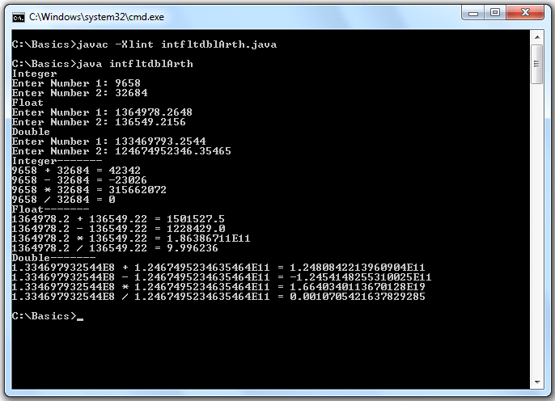

12) Write a program to demonstrate the Mixed mode arithmetic operation performed inJAVA
Program:-
import java.util.Scanner;
class mixdArth
{
public static void main(String argv[])
{
Scanner in = new Scanner(System.in);
int intNumber=0;
float floatNumber=0.0f;
System.out.print("Enter Integer Value: ");
intNumber=in.nextInt();
System.out.print("Enter Float Value: ");
floatNumber=in.nextFloat();
System.out.println("Mixed Mode Arithmetic\n"+intNumber+" * "+floatNumber+" = "+(intNumber*floatNumber)+"\n"+intNumber+" / "+floatNumber+" = "+(intNumber/floatNumber));
}
}

Output:-

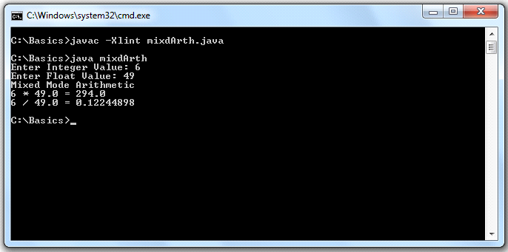
13) Write a program to demonstrate pre-increment and post-increment operation with an integer.Also perform decrement operation in the same way
Program:-
class postpreInDe
{
public static void main(String argv[])
{
int intNumber;
intNumber=198236;
System.out.println("Before Post-Increment --- "+intNumber+"\nAfter Post-Increment --- "+(intNumber++));
System.out.println("Before Pre-Increment --- "+intNumber+"\nAfter Pre-Increment --- "+(++intNumber));
intNumber=937464;
System.out.println("Before Post-Decrement --- "+intNumber+"\nAfter Post_Decrement ---"+(intNumber--));
System.out.println("Before Pre-Decrement --- "+intNumber+"\nAfter Pre_Decrement ---"+(--intNumber));
}
}

Output:-
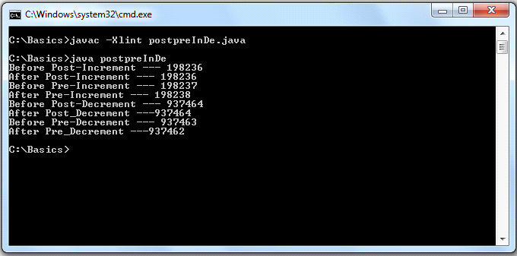

14) Write a program to demonstrate the printing facility provided by JAVA(use of print,printf,println)
Program:-
class printing
{ public static void main(String args[])
{
System.out.println("----------This line is printed using PRINTLN-----------");
System.out.print("****************This line is printed using PRINT***************");
System.out.printf("===============This line is printed using PRINTF==============");
System.out.println("----------This line is printed using 2nd PRINTLN-----------");
}
}

Output:-

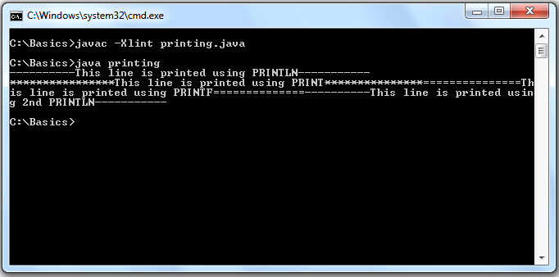

15) Write a program to demonstrate the working of relational operators and their evaluation as Boolean in JAVA
Program:-
class relationalOp
{
public static void main(String args[])
{
double a=19e199,b=48e150,c=19e199;
System.out.println("a = "+a+"\nb = "+b+"\nc = "+c);
System.out.println("a < b = "+(a<b));
System.out.println("c > b = "+(c>b));
System.out.println("a == c = "+(a==c));
System.out.println("a >= c = "+(a>=c));
System.out.println("a <= b = "+(a<=b));
System.out.println("a != c = "+(a!=c));
}
}

Output:-

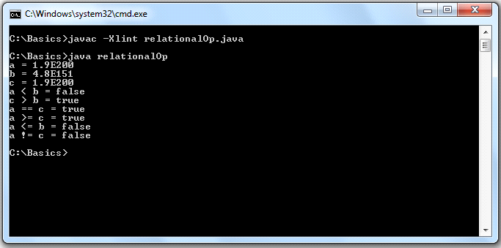

16) Write a program that will declare an integer type of array and display its values initialized at compiled time individually
Program:-
class runTimeArrIn
{
public static void main(String argv[])
{
int []a = {3,1,4,1,5,9};
int b[] = {78,98,63,25,54,49};
System.out.println("\nUsing enhanced for loop feature");
for(int i:a)
System.out.print(i+"\t");
System.out.println("\nUsing .length feature");
for(int i=0;i<b.length;i++)
System.out.println("b["+i+"] = "+b[i]);
}
}

Output:-

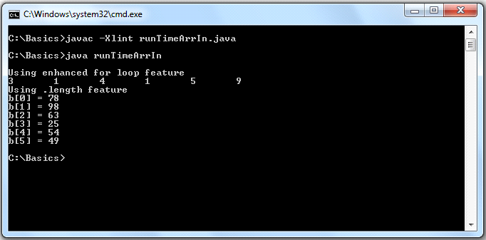

17) Write a program that will perform concatenation of two strings
Program:-
import java.io.DataInputStream;
class strCat
{
public static void main(String argv[])
{
DataInputStream in = new DataInputStream(System.in);
String str1="",str2="";
try
{
System.out.print("Enter a string1 : ");
str1=in.readLine();
System.out.print("Enter a string2 : ");
str2=in.readLine();
}
catch(Exception E)
{
}
System.out.println("After concatenation:-\n"+str1+" "+str2);
}
}

Output:-
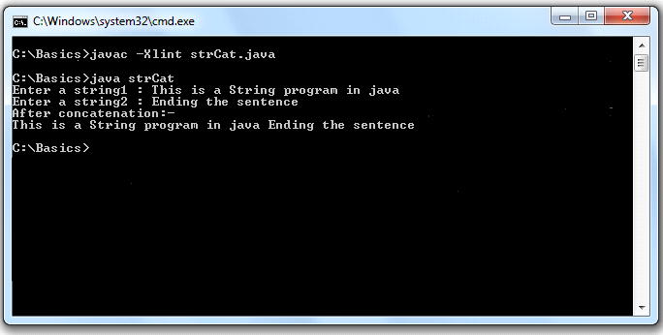

18) Write a program that will demonstrate initialization of string by user input
Program:-
import java.io.DataInputStream;
class strUserIn
{
public static void main(String argv[])
{
DataInputStream in = new DataInputStream(System.in);
String str="";
try
{
System.out.println("Enter a string: ");
str=in.readLine();
}
catch(Exception E)
{
}
System.out.println("Read string = "+str);
}
}
Output:-
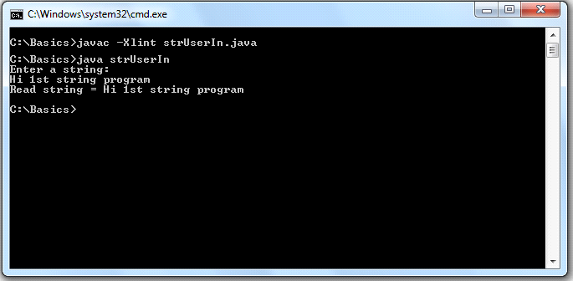

19) Write a program that will take two numbers from the user and check whether they are Amicable numbers or not

Program:-
import java.util.Scanner;
class amicablNo
{
public static void main(String argv[])
{
Scanner in = new Scanner(System.in);
int intNumber1=0,intNumber2=0,div1=0,div2=0,n=0;
System.out.print("Enter Number 1: ");
intNumber1=in.nextInt();
System.out.print("Enter Number 2: ");
intNumber2=in.nextInt();
n=intNumber1;
for(int i=1;i<=n/2;i++)
{
if(n % i == 0)
div1=div1+i;
}
n=intNumber2;
for(int i=1;i<=n/2;i++)
{
if(n % i == 0)
div2=div2+i;
}
if(intNumber1 == div2 && intNumber2 == div1)
System.out.println(intNumber1+" and "+intNumber2+" are Amicable Numbers");
else
System.out.println(intNumber1+" and "+intNumber2+" are Not Amicable Numbers");
}
}

OutPut:-

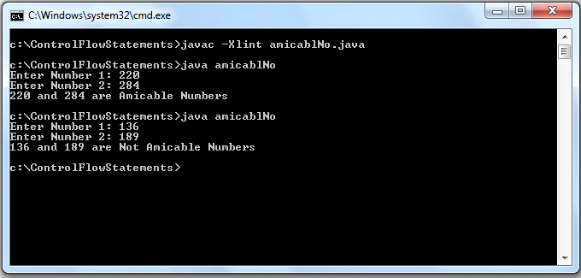

20) Write a program that will check whether a number is Armstrong number or not
Program:-
import java.util.Scanner;
class armstrng
{
public static void main(String argv[])
{
Scanner in = new Scanner(System.in);
int s=0,intNumber=0,n,b=0,x=0,a=1;
System.out.print("Enter Integer Value: ");
intNumber=in.nextInt();
n=intNumber;
while(n >= 1)
{
n=n/10;
x++;
}
n=intNumber;
while(n >= 1)
{
b=n%10;
n=n/10;
a=1;
for(int i=1;i<=x;i++)
a=a*b;
s=s+a;
}
if(s == intNumber)
System.out.println(intNumber+" is an Armstromg Number");
else
System.out.println(intNumber+" is Not an Armstromg Number");
}
}

Output:-

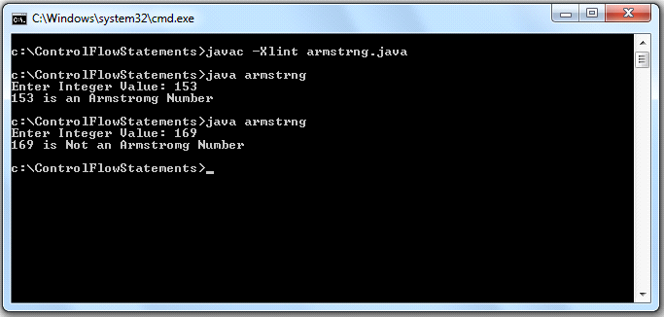

21) Write a program to demonstrate the Enhanced For Loop in JAVA
Program:-
class enForLoop
{
public static void main(String argv[])
{

int x=0;
int arr[]={49,93,85,73,82,8,27};
System.out.println("Displaying Array elements using Enhanced For Loop:--------");
for(int i:arr)
{
++x;
System.out.println("array["+x+"] = "+i);
}
}
}

Output:-
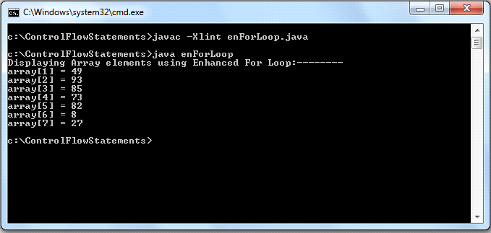

22) Write a program that will demonstrate instanceOf operator in JAVA
class x
{
x()
{
}
}
class y
{
y()
{
}
}
class instanceF
{
public static void main(String argv[])
{
x ob1 = new x();
y ob2 = new y();
if( ob1 instanceof x)
System.out.println("ob1 is instance of x ");
if( ob2 instanceof y)
System.out.println("ob2 is instance of y ");
}
}

Output:-
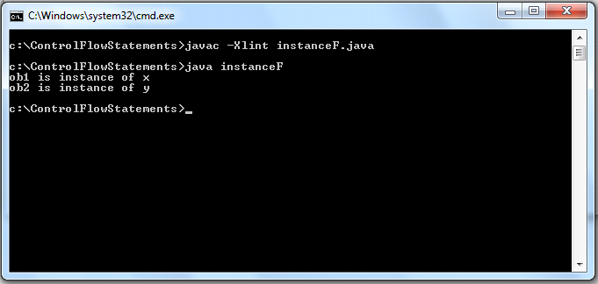

23) Write a program that will find sum of all the positive integers upto a specified range
Program:-
import java.util.Scanner;
class intRange
{
public static void main(String argv[])
{
Scanner in = new Scanner(System.in);
int i=0,n=0,s=0;
do
{
System.out.print("Enter Range(Positive Integer): ");
n=in.nextInt();
}while(n <= 0);
System.out.println("Intergers upto "+n+" are:-");
for(i=1;i<=n;i++)
s=s+i;
System.out.print("sum till "+i+" = "+s);
}
}
Output:-
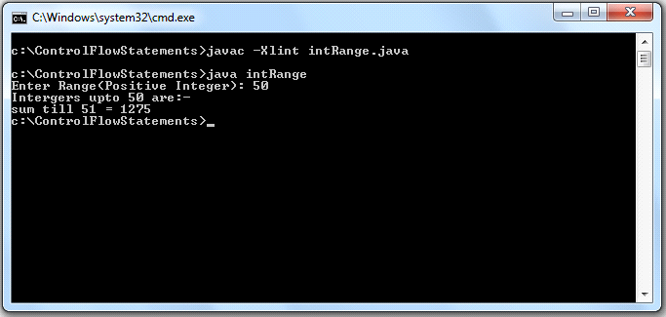

24) Write a program that will generate Lucas sequence up to certain range specified by user
Program:-
import java.util.Scanner;
class lucasNo
{
public static void main(String args[])
{
Scanner in = new Scanner(System.in);
int range=0,a=2,b=1,c=0;
System.out.print("Enter the range:- ");
range=in.nextInt();
System.out.println("The sequence is as follows : ");
System.out.print(a+"\t"+b);
for(int i=2;i<=range;i++)
{
c=a+b;
System.out.print("\t"+c);
a=b;
b=c;
}
}
}

Output:-

25) Write a program that will generate all prime numbers with in Fibonacci series up to certain range
Program:-
import java.util.Scanner;
class primeFibo
{
public static void main(String argv[])
{
Scanner in = new Scanner(System.in);
int a=0,b=1,c=0,n=0,x=0;
System.out.print("Enter Range: ");
n=in.nextInt();
System.out.print("All prime numbers that are also fibonacci numbers:\n1\t");
for(int i=2;i<n;i++)
{
x=0;
c=a+b;
a=b;
b=c;
for(int j=1;j <= c/2;j++)
{
if(c % j == 0)
x++;
}
if(x == 1)
System.out.print(c+"\t");
}
}
}

Output:-

26) Write a program that will take an integer from the user amd check whether it is perfect number or not
Program:-
import java.util.Scanner;
class perfectNo
{
public static void main(String argv[])
{
Scanner in = new Scanner(System.in);
int intNumber=0,n=0,s=0,j;
System.out.print("Enter Number: ");
intNumber=in.nextInt();
n=intNumber;
for(int i=1;i<=n/2;i++)
{
if(n % i == 0)
s=s+i;
}
if(s == intNumber)
System.out.println(intNumber+" is a Perfect Number");
else
System.out.println(intNumber+" is Not a Perfect Number");
}
}

Output:-

27) Write a program to check whether a number is even or odd.Put proper restrictions on the values given by the user
Program:-
import java.util.Scanner;
class oddOReven
{
public static void main(String argv[])
{
Scanner in = new Scanner(System.in);
int intNumber=0,f=1;
do
{
if(f == 0)
System.out.println("Wrong Entry:-ReEnter ");
System.out.print("Enter a Positive Number: ");
intNumber=in.nextInt();
f=0;
}while(intNumber <= 0);
if(intNumber % 2 == 0)
System.out.println(intNumber+" is Even");
else
System.out.println(intNumber+" is Odd");
}
}

Output:-

28) Write a program that will display modulo value (|x|) of a number taken from the user
Program:-
import java.util.Scanner;
class modulo
{
public static void main(String argv[])
{
Scanner in = new Scanner(System.in);
int intNumber=0;
System.out.print("Enter a Number: ");
intNumber=in.nextInt();
System.out.print("| "+intNumber+" | = ");
if(intNumber < 0)
intNumber*=(-1);
System.out.println(intNumber);
}
}

Output:-

29) Write a menu driven program that will perform arithmetic operation on two numbers
Program:-
import java.util.Scanner;
class menu
{
public static void main(String argv[])
{
Scanner in = new Scanner(System.in);
int resulti=0,intNumber1=0,intNumber2=0,c=0,cc=0;
float resultf=0,floatNumber1=0.0f,floatNumber2=0.0f;
System.out.println("\tMENU");
System.out.println("1.Integer");
System.out.println("2.Float");
System.out.print("Enter Choice :- ");
c=in.nextInt();;
switch(c)
{
case 1:
System.out.print("Enter Number 1: ");
intNumber1=in.nextInt();
System.out.print("Enter Number 2: ");
intNumber2=in.nextInt();
System.out.println("\tINTEGER-MENU");
System.out.println("1.ADDITION");
System.out.println("2.SUBTRACTION");
System.out.println("3.MULTIPLICATION");
System.out.println("4.DIVISION");
System.out.print("Enter Choice :- ");
cc=in.nextInt();
switch(cc)
{
case 1:
resulti=intNumber1+intNumber2;
System.out.println("ADDITION:----\n"+intNumber1+" + "+intNumber2+" = "+resulti);
break;
case 2:
resulti=intNumber1-intNumber2;
System.out.println("SUBTRACTION:----\n"+intNumber1+" - "+intNumber2+" = "+resulti);
break;
case 3:
resulti=intNumber1*intNumber2;
System.out.println("MULTIPLITION:----\n"+intNumber1+" * "+intNumber2+" = "+resulti);
break;
case 4:
resulti=intNumber1/intNumber2;
System.out.println("DIVISION:----\n"+intNumber1+" / "+intNumber2+" = "+resulti);
break;
default:
System.out.println("Wrong Input Int");
break;
}
break;
case 2:
System.out.print("Enter Number 1: ");
floatNumber1=in.nextFloat();
System.out.print("Enter Number 2: ");
floatNumber2=in.nextFloat();
System.out.println("\tFLOAT-MENU");
System.out.println("1.ADDITION");
System.out.println("2.SUBTRACTION");
System.out.println("3.MULTIPLICATION");
System.out.println("4.DIVISION");
System.out.print("Enter Choice :- ");
cc=in.nextInt();
switch(cc)
{
case 1:
resultf=floatNumber1+floatNumber2;
System.out.println("ADDITION:----\n"+floatNumber1+" + "+floatNumber2+" = "+resultf);
break;
case 2:
resultf=floatNumber1-floatNumber2;
System.out.println("SUBTRACTION:----\n"+floatNumber1+" - "+floatNumber2+" = "+resultf);
break;
case 3:
resultf=floatNumber1*floatNumber2;
System.out.println("MULTIPLITION:----\n"+floatNumber1+" * "+floatNumber2+" = "+resultf);
break;
case 4:
resultf=floatNumber1/floatNumber2;
System.out.println("DIVISION:----\n"+floatNumber1+" / "+floatNumber2+" = "+resultf);
break;
default:
System.out.println("Wrong Input Float");
break;
}
break;
default:
System.out.println("Wrong Input");
break;
}
}
}

Output:-

