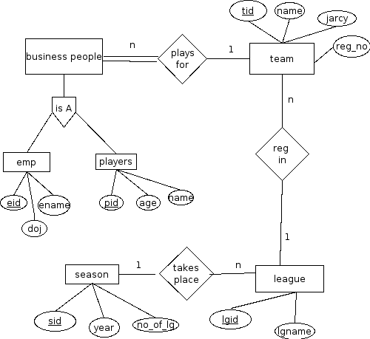

assumption
1 one team cannot participate in more than one game
2 only the games played with soft ball are considered here

Soft Ball complex schemas and functional dependencies

emp( eid, doj, ename)

eid---------> doj
eid---------> ename

this table is in 1NF because there are no multivalued attribute.
table is in 2NF because all the non key attributes are fully functionally dependend on the primary key.
this table is in the 3NF because there are no transitive dependency.

players( pid, age, name)

pid---------> name
pid---------> age

this table is in 1NF because there are no multivalued attribute.
table is in 2NF because all the non key attributes are fully functionally dependend on the primary key.
this table is in the 3NF because there are no transitive dependency.

team( tid, lgid, trid, name, jarcy, rg_no)

tid-------->name
tid--------> jarcy
tid--------> rg_no

this table is in 1NF because there are no multivalued attribute.
table is in 2NF because all the non key attributes are fully functionally dependend on the primary key.
this table is in the 3NF because there are no transitive dependency.

league( lgid, lgname, sid)

lgid----------> lgname

this table is in 1NF because there are no multivalued attribute.
table is in 2NF because all the non key attributes are fully functionally dependend on the primary key.
this table is in the 3NF because there are no transitive dependency.

season( sid, year, no_of_lg)
sid--------->year
sid---------->no_of_lg

this table is in 1NF because there are no multivalued attribute.
table is in 2NF because all the non key attributes are fully functionally dependend on the primary key.
this table is in the 3NF because there are no transitive dependency.

Requirement:
- Identify the players who are not employee.
- count the number of the league which takes place in a given season.
- how many teams in a particular league.
- identify the game played in a particular season by a particular team.

