**As Partial Fulfillment of:**

**MSc (IT) - Master of Science in Information Technology**

**Submitted To:**

**Atmiya Institute of Technology and Science – 2019**

GUIDED BY: Amit Sagpariya

PREPARED BY: Dipen Parmar

A PROJECT REPORT ON

Restaurant Management System

DEVELOPED AT

ATMIYA UNIVERSITY

-------

FOR THE PARTIAL FULLFILLMENT OF THE REQUIREMENTS FOR THE

AWARD OF DEGREE IN

**1th Semester**

IN

**MSc.IT & CA**

SUBMITTED BY

Dipen Parmar

SUBMITTED TO



**DEPARTMENT OF COMPUTER SCIENCE**

**ATMIYA UNIVERSITY, RAJKOT**

**ACKNOWLEDGEMENT**

I would like to highlight the fact that this project is the product of many contributors. First, I’d like to thank Professor **Prakash Gujarati** who accepted to work with me on my Project idea, supervising my work.

Second, I would like to thank the stack overflow community and Google for providing tremendous help to the elaboration of this project.

**ABSTRAT**

The Lara-POS Restaurant Management software is a capstone project that aims towards developing an all-in-one application that addresses the various problems and challenges faced by high-end restaurant owners today.

In order to achieve this goal, this project addresses various aspects of the modern Restaurant Management System in India.

All in all, this projects main aim is to reduce the time overhead in high-end management restaurants by providing an alternative to the traditional management system based on physical record keeping and paper work.

**HARDWARE REQUIREMENTS**

**Technical Details Hardware (**Requirements**)**

|  |  |
| --- | --- |
| **Particulars** | **Hardware**  **Requirements** |
| Processor Brand | Intel, Amd etc. |
| Processor Type | I3 Processor |
| Processor Speed | 1.5 GHz |
| RAM Size | 2 GB |
| Memory Type | DDR3 |
| Hard Drive Size | 500 GB |

**Technical Details Software (**Requirements**)**

|  |  |
| --- | --- |
| **Particulars** | **Software Requirements.** |
| Operating System | Windows, Linux, Mac, any |
| Browser | • Chrome* 36+ • Edge* 20+ • Mozilla Firefox 31+ |

WireFrame Link <https://s3.amazonaws.com/assets.mockflow.com/app/wireframepro/fileexport/Export_D7b7b0c913e15f3a4e1cddefa1287e431.pdf>

**Getting Started**

You will need a working version of Node and NPM to get started.

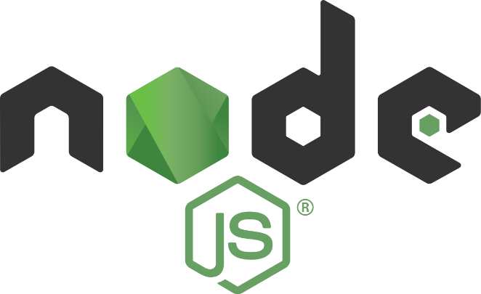

## What is Node.js?

* + Node.js is an open source server environment
  + Node.js is free
  + Node.js runs on various platforms (Windows, Linux, Mac OS X, etc.)
  + Node.js uses JavaScript on the server

## Why Node.js?

## Node.js uses asynchronous programming!

Here is how PHP or ASP handles a file request:

1. Sends the task to the computer's file system.
2. Waits while the file system opens and reads the file.
3. Returns the content to the client.
4. Ready to handle the next request.

Here is how Node.js handles a file request:

1. Sends the task to the computer's file system.
2. Ready to handle the next request.
3. When the file system has opened and read the file, the server returns the content to the client.

Node.js eliminates the waiting, and simply continues with the next request.

Node.js runs single-threaded, non-blocking, asynchronously programming, which is very memory efficient.

## What Can Node.js Do?

* + Node.js can generate dynamic page content
  + Node.js can create, read, write, delete, and close files on the server
  + Node.js can collect form data
  + Node.js can add, delete, modify data in your database

## What is a Node.js File?

* + Node.js files contain tasks that will be executed on certain events
  + A typical event is someone trying to access a port on the server
  + Node.js files must be initiated on the server before having any effect
  + Node.js files have extension ".js"

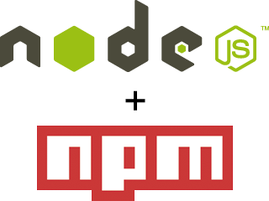

**Node Package Manager**

## What is NPM?

* + Node.js is an open source server environment
  + Node.js is free
  + Node.js runs on various platforms (Windows, Linux, Mac OS X, etc.)
  + Node.js uses JavaScript on the server

## Why Node.js?

* + NPM is a package manager for Node.js packages, or modules if you like.
  + [www.npmjs.com](https://www.npmjs.com/) hosts thousands of free packages to download and use.
  + The NPM program is installed on your computer when you install Node.js

## What is a Package?

* + A package in Node.js contains all the files you need for a module.
  + Modules are JavaScript libraries you can include in your project.

## Use npm to . .

* + Adapt packages of code for your apps, or incorporate packages as they are.
  + Download standalone tools you can use right away.
  + Run packages without downloading using [npx](https://www.npmjs.com/package/npx).
  + Share code with any npm user, anywhere.
  + Restrict code to specific developers.
  + Create Orgs (organizations) to coordinate package maintenance, coding, and developers.
  + Form virtual teams by using Orgs.
  + Manage multiple versions of code and code dependencies.
  + Update applications easily when underlying code is updated.
  + Discover multiple ways to solve the same puzzle.
  + Find other developers who are working on similar problems and projects.

## Sharing packages and collaborating with others

If you choose to share your packages publicly, there is no cost. To use and share private packages, you need to upgrade your account. To share with others, create organizations, called [**npm Orgs**](https://docs.npmjs.com/orgs), and invite others to work with you, privately (for a fee) or publicly (for free). Or you can sign up for a private instance of npm for your company, called [**npm Enterprise**](https://npmjs.com/enterprise), so you can develop packages internally that are not shared publicly.

**Install Node.js & NPM on Windows**

Go to the [official Node.js site](https://nodejs.org/) which will offer you two versions of Node to download. Click on the Installer that says “Recommended For Most Users”.

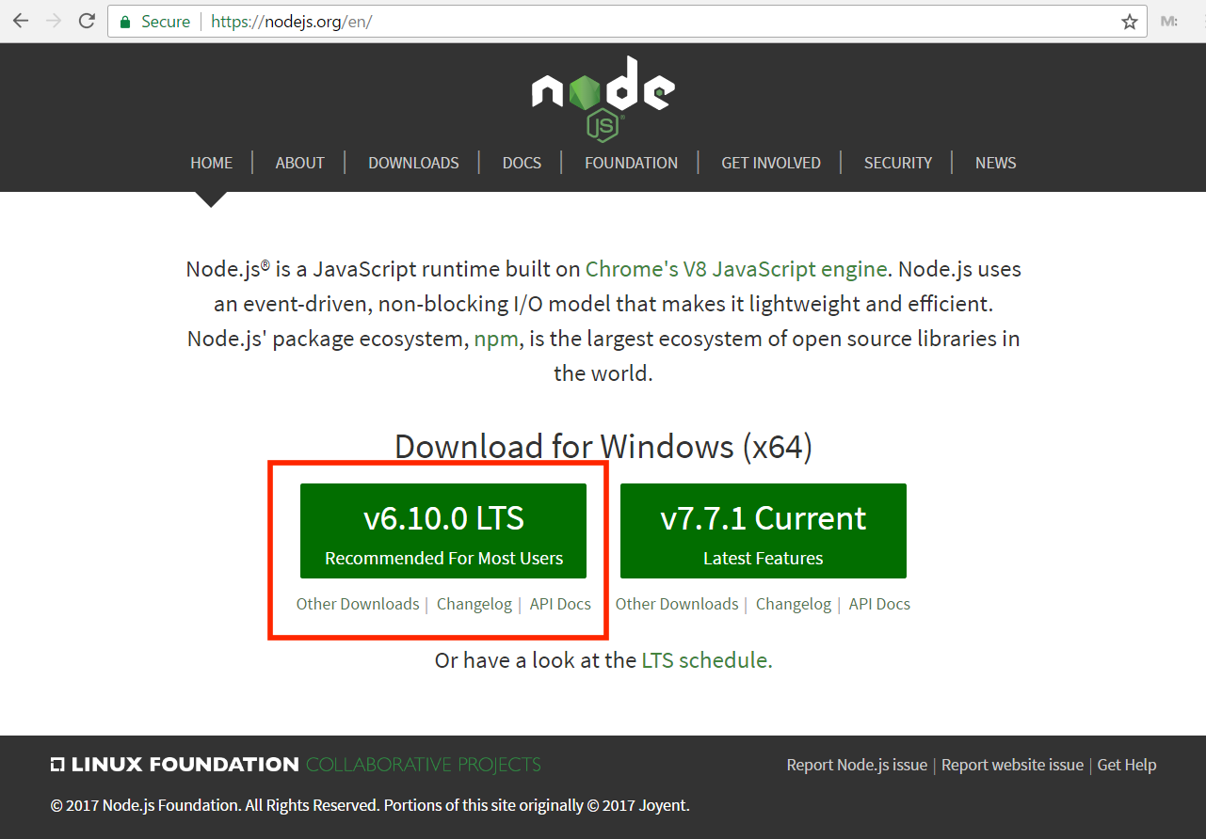

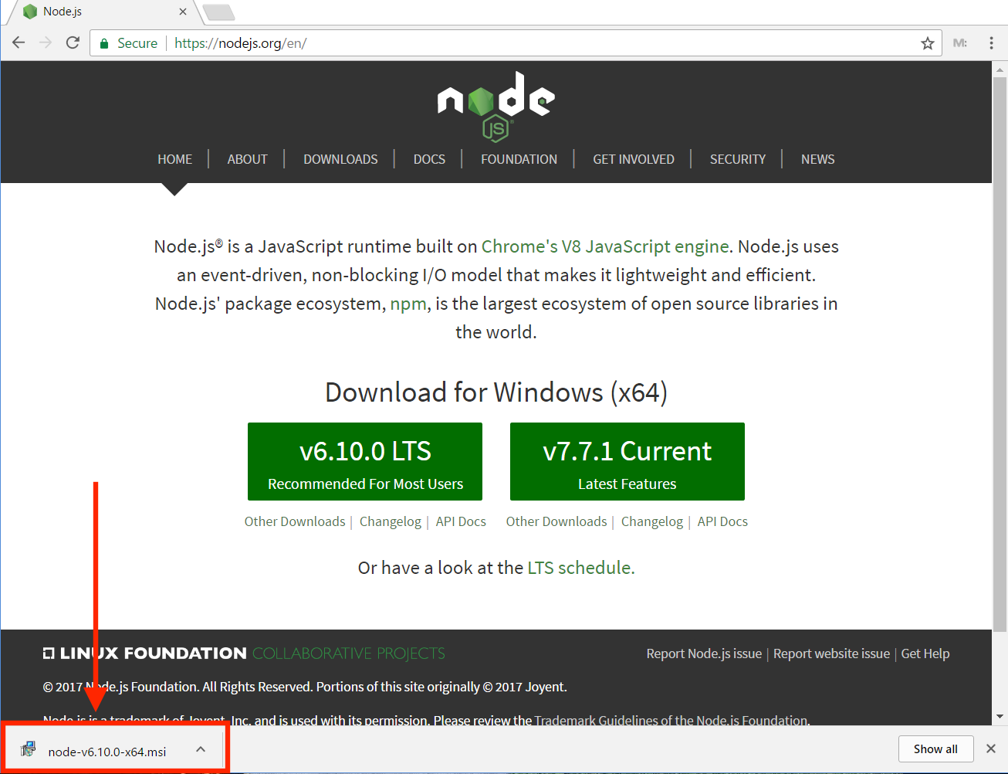

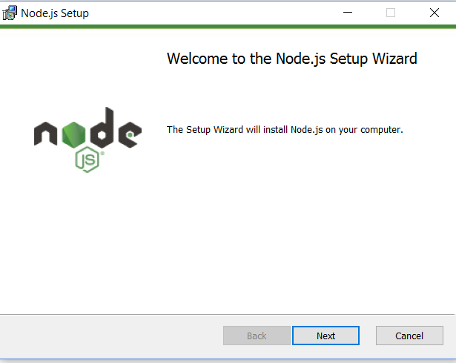

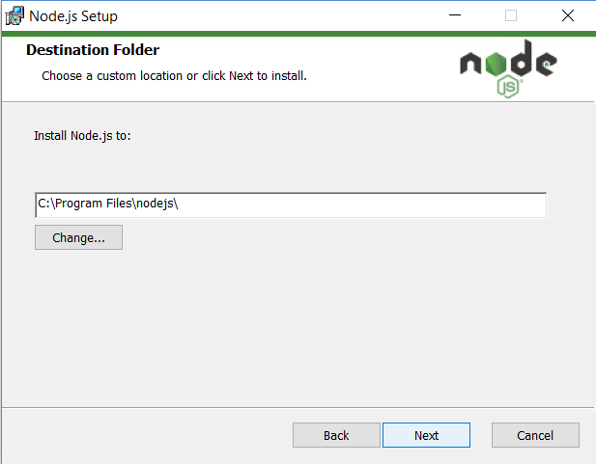

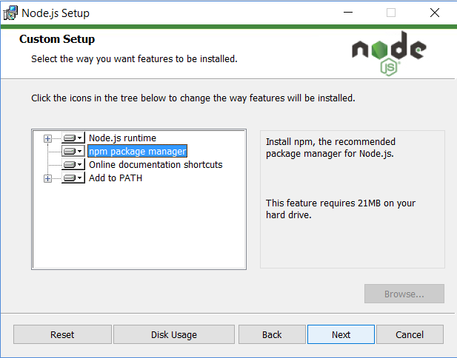

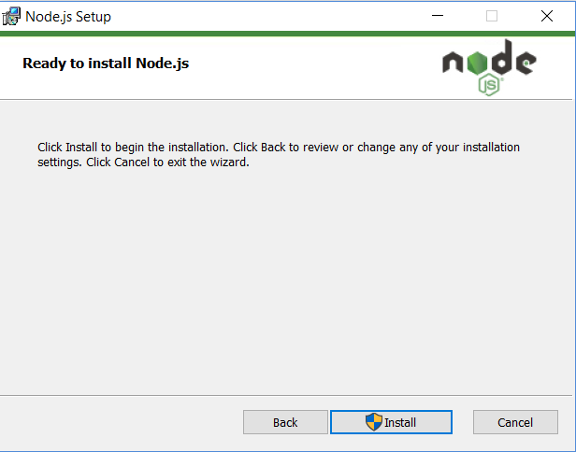

In The Command Prompt. To confirm Node is installed type node –v Which will print the current version number . To confirm NPM is installed type npm -v which will print its current version number.

