Project Report for Software Engineering I

Texas Tech University

April 5th, 2020

**Parking System**

Team Members:

Vision Poudel, Dipen Yadav, Pritish Ayer

**Contribution of each teammate**

Dipen Yadav – Question 2

Vision Poudel – Question 3

Pritish Ayer – Question 1

1. **Use Case Diagram**

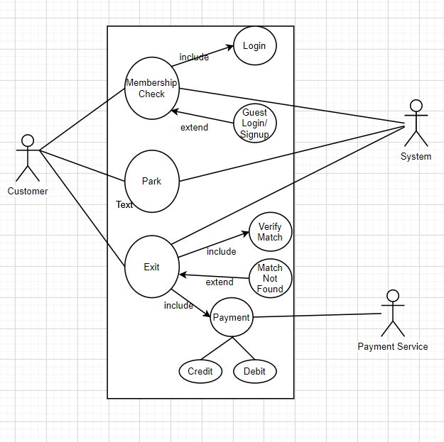

1. Use Case Specification
2. Membership Check
   1. Use Case Name: Membership Check
   2. Scenario/Description: Membership Check is the first use case of the program. In this use case, when the customer enters inside the facility they are asked to either Sign-in if they are the current member or sign-in as a guest if they are new customer. If the customer sign in as guest, they can simply sign up to be a member with one click. The information entered by the user is then stored in the system for the future records.
   3. Actors: i. Customer

ii. Parking System

* 1. Preconditions: ii. User correctly identifies his/her membership status.
  2. Post-conditions: The system updates the stored information for future records.
  3. Related Use Case: It uses the information from user and passes on the information to system for storage.
  4. Stakeholders: Customers using the parking, System Administration

1. Park
2. Use Case Name: Park
3. Scenario/Description: Park is the first use case that will be used by the customer. When the customer use the Park case, they will be directed to a ‘Park’ activity where they will be prompted to enter their information including the type of the vehicle, the number plate of the vehicle and number of hours the customer wants to use the parking. This information is then stored by the system to use later and calculate the total price of the parking. The customer will have access to all the use cases at the first screen, however, if the customer has not used the parking use case first to enter their information, the system will return an error message. It is so because the system will not identify the vehicle/ have store the information of the vehicle, until the park use has been completely executed.
4. Actors: Customer. Since this case does not stimulate the secondary actor (Parking System) to initiate any action, the customer is the only actor in this use case.
5. Preconditions: User needs to select the correct case and enter all the required information.
6. Post-conditions: The system stores the information for future calculation.
7. Related Use Case: Although the other two use cases i.e. Extend and Exit heavily rely on the information from the Park use case, this use case is totally independent of others.
8. Stakeholders: Customers using the parking, Administration
9. Exit
10. Use Case Name: Exit
11. Scenario/Description: Exit use case is only used by the customer when they are ready to leave the facility. When the customer first come to use the parking, they enter their vehicle information and number of hours they want to park their vehicle. In the Exit case, when the customer is ready to exit form the parking station, the customers has to enter their vehicle information. The system finds the match and uses the calculations from park and extend case to display the final amount and gives the customer options to pay their bill by either the debit card or the credit card.
12. Actors: i. Customer

ii. Parking System

iii. Payment Service

1. Preconditions: i. User has already executed Park Use case

ii. User enters correct/matching vehicle info

1. Post-conditions: The system calculates the total cost and prompts customers to pay.
2. Related Use Case: It uses the information from Park use case as well as Extend case.
3. Stakeholders: Customers using the parking, Administration, Payment Services

**2) Structural Design**

a) The architecture of the application

b) Class Diagram of the application

**3) Dynamic Design**

a) The sequence diagrams for each use case

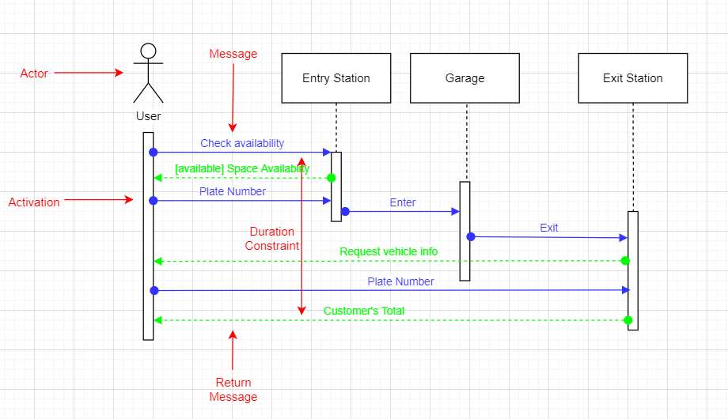

Figure 1: User's Use Case Sequence Diagram

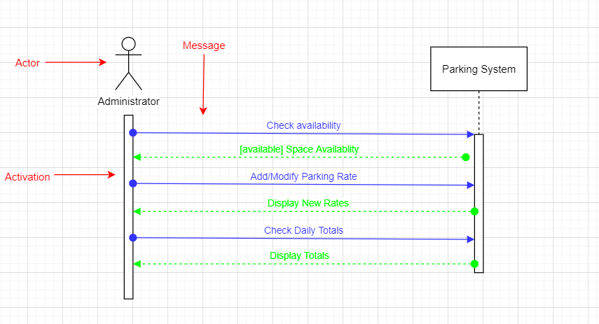

Figure 2: Administrator Use Case Sequence Diagram

b) The state diagram for each object

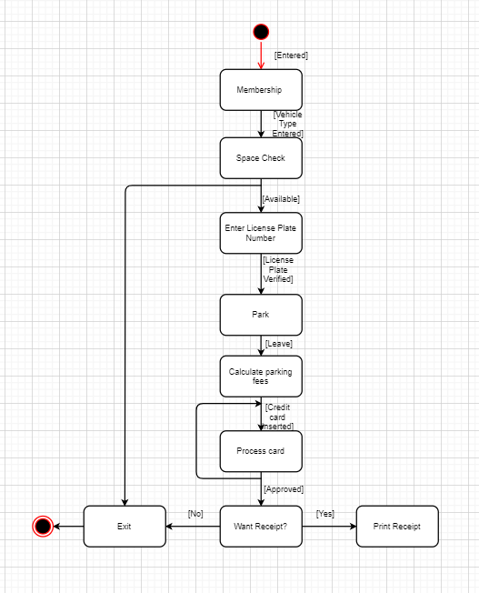

Figure 3: System State Diagram

c) The activity diagrams for the application

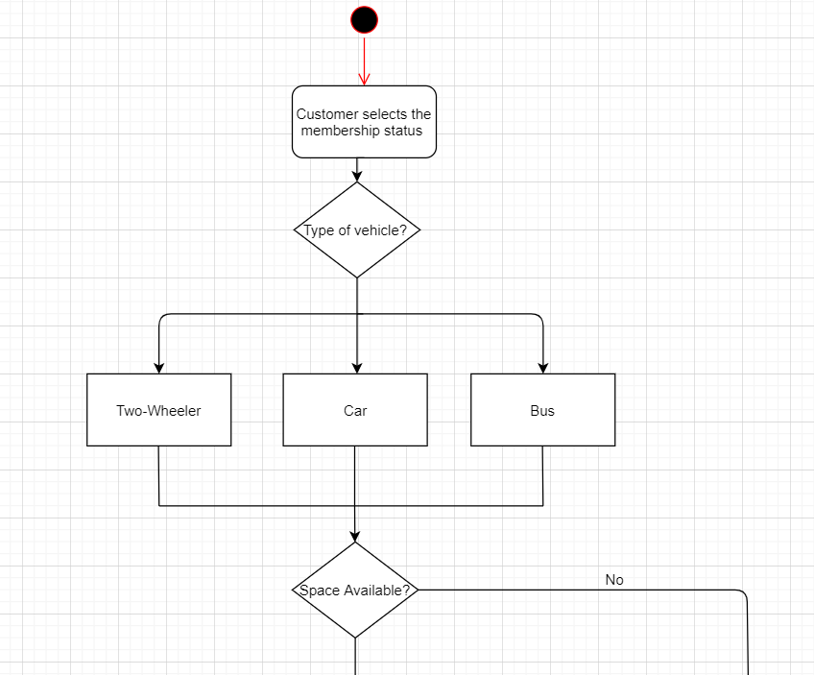

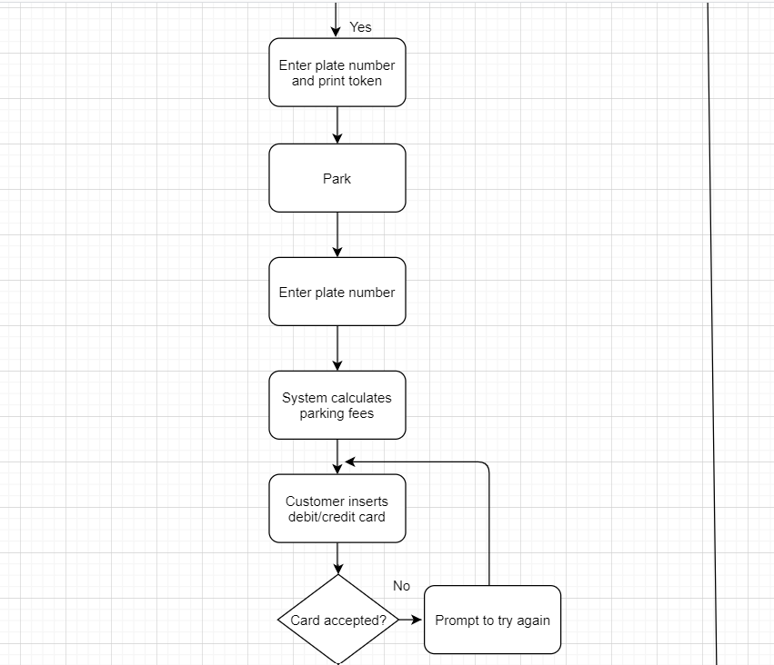

Continue in next page ….

