Contents

Section 1: Introduction 2

1.1 About this Document 2

1.2 About Fucha 2

Section 2: ADMIN PANEL 3

2.1 Login and Register 4

2.2 Category 4

2.3 Global GIG Meta 6

2.4 Language 7

2.5 Country 8

2.5 Profile Suggestions 9

2.6 Transaction Rules 9

2.7 Package 10

2.8 Search Tags 11

2.9 GIGS 12

2.9.1 Active GIGS 12

2.9.3 Reported Gigs 13

2.10 Orders 14

2.11 Site Info 16

2.12 Users 17

2.13 Status of GIGs 19

2.14 Status of Orders 20

2.14 Mailing Conditions 21

# Section 1: Introduction

## About this Document

This document explains how we use all the features of the Admin Panel of **Fucha** and the ways it gets visualized on the Front End (User End) of the website. This will be helpful for any person using the admin panel to fill in the required fields from the backend and for the user. It is divided into two parts. Part I has all the ways of adding the information in the **Admin Panel.** Likewise Part II is much more focused on the Visualization **User End.**

## About Fucha

**Fucha** is an online GIG’s based marketplace website. It focuses on 2 parts, one of which is buying a required GIG (Work) and another is the person who sells the GIG when a buyer orders the gig. We need to keep in mind that an individual can act as both Buyer and Seller. Fucha acts as a mediator between the two parties Buyer and Seller to create ease, efficiency and bound the two parties within a certain contract for the safety and guarantee of the work to be delivered.

# Section 2: ADMIN PANEL

We will be dividing the Admin Panel into different sub-categories. We have also added these sub categories in a chronological order such that while filling the required fields there will not be any confusion for the responsible person.



There is a visual representation of the Admin Panel for the current system which can be seen in the image below.

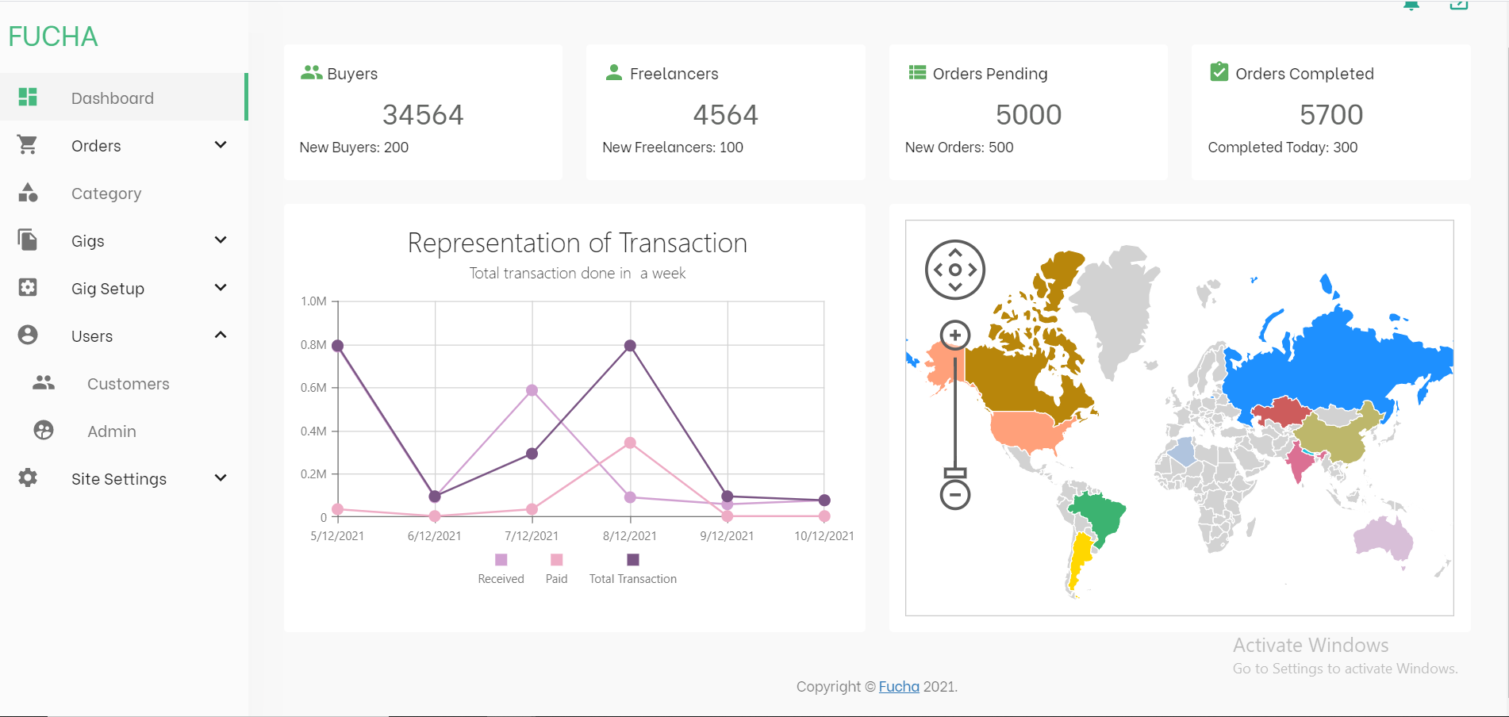

This will be the dashboard for the Admin Panel. The sidebar in the image above links to the respective pages where different data’s required for the front end are added. In this document we will be discussing each and every tabs present here and the relation of the Tabs with each other while adding the data.

## 2.1 Login and Register

At the beginning **Super Admin** is pre-fed from the Database to access the Admin Panel. The only way to add new admins is from the **Users Tab – Admin.** Different permissions to the new Admins can be given by the Super Admin but will discuss this part later in our topic Permission.

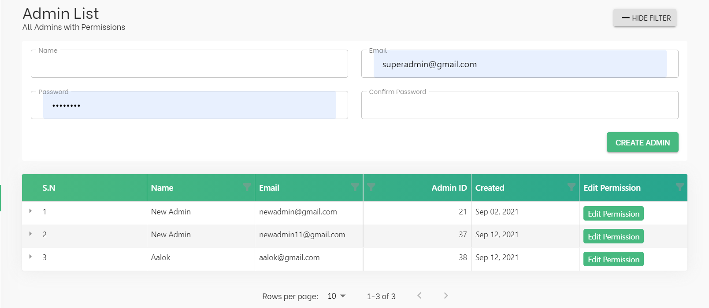

## 2.2 Category

Category of the website will determine which category the GIG created by the user resides in. Since, there will be many GIGs on the website, finding the gig by only a Parent Category is kind of a hectic task for any user. Thus, each category has an option to add its sub-category to further downsize the total number of gigs shown at once and also makes it easy for the user to find the Gigs. They are called child categories.

When we click the categories. It has been divided into two parts as we can visualize in the image.

1. **Add Category**

The **Add Category** button in the top will allow us to add a category.

The Parent Category field allows us to choose which parent category the created category falls in and also if it is Parent Category we can choose option “None”. This will ensure that the created category is a parent category.

**Note* Field Is Service Type:**

The checkbox at add categories table is checked if the category that is about to be added is final category under the sub-category. Checking this field will help us to further downsize the gigs that are to be displayed. We will be showing this in the Front End in our later section.

1. **Enlisted Category Table**

This table contains information on all the Categories and Sub-Categories that was created. We can see different header on the table. They are explained below:

1. **Shipping**

Any category created in the third level has the option to add shipping. The shipping option will be an optional checkbox parameter while creating the GIG. The checkbox determines whether the shipping is included in the price or not. The shipping price must be included in the pricing of the GIG.

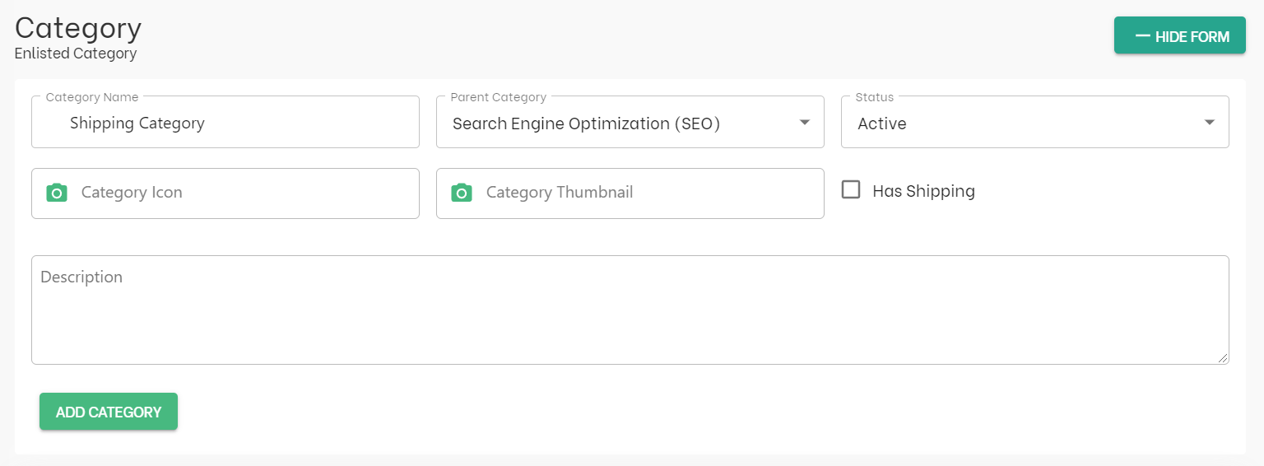

1. **GIG META**

GIG Meta are only available for the child categories. Before adding the GIG Meta we need to know about the GIG Meta. Please refer the section Adding Global Gig Meta for further information.

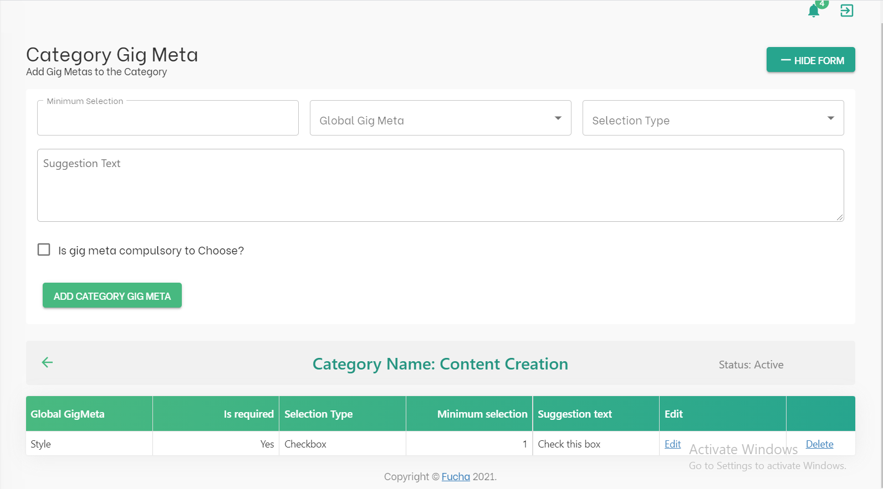

As we have learned about GLOBAL GIG META. We are now going to associate the required created metas to any category which requires it to be added.

The **Selection Type** refers to on how the metas are selected by the users while creating the GIG. There are 3 options available, “SELECT FIELD”, “RADIO FIELD” ,and “CHECKBOX”.

The **Suggestion Text** is just a small suggestion given to the seller on how it works.

The **Minimum Selection** refers to how many of the metas are required to be selected by the Seller (defaults to 1 for checkbox and radio).

**Is Gig Meta Compulsory To Choose?** It refers to whether or not it is required to choose the GIG Meta while creating the GIG.

\***Note:** A single category can have multiple Category GIG Meta. For easiness while creating the GIG for Seller, we can limit up to 3 options.

1. **PACKAGE META**

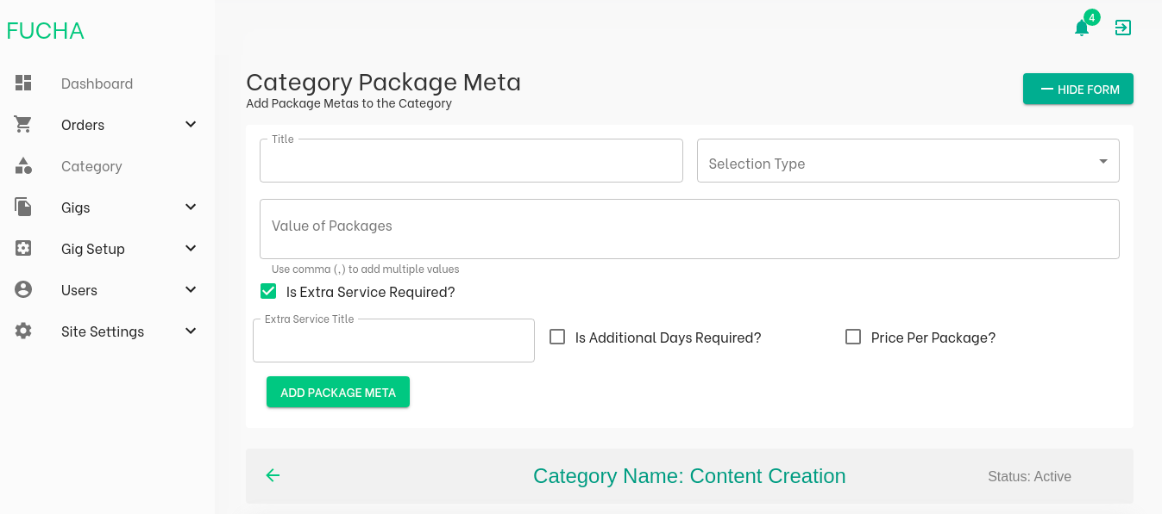

The Package Meta is the options that we give to the Seller to add into their package to show short bullet points on what they provide in their GIG. It is like the universal works for that particular category which the FUCHA will give the sellers to pick from.

We can see this options in the GIG CREATIONS – Pricing page down the document.

**Selection Type:** There are two options given. “Select Field” and “Checkbox Field”

**Value of Package:** This is used if we have selected the “Select Field”. These are the options to pick for the select Field.

**Is Extra Service Required?** This field is used if the work to be done is beyond the scope of the primary work**.** Thus, while creating the gig buyer can select if he is willing to provide this service.Checking this field leads to selection of three more options.

* **Is Additional Days Required?**

It allows the seller to set additional days to the gig completion time.

* **Price per Package?**

This means that there will be additional days and unique price for each package the Seller has created the number.

* **Extra Service Title**

This is to give an extra sub name to describe about the Service Type given (defaults to the category package title if not given).

All the other fields are implied fields that is just generated after filling the form.

## 2.3 Global GIG Meta

Under the tab **GIG Setup** we can see the options to set GLOBAL GIG META. They are known as the globally defined attributes that can be associated with Child Categories or Service Types as a service options while filtering the GIG list. They are global attributes, thus, it can be assigned to multiple categories and service types thereby preventing redundant data.

We have the option to add a parent and a child Metas to make it simpler for the users both Buyers and Sellers to use it while searching or creating the GIGs respectively.

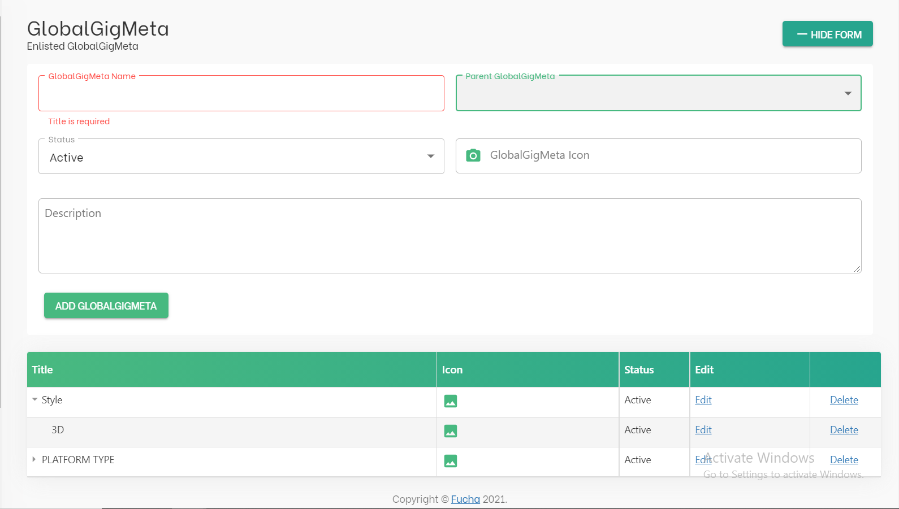

**\*Note:** Only the GLOBAL GIG META with its child METAs are visible for both Buyer and Sellers

## 2.4 Language

The Language Tab under the **Site Settings** section will allow Fucha to add the different types of languages for seller to select while filling in their details (in Become a Seller form). It is also one of the filter parameters for searching the GIGS from the list of gigs such that it allows people of common language tongue to speak with each other during the work.

It has 3 fields: Language Name, Short Name, and its Alias

**Example:**  Nepali - NEP – नेपाली

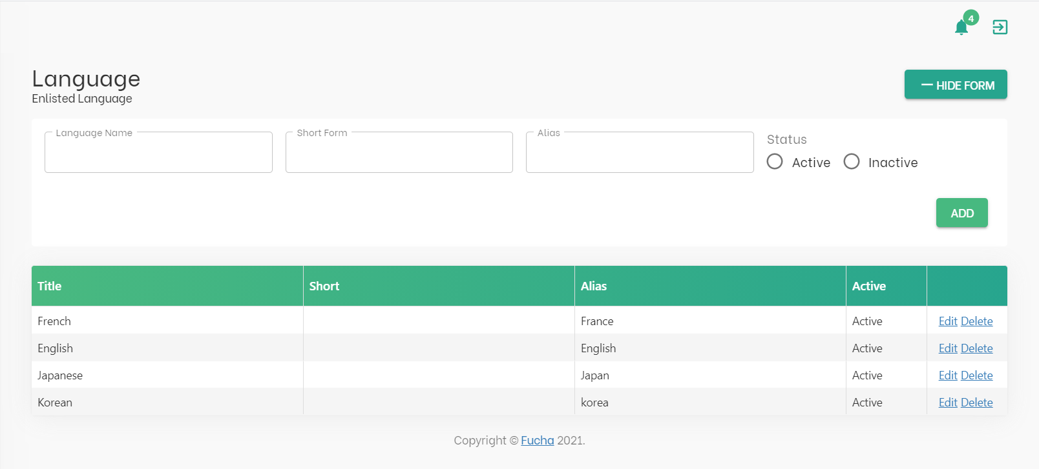

## 2.5 Country

The Country Tab under the **Site Settings** section will allow Fucha to add different countries which lets users pick the country they are working from. Like, the Language Tab is also one of the filter parameters for searching the Gigs. Besides filtering, it has other important functionalities as well. They are listed as below:

1. It will be one of the factors which will determine how we work on the **Invoicing** and **TAX** for the user.
2. The Dial Code in the form will allow us to send **Verification SMS** to the user to verify their authenticity.

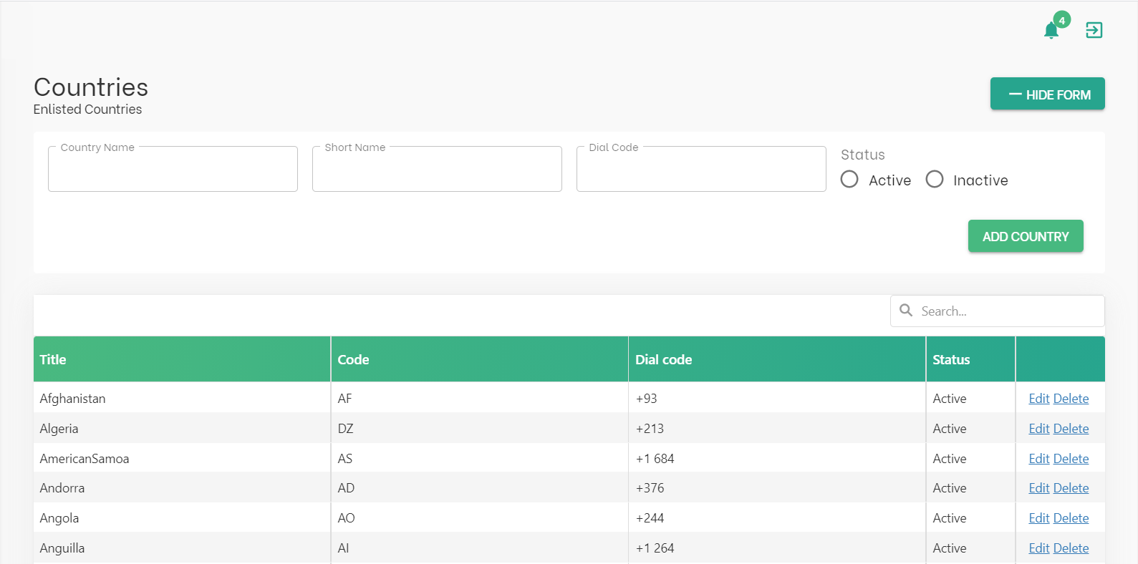

## 2.5 Profile Suggestions

The Profile Suggestion TAB under the **Site Settings** will allow the user to get some suggestions while filling in their Professional Information. There are 2 types of suggestions.

1. **Skill Suggestion**: It helps the user to add different skills to their profile with our suggestions. But, in our case, they can add their custom skills as well. Eg: Digital Marketing, SEO, WordPress, etc.
2. **University Suggestion:** It helps the user to add different Universities to their profile with our suggestions. But, in our case, they can add their custom skills as well. Eg: Harvard, Yale, TU, etc.

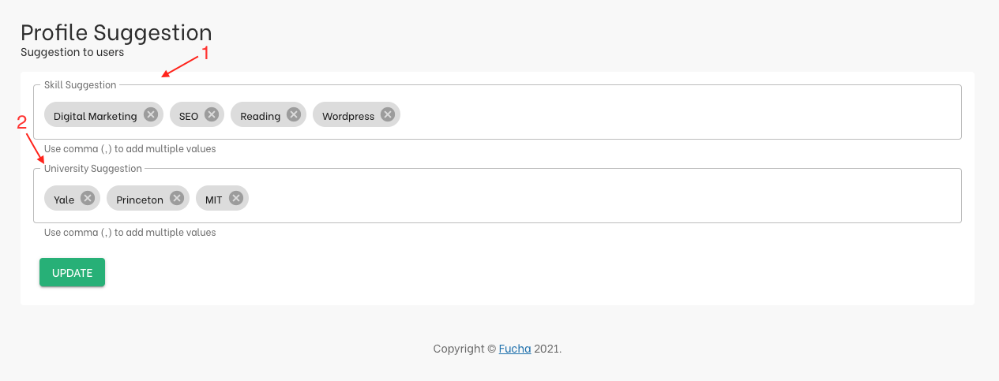

## 2.6 Transaction Rules

Under the tab **GIG Setup** we can work on the Transaction Rules for this platform. It has been divided into 3 components. Commissions, Base Rate, and Service Charge.

1. **Commission Rate**

Commission is the small sum of money that should be paid by the Seller or the gig creator to Fucha for using their platform to post the gigs. Commission money is evaluated in percentage (%). This rule can be changed under this section.

1. **Base Rate**

Base Rate is the minimum price margin for any gig. The Seller can’t post any gig that charges less than Base Rate. It is evaluated in dollar ($). This rule can be changed under this section.

1. **Service Charge**

Service Charge is the small sum of money that should be paid by the buyer to Fucha for using their platform to buy the service. Service Charge is evaluated in percentage (%). This rule can be changed under this section.

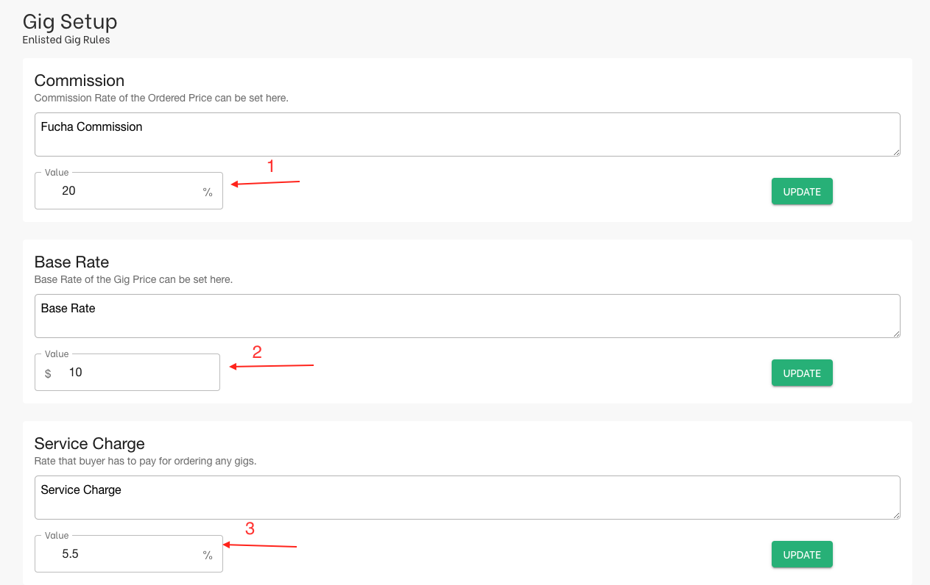

## 2.7 Package

Under the tab **GIG Setup** we can work on different package the Sellers are allowed to make. There are 3 Packages that needs to be setup by default. The Seller can move around choosing one of the 3 Packages or all the Packages while creating the GIG.

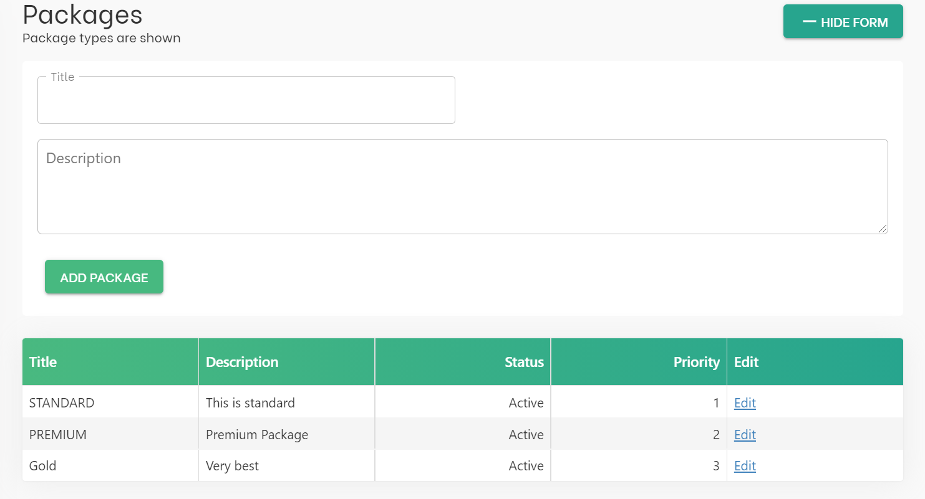

The priority of the packages are set and only the title of the Package is changed by the admin.

## 2.8 Search Tags

Search Tags are used while creating a gig to further group the created GIGs. Although these Tags can be created by the Seller while creating the GIG as well, these are some of the suggestions that admin can provide the Sellers for easiness.

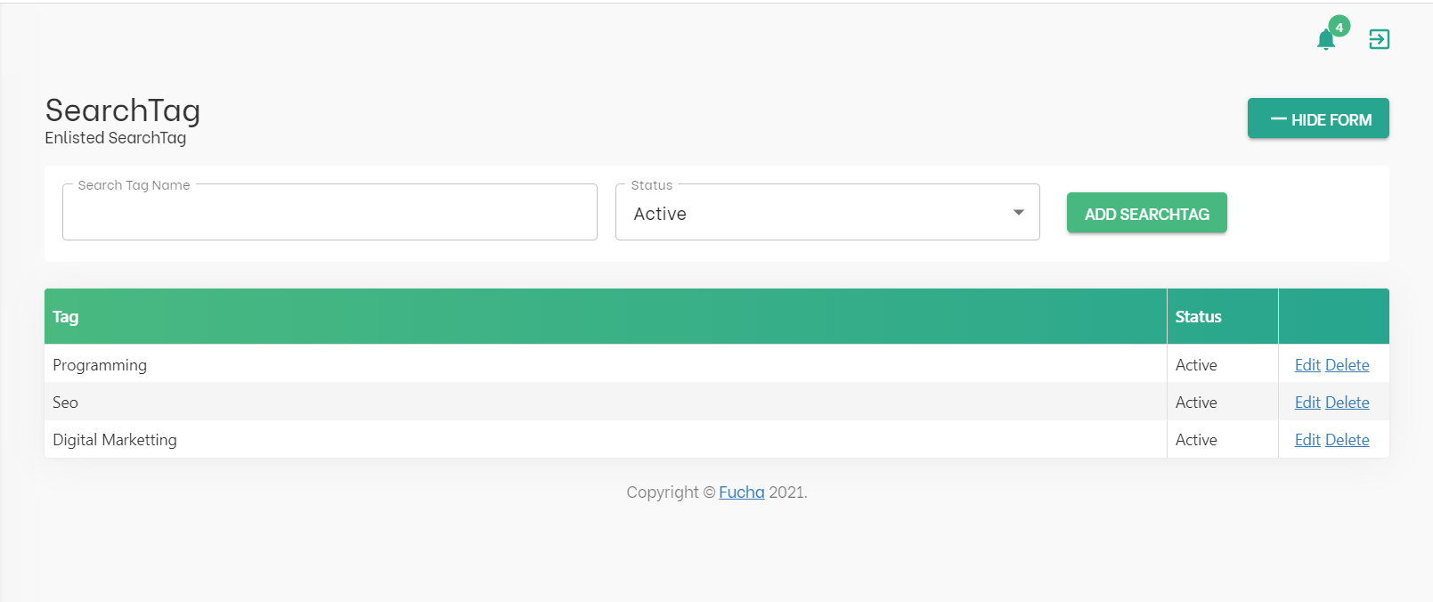

We can edit and delete these tags from the Form Given.

## 2.9 GIGS

The **GIGS** tab in the dashboard is currently sub divided into two sections **ACTIVE GIGS** and **REPORTED GIGS.**

### 2.9.1 Active GIGS

The active gigs are the list of all the created gigs by the seller from our platform. It has been further divided into two parts.

1. **GIG Filtration**

The GIGs can be filtered by the following parameters. **GIG Title, Category, Created From,**and**Created At.**

1. **GIG Table**

The summary of the GIGS can be visualized by clicking the **side-arrow** from Serial No. We can see brief information’s like **Gig Details, Seller’s Name, and Seller’s Email.**

We can see the full information of the Order from the **View Button** which is under the View Column. The View Page has been divided into four tabs.

1. **Previewing the GIG**

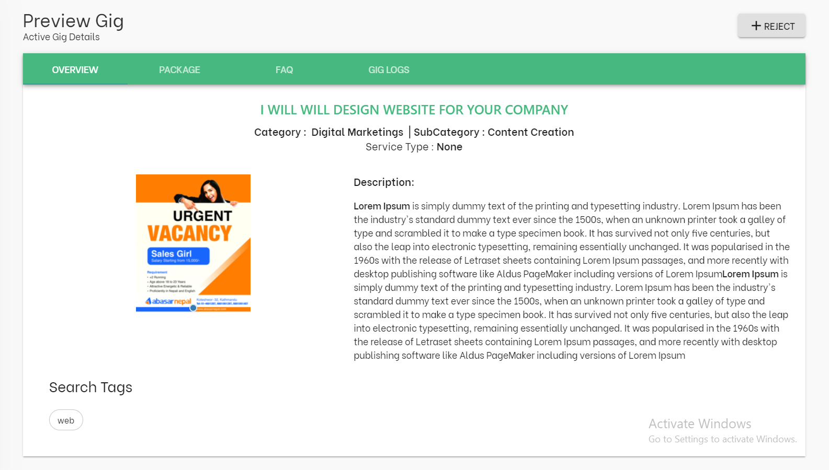

* + 1. **Overview**

It has all the basic overview of the gigs such as **Category, Sub Category, Service Type, Description, Search Tags, and Image + Videos**

* + 1. **Package**

It shows what the available packages are created for the particular GIG and the metas and services Buyer gets while buying that package.

* + 1. **FAQ’s**

It will add all the FAQ’s added by the Seller while creating the GIG

* + 1. **GIG LOGS**

It stores all the information on the Status the GIGS has been passed through. The Status of the gigs are explained later in the documentation.

### 2.9.3 Reported Gigs

Admin can navigate through all the reported GIGS through this tab. All the gigs reported by the user can be visualized in the table.

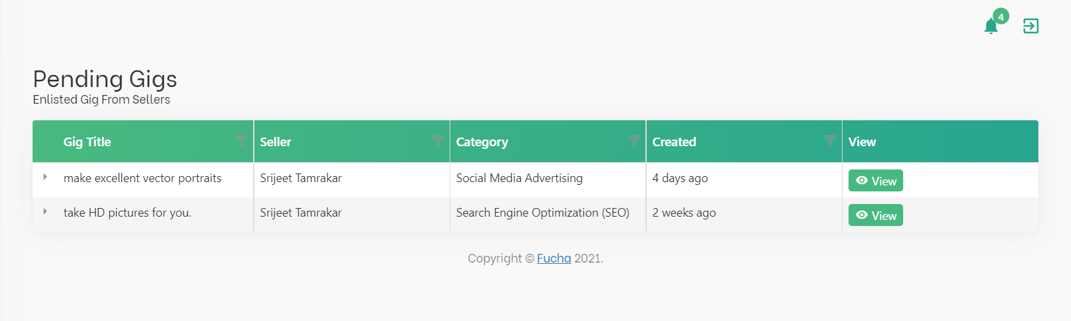

After Clicking the **View Button** from the table all the information about the GIG is displayed so as to check.

Since, the GIG is reported the admin can visualize it in the GIG Logs. The details on why the GIG was reported is also displayed in the GIG Logs.

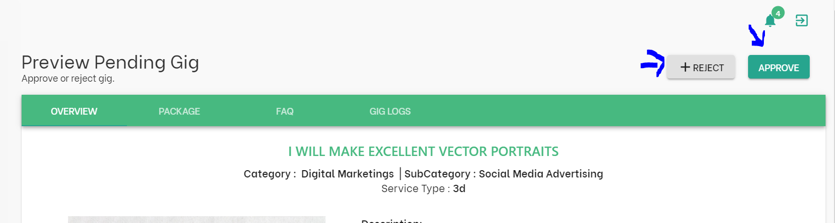

The two buttons on the top of the preview is used to toggle between different statuses of the GIG.

The **Approve** button simply activates the GIG. This is used if there is no issue in the GIG.

The **Reject** Button gives us the form to change the status of the GIG with the message on why the status has been changed.

There are different statuses of GIG which is discussed in the documentation later section.

## 2.10 Orders

The **Orders** Tab in the dashboard is currently divided into two sub-tabs All Orders, Payments

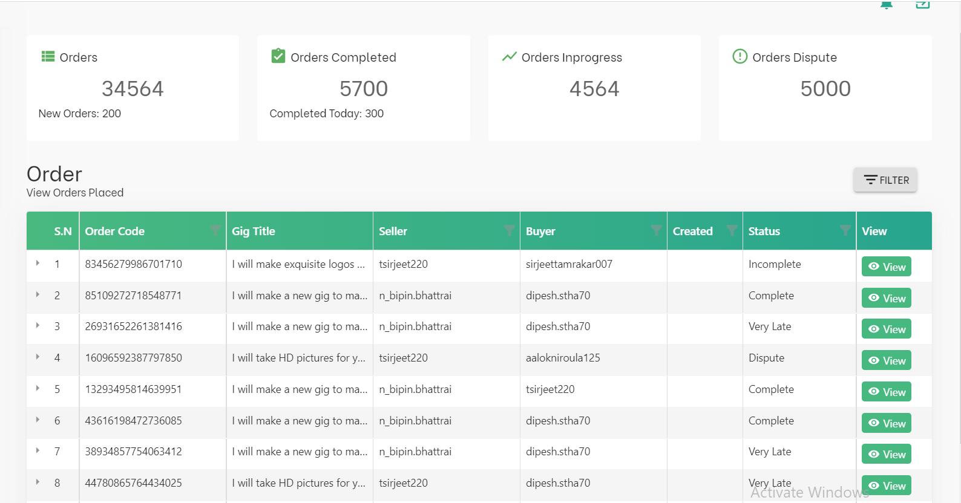

1. **ALL ORDERS**

The **All Orders**Section is further sub-divided into 3 components. The first being the **Statistics** of the different orders done in the Fucha till now. The second one is the **Filtration Section.**The third being the tabular representation of all the order for descriptive data.

1. **Statistics**

It will be the visualization of the count of the following elements. **Orders, New Orders, Orders Completed, Orders in Progress, Orders Dispute.**

1. **Filtration**

It will help to downsize the number of orders that can be seen in the table. It has dynamic details like a unique **Order Id,**Seller Name, Buyer Name, and the Status of the Order.

The summary can be seen by clicking the **side-arrow** from Serial No. The column where brief information’s like Buyer and Seller details, Order Id, Gig Title.

We can see the full information of the Order from the **View Button** which is under the View Column.

1. **View Page**

It is the all-order overview for that particular single order. It is a visual representation of every aspect going on in order. Just like the Single Order page in the User End. We will get that information in the Admin Panel.

It is mostly used to oversee the situation if there is an issue between the **Buyer**and **Seller.**Admin is allowed to intervene in the order if any dispute comes from the Buyer or the Seller.

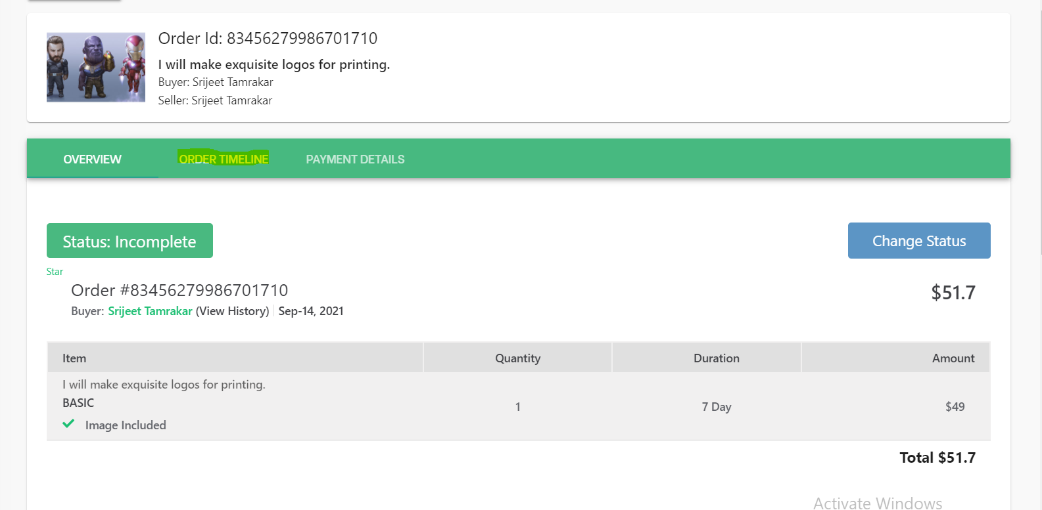

*The highlighted part Order Timeline is yet to be discussed. The Payment details goes further after payment integration but a small fraction of data available is shown

1. **Payments**

A representation of all the payments done in the platform is shown. Further details shall be added after the withdrawal is completed. The current features are as shown in the image below.

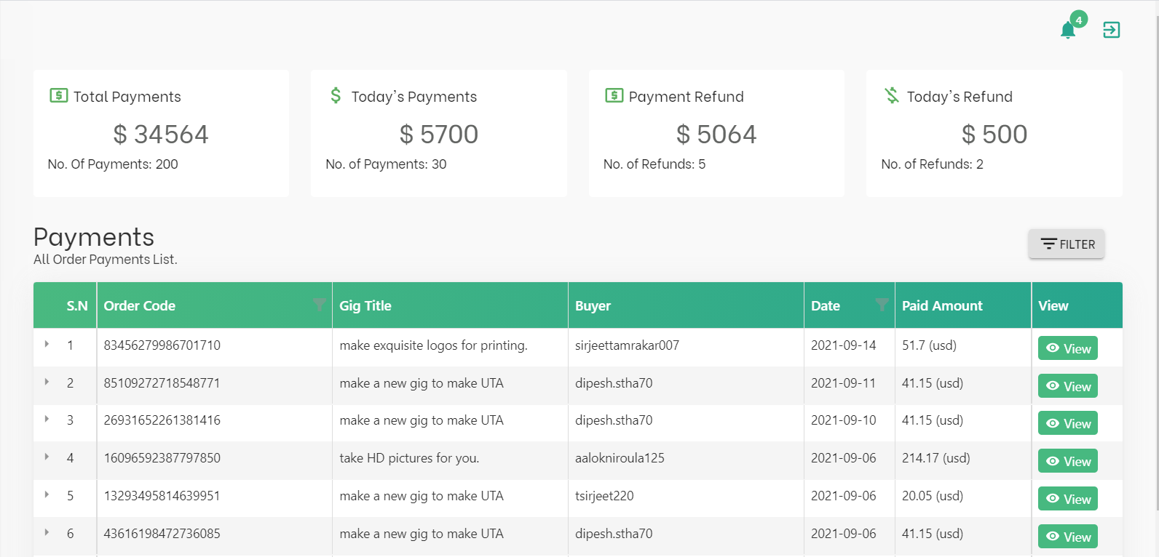

## 2.11 Site Info

For the time being, the **Site Information** (Site Info) has been made a simple form with implied fields. This information is about the FUCHA Marketplace itself.

Although, there are two options.

1. **Default Profile:** This field is to add a default profile picture for the user who is still to fill up their picture for the profile.

1. **Default GIG:**This field is for the default image for any GIGS that are yet to be completed by the seller while creating the GIG. As the GIG creation is left without filling up all the information, the gig created till that point will be saved in the draft with the following image as its default image. The Draft status will be explained in the upcoming topics.

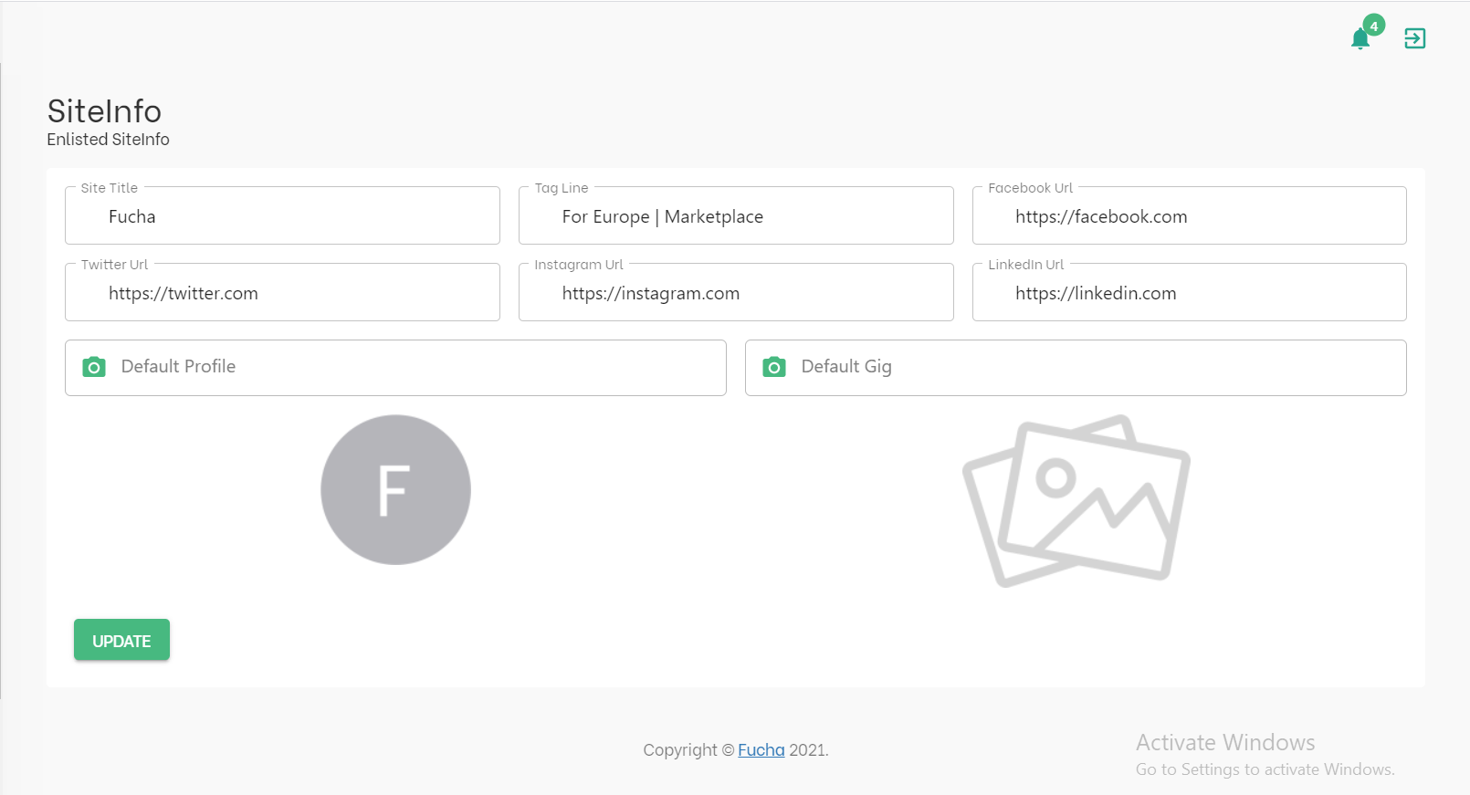

## 2.12 Users

All the information regarding the user is added in the User Sub Tab. We have seen the Admin Tab, this is just for the Customers.

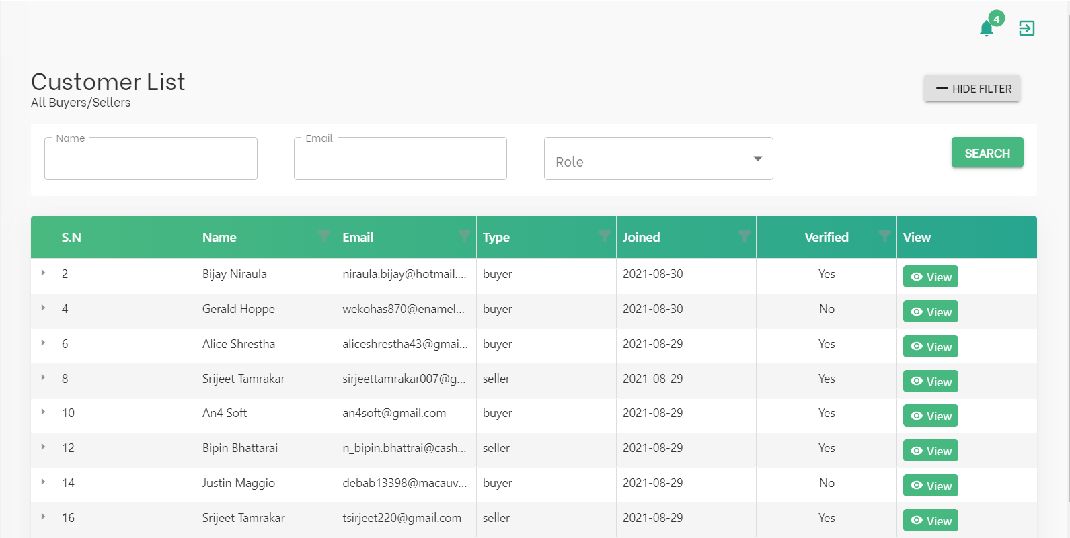

**Customer**All the information of customers is represented in the tabular form to navigate between the users. At the top of the page, we can look at the filter section. The admin is allowed to filter between the users using three parameters

* 1. **Name**
  2. **Email**
  3. **Role (Buyer/ Seller)**

There are two ways to navigate about the users from the table.

The summary can be seen by clicking the **side-arrow** from Serial No. Information’s like ID, Name, Email, and Joined Date can be determined.

The complete description can be visualized by clicking the **View Button**under the view column. It gives detailed information about the given user. Those information’s are listed as follows:

1. **Profile**

Description, Language, Country, Linked Accounts, Education, Skills, and Certifications

1. **Orders**
2. **Gigs**

All the created gigs by the particular user on the chronological order from the latest to the oldest. Under the View Tab of the Gigs we will see further information about the GIG’s which will be explained in the upcoming topics.

1. **Payments**

About all the payments the buyer/seller has done to website and dispatched to their personal account from the website.

1. **Review of the Seller**
2. **Total Earned**
3. **Total Expenditure**

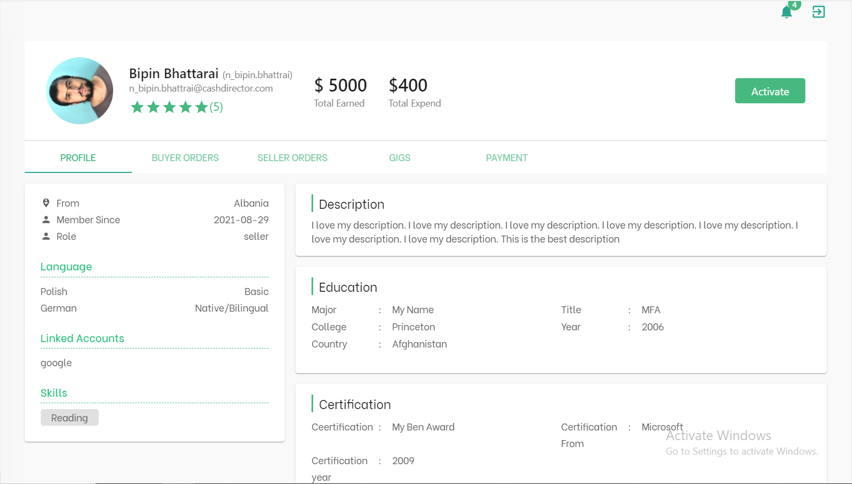

## 2.13 Status of GIGs

There are different status of the GIGs that has been created. Each has their own unique features thus shall be explained respectively.

1. **DRAFT**

The created GIG is considered to be draft if the different parameters of the GIGs are completed but the seller has not published the GIG while creating the GIG.

The first draft is created whenever seller completes the form of **GIG Overview Tab.**

1. **ACTIVE**

The Active Status in a gig represents that it has been published by the seller from the GIG Publish Tab. Only the GIG at status “ACTIVE” are seen by other users and able to be bought from the Front End.

1. **PENDING APPROVAL**

The pending status occurs in one of these two cases. The first one is, whenever someone reports the GIG and the second one is by the Admin if there is any Suspicious Activity.

1. **REQUIRES MODIFICATION**

If any modification in the GIG is required due to unauthorized pictures, links or texts, The Admin can change the status to Requires Modification and the USER can activate the GIG again by changing the given Modification

1. **DENIED, SPAM, BLOCKED**

The status blocks the GIG and different business logics can be created which are to be done in Version 2.0

1. **PAUSED**

This is the only status that a seller can toggle between. If the seller wishes to toggle the status of GIG to paused, the GIG will be paused until the seller activates it again. The GIG with status “PAUSED” will not be shown in the front end of the platform.

## 2.14 Status of Orders

1. **INCOMPLETE**

The status “INCOMPLETE” occurs in only one condition. Whenever the Buyer buys any GIG but fails to submit all the Requirements given by the Seller.

1. **INPROGRESS**

The Status “INPROGRESS” is the official start of the order whenever the Buyer fills in all the requirements from the seller. The started date will be added to the project alongside the end date for the order.

1. **DELIVERED**

After the order officially begins, if the Seller completes the work and delivers the order then the order will be marked as “DELIVERED”.

1. **REVISION**

If there is any issue on the work which the Seller provided to Buyer, then, the Buyer has option to ask the Seller to redo the tasks which he has not been satisfied with. This leads to the Status “REVISION”

1. **LATE**

The order is marked as “LATE” if the order deadline exceeds its original period.

1. **VERY LATE**

The order is marked as “VERY LATE” after the time passes 24 hours more from the “LATE” status.

1. **COMPLETE**

The order is marked as “COMPLETE” whenever the Seller delivers the order and Buyer accepts it. The order is marked completed automatically after 3 Days of submission even if the Buyer doesn’t accept the order.

1. **DISPUTE**

The order is marked as status “DISPUTE” if the order goes to customer support. This status will give the admin access to intervene the order and change the status accordingly.

1. **CANCELLED**

The order status “Cancelled” occurs in four conditions. The first condition is when both the Buyer and Seller decide to cancel the Order in mutual agreement. The second condition is when the buyer does not provide the required information given by the Seller. The third condition is when the order is marked as Very Late. The final condition is in the case of the dispute where the Admin can mark the order as cancelled.

## 2.14 Mailing Conditions

These are the conditions when a mail is sent to the Buyer or the Seller from the Admin Panel.

* 1. Changing the Status of the GIG from the Backend (**Reason & Status**)
  2. Message from the Admin inside the order when the Admin Intervenes