This document includes the following :-

* General guidelines
* Technology stack
* References
* Working of individual files and module
* Installation guidelines

GENENRAL GUIDELINES:-

1. Include the your name at appropriate paces when you modify / write a cetarin piece of code (not needed if code is minor correction ) . This is necessary as any future developer may contact you and development task will be easy .
2. Change this document (especially the working part ) if u happen to change the code or underlying logic also include the references in this document as well as at appropriate place in the code as comments.
3. It would be better if the conditions are double checked , extra conditions (constraints) prevent bugs . Example from download.php:-

download.php

<?php

if(!isset($_SESSION["email"])) // check if user is logged in

{

// if not logged in then redirect to login

}

if(isset($_GET['like']) // check if user pressed liked button

{

// if like press then do something

}

// rest of code

The above code works perfectly fine , but the problem may occur if a coder due to some reason swaps the ifs the resultant code will be :-

<?php

if(isset($_GET['like']) // check if user pressed liked button

{

// if like press then do something

}

if(!isset($_SESSION["email"])) // check if user is logged in

{

// if not logged in then redirect to login

}

// rest of code

This code does get an error if user is not logged in and somehow still has the download page open (in some other tab maybe when he was logged in )

To prevent this the following approach is suggested

<?php

if(!isset($_SESSION["email"])) // check if user is logged in

{

// if not logged in then redirect to login

}

if(isset($_GET['like'] **&& !isset($_SESSION["email"]**) // check if user pressed liked //button **and is logged in**

{

// if like press then do something

}

// rest of code

In the above code , in second “if “ it may redundant to check that user is logged in (as it is already checked in 1st “if “ ) but it prevents many future bugs (and since we are still in a very primitive stage these things are bound to happen more often )

Technology stack and software :-

* Php (all pages )
* JavaScript (most pages )and ajax (download.php)
* Html (most pages)
* MySQL (download.php , login_validator.php and register_validator.php)
* XAMP (for PHP )
* Notepad++ (or any text editor )

References:

Header.php :-

<https://www.tutorialrepublic.com/snippets/preview.php?topic=bootstrap&file=navbar-dropdown-login-and-signup-form-with-social-buttons>

<https://stackoverflow.com/questions/10572735/javascript-getelement-by-href>

<https://stackoverflow.com/questions/33178114/using-queryselectorall-to-change-the-style-property-of-multiple-elements>

login_student.php, login_teacher.php, register.php

<https://colorlib.com/wp/template/login-form-v1/>

<https://www.webdeveloper.com/d/116317-how-to-pass-a-parameter-from-one-html-page-to-another-html-page/6>

download.php

<https://codepen.io/wallaceerick/pen/ctsCz>

<https://getbootstrap.com/docs/4.0/components/dropdowns/>

heart :

<https://codepen.io/mindstorm/pen/aZZvKq>

<https://www.w3schools.com/xml/tryit.asp?filename=tryajax_get2>

php:-

<https://www.php.net/manual/en/function.header.php> // 1st example

<https://stackoverflow.com/questions/3252387/a-php-script-to-let-users-download-a-file-from-my-website-without-revealing-the>

mysql :

<https://www.w3schools.com/php/php_mysql_connect.asp>

<https://www.w3schools.com/php/php_mysql_select.asp>

register_validate.php , login_validate.php

mysql :

<https://www.w3schools.com/php/php_mysql_connect.asp>

<https://www.w3schools.com/php/php_mysql_select.asp>

Working:-

Abstract Overview :-

Database

MySql

Login_teacher.php

Register.php

Login_student.php

Header.php:

The template is modified to suit the edubuntu theme , certain parts of template : search , top bar login and signup were removed and were replaced with links to corresponding pages.

The css part has been modified for the color and , on hover orange colour submenus are shown

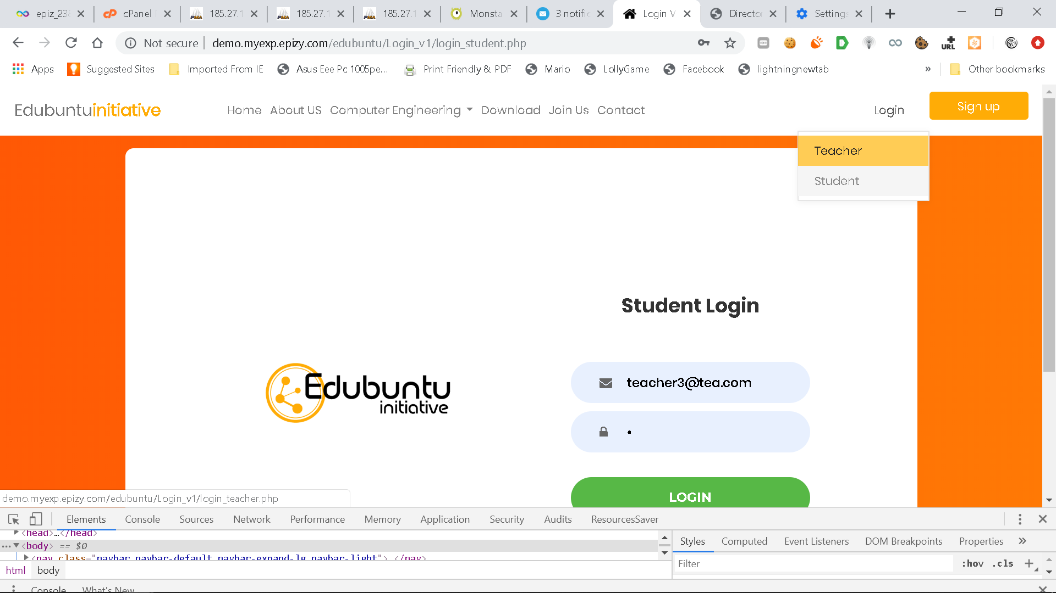

Teacher becomes orange when you place your mouse over it.(here student is actual page open so it is greyish color )

The css also includes attributes for the register.php , it may be moved to the specific page or a generalized can be applied also to login buttons ( if ajax is used for login in future )

Php:

Reason for making this page and all other pages php was to get the current user session with $_SESSION[‘email’] variable it allows user email to be displayed on all pages when he is logged in and signup button is changed to sign-out .

Php is used to check if user is logged in -> if he is then change_button() function is called which changes the buttons and displays email (using session email variable ( $_SESSION[‘email’] ))

Also the current page has to be highlighted in browser (that is if download page is open then download tab should be dark and rest all should not be dark )

For this we get current page by using basename($_SERVER['PHP_SELF']) and pass it to javacript -> queryselector and get the button which is to be activated and make corresponding class active (active class is used to make required part highlighted )

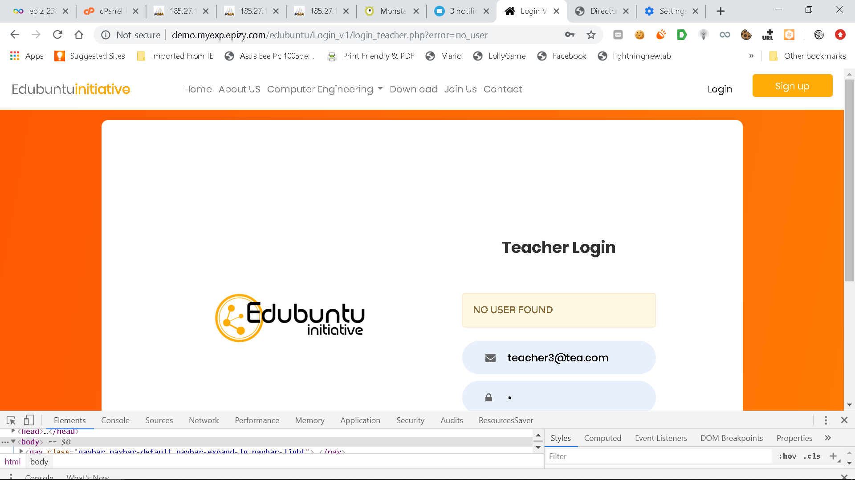

Here login is active

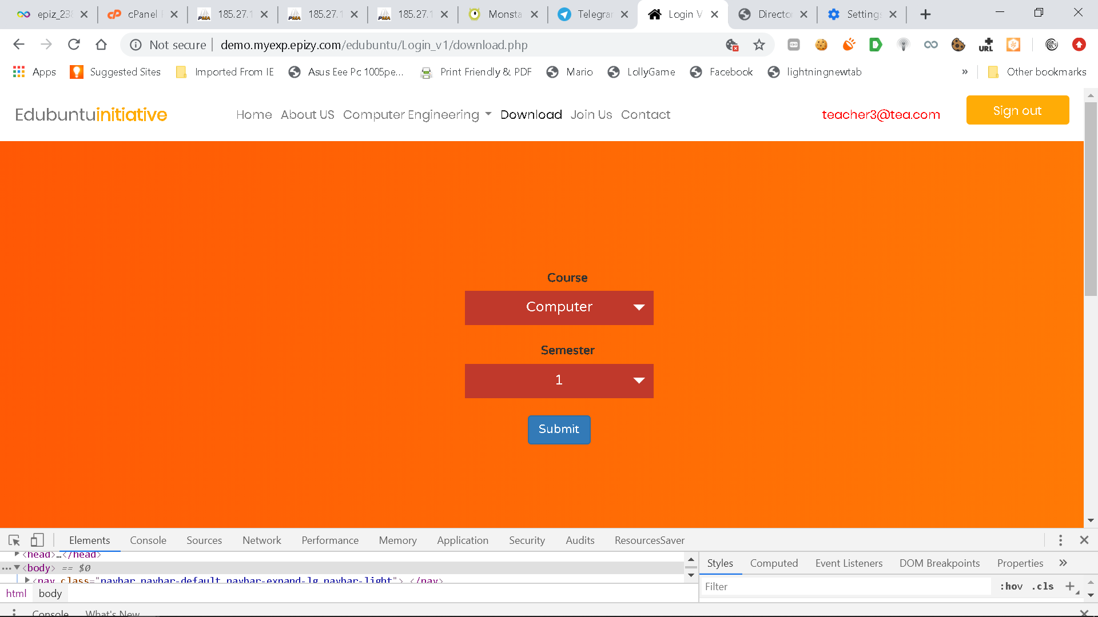

Here download is active

Login_student.php and Login_teacher.php:

Main.css and main.js

Login is a template which was modified for its color in main.css

Also the image is present at images/img-01.png

Most of template working is same except a script and a div box

When login button is clicked all the data is sent to login_validator.php and login_validator.php then either sends a error msg or redirects to download page

When error msg is sent it looks like this in url

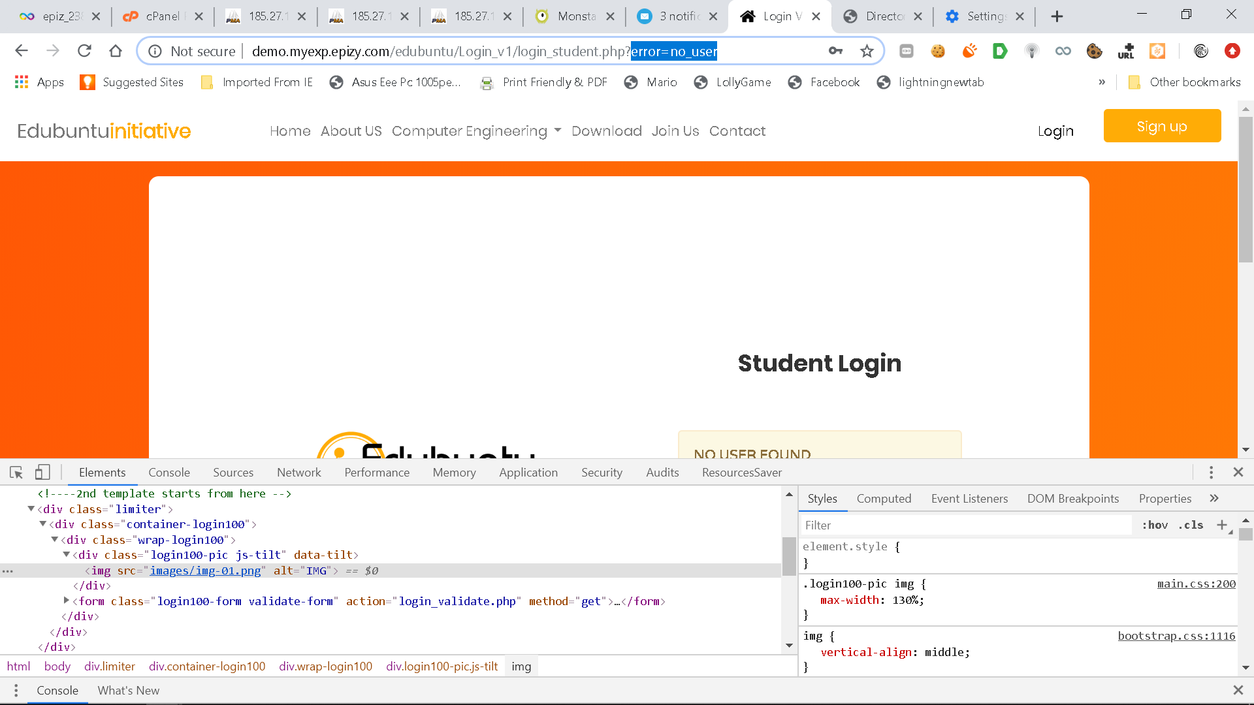

When document is loaded completely checkmsg() function is called it checks the current url for error=<some value > , <some value > can be no_user , invalid_pass or download

download: it means that user clicked on download page but is not logged in

no_user: email does not correspond to a valid user in database

invalid_pass : email is present in database but password entered is wrong

checkmsg() then displays the appropriate msg with color in <div id=”message”> </div> box

NOTE: all these could be passed and checked in login_student.php or login_teacher.php (as get parameters )itself but it would increase the server work unnecessarily

register.php

it has same template of login but only other feature included is the retype password

The check() function checks the two entered passwords and if they are same then enables the register button (css for register button is in the header.php file )

Register passes its data to register_validator and register_validator then either redirects to download or sends error=<some value >

The function checkmsg() is same as in login but it also checks for the following <some value>

student_email_exhist: already there exhist a email in student table

teacher_email_exhist: already there exhist a email in teacher table

NOTE: read the NOTE of login_student.php

Login_validator.php

1st thing is to check is user is already logged in (by checking if $_SESSION[email] is set )

If it is so then redirect to download

Else

Connect to database

Select the password and valid status of user from corresponding table ( decided by type variable which is sent along with form)

If result received has more then 0 rows then proceed else redirect to login_{$type}.php?error=no_user

If passwords do not match then send error invalid_pass

If password match set the variable $_SESSION[“email”] (used for dispaying him in header ) and $_SESSION[“type”] (used in download.php) to corresponding values

Redirect to download

Register_validator.php

1st thing is to check is user is already logged in (by checking if $_SESSION[email] is set )

If it is so then redirect to download

Else

Connect to database

Select the password and valid status of user from corresponding table ( decided by type variable which is sent along with form)

If result received has more than 0 rows then redirect to register.php?error={$type_email_exhist} as user already exist for that email

Else

set the variable $_SESSION[“email”] (used for dispaying him in header ) and $_SESSION[“type”] (used in download.php) to corresponding values

Redirect to download

Download.php

1st thing is to check is user is not already logged in (by checking if $_SESSION[email] is set )

If it is so then redirect to login with error=download as user should be logged in to download

Else

Connect to database and check if liked button was pressed by him in past , if liked button was pressed then $liked_msg is set to total no of likes else liked_msg =”LIKE US!”

$liked is like a flag variable which also includes the css class name of heart

If css class is “heart ” then greyish heart is shown which represents unclicked like button

If css class is “heart is-active ” then a red color heart is shown which represents clicked button .

The download.php receives a ajax call when heart is pressed [ that means the variable $_GET[‘like’] is set ]

If so then increment likes for respective user table (if haven’t already done in previous sessions )

Also increment likes in global table

If all above checks fail then check if request to download.php was a download request (here $_GET[‘course’] and $_GET[‘sem’] will contain the required data)

Update downloads counter in global table and set $FileName variable to link to actual file

HTML part of download .php

It basically contains header , heart animation and form template

Form is a normal form which submits data to same page (i.e. download.php)

Heart class css is decided by the $liked variable and also the message below heart is decided by $liked_msg variable

When heart is clicked inc_like is the function called which is basically a ajax call to the same page (download.php )

Installation of xamp

Xamp can be installed at <https://www.apachefriends.org/download.html> at any drive of your choice

Htdocs folder should contain edubuntu folder as shown

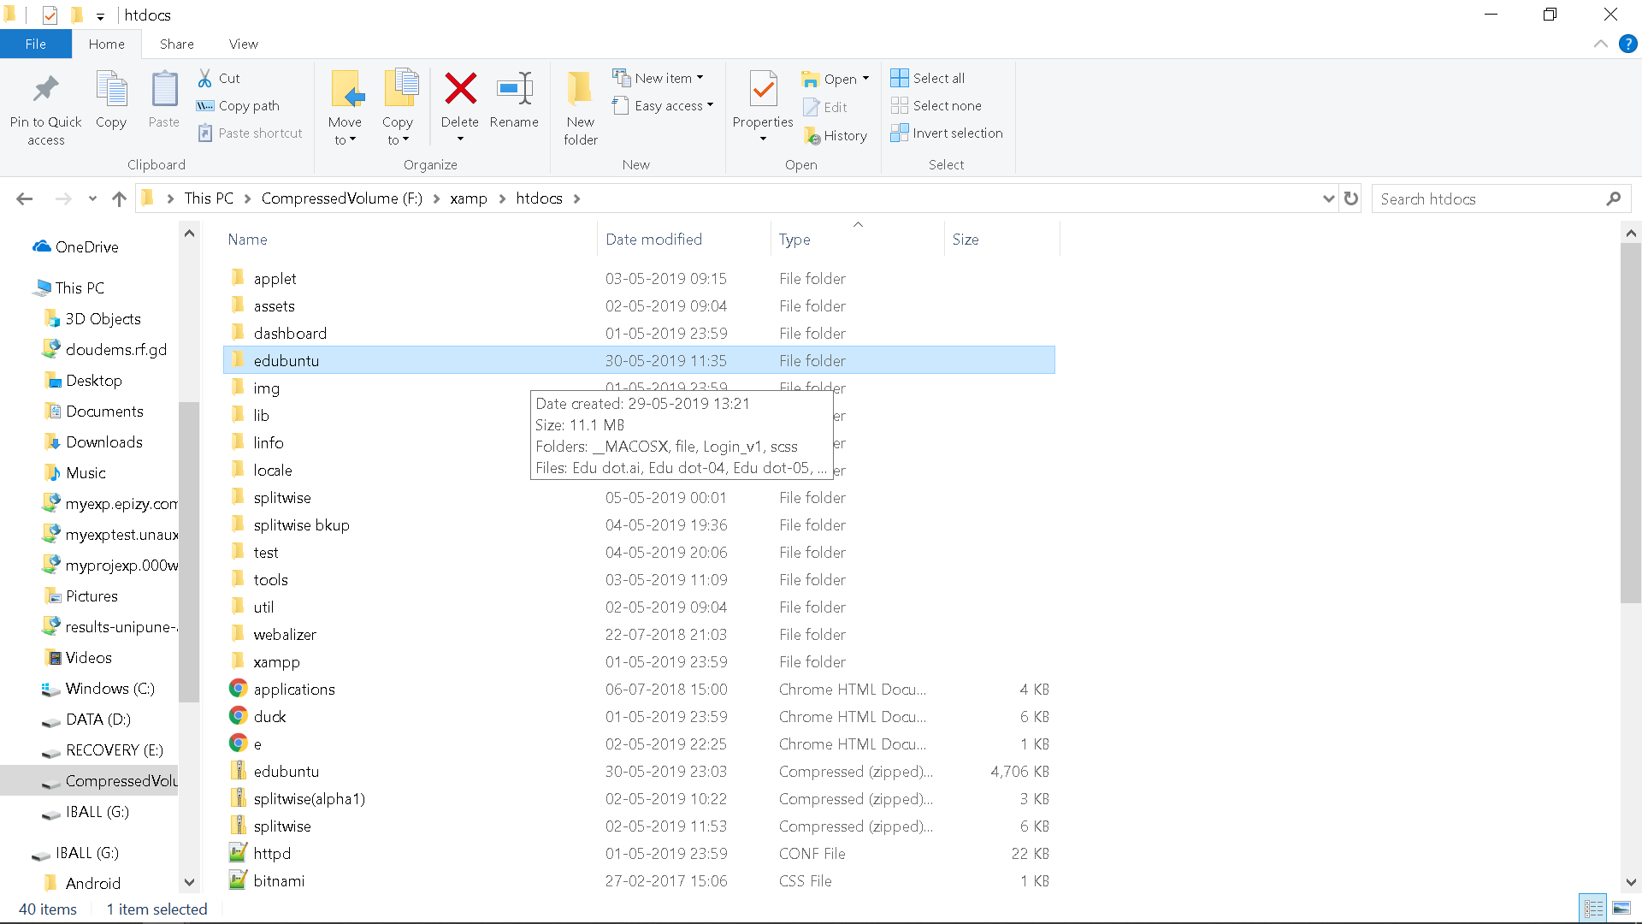

Open xamp control panel and start apache and mysql as shown

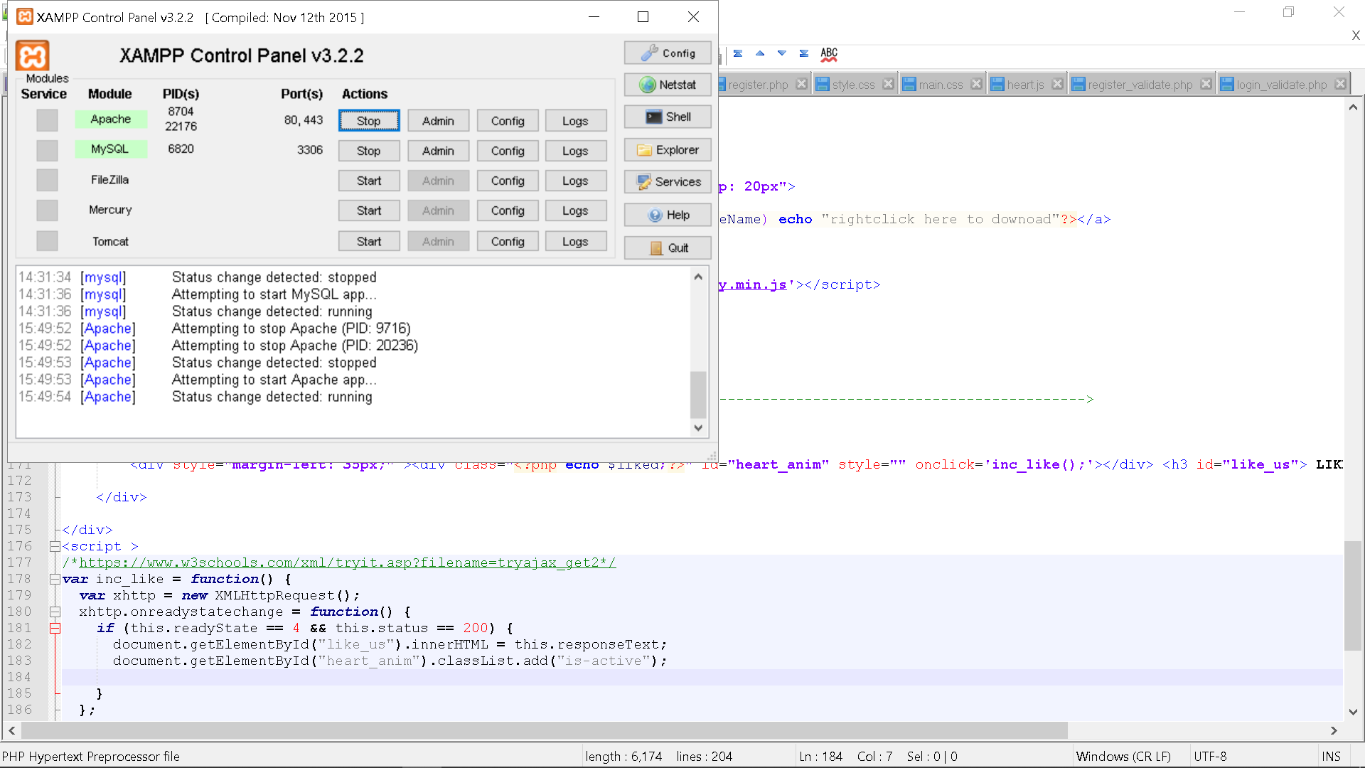

Goto chrome and type link <http://localhost/edubuntu/Login_v1/login_student.php>

Following page should be loaded

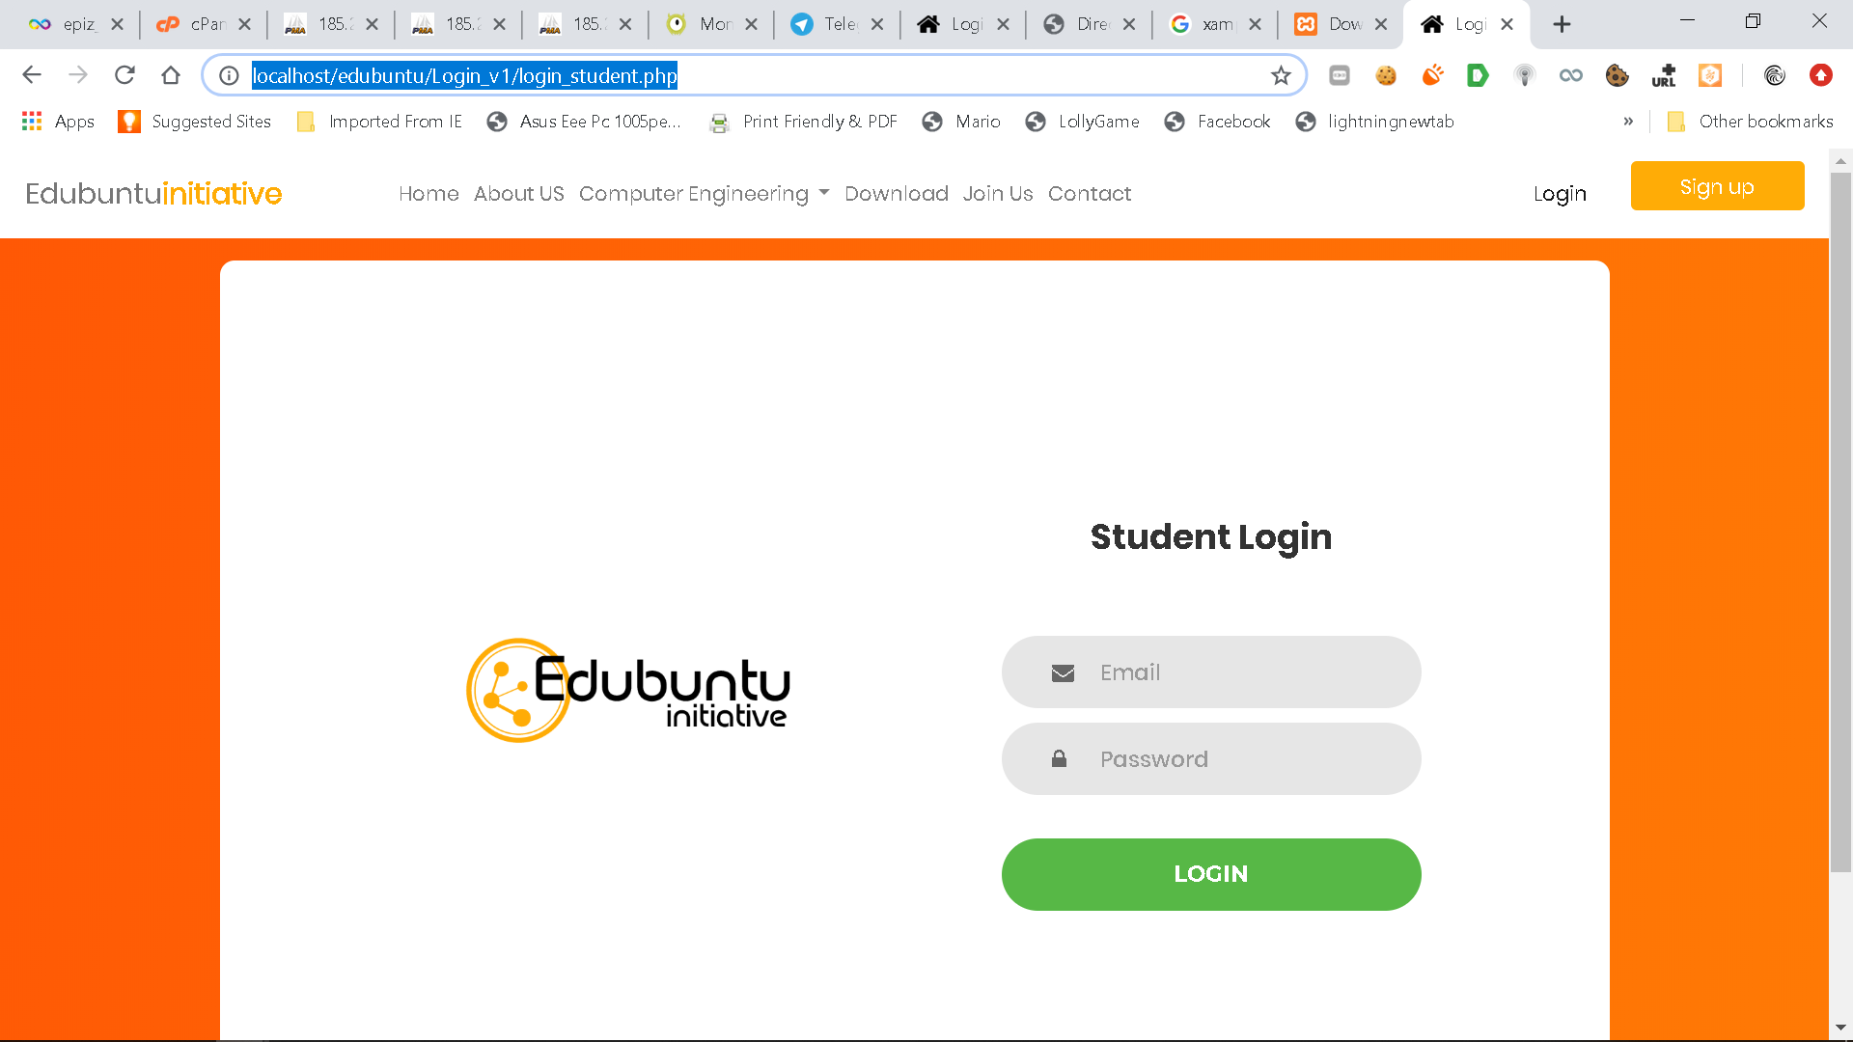

For viewing sql goto <http://localhost/phpmyadmin/>

Create new db with any name

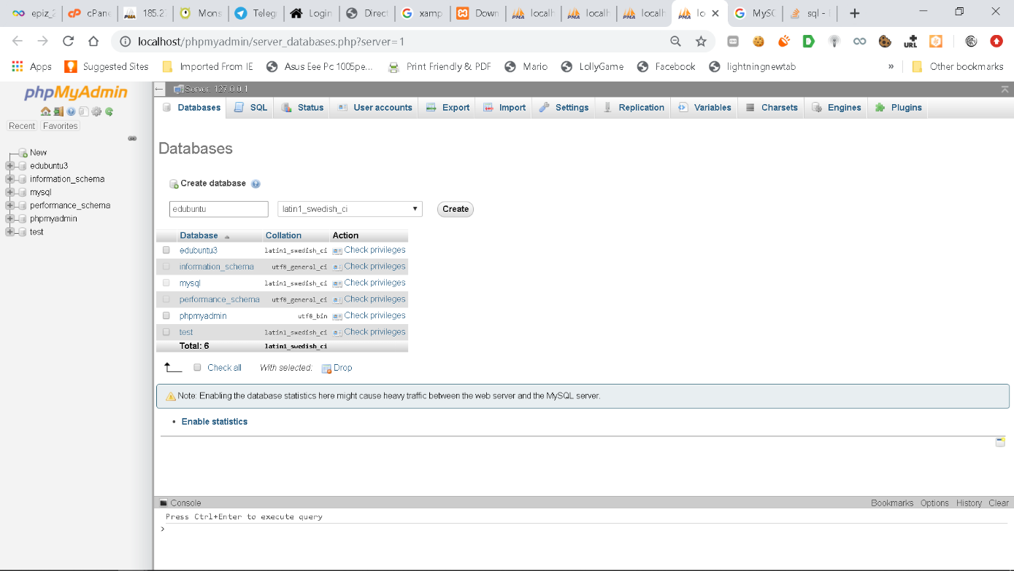

Select import while in current new database (6th option form left)

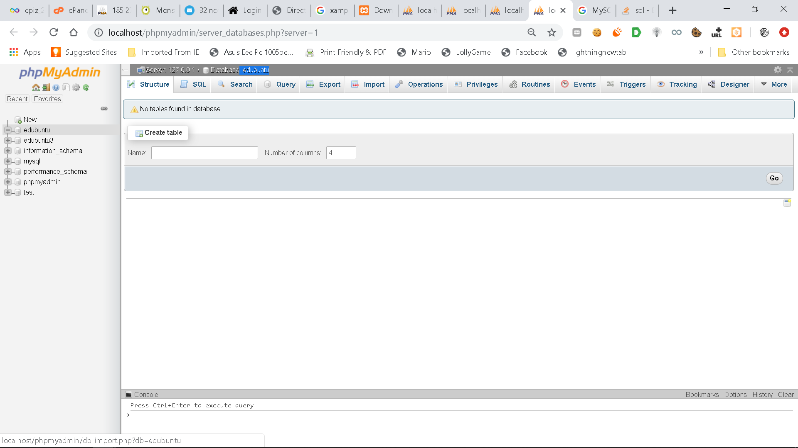

Choose file and scroll down to hit go

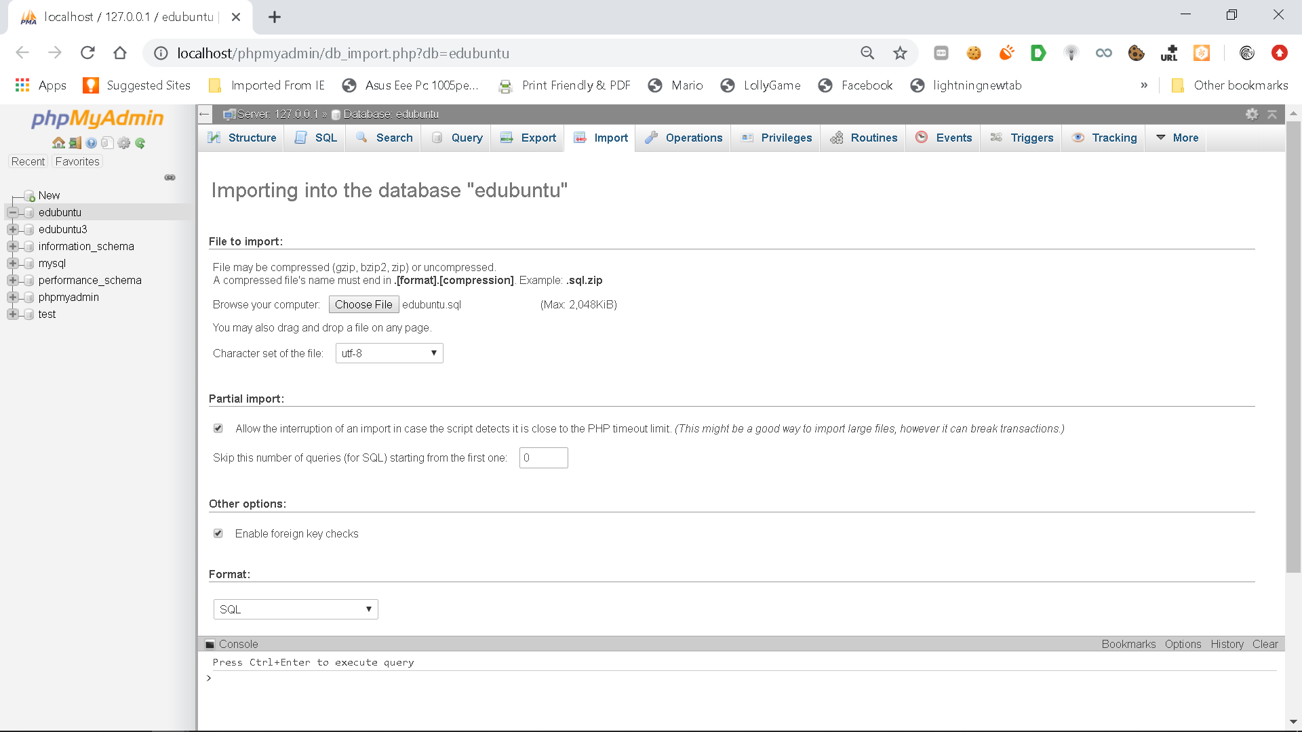

Database will be imported

