Day 1 - 16th May 2025

Day 1- 113145793 -Dipesh varma

Task: 1

What is SDLC?

5 min 10.10 to 10.15 to 10.18

SDLC Stands for Software Development Life Cycle. It starts from gathering requirements and ends on Maintenance. SDLC is important for carrying out tasks effectively and deliver on time. There are few common models in SDLC, Waterfall, agile, spiral, V-Model, Devops.

Task 2:

Why is SDLC ?

5 min  10.20 to 10.25

SDLC is important to carryout the entire software development task effectively. It is a structured process to start and finish the development effectively and with better quality. It helps in recognizing and predicting errors or challenges which might come along with the development and resolving them on time.

Task 3:

What are the stages of SDLC ? write 2 lines about each

10 min 10.28 to 10.38

Below are the stages of SDLC.

* Requirement gathering and analysis:- It is to understand the outcome which the client want. This step helps in having a clear expectations of the client or the user which helps in avoiding any major changes in the the last minute.
* System design:- This step helps in planning about the building of the software. The decision of choosing the technologies and tools to use is done in this step. Blueprint of the software is created in this step.
* Implementation:- This step is also know as as coding step, The created system design is now converted into a working system by writing the code.
* Testing: - Testing is done to check for any bugs or error which might come during the user experience. This step gives test reports and bug logs.
* Deployment: - In this step the product/software is delivered to the user. An initial training and document is also provided.
* Maintenance: - This is the last step in SDLC, Goal of this step is to keep the software running smoothly and bug free. Updates and improvements are executed in this step.

Task 4:

SDLC Models:

List them, description - 4 lines min and with a image

Below are the list of models of SDLC

1. **Waterfall Model** :- sequential or step by step approach, It is best for small scale projects with clearly defined objective. It is simple and easy to manage. Next phase cannot be executed without completing the current phase as it is an model with linear approach.

**Applications**:- Inventory management for warehouses.

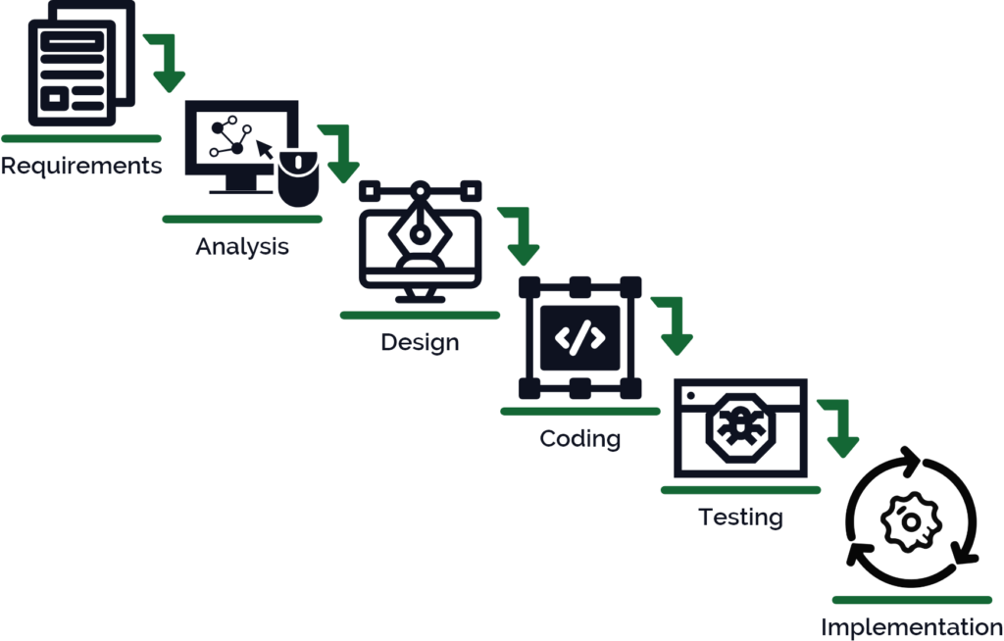

**Advantages** of Waterfall Model: - simple and easy to understand and use. Suitable for small projects and fixed requirements.

**Disadvantages** of Waterfall Model: - Not suitable for long term projects or on going projects.

1. **V-Model**:- Verification and validation is an extended version of the waterfall model. As the name suggests if focuses on verification and validation on each development stage. **Applications**:- healthcare industry. As it need critical testing.

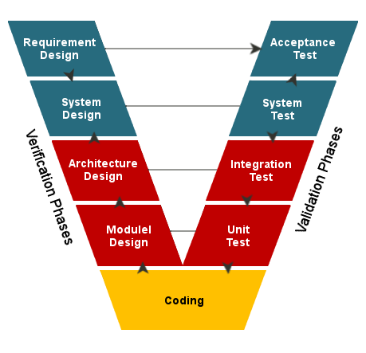

**Advantages** of V Model: - Focuses on testing and quality, Errors can be found in early stages

**Disadvantages** of V Model: - less flexibility ot best for complex long-term projects

1. **Incremental model**: - in this model each increment step adds functional capabilities. It is suitable for projects of which requirements can be evolved or changed. The integration of these model can be complex.

**Application**: - banking and finance, as it requires step by step development which can be improved and extend over the time.

**Advantages** of Incremental Model: - Provides a working model at early stage Flexible as it allows to changes between increments.

**Disadvantages** of Incremental Model: - requires good planning and design. Complicated integration.

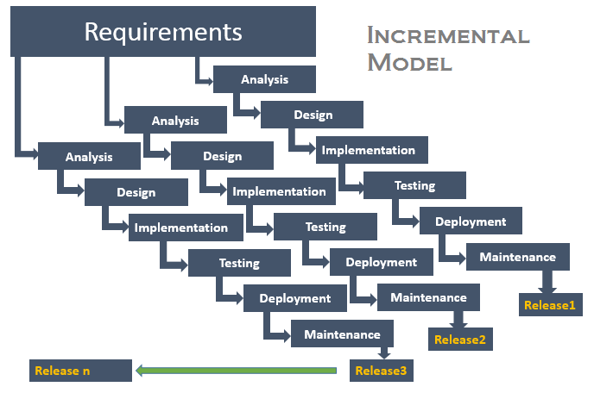

4.**Iterative Model** :- it is best for large and complex projects with evolving requirements. It requires strong management. Each iteration goes through sdlc phases.

**Applications**:- Telecommunication industry, Suitable for large systems and large number of users as it need regular updates.

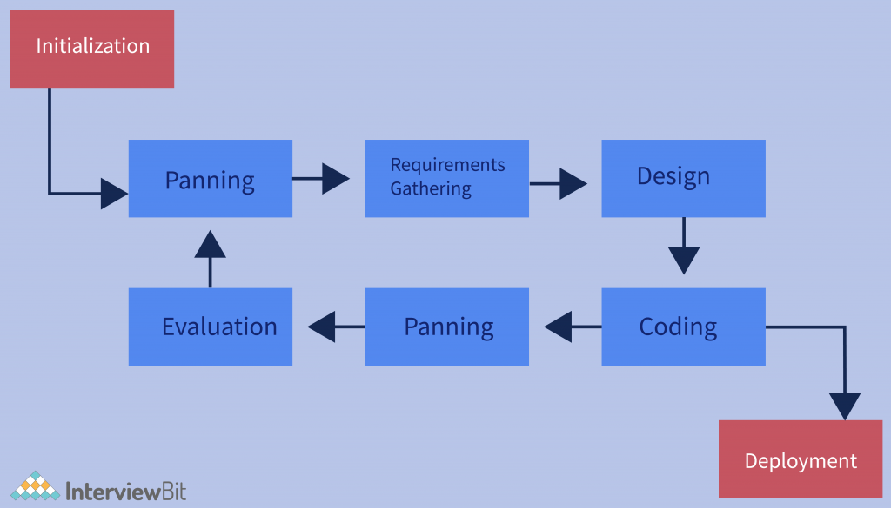

**Advantages** of Iterative Model: - best for risk reduction, allows for changes as it iterates on each step.

**Disadvantages** of Iterative Model: - requires user involvement at each step. More resources are needed for this.

1. **Spiral Model**: - This is best for the high risk and large scale projects. It can be complex and expensive. It combines few elements of waterfall and iteratie models with risk analysys. Risk evaluation takes place in each stages.

**Applications**: - Insurance industry, as it is a combination of iterative

development along with risk assessment at every phase.

**Advantages** of spiral model: - focuses in risk management, flexibility. Citable for large, high-risk projects

**Disadvantages** of spiral model: - Expensive and complex to manage. Not best for low budget projects.

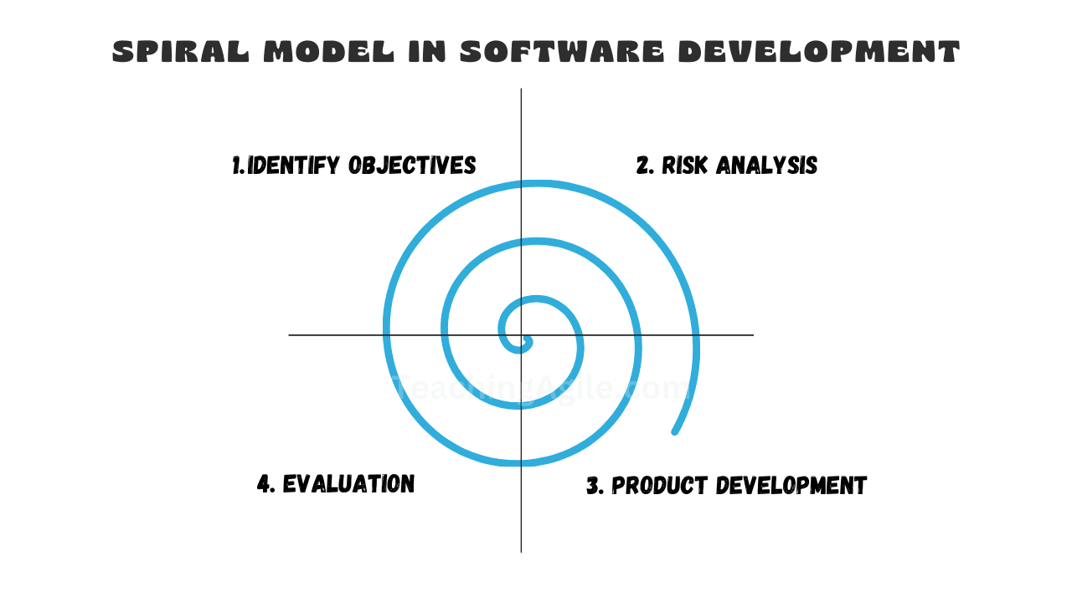

6)**Agile Model**: - Works in small integration, it can be highly adaptable and be delivered fast. It focuses on customer feedback and collaboration.

**Applications**: - Startups, e-commerce, live streaming platforms. Agile models are highly adaptable. It’s best for user-centric software.

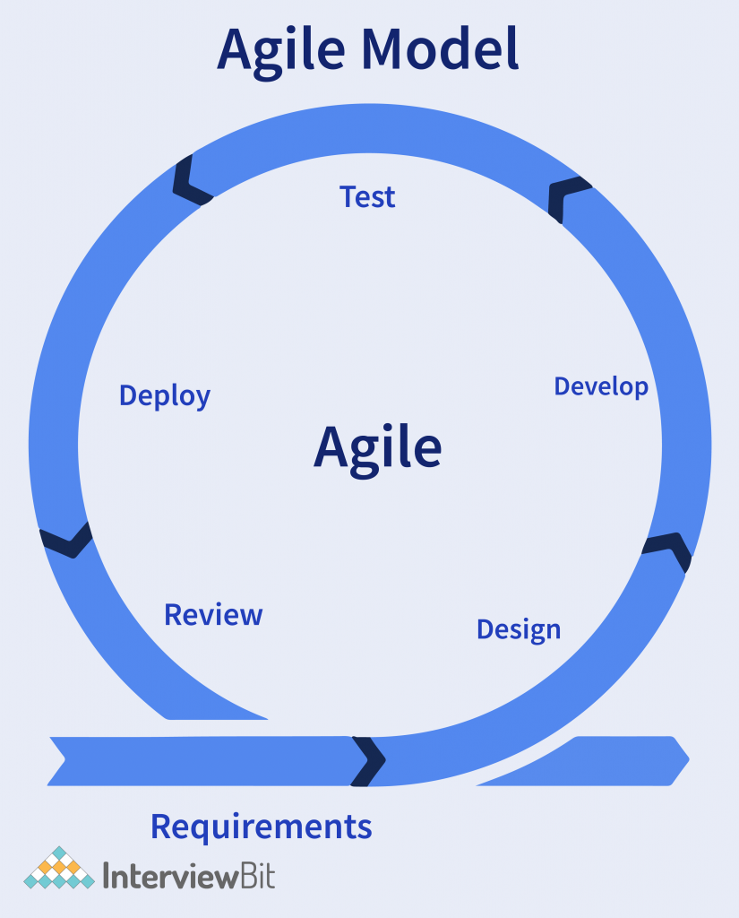

**Advantages** of agile model: - Frequent delivery of working software, Increased visibility and transparency

**Disadvantages** of agile model: - tough the predict the completion timeline. Not ideal for fixed-scope projects

1. **Big Bang Model**: - best for small scale projects. Miminal planning and coding is required. Mostly used in proof of concepts.

**Applications**: - Research and development. As it requires low planning its ideal for academic projects to implement new ideas at a fast speed.

**Advantages** of Big Bang Model: - very little planning required. Best for experimental projects.

**Disadvantages** of bug band model: - more risk of project failure, not suitable for large scale requirement.

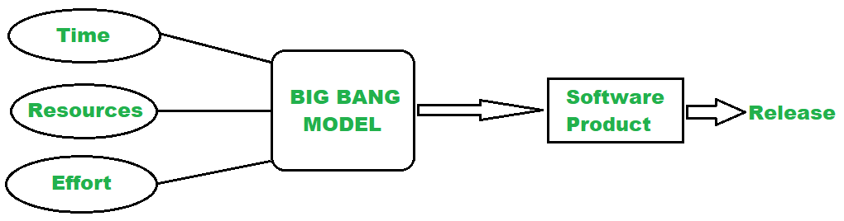

Task 7:

What is Scrum in Agile?

Scrum is model which is used to divide the development part in very small chunks to be completed by different developers in a very short time. It emphasizes collaboration and flexibility. Scrum provides a structured yet flexible way to deliver high-quality software quickly.

Task 8:

What is Sprint?

Its and fixed length iteration process. During this a set of tasks from the backlog is completed.

Task 9:

What are the dos and don’ts of Sprint? 3 points each.

Dos of a sprint

Define a clear goal.

Doing tests during the sprint.

Protecting the scope of the sprint by avoiding any new tasks unless its critical.

Don’ts of sprint

Avoid overcommitting

Sticking to the goal and avoid changing midway

Don’t neglect quality.

Task 10:

What are stories and Backlogs in Scrum World?

Stories is simply a description of features or functionalities which the customer or the end user wants.

Backlogs are of 2 types, product backlog and sprint backlog.

Product backlog: - A list of desired tasks and work to be done on the product it

is managed by the product owner.

Sprint backlog: - This is a subset of product backlog from the development

end point. This is managed by the Scrum team and executed

during the sprint planning.

Task 11:

Scrum Artifacts

Product Backlog

* Sprint Backlog
* Burn-Down Chart
* Increment

Can you brief the above Artifacts.

Product backlog: - A list of all the things which is needed in the product. It owned by the owner of the product.

Sprint backlog: - This is a subset of product backlog from the development end point. This is managed by the Scrum team and executed during the sprint planning.

Burn-Down chart: - It’s a graph that visualizes Remaining tasks VS the Remaining time. The purpose of this is to have a clear goal of the deadline. It encourages transparency and accountability.

Increment: - Increment is an artifact which represents sum of all the Product Backlog items completed during a sprint. It is inspected in sprint Review to demonstrate the product to the stakeholders during the sprint review to gather feedback.

Networking Concepts 👍

What are Ports and Protocols

Protocols are set standards that define how the devices communicate over a network. Eg:- HTTP, HTTPS,FTP e.t.c. Browsers uses protocols to connect to the ports on the web server. Protocols decide how the devices communicated, formatted, sent and received.

Ports are virtual entrance in a computer that help to route the web traffic to the correct application. Eg of port number:- 80(web traffic), 25(email sending). Ports are logical endpoints or channels in a device used to identify specific processes or network services.

Task 13:

What are the different Network types?

PAN(personal are network):- Small and within few meters. Used in Bluetooth.

LAN(Local area network):- Small areas like home or office buildings. Used in wi-fi

or office network

WLAN (Wireless LAN):- Small areas like home or office buildings but in wireless

form.

MAN (Metropolitan Area Network):- It covers city or a large campus. Used to

Connect multiple LAN networks in the city

WAN (Wide Area Network):- Large geographical area – country or worldwide.

Connects Lan’s and MAN’s.

CAN (Campus Area Network):- used to connect Multiple buildings in close

Proximity. College campus or Housing society’s

SAN (Storage Area Network):- Used to provide access to high-performance

storage devices like DATA center.

VPN (Virtual Private Network):- Secure and virtual network over the internet.

Used to securely access data to a company. It

encrypts data network. Following are the Type of

vpn’s. Peer-to-Peer VPN, Cloud VPN, Mobile VPN.

Task 14:

What are the types of servers ?

1. Web Server:- Hosts websites and delivers web pages to users via HTTP/HTTPS.
2. Database Server:- Stores and manages databases; responds to queries from clients. Examples:- MySQL
3. File Server:- Provides a centralized location for storing and managing files. User can can access files and share them. Example:- Google drive. Amazon Workdocs.
4. Mail Server:- Handles sending, receiving, and storing emails. Uses SMTP protocols.
5. Application Server:- Used to runs specific software applications. Bridge between web server and the database server.
6. DNS Server (Domain Name System):- Translates domain into IP addresses. Essential access websites without remembering IPs.
7. 7. Proxy Server:- Acts as a gateway between users and the internet. Can be used to security and content filtering
8. FTP Server (File Transfer Protocol):- Allows users to upload and download files using FTP.
9. 9. Virtual Server:- A server created using virtualization, running multiple OS instances on one physical machine.
10. 10. Game Server:- Hosts multiplayer online games.
11. 11. Print Server:- Manages print requests from multiple users to one or more printers.

Task 15:

What do you know about DNS? Domain Name System

DNS (Domain Name System) is like the phonebook of the internet. It translates human-friendly domain names (like www.amazon.com) into IP addresses (like 142.250.190.4) that computers use to identify each other on the network.

Task 16:

What are the different Network Topologies?

There are 2 types of network topologies

1. Physical topology:- How devices and cables are physically laid out.
2. Logical topology:- How data flows between devices regardless of physical layout.

Following are the different topologies

1. **Bus Topology**: - All devices are connected to a single central cable, called the "bus" or "backbone. Its simple and cost effective. The drawback of these is if the main cable fails the entire network goes down.

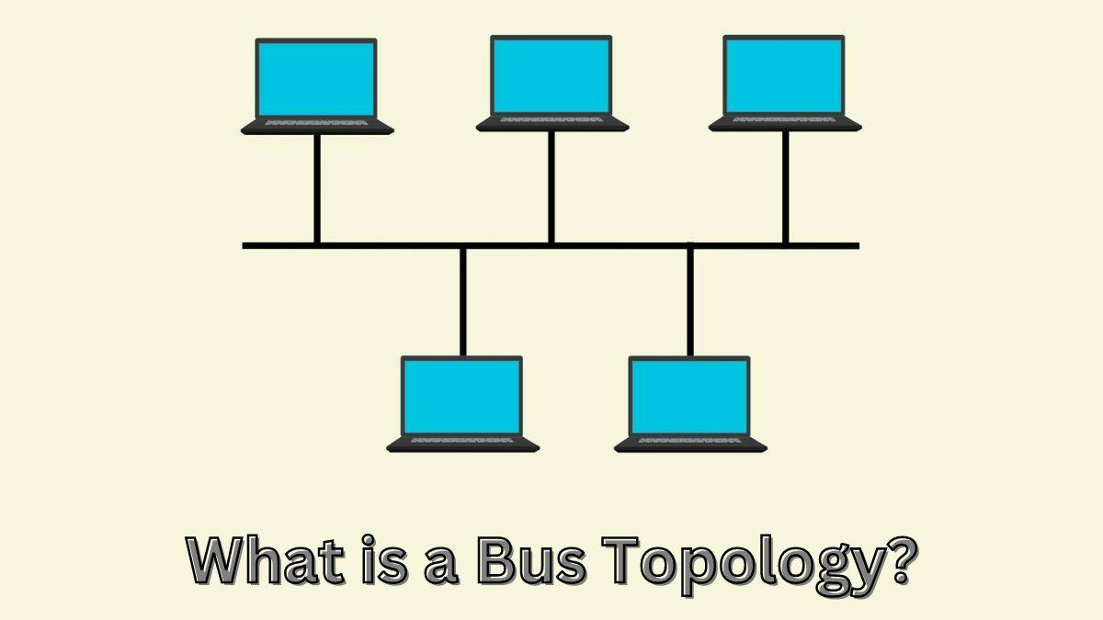

2. **Star Topology**: - All devices connect to a central hub or switch which manages data traffic. It's easy to manage and troubleshoot, but if the hub fails, the network is disrupted.

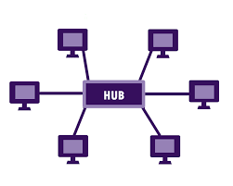

3. **Ring Topology**: - Devices are connected in a circular loop, and data travels in one direction. The drawback of this is, one break in the ring can bring the entire network down.

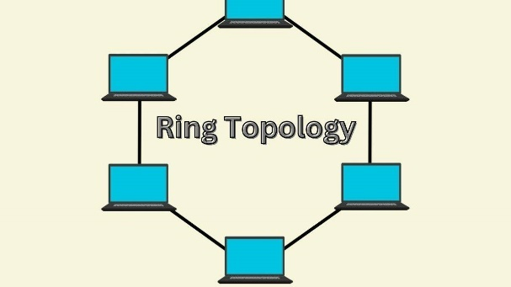

4**. Mesh Topology**: - Every device is connected to every other device directly from the main network. The drawback is that it is expensive and complex to setup.

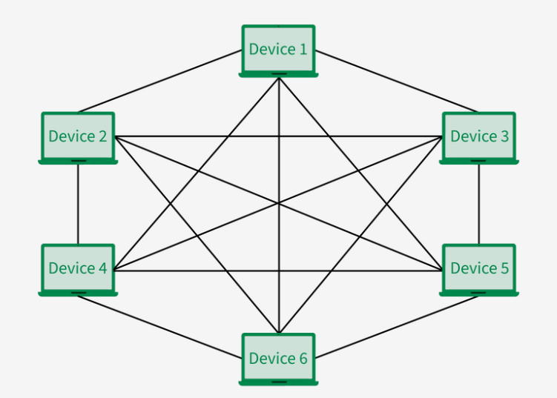

5. **Tree Topology** (Hierarchical Topology): - Combines star and bus topologies in a layered structure, like a tree. It’s scalable and commonly used in large networks, but backbone failure affects multiple devices.

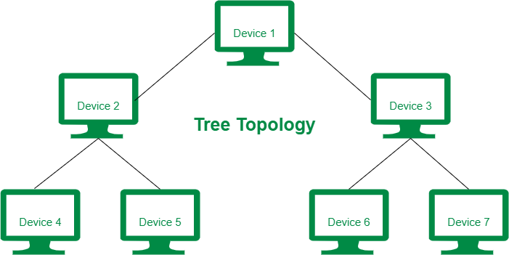

6. **Hybrid Topology**: - A mix of two or more different topologies, Offers flexibility and customization for complex networks. The drawbacks is that it can be more complex to set up and manage.

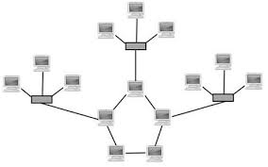

Task 17:

What is OSI Model ?

Describe the 7 layers with description.

The OSI Model is a conceptual framework used to understand and describe how data travels through a network. It breaks the communication process into 7 layers, each with a specific function.

Below are the 7 layers of OSI model.

1. Physical Layer:- Transmits raw binary data (0s and 1s) over physical media like cables switches and electrical signals.
2. Data Link Layer:- It Provides error detection and organizes data into frames. Examples are MAC addresses, Ethernet
3. Network Layer :- It handles routing and addressing between devices on different networks. Examples :- IP addresses, routers.
4. Transport Layer:- Ensures reliable data transfer with error correction and flow control. Examples are TCP, UDP.
5. Session Layer- Manages sessions (open, close, maintain) between applications. Examples APIs.
6. Presentation Layer:- Translates data formats, encrypts/decrypts, compresses data. Examples:- SSL/TLS, JPEG,Encryption.
7. Application Layer:- Closest to the end-user; provides services like email, file transfer, and web browsing. Examples:- HTTP, FTP, DNS, SMTP.