Partitions:
- The topic represented as logical concept is represented by one or more physical log files called partitions.
- The number of partitions per topic is entirely configurable.
- Each Partition is maintained over one or more broker.

ZooKeeper:
- Zookeeper manages the brokers and there metadata.
- It decides which broker will be elected as leader to manage the partitions and other brokers.

Replication Factor:

- It decides how many replicas do a partition will have.

Que) How kafka producer determines what partition to direct message to?

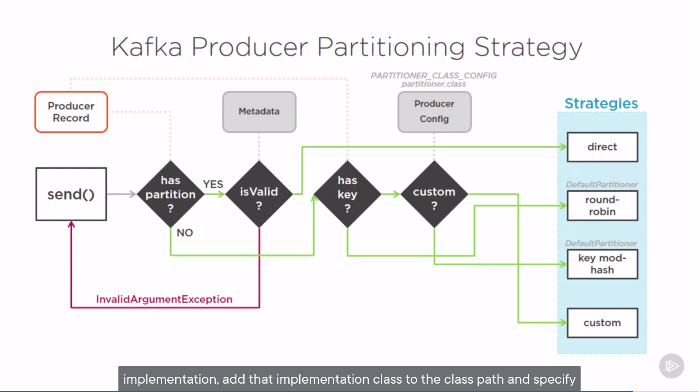

Delivery Guarantees:

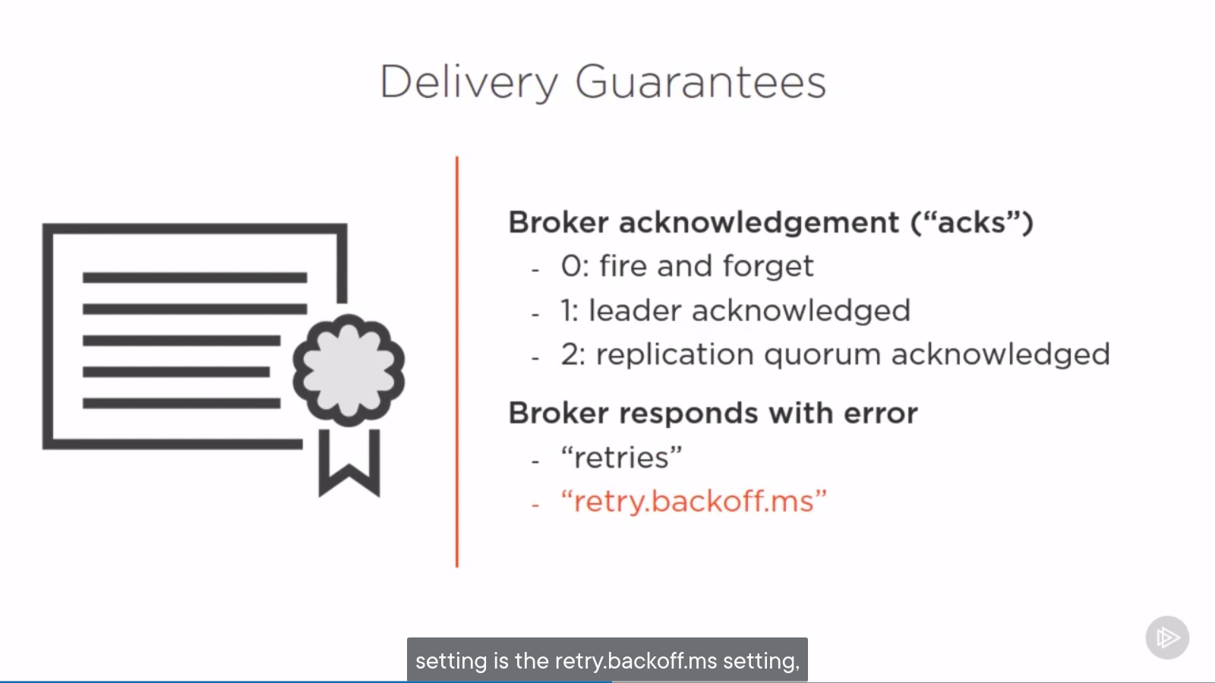

Consumer Groups:

- When we need multiple consumer to read from one topic having 100s of partions we use consumer groups.
- A group cordinator is responsible to manage all this consumer groups and there rebalancing.

Que) What is rebalancing?
Ans) When a consumer in group fails, then rebalancing happens and a existing consumer is assigned the partition the failed consumer was dealing with. Or else a new consumer is assigned that partition.
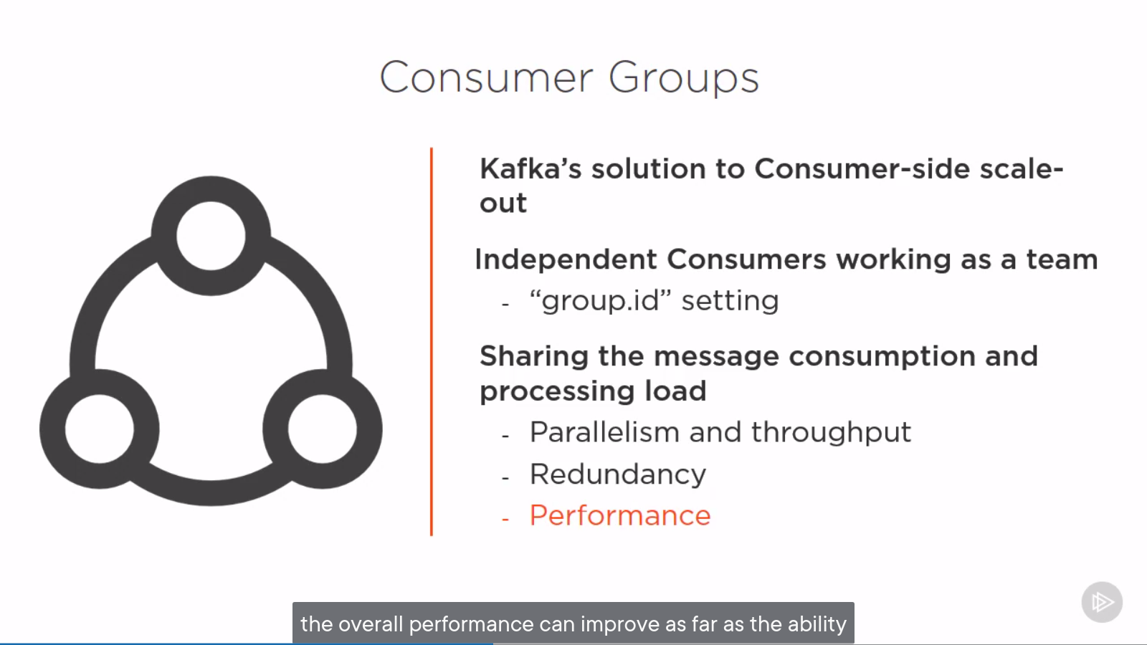

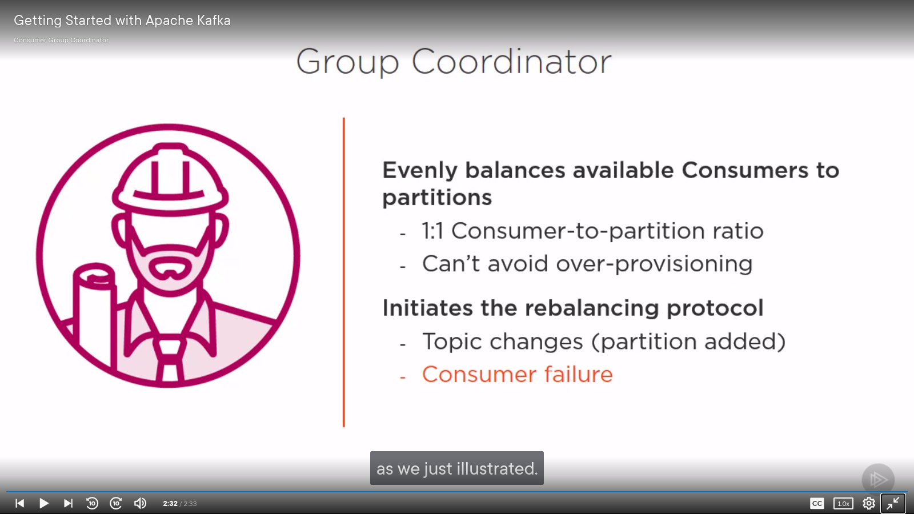

STEP 2: START THE KAFKA ENVIRONMENT
NOTE: Your local environment must have Java 8+ installed.
Apache Kafka can be started using ZooKeeper or KRaft. To get started with either configuration follow one the sections below but not both.

Kafka with ZooKeeper
Run the following commands in order to start all services in the correct order:
kafka installation location: /home/dipesh/kafka/kafka_2.13-3.4.0
# Start the ZooKeeper service
$ bin/zookeeper-server-start.sh config/zookeeper.properties
Open another terminal session and run:
# Start the Kafka broker service
$ bin/kafka-server-start.sh config/server.properties
Once all services have successfully launched, you will have a basic Kafka environment running and ready to use.

Kafka with KRaft
Generate a Cluster UUID
$ KAFKA_CLUSTER_ID="$(bin/kafka-storage.sh random-uuid)"
Format Log Directories
$ bin/kafka-storage.sh format -t $KAFKA_CLUSTER_ID -c config/kraft/server.properties
Start the Kafka Server
$ bin/kafka-server-start.sh config/kraft/server.properties
Once the Kafka server has successfully launched, you will have a basic Kafka environment running and ready to use.

STEP 3: CREATE A TOPIC TO STORE YOUR EVENTS
Kafka is a distributed event streaming platform that lets you read, write, store, and process events (also called records or messages in the documentation) across many machines.
Example events are payment transactions, geolocation updates from mobile phones, shipping orders, sensor measurements from IoT devices or medical equipment, and much more. These events are organized and stored in topics. Very simplified, a topic is similar to a folder in a filesystem, and the events are the files in that folder.
So before you can write your first events, you must create a topic. Open another terminal session and run:
$ bin/kafka-topics.sh --create --topic quickstart-events --bootstrap-server localhost:9092
All of Kafka's command line tools have additional options: run the kafka-topics.sh command without any arguments to display usage information. For example, it can also show you details such as the partition count of the new topic:
$ bin/kafka-topics.sh --describe --topic quickstart-events --bootstrap-server localhost:9092
Topic: quickstart-events TopicId: NPmZHyhbR9y00wMglMH2sg PartitionCount: 1 ReplicationFactor: 1 Configs:
Topic: quickstart-events Partition: 0 Leader: 0 Replicas: 0 Isr: 0

STEP 4: WRITE SOME EVENTS INTO THE TOPIC
A Kafka client communicates with the Kafka brokers via the network for writing (or reading) events. Once received, the brokers will store the events in a durable and fault-tolerant manner for as long as you need—even forever.
Run the console producer client to write a few events into your topic. By default, each line you enter will result in a separate event being written to the topic.
$ bin/kafka-console-producer.sh --topic quickstart-events --bootstrap-server localhost:9092
This is my first event
This is my second event
You can stop the producer client with Ctrl-C at any time.

STEP 5: READ THE EVENTS
Open another terminal session and run the console consumer client to read the events you just created:
$ bin/kafka-console-consumer.sh --topic quickstart-events --from-beginning --bootstrap-server localhost:9092
This is my first event
This is my second event
You can stop the consumer client with Ctrl-C at any time.
Feel free to experiment: for example, switch back to your producer terminal (previous step) to write additional events, and see how the events immediately show up in your consumer terminal.
Because events are durably stored in Kafka, they can be read as many times and by as many consumers as you want. You can easily verify this by opening yet another terminal session and re-running the previous command again.

