-
Department of Computer Engineering
Faculty of Technology, Dharmsinh Desai University
College Road, Nadiad-387001

B.Tech. CE Semester – VI

Subject: Service Oriented Computing

Project Title: Daily Expenses Management System

Developed By
Darji Dipesh – CE022, 17CEUBS137
Darshan Gohel – CE037, 17CEUBG002

Guided By
Prof. Apurva A. Mehta
Department of Computer Engineering
Faculty of Technology,
Dharmsinh Desai University

DHARMSINH DESAI UNIVERSITY

CERTIFICATE

This is to certify that the project entitled “Daily Expense Management System” is a bonafide report of the work carried out by
1) Mr. DARJI DIPESH, Roll No: CE022, Student ID No: 17CEUBS137
2) Mr. DARSHAN GOHEL, Roll No: CE037, Student ID No: 17CEUBG002
of Department of Computer Engineering, semester VI, under the guidance and supervision for the subject Service Oriented Computing. They were involved in Project training during academic year 2020-2021.

Prof. Apurva A. Mehta Dr. C.K. Bhensdadia
Department of Computer Engineering, Head, Department of Computer Engineering,
Faculty of Technology, Faculty of Technology,
Dharmsinh Desai University, Nadiad Dharmsinh Desai University, Nadiad

Date:

Contents
- Front Page...........................................................................1
- Certificate............................................................................2

- Abstract...............................................................................4
- Introduction........................................................................5
- Software Requirement Specification..................................6
- Design................................................................................8
- Use Case Diagram.......................................8
- Class Diagram..............................................9
- Sequence Diagram......................................10
- Activity Diagram.........................................11
- E-R Diagram……………………………………………..12
- Data Dictionary…………………………………………13
5. Implementation Detail......................................................14
6. Screen-shots.....................................................................15
7. Conclusion........................................................................19
8. Limitation and Future Extension......................................20
9. Bibliography......................................................................21

Abstract
This project mainly deals with creating an application regarding Income and Expense of User. The purpose of Expense management system is to automate the existing manual system by the help of computerized equipment and software, fulfilling their requirements, so that their valuable data/info can be stores for longer period with easy accessing and manipulation of the same. Expense management system, as described, can lead to error free, secure, reliable and fast management system. It can assist the user to concentrate on their other activities rather to concentrate on record keeping. So users can have all record of their income and expense easily with net balance.

Introduction

The “Expense management system” has been developed to override the problems of keeping record manually with redundant data. The application is reduced as much as possible to avoid the errors while entering the data. No formal knowledge is needed for user to use this system. Thus by all this it proves it is user-friendly. Every user or organization has challenges to overcome and managing the information of Income, Expense, Payment, Registration. Every expense management system has different expense needs, therefor we design exclusive Income management system that is adopted to your income requirements. This system will allow user to better manage its all transactions based on their domain.
- Technology Used
- ASP.NET
- MySQL
- WCF Services

- Platform
- Desktop

- Tools
- Visual Studio 2015

Software Requirement Specification
Expense Management System
- Types of Users:
- End User

R.1: End User
R.1.1: Add Income
Input: Amount, Source, Date, Description and Type of payment, etc.
Output: Success message of income is added.
Description: User can add his/her income by providing necessary details. Income and Total balance will be updated.

R.1.2: Add Expense
Input: Amount, Source, Date, Description and Type of payment, etc.
Output: Success message of expense is added.
Description: User can add his/her income by providing necessary credentials. According to it total balance will be deducted. Expense and Total balance will be updated.

R.1.3: Show transactions
Input: User selection
Output: Record of all transaction has been done.
Description: User can view their history of transactions.

R.1.4: Update transaction
Input: User selection
Output: Displayed updated information
Description: User can select any past transaction and update its information by providing updated detail. According to that net balance would also be update.

R.1.5: Delete transaction
Input: User selection
Output: Transaction will be deleted from history.
Description: User can select any past transaction and delete it from history and according to income or expense type of it’s the net balance would be updated.

R.1.6: Reset Transactions
Input: User selection
Output: Success message.
Description: User can clear their past all transactions. So net income, expense and balance would become nill.

Design
- Use Case Diagram

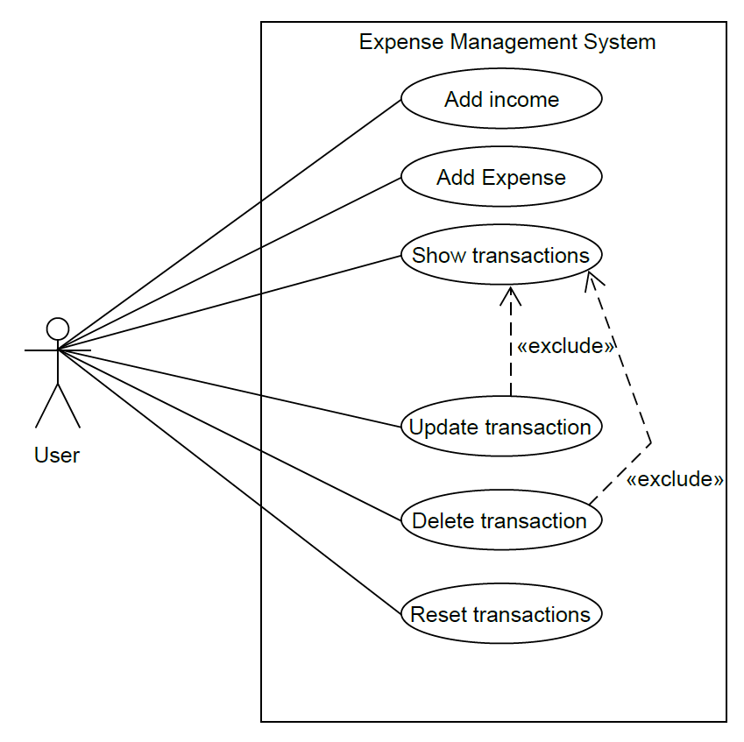

2.) Class Diagram

3.) Sequence Diagram

4.) Activity Diagram
5) E-R Diagram
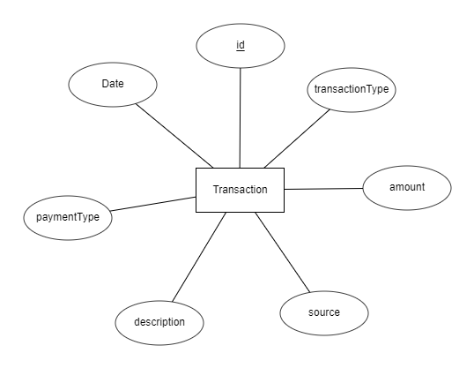

6) Data Dictionary
1.TRANSACTION
Attribute name | Data Type | PK | Unique | Ref | Description
Transaction_id | Int | Yes | Yes |  | Unique id of transaction
Transaction_type | Varchar | No | No |  | Type of transaction  Like INCOME and EXPENSES
Amount | Number | No | No |  | Amount as expense or income
Source | Varchar | No | No |  | From where amount is come and on which its spent
Date | Datetime | No | No |  | At which date transaction has been done
Description | Varchar | No | No |  | Brief description of transaction
paymentType | Varchar | No | No |  | Cash, cheque, credit card, etc.

Implementation Detail

- Client Side Module

- Add Income – user can add his/her income by providing mandatory details like amount, date of transaction, brief description, type of payment like credit card, etc.
- Add Expense – user can add his/her expenses by providing mandatory details like amount, date of transaction, brief description, type of payment like credit card, etc.
- Show all transaction – user can see his/her all past transactions.
- Update transaction – user can update its existing transaction by providing updated details.
- Delete transaction – user can update its existing transaction.
- Reset system – user can delete past history of transaction.

Screen-shots

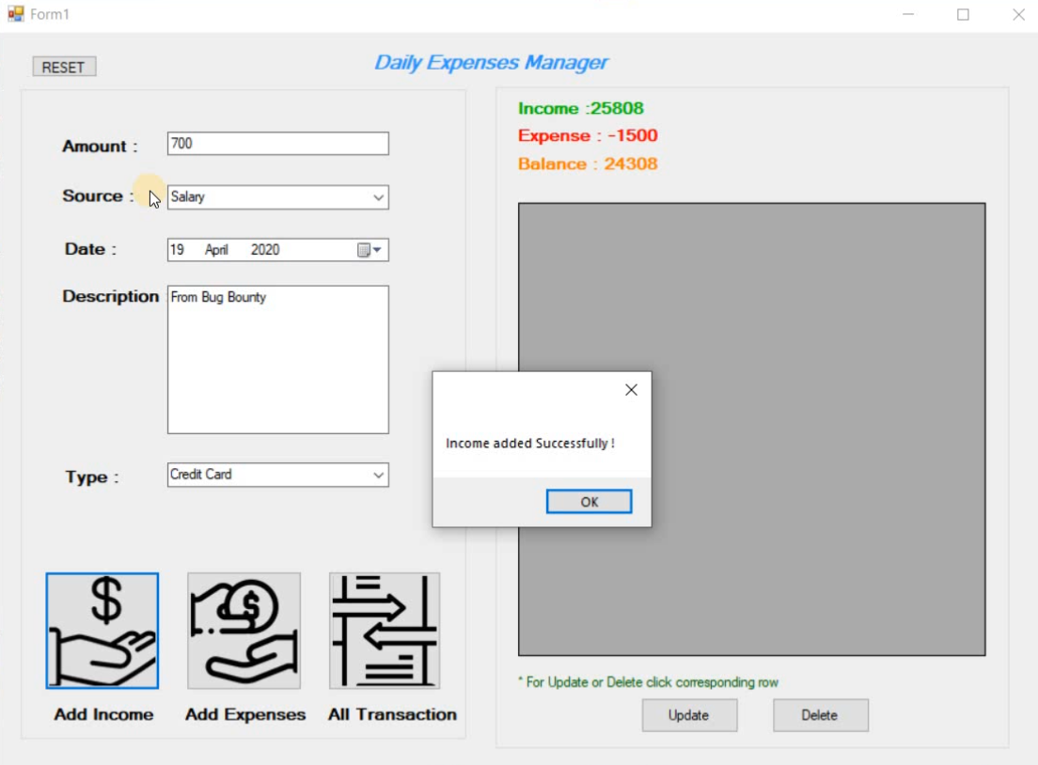
- View of system when user add his/her income.

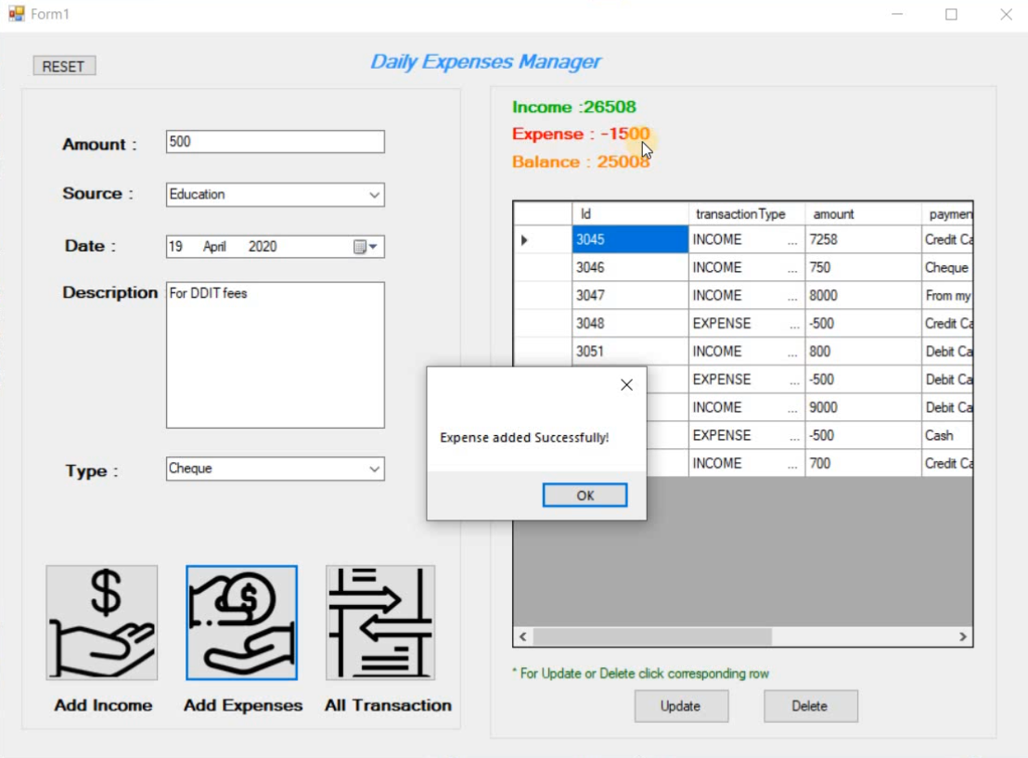
- View of system when user add his/her expense.
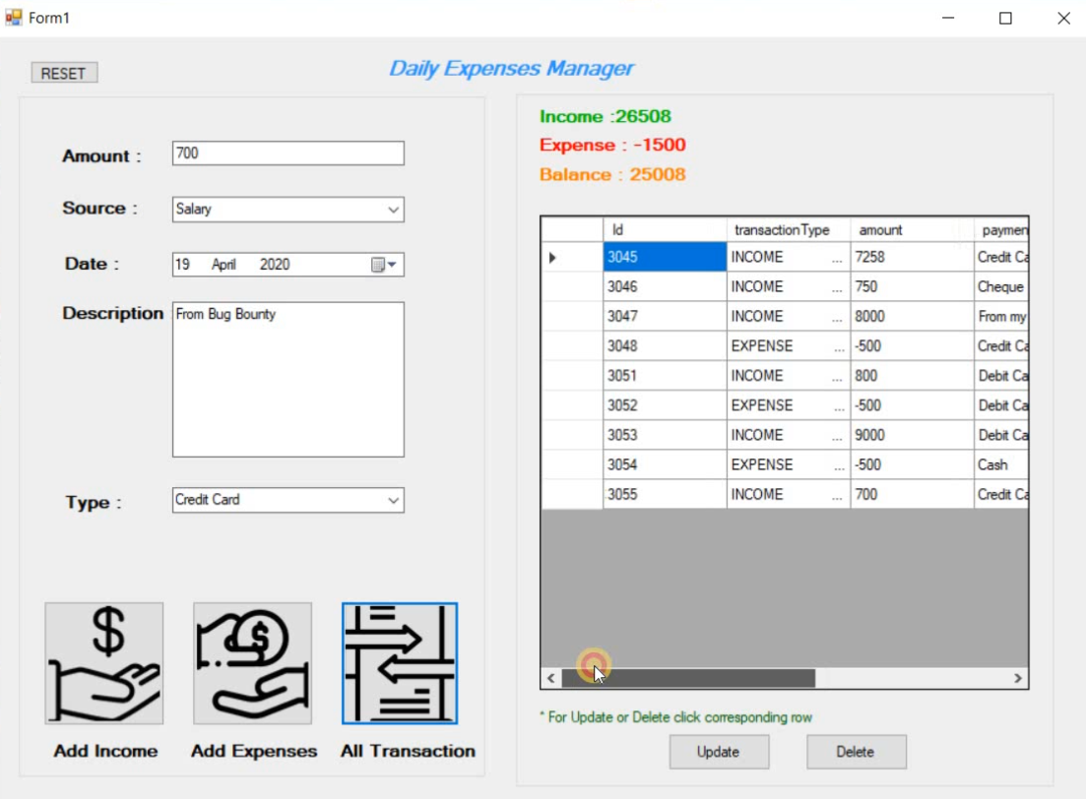
- View of system when user click on “All transactions”
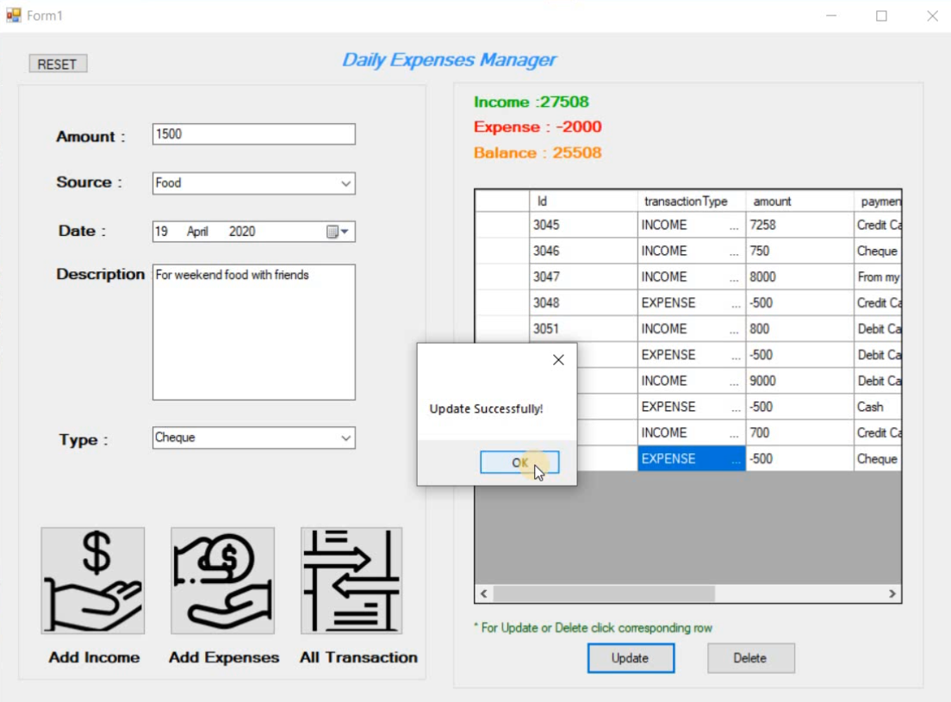
- View of system when user update past record.
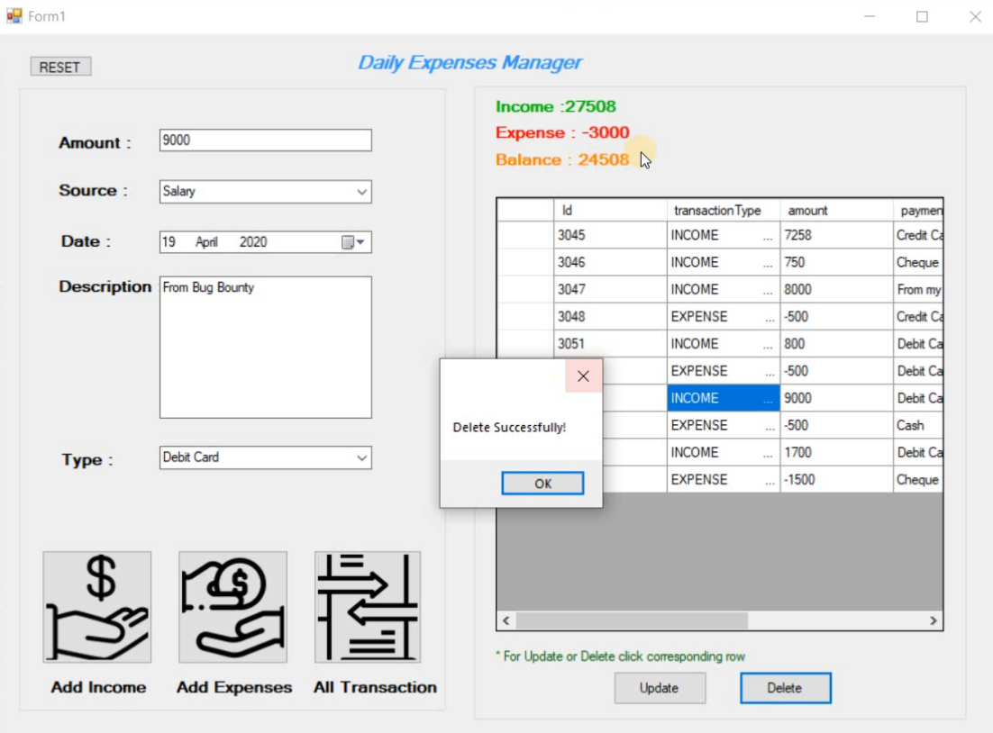
- View of system when user delete past record.
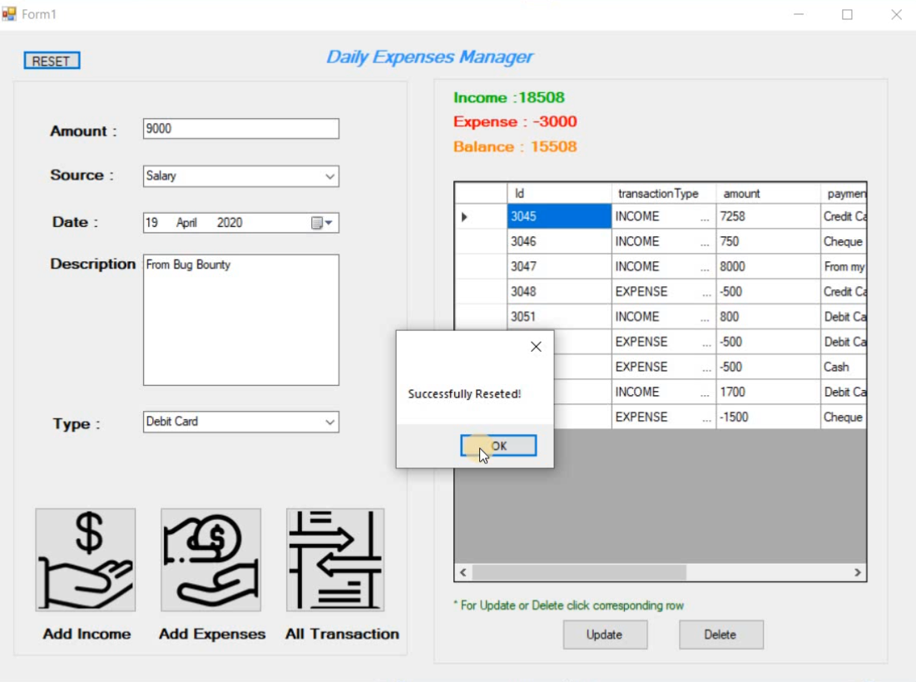
- View of system when user reset transaction history.

Conclusion

Expense Management System is very effective, efficient, reliable and flexible solution for keeping track of group of expenses on the go rather than contemporary way of making mental and sometimes erroneous calculations. It provides all the current needs of a client when it comes to managing expense or income or keeping record of it. The proposed project is very flexible, so new features and modules can be added in future as per user requirements. We have implemented all the functionalities in end user side. User can add income or expense and view all past transaction that has been made by user and he/she can edit any particular transaction.

Limitation and Future Extension

- Application has lacks in terms of security aspects.

- Future Enhancements

  - If an appropriate module for secure Notification identified or externally developed, then it shall be incorporated in the next version to notify particular user if his/her expense exited some limits.
  - We can provide more facilities to user or advanced features.
  - We can add print functionality in future for printing history of transaction.
  - We can also provide good attractive GUI for the system.

BIBLIOGRAPHY
For the successful implementation of this project we referred to many websites and books. The schema was designed by taking ideas from website like https://docs.microsoft.com/. We created ER Diagram on https://erdplus.com/ website and developed Desktop application on visual studio 2015.

Reference Websites:

- http://vbtutor.net
- https://docs.microsoft.com/
- https://www.tutorialspoint.com/

