

Department of Computer Science and Engineering
Global Campus, Jakkasandra Post, Kanakapura Taluk, Ramanagara District, Pin Code: 562 112

2025-2026

Third Semester Progress Report on

“QR Code Based Contactless Visitor Management System”

Submitted for the partial fulfilment of Project Centric Learning activity of

BACHELOR OF TECHNOLOGY
IN
COMPUTER SCIENCE AND ENGINEERING

Submitted by

Dipak Kurmi
22BTRCN077

Avay Choudhary Kurmi
22BTRCN041

Dipesh Kuma Panjiyar
22BTRCN079

Mohammad Nasser
22BTRCN174

Under the guidance of

Dr. Surya Prakash ,
Assistant Professor
Department of Computer Science & Engineering

School of Computer Science and Engineering
JAIN (Deemed-to-be University)


Department of Computer Science and Engineering
Global Campus, Jakkasandra Post, Kanakapura Taluk, Ramanagara District, Pin Code: 562 112

CERTIFICATE

This is to certify that the project centric learning work titled “QR Code Based Contactless Visitor Management System” is carried out by Dipak Kurmi (22BTRCN077), Avay Choudhary Kurmi (22BTRCN041), Dipesh Kumar Panjiyar (22BTRCN079), Mohammad Nasser(22BTRCN174), bonafide students of Bachelor of Technology at the Faculty of Engineering & Technology, Jain Deemed-to-be University, Bangalore in partial fulfillment for the project centric learning activity of degree in Bachelor of Technology in Computer Science & Engineering, during the year 2025-2026.

Dr. Suriya Prakash J | Dr. Mahesh T R | Dr. Kamlesh Tiwari
Associate professor,  Dept. of CSE,  School of Computer Science and Engineering  JAIN (Deemed-to-be University)  Date: | Program Head,  Dept. of CSE,  School of Computer Science and Engineering  JAIN(Deemed-to-be University)  Date: | HOD  School of Computer Science and Engineering  JAIN (Deemed-to-be University)  Date:

Name of the Examiner Signature of Examiner
1.

2

DECLARATION

We, Dipak Kurmi (22BTRCN077), Avay Choudhary Kurmi (22BTRCN041), Dipesh Kumar Panjiyar (22BTRCN079), Mohammad Nasser(22BTRCN174), are student’s of second semester B.Tech in Computer Science & Engineering, JAIN(Deemed-to-be University), hereby declare that the project centric learning work titled “QR Code Based Contactless Visitor Management System” has been carried out by us and submitted in partial fulfilment for the project centric learning activity of degree in Bachelor of Technology in Computer Science & Engineering during the academic year 2025-2026.

Signature

Dipak Kurmi
22BTRCN077
Avay Choudhary Kurmi
22BTRCN041
Dipesh Kumar Panjiyar
22BTRCN079
Mohammad Nasser
22BTRCN174

Place : Banglore
Date :

ACKNOWLEDGEMENT

It is a great pleasure for us to acknowledge the assistance and support of School of Computer Science and Engineering, Jain (Deemed-to-be University) for the progress of this project centric learning work.
In particular we would like to thank Dr. Kamlesh Tiwari, Director, School of Computer Science Engineering and Dr. Mahesh T R, Program Head, Department of Computer Science and Engineering, JAIN (Deemed-to-be University) for their constant encouragement and expert advice.

We would like to thank our guide Dr. Suriya Prakash J Associate Professor, Department of Computer Science & Engineering, JAIN (Deemed-to-be University), for sparing his valuable time to extend help in every step of our project work, which paved the way for smooth progress of the project.

We would like to thank one and all who directly or indirectly helped us in the progress of our Project.

Signature of Students

TABLE OF CONTENTS

 | Page No
Chapter 1 | 01
- INTRODUCTION  Overview  Background and Motivation | 01  01  01
Chapter 2
- Literature Survey  2.1 Existing Visitor Management Systems  2.2 QR-Based Authentication Systems  2.3 Biometric-Based Visitor Verification |  | 02  02  03  05  06
Chapter 3 | 08
3. Objective and Methodology | 08
3.1 Objective | 08
3.2 Methodology | 08
Chapter 4 | 09
4. System Design | 09
4.1 System Architecture | 09
4.5 Implementation | 09
Chapter 5 | 13
5. Features and Functionality | 13
Chapter 6 | 14
6. Result | 14
Result Screenshots | 14
Conclusion  References | 15  16

Chapter 1

INTRODUCTION

Overview
The Intelligent, Integrated Visitor Management System (II-VMS) is a smart, secure platform designed to modernize how organizations handle visitors. Instead of relying on manual registers or simple QR scans, the system combines contactless registration, QR-based check-ins, biometric face verification, tamper-proof audit logs, and AI-driven analytics.
Built using React.js, Express.js, PostgreSQL, and Python microservices, II-VMS ensures faster verification, stronger security, and more reliable visitor tracking.
Background and Motivation
Most existing visitor systems lack proper identity verification, are easy to manipulate, and offer no meaningful reporting. This creates security risks, delays, and poor record accuracy.

To solve these issues, II-VMS introduces multi-layer verification, automated logging, and intelligent analysis. The motivation behind this project is to create a secure, efficient, and future-ready visitor management solution that improves both security operations and visitor experience.

Chapter 2

LITERATURE SURVEY

2.1 : "Existing Visitor Management Systems"
Visitor management has traditionally been handled through manual logbooks, physical registers, or basic digital forms. Studies show that handwritten logs are inefficient, prone to human error, and lack verification. Digital systems introduced in recent years mainly focus on storing visitor details through simple web forms or on-premise desktop software. However, most of these systems suffer from several shortcomings:
- No identity verification: The system only collects the information provided by the visitor, without validating its authenticity.
- Limited security: Existing applications lack multi-factor verification mechanisms and do not protect against impersonation or unauthorized entry.
- No integrated analytics: Administrators are unable to analyze visit patterns or detect anomalies.
- Centralized, editable logs: Traditional databases allow entries to be modified, leading to potential misuse or data tampering.
These limitations highlight the need for a more advanced system that ensures both security and accuracy while maintaining a smooth user experience. II-VMS addresses these gaps through biometrics, QR authentication, and blockchain-inspired immutable logs.

2.2 Literature Survey 2

Title: "QR-Based Authentication Systems"
QR codes have been widely used for contactless verification in industries like tourism, healthcare, and corporate access control. Research on QR-based visitor systems shows that they significantly reduce registration time and simplify check-in procedures. QR codes work by encoding a unique token that links to visitor information in the backend database.
However, the literature reveals several inherent weaknesses:
- QR codes can be shared: A visitor may pass their QR code to someone else, bypassing the system.
- Static QR codes can be copied: A screenshot or printed version can be reused without detection.
- Lack of biometric association: The QR system alone cannot confirm whether the person scanning the code matches the registered individual.
- No behavior analysis: QR-based systems do not identify suspicious patterns such as repeated unknown visitors.
While QR codes improve convenience and reduce physical interaction, they must be combined with advanced verification methods. This motivates the integration of QR codes with biometric face recognition and backend cryptographic validation in II-VMS.

2.3 Literature Survey 3:

Title: "Biometric-Based Visitor Verification"
Biometrics, especially face recognition, has emerged as one of the most reliable identity verification technologies in modern digital systems. Research using libraries such as dlib, OpenCV, and face_recognition highlights their high accuracy in recognizing and matching human faces in real time. Key advantages of biometric systems include:
- Non-intrusive verification: Users simply look at a camera—no typing or scanning required.
- High accuracy: Modern models achieve above 90% recognition accuracy under stable conditions.
- Reduced impersonation risk: Unlike cards or codes, biometric traits cannot be shared or easily forged.
However, biometric systems also have challenges:
- They require clear images to generate high-confidence matches.
- Standalone biometric systems do not guarantee tamper-proof record keeping.
- They must be supported by a secure backend with encrypted data pipelines.
This reinforces the need for a hybrid approach—combining biometric verification with QR authentication and secure logging, ensuring reliability and integrity across the entire visitor lifecycle.

Chapter 3

OBJECTIVE AND METHODOLOGY
- Objective
The primary goal of the Intelligent, Integrated Visitor Management System (II-VMS) is to build a secure, automated, and intelligent platform that modernizes and improves how organizations handle visitor entry. The system aims to offer a smooth, contactless registration process through a simple and responsive web-based form, reducing manual effort and speeding up visitor onboarding. To ensure accurate identity verification, II-VMS integrates QR-based authentication with biometric face recognition, preventing impersonation and unauthorized access. Another key objective is to maintain tamper-proof records by storing all visitor entries in an immutable ledger using SHA-256 hashing, ensuring that logs cannot be altered without detection. The system also focuses on delivering real-time monitoring and analytics by applying machine learning techniques to identify peak hours, frequent visitors, and unusual behavior patterns, enabling smarter decision-making. Additionally, II-VMS is designed to enhance overall security and administrative efficiency by automating repetitive tasks and providing a centralized dashboard for streamlined management. Finally, the architecture is built to be modular and scalable, allowing each component—frontend, backend, database, and microservices—to evolve or expand independently without affecting the entire system..

Methodology
The methodology of the Intelligent, Integrated Visitor Management System (II-VMS) follows a structured and modular approach to ensure security, accuracy, and efficiency across all stages of visitor handling. The process begins with a React-based registration interface where visitors provide essential details through a responsive and validated web form. This information is securely transmitted to the Express.js backend, which manages all communication between the user interface and the database, performs CRUD operations, authenticates administrators, and generates a unique QR token for each visitor using UUID. All visitor data, verification records, and audit logs are stored in a PostgreSQL database designed with ACID compliance and optimized indexing for fast lookups. During check-in, the visitor’s QR code is scanned to retrieve and verify their details. For enhanced security, a Python microservice performs biometric face recognition using libraries such as dlib and face_recognition by comparing the visitor’s live image with stored facial data. Every visitor entry is then secured through an immutable ledger mechanism, where a SHA-256 hash is generated and stored to ensure tamper-proof records. In addition, Python-based analytics models analyze visitor trends, predict peak hours, detect anomalies, and provide insights that are displayed on the admin dashboard. Optional notification modules can trigger SMS or email alerts for important events such as visitor arrival or failed verification attempts. This step-by-step methodology ensures that II-VMS functions as a reliable, scalable, and intelligent visitor management solution.

Chapter 4

SYSTEM DESIGN
4.1 Proposed System Architecture
The system architecture of II-VMS follows a multi-layered, modular, and service-oriented design, ensuring clear separation of responsibilities and smooth communication between components. Each layer focuses on a specific task, which enhances scalability, maintainability, and reliability.
1. Presentation Layer (Frontend – React.js)
The frontend is developed using React.js, providing an interactive and user-friendly interface for visitors and administrators.
- Visitors use the interface for registration, QR retrieval, and check-in instructions.
- Administrators access the dashboard for monitoring visitor logs, analytics, and system alerts.
The frontend communicates with the backend through secure REST API calls.
2. Application Layer (Backend – Express.js)
The backend acts as the central controller of the system.
It handles:
- Visitor registration and validation
- Admin authentication
- QR token generation
- Database operations
- Communication with Python microservices (face recognition, analytics, hashing)
This layer ensures smooth integration between the UI, database, and external services.
3. Data Layer (PostgreSQL Database)
PostgreSQL is used to store structured, relational data, including:
- Visitor information
- QR token mappings
- Biometric verification logs
- Immutable ledger hashes
- Admin user credentials
The database follows ACID principles and includes indexing for fast search during check-ins.
4. Python Microservices Layer
Python-based microservices handle the system's intelligent and security-critical components:
- Face Recognition Service: Uses dlib and face_recognition to verify visitor identity.
- Analytics Engine: Uses pandas and scikit-learn to generate insights such as peak visitor hours and anomaly detection.
- Hashing Engine: Generates SHA-256 hashes for immutable records and detects tampering.
These services run independently and communicate with the backend through HTTP requests, ensuring modularity.
5. QR-Based Validation Layer
Each visitor receives a QR code containing a unique UUID token.
At the checkpoint:
- The QR code is scanned
- The backend verifies the token
- If matched, the visitor is marked for face verification or final approval
This adds a fast and contactless authentication step.
6. Immutable Ledger Layer
A cryptographic hashing mechanism ensures that once visitor logs are created, they cannot be edited silently.
- Each log generates a SHA-256 hash
- Any change produces a mismatch
- Administrators are alerted instantly
This enhances trust and audit readiness.
7. Notification Layer (Optional)
SMS or email alerts can be triggered for specific events:
- Visitor arrival
- Failed biometric verification
- Suspicious repeat visits
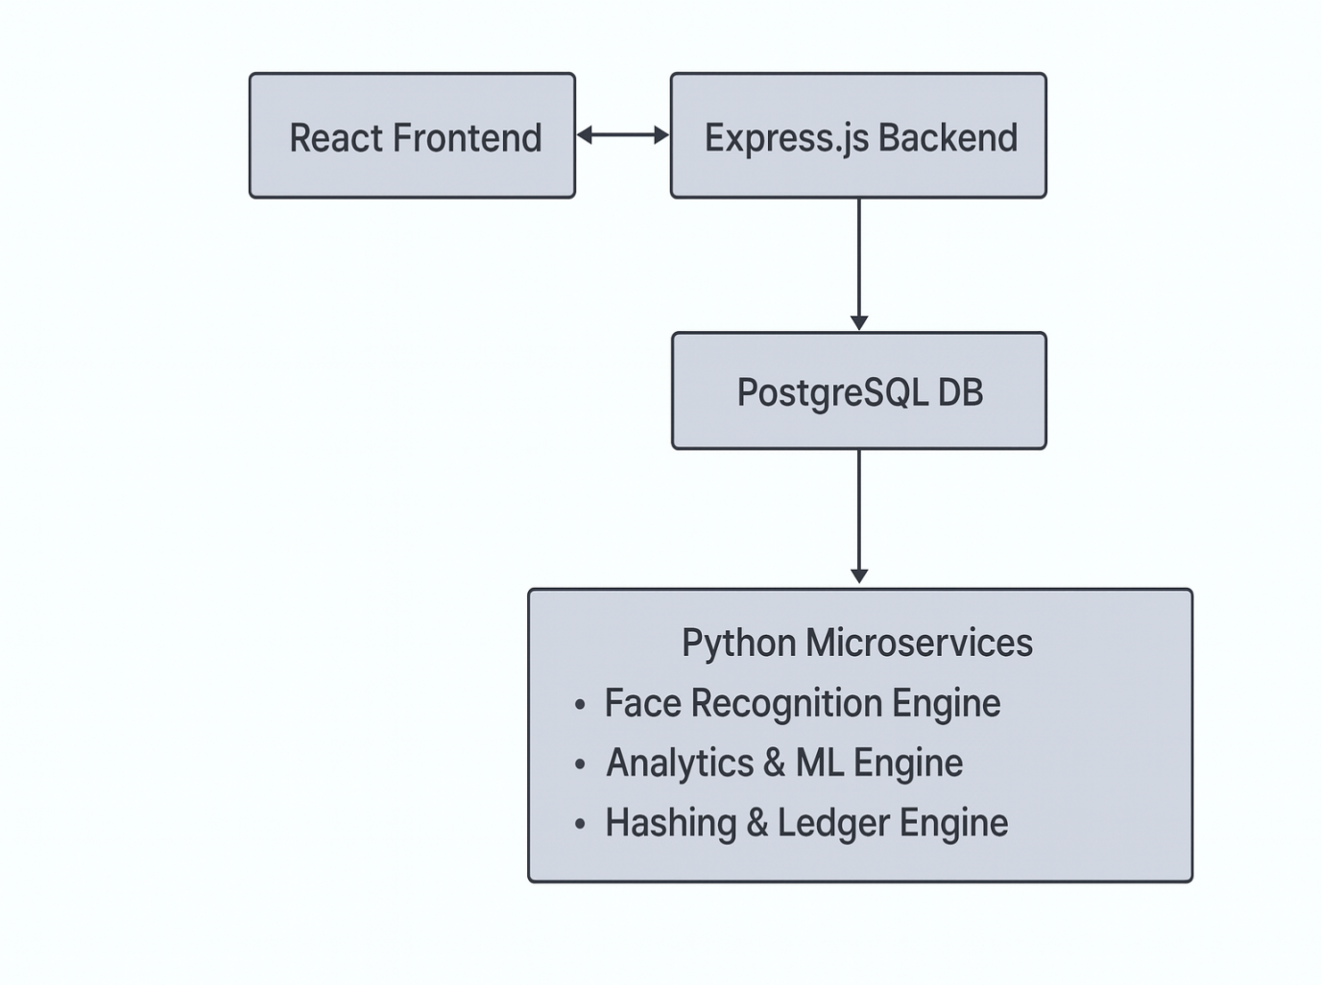
4.2 IMPLEMENTATION
The implementation phase focuses on converting system design into a functional application by building, integrating, and testing all components. The II-VMS was implemented using modern web technologies and structured in a modular development workflow.

1. Frontend Implementation (React.js)
The frontend interface was developed using React.js for its component-based structure and smooth user interactions.
Key features implemented:
- Visitor registration form with validation
- QR generation and download page
- Admin dashboard for viewing logs and analytics
- Responsive UI using modern CSS frameworks
APIs were integrated using Axios for secure and efficient communication with the server.

2. Backend Implementation (Express.js)
The backend was built using Node.js and Express.js, structured with separate routes, controllers, and middleware.
Major tasks:
- Creating REST APIs for registration, login, QR verification, and logs
- Integrating JWT-based admin authentication
- Communicating with Python microservices
- Implementing error handling and security validation
- Generating unique UUID-based QR tokens
The backend also includes dedicated services for hashing and event-based processing.

3. Database Implementation (PostgreSQL)
The database was designed using SQL schema with normalized tables.
Implementation tasks included:
- Creating tables for visitors, QR tokens, verification logs, and audit ledger
- Writing SQL queries and triggers
- Using indexes for faster retrieval
- Ensuring relational integrity using primary and foreign keys
All CRUD operations were tested using pgAdmin and Postman.

4. Microservices Implementation (Python)
Three independent Python microservices were built:

a. Face Recognition Service
- Implemented using dlib, face_recognition, and OpenCV
- Converts images into facial embeddings and compares them
- Returns confidence score and verification status

b. Analytics Engine
- Developed using pandas and scikit-learn
- Generates predictions for peak hours
- Detects frequent visitors and unusual behavior
- Sends summarized insights to the dashboard

c. Ledger Hashing Service
- Generates SHA-256 hashes for every visitor record
- Validates stored logs to detect tampering
- Communicates results back to the backend

5. QR System Implementation
Using the UUID library, the QR generator encodes a unique token.
The qrcode library was used to produce downloadable QR images.
The backend verifies the QR token during check-in.

6. Testing and Integration
- Unit testing was performed for individual modules
- API testing was conducted using Postman
- Integration testing ensured that React, Express, PostgreSQL, and Python microservices worked together smoothly
- Edge-case scenarios such as incorrect QR, low-light face images, tampered logs, or repeated visits were thoroughly tested

Chapter 5

Features and Functionality:

The Intelligent, Integrated Visitor Management System (II-VMS) offers a comprehensive set of features designed to improve security, streamline visitor entry, and support efficient administration. The system provides a fully contactless registration process through a responsive web interface, allowing visitors to easily submit their details online. After registration, a unique QR token is generated for each visitor, enabling fast and reliable check-in at the entry point. To enhance identity assurance, the system incorporates biometric face verification using Python-based recognition models, ensuring that only the authorized individual can enter. Every visitor log is secured using a SHA-256 hashing mechanism, creating an immutable ledger that instantly detects any attempts at data tampering. Administrators can track visitor activity in real time through a centralized dashboard that displays active check-ins, timestamps, and verification statuses. The system further integrates machine-learning–based analytics to provide insights such as peak visiting hours, frequent visitors, and unusual activity patterns. Additional features include secure role-based admin access, automated email or SMS alerts for important events, exportable visitor reports, and a highly scalable architecture where each module operates independently. Together, these functionalities make II-VMS a smart, secure, and future-ready visitor management solution.

Chapter 6

Result
The implementation of the Intelligent, Integrated Visitor Management System (II-VMS) resulted in a fully functional and efficient platform capable of securely managing visitor entry from start to finish. The system successfully demonstrated seamless visitor registration through a responsive React-based interface, allowing users to submit their details quickly without manual intervention. The QR code generation feature worked reliably, producing unique and scannable tokens that enabled effortless and contactless check-ins. During testing, the QR verification endpoint consistently retrieved accurate visitor information and validated their entry status in real time. The biometric face recognition module performed effectively by comparing live images with stored records and providing a confidence score for identity verification. This significantly strengthened security by ensuring that only the legitimate visitor was granted access.
The immutable ledger feature also provided strong evidence of tamper-proof logging. When visitor data was stored, its corresponding SHA-256 hash remained consistent, and intentional data modifications generated mismatched hashes—proving the system’s ability to detect any unauthorized changes. The analytics engine successfully generated meaningful insights, including daily visitor trends, peak hours, and repeat visit patterns. These results were visualized clearly on the admin dashboard through interactive charts. Administrators were able to monitor live check-ins, track suspicious events, and export logs for reporting purposes. Overall, the system performed smoothly under various test scenarios, confirming that the architecture is stable, scalable, and capable of handling real-world institutional visitor management needs.

CONCLUSION
The Intelligent, Integrated Visitor Management System (II-VMS) successfully demonstrates how modern technologies can transform the traditional visitor entry process into a secure, efficient, and intelligent experience. By integrating contactless registration, QR-based authentication, biometric face verification, and immutable audit logging, the system provides a level of security and accuracy that conventional visitor logs cannot achieve. The modular architecture built using React.js, Express.js, PostgreSQL, and Python microservices ensures that each component functions independently while contributing to a seamless end-to-end workflow. Through machine-learning–driven analytics, the system not only records visitor information but also generates valuable insights that support better administrative decision-making.
Overall, the project meets its objectives by delivering a scalable, tamper-proof, and user-friendly platform suitable for institutions, corporate environments, and secure facilities. The II-VMS enhances operational efficiency, strengthens identity assurance, and improves audit readiness, making it a comprehensive solution for modern visitor management challenges. This project highlights the potential of integrating software engineering principles with emerging technologies to build real-world, impactful applications.
.

REFERENCES
- Abate, A. F., Nappi, M., Riccio, D., & Sabatino, G. (2007). 2D and 3D face recognition: A survey. Pattern Recognition Letters, 28(14), 1885–1906.
- King, D. E. (2009). Dlib-ml: A Machine Learning Toolkit. Journal of Machine Learning Research, 10, 1755–1758.
- Huang, G. B., Ramesh, M., Berg, T., & Learned-Miller, E. (2007). Labeled Faces in the Wild: A Database for Studying Face Recognition in Unconstrained Environments. University of Massachusetts, Amherst.
- Zulkifli, N., Sulaiman, S., & Ahmad, R. (2018). QR Code-Based Security System: A Review. International Journal of Engineering & Technology, 7(4), 27–31.
- Woodward, J. D., Orlans, N. M., & Higgins, P. T. (2003). Biometrics: Identity Assurance in the Information Age. McGraw-Hill.
- Mavroudi, E., Kapassa, E., & Alonistioti, N. (2020). Security and Privacy in Modern Visitor Management Systems. IEEE Access, 8, 130221–130234.
- Kwon, T., & Kim, H. (2018). A Tamper-Proof Logging System Using Hash Chains and Blockchain Principles. IEEE Transactions on Dependable and Secure Computing, 17(5), 965–978.
- PostgreSQL Global Development Group. (2023). PostgreSQL Documentation. https://www.postgresql.org/docs/
- Node.js Foundation. (2023). Express.js Guide: Web Application Framework for Node.js. https://expressjs.com/
- Paszke, A., Gross, S., Chintala, S., & others. (2019). PyTorch: An Imperative Style, High-Performance Deep Learning Library. Advances in Neural Information Processing Systems (NeurIPS).
- Pandas Development Team. (2023). pandas: Python Data Analysis Library. https://pandas.pydata.org/
- Pedregosa, F., Varoquaux, G., Gramfort, A., & others. (2011). Scikit-learn: Machine Learning in Python. Journal of Machine Learning Research, 12, 2825–2830.
- Szeliski, R. (2022). Computer Vision: Algorithms and Applications (2nd Edition). Springer.
- Seung-Hyun Kong & Yu-Jin Zhang. (2010). Biometric Authentication: A Machine Learning Approach. Springer.
- ISO/IEC 19794-5:2011. Information Technology — Biometric Data Interchange Formats — Part 5: Face Image Data.

