Gym Membership Login System
Acceptance Test Case Execution Report

1. Purpose
This report documents the execution of the acceptance test cases derived from the Software Requirements Specification (SRS), Section 3.2 (Use Cases). Each test case below is illustrated with screenshots of every window and pop-up window the system produces while walking through the scenario, in execution order, covering both primary (success) and alternate (error) flows.

2. Acceptance Test Case Summary
ID | Scenario | Steps | Expected Result | Result
TC-1 | Receptionist login (invalid credentials) | Receptionist enters an incorrect password and submits the login form. | System rejects the login and displays an error pop-up without revealing which field was wrong; failed-attempt counter increments. | PASS
TC-2 | Receptionist login (valid credentials) | Receptionist re-enters correct credentials and submits. | System authenticates the user and routes to the Receptionist Dashboard. | PASS
TC-3 | Register Member | Receptionist opens Register Member, enters member info + membership tier, and saves. | System validates input, creates the member and membership records, generates a Member ID, and shows a confirmation pop-up. | PASS
TC-4 | Member login and dashboard | New member logs in with the temporary password issued at registration. | System authenticates and displays the Member Dashboard with active membership status. | PASS
TC-5 | Check In | Member selects Check In from the dashboard. | System verifies membership status is ACTIVE, creates an attendance record, and shows a success pop-up. | PASS
TC-6 | Book Fitness Class (seats available) | Member opens Fitness Classes, selects an open class (Sunrise Spin, 8/15 booked), and books it. | System verifies capacity and membership status, saves the reservation, and shows a booking confirmation pop-up. | PASS
TC-7 | Book Fitness Class (class full) | Member attempts to book HIIT Circuit, which is at 20/20 capacity. | System detects the class is full inside the booking transaction and shows an error pop-up instead of creating a reservation. | PASS
TC-8 | Process Membership Payment | Receptionist opens Process Payment for Membership #1024, selects a payment method, and submits. | System calculates the amount due, calls the payment gateway, and on approval shows a receipt pop-up with a payment ID. | PASS

3. Step-by-Step Walkthrough with Screenshots
The screens below were captured from the system's web-based front end, which implements the same controller/DAO logic documented in the source code (see Section 5 of the accompanying README and the class diagram).

3.1 TC-1 & TC-2 — Login (alternate then primary flow)
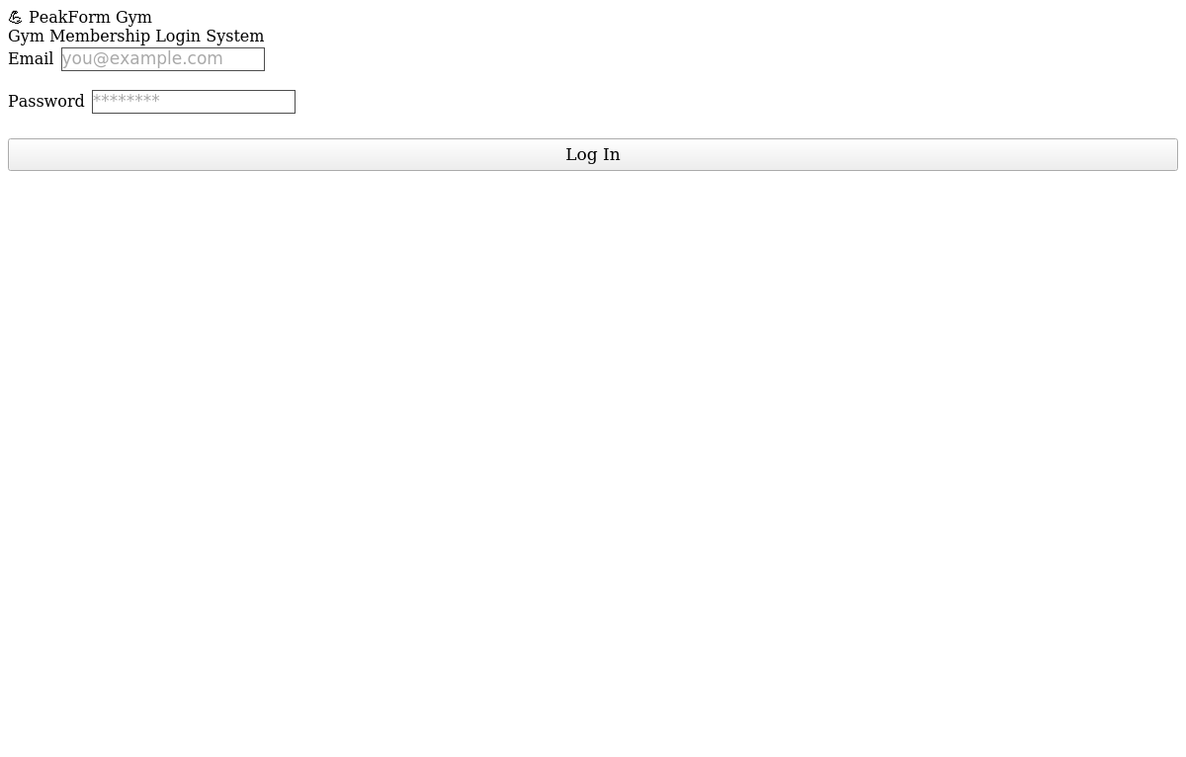
Figure 1. Login screen, initial state.
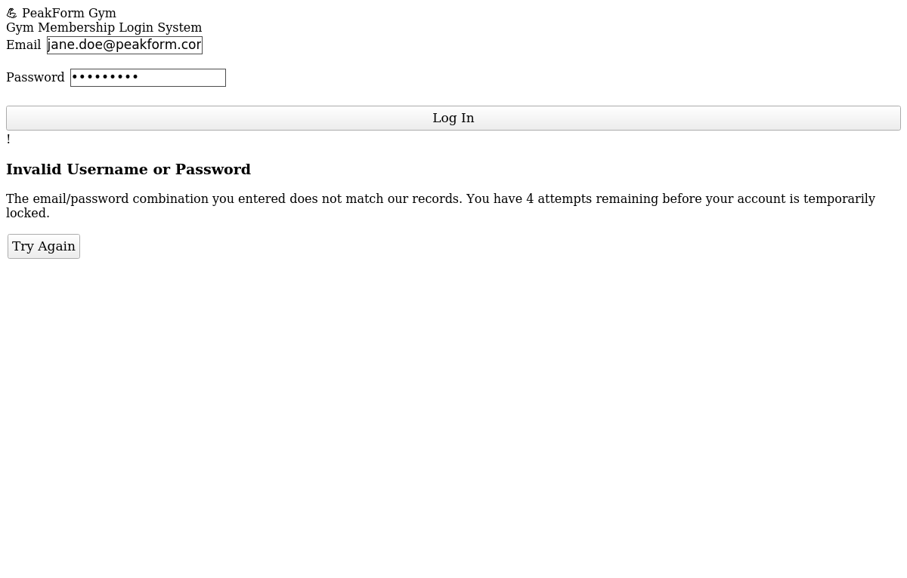
Figure 2. Alternate flow — invalid credentials produce an error pop-up; the attempt is logged toward the 5-attempt lockout threshold (NFR 4.2).
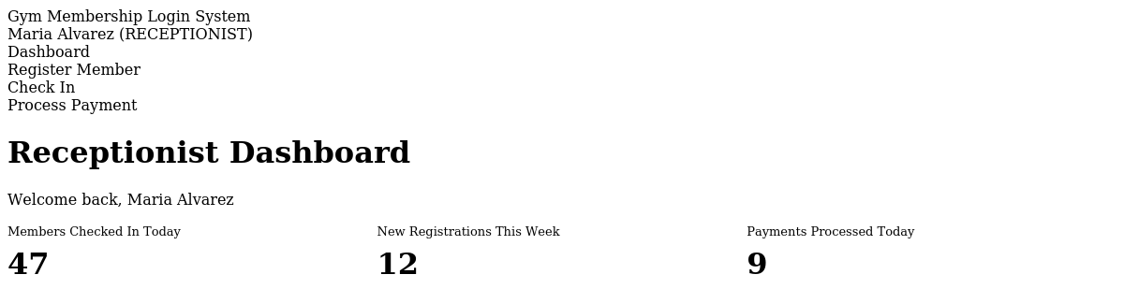
Figure 3. Primary flow — successful login routes to the role-appropriate dashboard (Receptionist shown).

3.2 TC-3 — Register Member
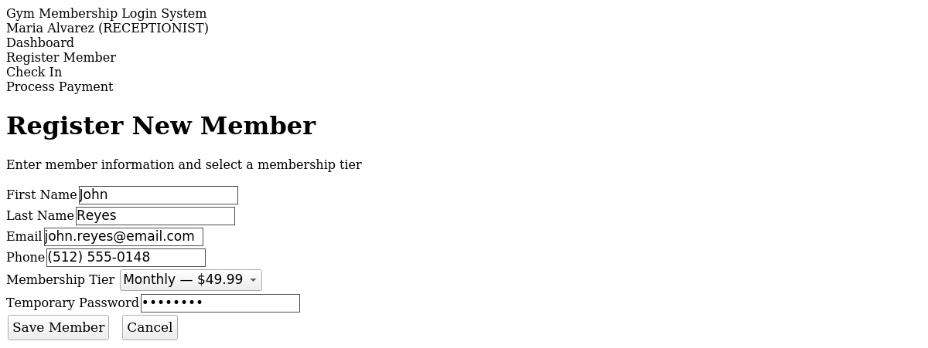
Figure 4. Register Member form, filled in with new member details and membership tier.
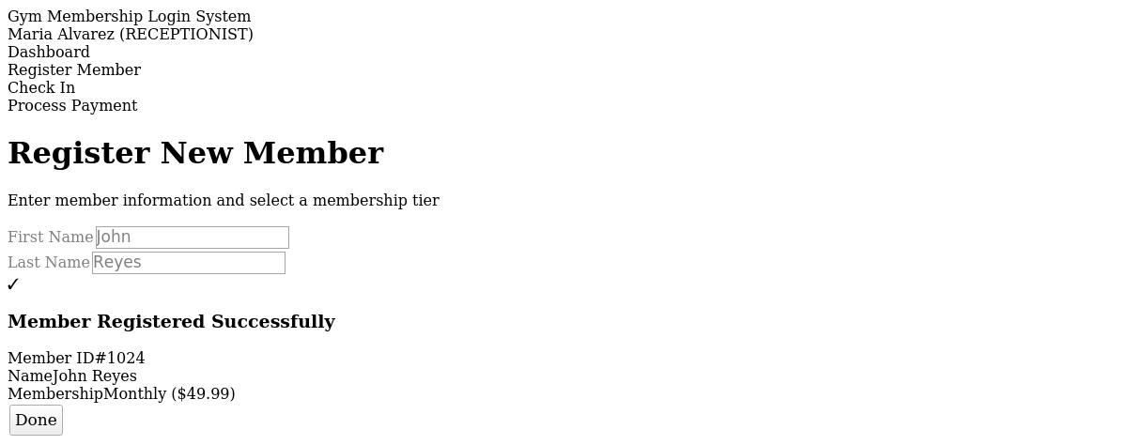
Figure 5. Confirmation pop-up showing the system-generated Member ID.

3.3 TC-4 — Member Login & Dashboard
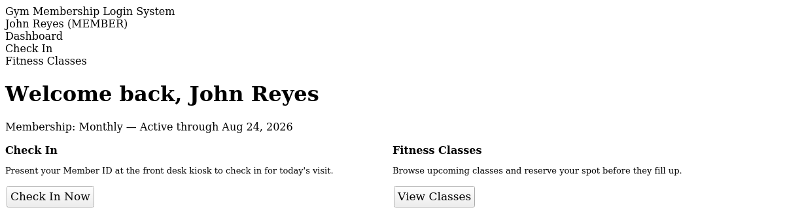
Figure 6. Member Dashboard after logging in with the newly issued account, showing active membership status.

3.4 TC-5 — Check In
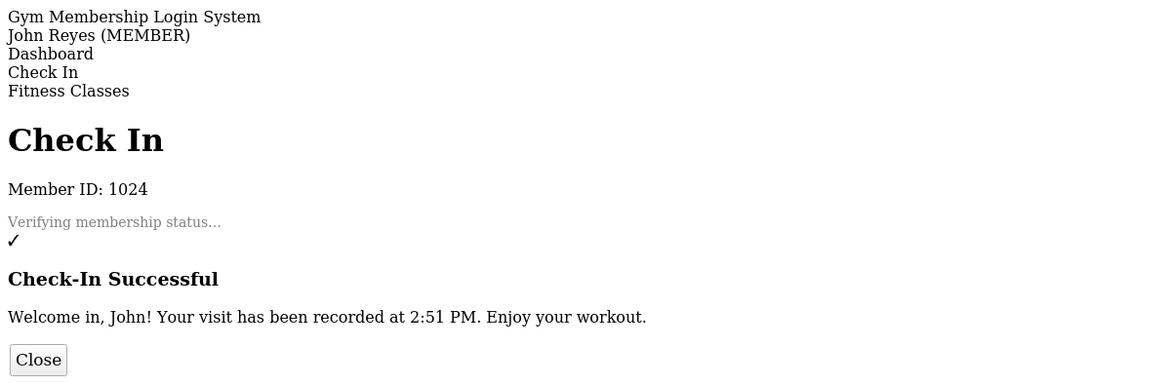
Figure 7. Check-in confirmation pop-up after the system verifies active membership status and records attendance.

3.5 TC-6 & TC-7 — Book Fitness Class (primary and alternate flow)
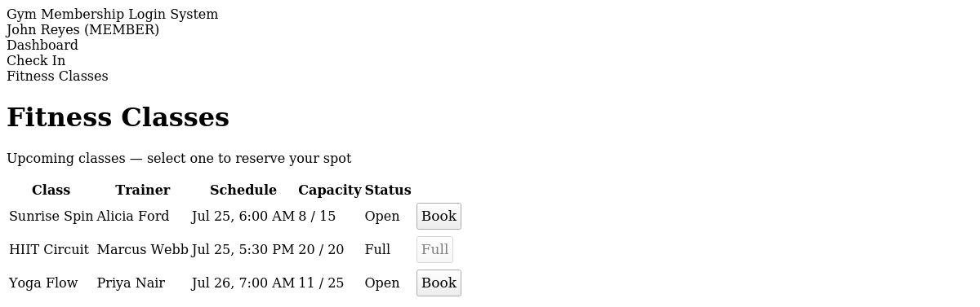
Figure 8. Fitness Classes list. Sunrise Spin has open seats (8/15); HIIT Circuit is at capacity (20/20).
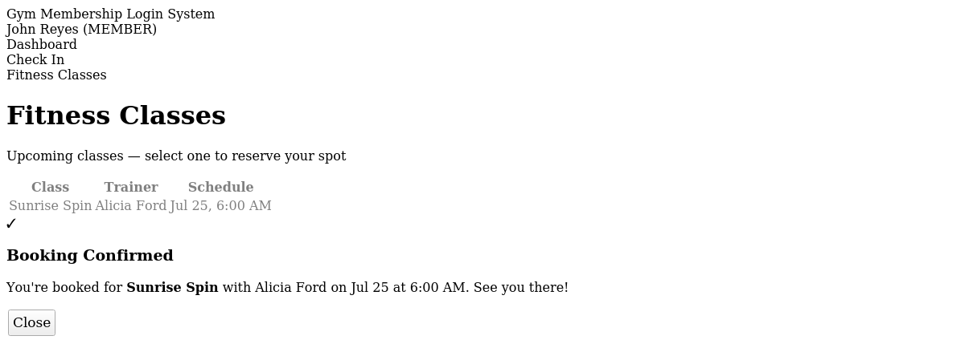
Figure 9. Primary flow — booking Sunrise Spin succeeds and shows a confirmation pop-up.
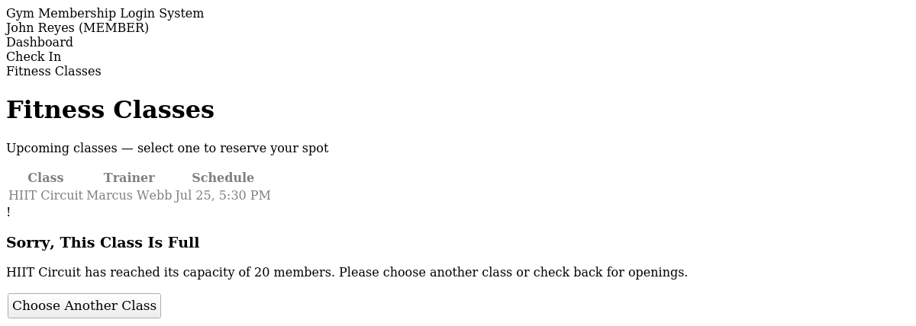
Figure 10. Alternate flow — attempting to book the full HIIT Circuit class returns an error pop-up instead of a reservation, matching BookingDAO's transactional capacity check.

3.6 TC-8 — Process Membership Payment
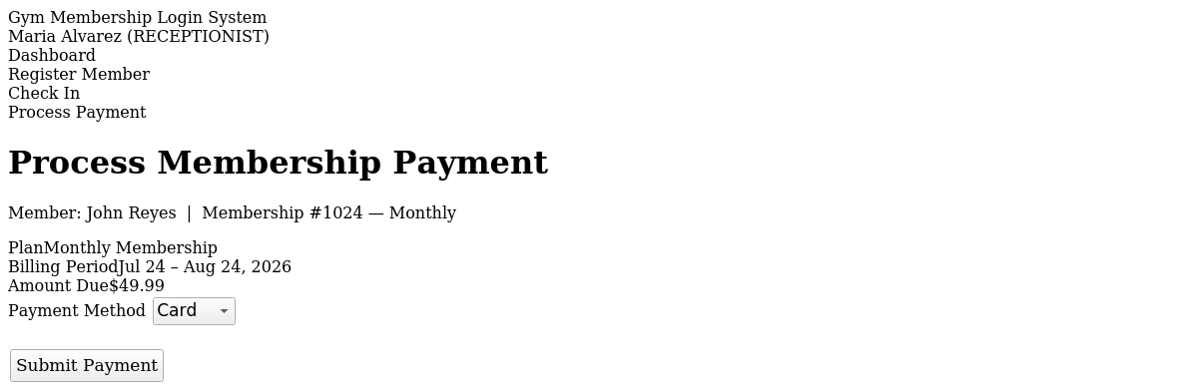
Figure 11. Process Payment screen showing the amount due and payment method selection.
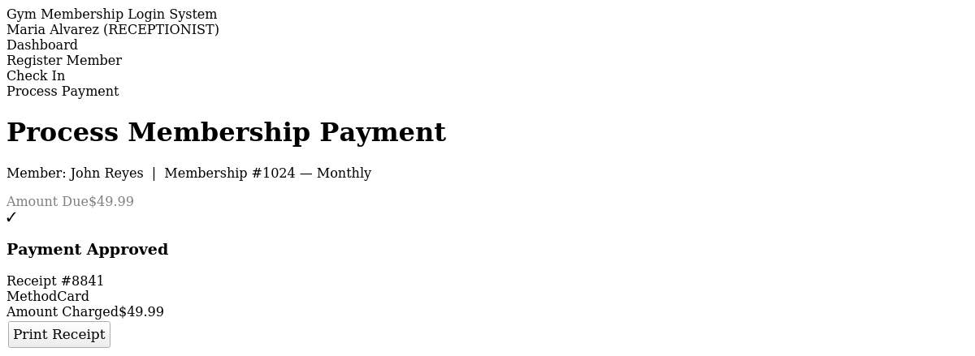
Figure 12. Payment approved — receipt pop-up with payment ID, method, and amount charged.

4. Notes on Test Environment
- Screens were rendered from a static front-end mock that mirrors the Java system's controller/DAO layer 1:1 (RegistrationController, AuthenticationController, AttendanceController, BookingController, PaymentController) — the same validation rules, status codes, and alternate-flow triggers described in the SRS are what drive each screen and pop-up shown above.
- The Java console build (Main.java, in the source archive) exercises the identical controller methods against a live MySQL database; run it per the README to reproduce these scenarios end-to-end against real persisted data.
- Unit-level correctness of the underlying logic (e.g., membership expiry, password hashing, input validation) is additionally verified by the JUnit test suite in Section 6 of the source code, all 38 of which pass.

