PROJECT REPORT
SMARTSERVE
Food Waste Risk Prediction and Decision Support System
Submitted in partial fulfilment of the requirements for the degree of
Bachelor of Computer Applications (Honours)
Submitted by
Dipesh Panchal
Enrollment No.: 202312101920
Semester: VII
Under the guidance of
Mrs. Naina Asnani
Asia Pacific BCA College
Gujarat University
Ahmedabad, Gujarat
Academic Year: 2026–2027

INDEX

No. | Description | Page No.
1 | College Certificate | 3
2 | Acknowledgement | 4
3 | Project Overview | 5
4 | Purpose and Scope of the project | 6-7
5 | Existing vs Proposed system | 7-8
6 | Feasibility study | 8-9
7 | Hardware and Software Requirement specification | 9-10
8 | Project Folder structure | 10-11
9 | Core Modules | 11–16
10 | Screenshots | 17–18
11 | Limitations | 19
12 | Future Enhancements | 20
13 | References | 21

COLLEGE CERTIFICATE


“SMARTSERVE: FOOD WASTE RISK PREDICTION USING MACHINE LEARNING”
is submitted by the student named below in partial fulfilment of the academic requirements of the Bachelor of Computer Applications (Honours) programme.
The project work is based on the development and analysis of a machine-learning workflow using Python in Jupyter Notebook. The work includes preparation of a synthetic food-service dataset, data cleaning, exploratory data analysis, preprocessing, classification model comparison and prediction of food-waste risk.

Student Details | To be completed by the student / college
Student Name | Panchal Dipesh Ganpatbhai
Enrollment / Roll Number | 202312101920
College Name | Asia Pacific BCA College
University | Gujarat University
Academic Year | 2026-2027
Project Guide | Mrs. Naina Asnani

Project Guide Signature | Head of Department | Principal
Mrs. Naina Asnani
Date: | Date: | Date:

College seal:

ACKNOWLEDGEMENT
I would like to express my sincere gratitude to my project guide and faculty members for their guidance, suggestions and support during the development of SmartServe. Their feedback helped me understand the stages involved in planning a machine-learning project, preparing data and evaluating classification models.
I am thankful to my college and the Department of Computer Applications for providing the academic environment and resources required to complete this project. I also acknowledge the authors and developers of Python, Jupyter Notebook, Pandas, NumPy, Matplotlib, Seaborn and Scikit-learn. These tools provided the libraries and environment used for data preparation, analysis, visualization and model development.
I would also like to thank my family and friends for their encouragement throughout the project. Finally, I acknowledge that the dataset used in this academic project is synthetic and was generated for learning and experimentation. It is not a collection of confidential operational records from actual restaurants or canteens.

Student Name: Dipesh Panchal
Date: __________________

3. PROJECT OVERVIEW
SmartServe is an academic machine-learning project designed to estimate the food-waste risk associated with a planned food-service operation. It focuses on establishments such as restaurants, hotels, college canteens, hostel mess facilities and catering services. The system classifies the expected waste risk into three categories: Low, Medium and High.
Food waste can occur when the quantity of food prepared is greater than the quantity demanded. The difference may be influenced by the number of expected customers, previous-day sales, food prices and costs, discounts, meal type, day of the week, weather conditions, establishment type, cuisine and special events. SmartServe uses these planning-related attributes as input features for machine-learning classification.

3.1 Project implementation approach
The project is implemented entirely in Jupyter Notebook using Python. It is a notebook-based data science and machine-learning project. Dataset generation, data cleaning, exploratory analysis, preprocessing, model training, evaluation and sample prediction are performed through notebook cells.

3.2 Main objective
The main objective is to build and compare machine-learning classifiers that can identify whether a planned food preparation activity is likely to have Low, Medium or High food-waste risk. The prediction is intended to support planning before food is served, rather than to report waste after the event.

3.3 Dataset overview
The project uses a synthetically generated dataset named SmartServe_food_waste_dataset.csv. The dataset contains 13248 records. The target column is waste_risk, with three classes: Low (4080 records), Medium (4203 records) and High (4965 records). Synthetic data makes it possible to build and test the complete workflow without requiring access to private business records.

3.4 Main technologies
- Python — programming language used for the complete workflow.
- Jupyter Notebook — interactive environment used to write and execute the project.
- Pandas and NumPy — dataset loading, transformation and numerical operations.
- Matplotlib and Seaborn — charts and exploratory data analysis.
- Scikit-learn — preprocessing, model training, prediction and evaluation.

4. PURPOSE AND SCOPE OF THE PROJECT

4.1 Purpose
The purpose of SmartServe is to demonstrate how machine learning can be applied to a practical food-service planning problem. Preparing too much food may increase leftovers and disposal, while preparing too little may affect customer service. A risk classification can help a food-service manager review a planned quantity before preparation.
The project also provides practical experience in the end-to-end machine-learning process: creating a dataset, understanding its structure, checking data quality, exploring patterns, preparing input features, training multiple algorithms, comparing evaluation metrics and testing a prediction on an unseen record.

4.2 Objectives
- Create a structured synthetic dataset representing food-service planning and outcome information.
- Inspect the dataset for missing values, duplicate records, invalid values and inconsistent data.
- Clean the data and prepare a separate cleaned CSV file.
- Perform exploratory data analysis using statistical summaries and visualizations.
- Prepare categorical and numerical features for machine-learning algorithms.
- Train and compare a baseline classifier, Decision Tree, K-Nearest Neighbors and Random Forest.
- Use K-Means as an unsupervised clustering technique for exploratory grouping where applicable.
- Evaluate classification models using Accuracy, Precision, Recall, F1-score and ROC-AUC.
- Use the selected Random Forest pipeline to predict the risk category for a new, unseen input record.

4.3 Scope
The scope is limited to dataset-based experimentation in Jupyter Notebook. It covers food-service planning attributes and a three-class risk prediction. The model is intended as a decision-support experiment and does not automatically control kitchen operations or guarantee the exact quantity of waste in real life.

4.4 Input information
Feature | Meaning in the project
establishment_type | Type of food-service establishment, such as restaurant, canteen, hotel, hostel mess or caterer.
city | City associated with the establishment.
cuisine_type | Cuisine category.
food_item | Name of the food item being planned.
item_category | Category of the food item, such as main course.
meal_type | Meal period, such as breakfast, lunch or dinner.
day_of_week | Day on which the food is planned.
weather_condition | Weather category such as sunny, cold or rainy.
special_event | Whether a special event or occasion may affect demand.
previous_day_sales | Sales information from the previous day.
price_per_plate_inr | Selling price per plate in Indian rupees.
cost_per_plate_inr | Cost per plate in Indian rupees.
discount_applied_pct | Discount applied, expressed as a percentage.
expected_customers | Estimated number of customers for the planned service.
quantity_prepared | Planned quantity of food to be prepared.

5. EXISTING VS PROPOSED SYSTEM

5.1 Existing system
In a basic food-service operation, preparation quantities may be decided using staff experience, rough estimates, manual records or simple comparisons with previous sales. These methods can be useful, but they may not consistently consider several factors together. Changes in weather, events, meal periods, discounts and expected customer numbers can make demand difficult to estimate.
- Preparation decisions may depend heavily on personal experience.
- Different demand-related factors may be considered separately rather than together.
- Historical sales may not be analysed systematically.
- There may be no consistent method to assign a Low, Medium or High waste-risk category before preparation.
- Manual estimation can be difficult to repeat and compare across different food items or service days.

5.2 Proposed system: SmartServe
SmartServe proposes a notebook-based machine-learning workflow. It uses structured input features and a labelled dataset to train classification models. The models learn relationships between the available planning features and the target waste_risk category. The trained Random Forest pipeline is then used to classify an unseen planning record.
- Uses a structured dataset with multiple food-service planning attributes.
- Applies data cleaning and exploratory data analysis before model training.
- Preprocesses categorical and numerical columns for machine-learning algorithms.
- Compares several classifiers using common evaluation metrics.
- Produces a three-class prediction: Low, Medium or High.
- Allows a new input record to be tested directly from a Jupyter Notebook.

5.3 Comparison
Existing approach | SmartServe approach
Mostly manual or experience-based estimation. | Machine-learning classification using structured input data.
Factors may be reviewed separately. | Multiple planning attributes are considered together.
No standard model evaluation. | Models are compared using Accuracy, Precision, Recall, F1-score and ROC-AUC.
Risk judgement may vary between users. | Consistent class labels are produced by the trained model.
Often depends on existing records and manual calculations. | Uses a synthetic dataset for academic experimentation.

6. FEASIBILITY STUDY
A feasibility study considers whether the project can be completed with the available technology, skills, time and resources. SmartServe is feasible as an academic machine-learning project because it uses commonly available Python libraries and a locally generated dataset.

6.1 Technical feasibility
The project is technically feasible because the complete workflow can be executed in Jupyter Notebook. Python provides the required data-processing and machine-learning libraries. Pandas and NumPy support tabular and numerical operations; Matplotlib and Seaborn support visual analysis; and Scikit-learn provides preprocessing tools and classification algorithms. A synthetic dataset avoids dependency on access to confidential restaurant records.

6.2 Economic feasibility
The project can be developed with open-source software. Python, Jupyter Notebook, Pandas, NumPy, Matplotlib, Seaborn and Scikit-learn are available without purchasing a commercial development licence. The dataset is generated locally, so the project does not require payment for a third-party dataset. The main resources are a computer and the time required for coding, testing and analysis.

6.3 Operational feasibility
The notebook workflow is suitable for academic demonstration and experimentation. A user familiar with Jupyter Notebook can run the cells in sequence, inspect charts and metrics, and modify the input values for an unseen prediction. However, it is not designed as a ready-to-use interface for restaurant staff. Operational use would require validation with real business data and a separate user-facing implementation.

6.4 Schedule feasibility
The project is manageable within an academic project schedule because it is divided into clear stages: dataset creation, data inspection, cleaning, exploratory analysis, preprocessing, model training, evaluation and prediction. Each stage can be developed and tested in separate notebook sections.

6.5 Feasibility conclusion
SmartServe is feasible for its defined academic scope. It demonstrates a complete machine-learning workflow using locally available tools. Its results should be interpreted as experimental results on synthetic data, not as proof of performance on real restaurant operations.

7. HARDWARE AND SOFTWARE REQUIREMENT SPECIFICATION

7.1 Hardware requirements
Component | Minimum practical requirement
Processor | Modern dual-core processor or equivalent.
RAM | 4 GB minimum; 8 GB or more recommended for smoother notebook execution.
Storage | At least 1 GB free space for Python environment, notebooks, CSV files and outputs.
Display | Standard monitor or laptop display.
Input devices | Keyboard and mouse or touchpad.

7.2 Software requirements
Software / Library | Purpose
Operating System | Windows, Linux or macOS capable of running Python and Jupyter Notebook.
Python | Main programming language.
Jupyter Notebook | Environment for writing and executing code in cells.
Pandas | Loading, inspecting, cleaning and transforming CSV data.
NumPy | Numerical calculations and synthetic data generation.
Matplotlib | Creating plots and charts.
Seaborn | Statistical data visualization.
Scikit-learn | Preprocessing, classification, clustering and model evaluation.

7.3 Project files
- SmartServe_food_waste_dataset.csv — original generated dataset.
- smartserve_cleaned_data_phase02.csv — cleaned dataset produced during the data preparation phase.
- Jupyter Notebook (.ipynb) — contains code, analysis, model training, evaluation and prediction.

7.4 Software scope clarification
The implemented project uses Jupyter Notebook and Python libraries only. HTML, CSS, JavaScript, Flask, Django, database servers and web hosting are not part of the completed implementation. They are not required to run the current notebook-based project.

8. PROJECT FOLDER STRUCTURE
The project is organised around the notebook and its supporting CSV files. The following is a logical structure for the files used in the notebook-based implementation. File names may be adjusted to match the student's actual saved folder.

SmartServe/

│

├── Phases.ipynb

│ #

├── SmartServe_food_waste_dataset.csv

│

├── smartserve_cleaned_data_phase02.csv

│

├── .ipynb_checkpoints/

│

└── .jupyter/

8.1 File description
File or folder | Role in the project
Phases.ipynb | Main notebook for the SmartServe project workflow.
SmartServe_food_waste_dataset.csv | Original food-waste dataset used for analysis and model development.
smartserve_cleaned_data_phase02.csv | Cleaned dataset prepared during the preprocessing stage.
.ipynb_checkpoints/ | Supporting folder shown alongside the notebook. Its internal files are omitted from this structure.
.jupyter | Supporting Jupyter folder. Its internal files are omitted from this structure.

9. CORE MODULES

9.1 Dataset generation module
The dataset generation stage creates synthetic records representing food-service planning. Synthetic records are used because real establishments may not share internal sales, customer and waste information. The generated dataset provides controlled sample data for learning and testing the machine-learning workflow.
The dataset contains 13,248 rows and includes establishment, location, cuisine, food item, meal, day, weather, event, sales, price, cost, discount, customer and preparation information. It also contains outcome-related columns such as actual customers, quantity sold, leftover quantity, waste percentage and the derived waste-risk label.

9.2 Target variable
The target variable is waste_risk. It represents the waste-risk category derived from the waste outcome in the synthetic data. It has three labels:
Class | Number of records | Share of dataset
Low | 4,080 | 30. 8%
Medium | 4,203 | 31.7%
High | 4,965 | 37. 5%
Total | 13,248 | 100.0%

9.3 Data loading and inspection
The original CSV is loaded into a Pandas DataFrame. Initial inspection includes viewing sample records, checking the dataset shape, listing column names, reviewing data types and using dataset information summaries. Duplicate rows and missing or invalid values are also checked.

9.4 Data cleaning
The cleaning stage checks whether the records are suitable for analysis. It includes duplicate detection, validation of data values, date-related processing and outlier inspection. The project extracts useful date components such as month and day where required. Interquartile Range (IQR) analysis is used to identify unusually low or high numerical values for review. The cleaned output is saved as smartserve_cleaned_data_phase02.csv.

9.5 Exploratory Data Analysis (EDA)
Exploratory Data Analysis is used to understand the dataset before model training. It helps identify distributions, category frequencies, numerical relationships and possible unusual patterns. EDA also helps check whether the generated data is internally consistent.
- Dataset overview: shape, column names, data types and summary statistics.
- Data quality: missing values, duplicate records and invalid values.
- Categorical analysis: frequency counts for establishment, cuisine, meal, weather and risk categories.
- Numerical analysis: distributions of customer estimates, sales, prices, costs, prepared quantity and waste-related measures.
- Outlier analysis: boxplots and IQR-based review of numerical columns.
- Relationship analysis: charts such as bar plots, histograms, boxplots, scatter plots and correlation heatmaps where suitable.

9.6 Data preprocessing
Machine-learning algorithms require data in a suitable numerical format. SmartServe separates the input features (X) from the target label (y). Categorical and numerical columns are handled through a preprocessing stage. Categorical values are encoded into numerical representations, while numerical columns are passed through the numerical preprocessing steps configured in the notebook.
The preprocessing operations are combined with the classifier in a Scikit-learn Pipeline for the final Random Forest prediction workflow. This is important because the same fitted transformations must be applied consistently during both training and prediction.

9.7 Prevention of data leakage
A pre-service prediction must use information that is available before food is prepared or served. Columns that describe the final outcome, such as quantity_sold, leftover_quantity and waste_percentage, should not be used as prediction inputs when the model is intended to predict risk in advance. These values are only known after the service. Keeping outcome information out of the model input prevents the model from receiving information that would not be available at the actual prediction time.

9.8 Training and testing data
The dataset is divided into training and testing portions. The training portion is used to fit the preprocessing steps and classifier. The testing portion is kept separate to evaluate how the trained model performs on records that were not used during fitting. A fixed random state is used in the relevant workflow to support repeatable results.

9.9 Classification algorithms

A. Decision Tree Classifier
A Decision Tree is a supervised learning algorithm that makes predictions by splitting the dataset into branches based on feature conditions. Each split aims to separate the target classes. It is relatively easy to understand and can model non-linear relationships, but an unrestricted tree may overfit the training data.

B. K-Nearest Neighbors (KNN)
KNN is a supervised algorithm that predicts the class of a new record using the labels of nearby training records. It is based on a distance calculation. Feature scaling and suitable preprocessing are important because variables with larger numerical ranges can otherwise dominate distance calculations. KNN can be useful for comparison, but prediction can become slower as the training dataset grows.

C. Random Forest Classifier
Random Forest is an ensemble algorithm that combines predictions from multiple decision trees. Each tree is trained using a sample of the training data and a subset of features. The combined prediction generally provides more stable results than a single tree. In SmartServe, the untuned Random Forest pipeline using RandomForestClassifier(random_state=42) was selected for the unseen-data prediction workflow.

D. K-Means Clustering
K-Means is an unsupervised learning algorithm that groups records into clusters based on similarity. Unlike Decision Tree, KNN and Random Forest classification, K-Means does not learn the Low, Medium and High target labels directly. It can be used for exploratory grouping of food-service records. Cluster labels represent groups discovered by the algorithm and should not automatically be interpreted as waste-risk labels.

9.10 Baseline model
A baseline classifier provides a simple reference point against which more advanced classifiers can be compared. It helps determine whether the trained machine-learning models provide an improvement over a basic prediction strategy.

9.11 Model evaluation
The project evaluates the classifiers using multiple metrics. No single metric provides a complete view of model performance, especially when the target classes are imbalanced.
Metric | Meaning
Accuracy | Proportion of all test records classified correctly.
Precision | Among records predicted as a class, the proportion that truly belongs to that class.
Recall | Among records that truly belong to a class, the proportion correctly identified.
F1-score | Harmonic mean of Precision and Recall.
ROC-AUC | Measures the model's ability to distinguish classes across decision thresholds; the multi-class calculation depends on the evaluation configuration.

9.12 Final comparison results
The following values are the latest model comparison results provided for the project. Values are shown in decimal form.
Model | Accuracy | Precision | Recall | F1-score | ROC-AUC
Baseline | 0.4080 | 0.1665 | 0.4080 | 0.2365 | —
Decision Tree | 0.9018 | 0.9025 | 0.9018 | 0.9021 | 0.9579
KNN | 0.6237 | 0.6347 | 0.6237 | 0.6241 | 0.8023
Random Forest | 0.9304 | 0.9314 | 0.9304 | 0.9307 | 0.9906

Based on these reported results, Random Forest achieved the highest overall values among the compared classifiers: 0.9304 Accuracy, 0.9314 Precision, 0.9304 Recall, 0.9307 F1-score and 0.9906 ROC-AUC. Decision Tree also produced strong results. KNN performed lower than the two tree-based classifiers in this experiment.
The Baseline ROC-AUC is not available in the reported result and is therefore shown as a dash. The metrics describe performance on the synthetic dataset and should not be interpreted as validated real-world performance.

9.13 Tuned model comparison note
The later tuning comparison reported that the tuned Random Forest achieved lower accuracy (0.8477) than the untuned Random Forest result (0.9304). The untuned Random Forest was therefore retained for the final unseen-record prediction workflow. The reported tuned Decision Tree metrics remained the same as the Decision Tree comparison, while KNN's reported metrics were also unchanged.

9.14 Final model and unseen-data prediction
The final prediction workflow uses a Scikit-learn Pipeline containing the fitted preprocessing stage and a Random Forest classifier. The classifier configuration used for the accepted unseen-data workflow is RandomForestClassifier(random_state=42). The pipeline is trained using the raw training feature DataFrame and target labels, allowing the preprocessing stage to transform the data consistently.
For an unseen prediction, a new Pandas DataFrame is created with the same input columns and column structure used during training. The values are filled with a realistic example, such as establishment type, city, cuisine, food item, item category, meal type, day, weather, special event, previous-day sales, price, cost, discount, expected customers and quantity prepared. The trained pipeline then predicts the waste_risk class for that record.

9.15 Prediction process
- Load the original dataset and separate X (input features) and y (waste_risk target).
- Prepare the training and testing data using the same feature definitions.
- Create the preprocessing and Random Forest pipeline.
- Fit the pipeline on X_train and y_train.
- Create one unseen input record with the required feature columns.
- Pass the unseen DataFrame to the pipeline's predict() method.
- Display the predicted class: Low, Medium or High.

9.16 Why a pipeline is used
A pipeline connects preprocessing and model prediction into one object. This reduces the chance of applying different transformations to training data and unseen data. It also allows the user to provide a DataFrame with the original categorical and numerical columns rather than manually reproducing every encoding operation.

9.17 Interpretation of output
The output is a predicted risk category, not an exact quantity of food waste. A High result indicates that the record is classified in the High-risk category according to patterns learned from the synthetic training data. The result can be used to review planned preparation quantities and assumptions. It should be treated as an indication for analysis, not as a guaranteed outcome.

10. SCREENSHOTS
Insert actual screenshots captured from the completed Jupyter Notebook in the spaces below. The report must contain screenshots from the student's own executed notebook. The boxes below are labelled placeholders and are not claimed to be actual project screenshots.
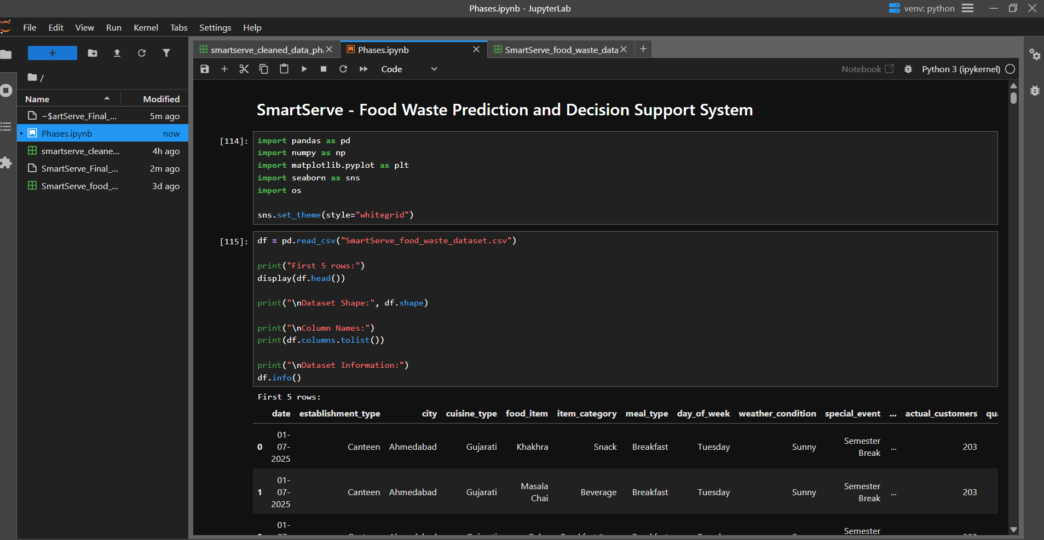
Screenshot 1: Jupyter Notebook showing the SmartServe project title and imported Python libraries.
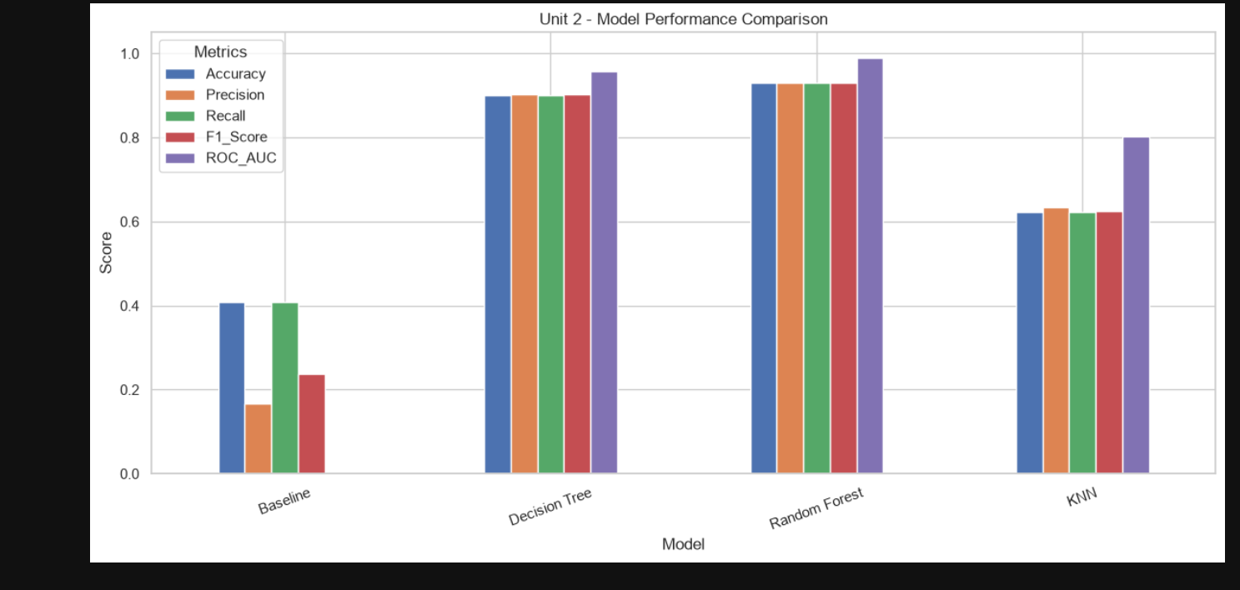
Screenshot 2: Model Performance Comparison.

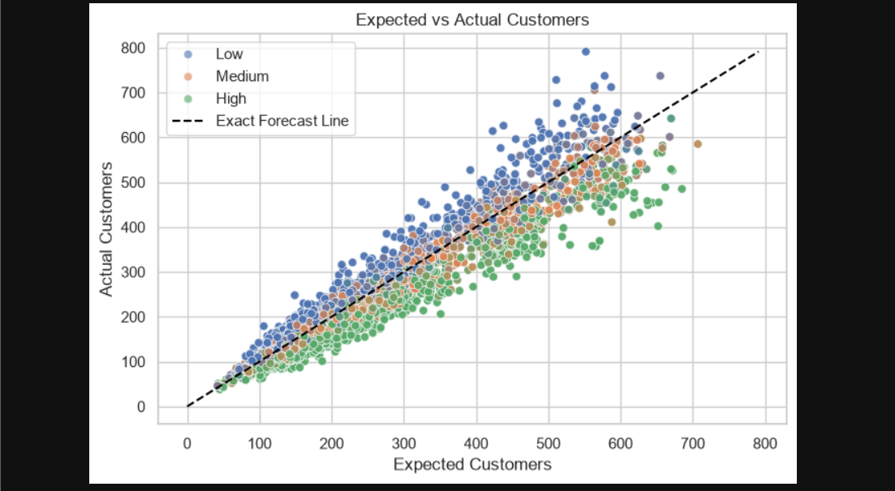
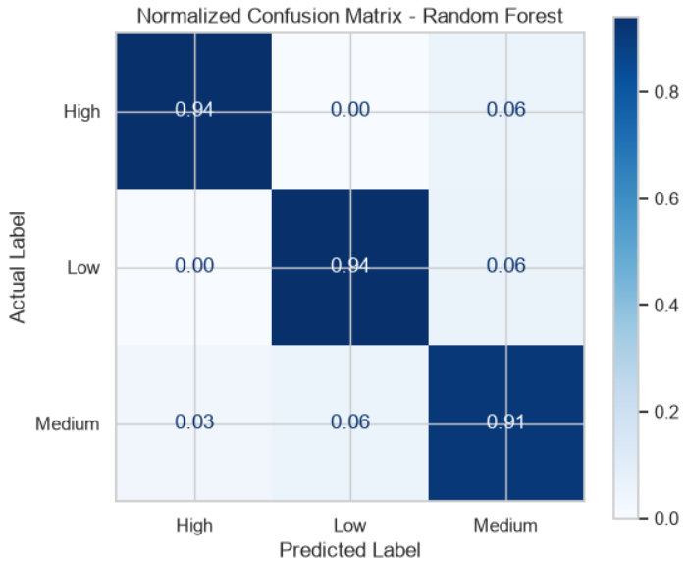
Screenshot 3: Data cleaning and the cleaned dataset output.
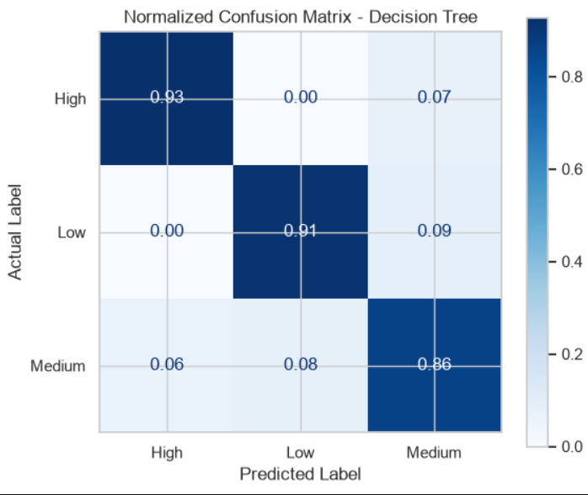
Screenshot 5: Model comparison table showing the evaluation metrics.

11. LIMITATIONS
SmartServe demonstrates a machine-learning workflow, but several limitations should be considered when interpreting its output.
- Synthetic dataset: The dataset is generated for academic use and does not represent verified records collected from actual restaurants, hotels, canteens or caterers.
- Real-world generalisation: Strong evaluation scores on synthetic data do not guarantee similar performance on real operational data. Real customer behaviour and food demand may be more complex.
- Dependence on input quality: Incorrect or unrealistic values for expected customers, prepared quantity, price, sales or other features can affect the prediction.
- Class imbalance: The Low class has more records than the Medium and High classes. Accuracy alone may hide weaker performance for a less frequent class.
- Risk category rather than exact waste: The classifier predicts Low, Medium or High risk. It does not directly provide a guaranteed amount or percentage of future food waste.
- Limited operational validation: The model has not been established as a live decision system through a trial in a real food-service business.
- Notebook-only interface: The completed project runs in Jupyter Notebook. It does not provide a dedicated interface for restaurant staff or an independently deployed application.
- Changing demand conditions: Unexpected events, sudden customer changes, supply interruptions and local conditions may not be fully represented in the synthetic data.
- Model dependence: The selected Random Forest reflects the patterns and assumptions in the generated dataset. Changes in the dataset-generation logic can change model behaviour.

11.1 Overall limitation
The most important limitation is that the model has been trained and evaluated on synthetic data. Therefore, the reported metrics are useful for demonstrating the project workflow, but they are not evidence of the same level of accuracy in real food-service environments.

12. FUTURE ENHANCEMENTS
The following improvements can be considered in future versions of SmartServe. They are proposed enhancements and are not described as features already completed.
- Real-world dataset collection: Collaborate with food-service establishments to collect authorised and anonymised historical planning, sales and leftover records.
- Larger and more diverse data: Include records from different cities, seasons, establishment sizes, cuisines and meal periods.
- Regular model validation: Re-train and evaluate the model on new records to check whether performance remains consistent over time.
- Class-wise evaluation: Review precision, recall and F1-score separately for Low, Medium and High classes, with special attention to identifying High-risk cases.
- Improved model comparison: Test additional algorithms and carefully tune parameters using cross-validation without allowing outcome information to leak into the input features.
- Better demand information: Add reliable historical demand trends and calendar information when such information is available before preparation.
- Prediction explanation: Add feature-importance or explainability analysis so that users can understand which input factors contributed to a risk prediction.
- User-facing interface: If required in a later phase, the notebook workflow could be connected to a separate interface. Such an interface is not part of the current completed project.
- Practical pilot testing: Evaluate predictions in a controlled pilot with a participating food-service establishment before considering operational use.

12.1 Expected benefit of future work
These improvements could make the project more reliable and useful in practical settings. The priority should be to obtain representative real-world data and validate the model before adding an interface or treating its predictions as operational recommendations.

13. REFERENCES
The following references relate to the programming language, notebook environment and libraries used in the SmartServe project.
1. Python Software Foundation. Python Documentation. https://docs.python.org/3/
2. Project Jupyter. Jupyter Notebook Documentation. https://jupyter-notebook.readthedocs.io/
3. Pandas Development Team. pandas Documentation. https://pandas.pydata.org/docs/
4. NumPy Developers. NumPy Documentation. https://numpy.org/doc/
5. Matplotlib Development Team. Matplotlib Documentation. https://matplotlib.org/stable/
6. The Seaborn Development Team. Seaborn Documentation. https://seaborn.pydata.org/
7. Scikit-learn Developers. Scikit-learn User Guide. https://scikit-learn.org/stable/user_guide.html
8. Scikit-learn Developers. RandomForestClassifier API Reference. https://scikit-learn.org/stable/modules/generated/sklearn.ensemble.RandomForestClassifier.html
9. Scikit-learn Developers. DecisionTreeClassifier API Reference. https://scikit-learn.org/stable/modules/generated/sklearn.tree.DecisionTreeClassifier.html
10. Scikit-learn Developers. KNeighborsClassifier API Reference. https://scikit-learn.org/stable/modules/generated/sklearn.neighbors.KNeighborsClassifier.html
11. Scikit-learn Developers. KMeans API Reference. https://scikit-learn.org/stable/modules/generated/sklearn.cluster.KMeans.html
Project-specific source files: SmartServe_food_waste_dataset.csv, smartserve_cleaned_data_phase02.csv and the SmartServe Jupyter Notebook developed for this academic project.
Note: The references above document the software and libraries used. The synthetic dataset is project-generated and is not an externally published real-world dataset.

