Autonomous Multi-Agent LLM Pipeline for Continuous Software Creation:
Architecture, Empirical Findings, and Emergent Behaviours

Dipesh Ray
Ulster University, Belfast, United Kingdom
ray-d@ulster.ac.uk - ORCID: 0009-0001-9970-0220

Abstract
This paper presents the design, implementation, and empirical evaluation of an autonomous multi-agent Large Language Model (LLM) pipeline that continuously conceives, architects, implements, quality-assures, and publishes novel software projects without human intervention. The system, Autonomous Brain, operates entirely on free-tier infrastructure, GitHub Actions for compute, GitHub Models API for LLM inference [2], and GitHub Pages for deployment, incurring zero operational cost. Over a 21-day observation period, the pipeline shipped 54 projects spanning six distinct project types, with complexity scores ranging from 3 to 52 on an open-ended scale, and 279 refused builds documented and analysed. The work demonstrates that hierarchical LLM role specialisation, failure-aware persistent memory, and automated quality gates can produce a self-improving, self-healing creative pipeline at zero marginal cost. Emergent behaviours, including autonomous strategy pivots, type bans, complexity escalation, and recovery modes, are characterised and analysed against the prior multi-agent systems literature [6][7][8]. The paper further examines enterprise-scale feasibility, cost projections, and a comparative analysis of contemporary multi-agent orchestration frameworks [9][10][11][12].
Index Terms: multi-agent LLM systems, autonomous software engineering, GitHub Actions, continuous deployment, emergent AI behaviour, zero-cost infrastructure, LangChain, CrewAI, AutoGen, enterprise LLM orchestration, agent frameworks.

I. Introduction
The rapid capability improvement of large language models (LLMs) has prompted significant research interest in agentic systems: pipelines in which multiple LLM calls are chained to accomplish multi-step tasks [6]. Prior work has concentrated on narrow agentic loops, code completion, web browsing, and tool use, rather than on sustained creative output over extended periods. This paper addresses a distinct question: can a hierarchical, multi-agent LLM system autonomously create diverse and novel software projects continuously, without human prompting, on entirely free-tier infrastructure?
The motivation is twofold. First, practically: many researchers and independent practitioners lack the budget for commercial AI APIs. GitHub's free tier, unlimited Actions compute, the GitHub Models API [2], and GitHub Pages, provides a meaningful zero-cost substrate. Second, scientifically: studying what such a system produces over weeks, and where it fails, reveals properties of LLM-based creative autonomy that are not observable in single-turn or short-horizon experiments.
The contributions of this work are: (1) a complete, open-source autonomous software-creation pipeline running on zero-cost infrastructure; (2) a hierarchical role architecture with thirteen distinct LLM personas across three model families with adversarial disagreement structurally encouraged; (3) an empirical record of projects shipped and builds refused over 21 days; (4) documentation of emergent system behaviours not explicitly programmed; (5) a Project Evolution mandate expanding to Python tools, browser games, generative art, and compiled CLI tools; and (6) a forward-looking enterprise scalability analysis covering cost projections, framework comparisons, and production-grade architectural requirements.
A. Scope and Limitations
This work is observational rather than controlled. The system runs on shared infrastructure with models periodically updated by their providers, studied over a 21-day window. Findings are descriptive rather than statistically rigorous. All source code and the complete memory log are publicly available at the repository stated above.
II. Related Work
The closest prior work is AutoGen [8], which provides a framework for multi-agent LLM conversation. Where AutoGen provides general orchestration primitives, the present work instantiates a specific creative pipeline with persistent memory, typed output validation, and mechanical browser-level quality gates. The generative agents system of Park et al. [7] demonstrates emergent social behaviour from LLM agents with memory; this paper examines analogous emergence in a software-engineering context.
ReAct [6] demonstrates the value of interleaving reasoning and action in agentic tasks. The present pipeline extends this across an eight-stage pipeline where each stage produces structured JSON output constraining the next. Playwright [4] provides mechanical verification; headless browser execution produces ground-truth interaction data that LLM reviewers alone cannot provide.
A. Contemporary Multi-Agent Frameworks
LangChain [9] is the most widely adopted framework, providing a graph-based orchestration layer (LangGraph) where agents are nodes and state transitions are edges. It supports streaming, tool use, memory backends (Redis, PostgreSQL), and hosted observability (LangSmith). CrewAI [10] is the closest conceptual match to Autonomous Brain: it assigns human-readable roles and goals to agents and runs them as a structured crew. However, CrewAI lacks a mechanical quality gate and relies on in-context memory rather than a persistent, committed state file.
MetaGPT [11] simulates a software company with Product Manager, Architect, and Engineer roles, generating structured artefacts (PRDs, design documents, code). Unlike Autonomous Brain, MetaGPT produces code for human review rather than autonomously deploying to a live URL with mechanical pass/fail verification. Microsoft Semantic Kernel [12] integrates LLMs via plugins and planners, better suited to assistant-style agents than creative generation pipelines. DSPy [13] from Stanford compiles declarative LLM programs by automatically optimising prompts against a metric. Haystack [14] by deepset provides enterprise-grade NLP pipeline tooling specialising in RAG, document search, and question answering.
TABLE A. Autonomous Brain vs. Contemporary Multi-Agent Frameworks
Framework | Approach | Memory | Verification | Auto-Deploy
Autonomous Brain | Boardroom roles | Persistent JSON | Playwright + LLM | Yes (GitHub Pages)
LangChain/LangGraph | Graph-based nodes | Configurable | None built-in | No
AutoGen | Conversational msgs | Session-based | None built-in | No
CrewAI | Role-based crew | Task memory | None built-in | No
MetaGPT | Software company | Structured docs | Code execution | No
Semantic Kernel | Plugin/planner SDK | Embeddings | None built-in | No
DSPy | Compiled programs | Optimised prompts | Metric-based | No
Haystack | NLP pipeline | Vector store | QA pipeline | No

A distinctive feature relative to all listed frameworks is the fully autonomous deployment loop: the pipeline not only generates code but commits it to GitHub, triggers GitHub Pages, and only records the project as shipped after the live URL is mechanically verified. No listed framework implements end-to-end deployment with live-URL verification as part of the agent loop.
III. System Architecture
A. Infrastructure
The entire system runs on GitHub's free tier. GitHub Actions [1] provides compute (unlimited minutes for public repositories). The GitHub Models API [2] gives access to GPT-4o and GPT-4o-mini via an OpenAI-compatible endpoint authenticated with the auto-injected GITHUB_TOKEN. Groq provides Llama and Mixtral inference at zero cost. Google AI Studio provides Gemini at zero cost. GitHub Pages [5] serves static output. The system's persistent state is a single JSON file, memory_log.json, committed to the repository after each run.
TABLE I. Infrastructure Components and Operational Costs
Component | Free-Tier Resource | Monthly Cost
Compute | GitHub Actions (public repo) | GBP0
LLM inference | GitHub Models, Groq, Google AI | GBP0
Hosting | GitHub Pages (static, unlimited) | GBP0
Persistent state | Git-committed JSON file | GBP0
Total |  | GBP0

B. Agent Roles
The pipeline instantiates a boardroom metaphor: thirteen distinct LLM roles, each with a specific mandate and explicit instruction to disagree with the others. Architects run at temperature=1.0 to maximise proposal diversity; higher-stakes roles (Judge, QA Tester) use lower temperatures for consistency.
TABLE II. Agent Roles, Models, and Mandates
Role | Model | Provider | Mandate
CEO | gpt-4o | GitHub Models | Visionary strategy, failure-aware directives
CSO | llama-3.3-70b | Groq | Scientific novelty, algorithmic depth
CTO | gemini-2.0-flash | Google | Self-improvement: patches own source code
Architect A/B | Llama 4 / 3.3 | Groq | Parallel proposals, temp=1.0
Judge | gpt-4o | GitHub Models | Predictability filter, reject derivative plans
Engineer | gpt-4o | GitHub Models | File-by-file implementation, full context
Reviewer A/B | Llama / Gemini | Groq / Google | Parallel critique conference
Fixer | gpt-4o-mini | GitHub Models | Targeted repairs from reviewer feedback
Polisher | Phi-4 | GitHub Models | Final UX pass with rollback protection
QA Tester / Fixer | gpt-4o / Gemini | GH / Google | Mechanical verification + structured verdict

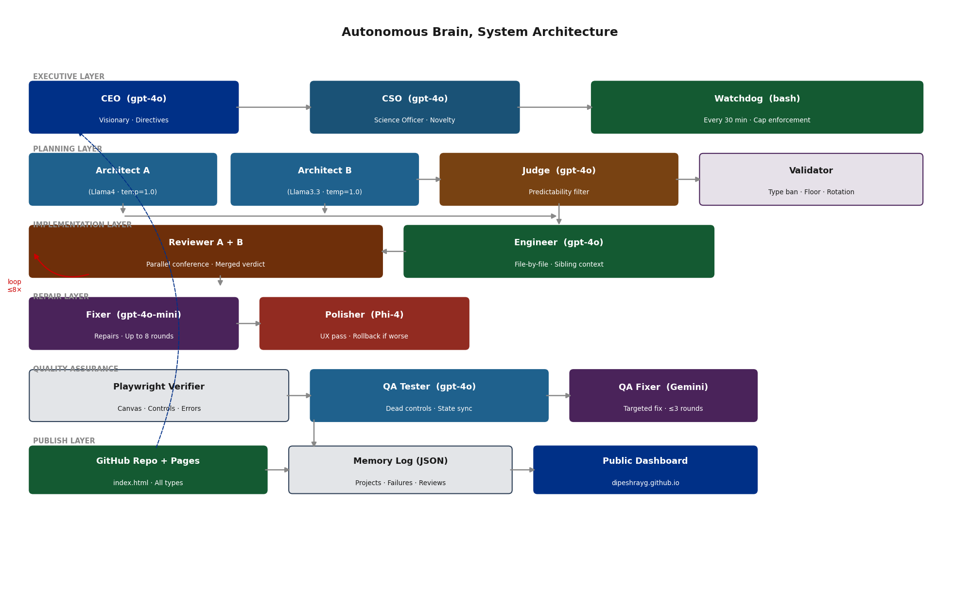
Fig. 1. Full system architecture, agent layers, data flows, and the memory feedback loop connecting the Publish layer back to the Executive layer.
C. Pipeline Stages
Each build traverses eight stages (Fig. 2). The Architect Conference carries the highest rejection rate: the validator checks complexity floor, file count, pattern/domain rotation, type diversity, type ban status, and novel concept requirements before any candidate advances. Approximately 30% of refused builds were rejected at this stage.
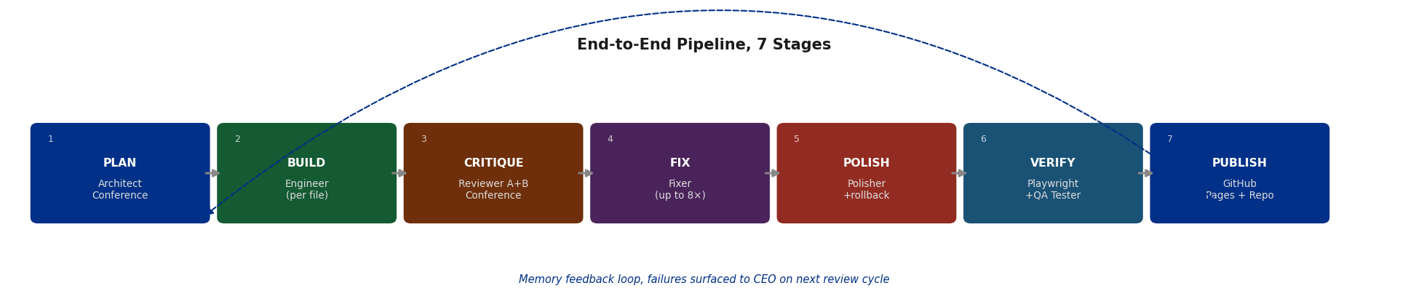
Fig. 2. Pipeline stage flow. The dashed arrow denotes the memory feedback loop: every refused build is appended to memory_log.json and read by the CEO on its next review cycle.
D. Project Types
The Project Evolution mandate expanded the system to ten distinct project types. Every type must produce an index.html at the repository root for GitHub Pages hosting, ensuring every project has a one-click live demo.
TABLE III. Project Types, Output Formats, Verifiers, and Complexity Ceilings
Type | Output | Verifier | Ceiling
web_interactive | HTML + JS + Canvas | Playwright | 80
game_web | Browser game with state | Playwright | 90
web_3d | Three.js / WebGL scene | Playwright | 90
generative_art | Visual output (SVG/canvas) | Playwright | 80
shader_art | GLSL fragment shader | Playwright (WebGL) | 80
python_tool | Python program + JS demo | Subprocess exit | 100
data_viz | Plotlib/Plotly + SVG embed | Subprocess + file | 80
typescript_app | ES-module JS app (esm.sh) | Playwright | 85
document | Markdown + styled HTML | Structure check | 60
cli_tool | Rust/Go CLI + devcontainer | File + Playwright | 90

IV. Key Mechanisms
A. Complexity Escalation
Each plan must exceed the maximum complexity score of recent projects by at least one point. The scale is open-ended. Architects consistently propose 1-3 points above the floor, producing compounding escalation from 3 to 52 over the observation period. In recovery mode (three or more consecutive failures), the floor is temporarily relaxed. A safeguard prevents emergency plans from recording lower complexity than the trajectory peak, stopping permanent regression.
B. Type Diversity Enforcement
Three constraints apply: (i) the same type may not be used consecutively; (ii) each type has a complexity ceiling; (iii) a type ban activates after three consecutive failures. Banned types are communicated to the CEO via a TYPE DIVERSITY REPORT. This mechanism converted an 18-build web_3d stuck loop into a single-build recovery.
C. Mechanical Verification
Playwright [4] drives headless Chromium against a locally-served project copy, checking page load, non-blank canvas pixel content (getImageData), observable control state changes, and console errors (with environmental artefacts filtered). A separate LLM QA Tester assigns a structured verdict, shippable, partially_usable, or non_functional.
D. CTO Self-Improvement
After each CEO review, self_improve.py analyses the 30 most recent failed builds and asks the CTO agent (Gemini 2.0 Flash) to propose one surgical old_string/new_string patch. The patch is validated with ast.parse(), committed, and logged, creating a genuine self-modification loop.
E. Watchdog Autonomy
A watchdog workflow runs every 30 minutes, dispatching builds when daily ship count is below five, at least five hours have elapsed since the last ship, and no build is currently running. A hard cap of eight dispatches per day prevents runaway token consumption.
V. Results and Evaluation
A. Overview
TABLE IV. Summary Statistics, 21-Day Observation Period
Metric | Value
Total projects shipped | 54
Total refused builds | 279
Overall ship rate | 16% (54 / 333 attempts)
Observation period | 21 days (28 April - 18 May 2026)
Complexity range | 3 - 140 (open-ended scale)
Mean complexity | 46.7
Peak complexity | 140
Project types shipped | 6 of 10 available types
CEO review cycles | 184
Total infrastructure cost | GBP0

B. Complexity Progression
Complexity rose from 3-8 to 40-52 over the observation period. The progression was not monotonic -- failure streaks triggered recovery mode -- but the linear trend (Fig. 3) held throughout. The escalation was not directed: it emerged from the floor rule combined with architects' tendency to aim just above the minimum threshold.
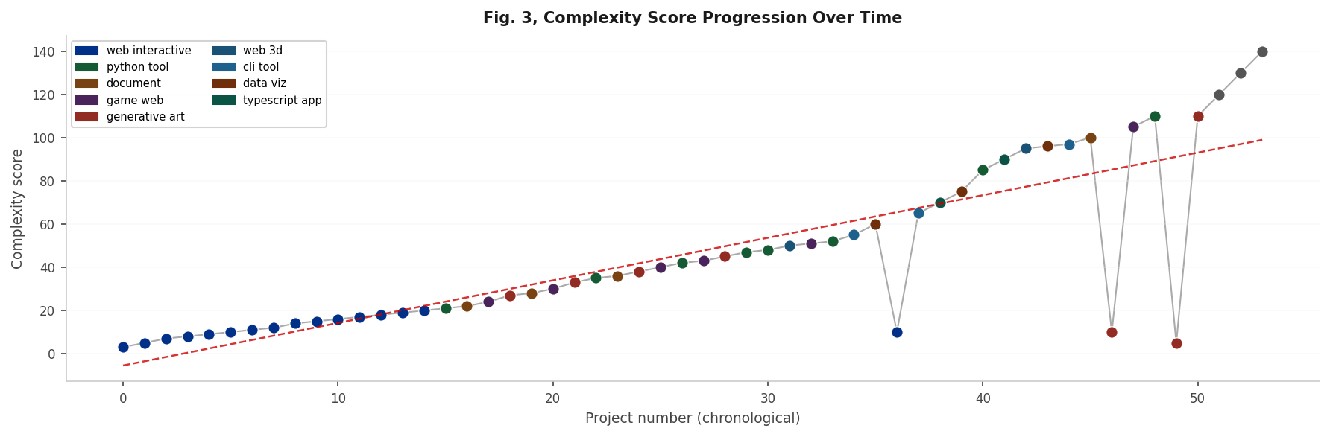
Fig. 3. Complexity score progression over shipped projects. Dashed red line: linear trend. Dot colours indicate project type.
C. Type Distribution and Failure Modes
Six of ten available project types were shipped. web_interactive dominated early output before type rotation enforced diversity. The five primary failure modes are shown in Fig. 4: blank canvas rendering (35%) was addressed by adding explicit requestAnimationFrame instructions to the engineer prompt.
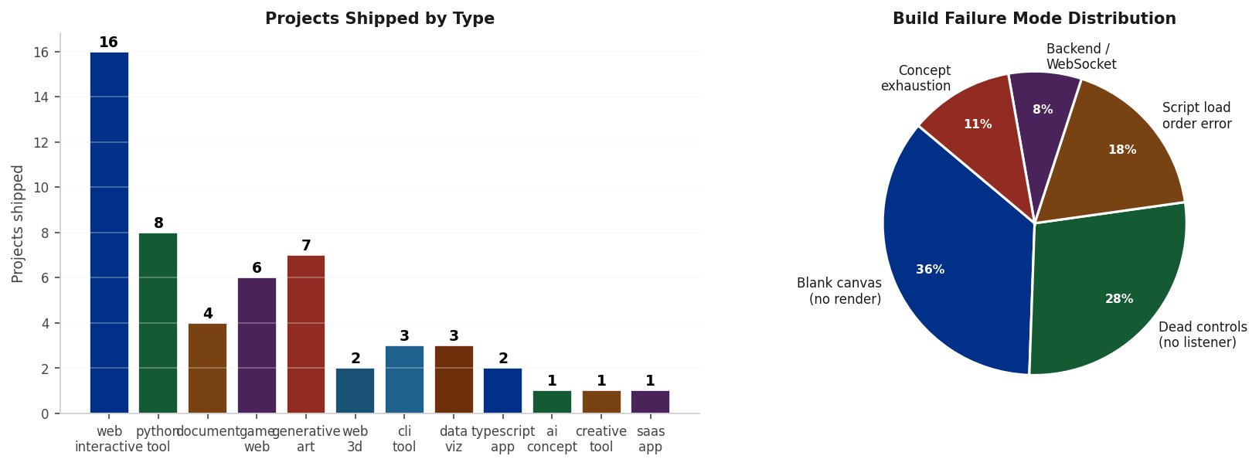
Fig. 4. Left: projects shipped by type. Right: failure mode distribution.
D. CEO Verdict Trajectory
The CEO issued review cycles throughout the observation period. The most notable event was an alarming verdict during the web_3d failure streak; the CEO independently pivoted directives and the next build shipped first attempt.
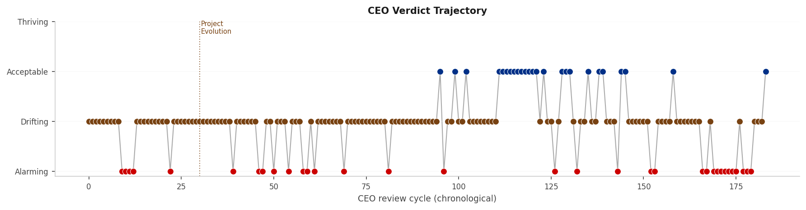
Fig. 5. CEO verdict trajectory. Dotted vertical line marks Project Evolution mandate.

VI. Emergent Behaviours
A. Failure-Driven CEO Strategy Pivots
Adding failed_builds[] to the CEO's context changed its behaviour immediately: it spontaneously scaled back complexity demands and shifted domain without explicit instruction. This matches the ReAct pattern [6] at a strategic level.
B. Unsupervised Complexity Escalation
Architects consistently propose 1-3 points above the floor, compounding into a steady upward trajectory over dozens of projects. The result resembles escalation dynamics in competitive multi-agent settings, produced here by a single-objective floor constraint.
C. Adversarial Reviewer Disagreement as a Quality Signal
Running two independent reviewers at temperature=0.85 produces frequent disagreement. The merger treats a split as fix. This correlated with genuine quality issues: projects with unanimous ship had markedly higher QA pass rates. Adversarial structure turned disagreement from noise into a predictive signal.
D. Type Ban Self-Healing
The type ban mechanism broke an 18-build web_3d loop. The CEO's verdict shifted to alarming and directives pivoted away from web_3d. The following document-type build shipped first attempt. The pivot language was not scripted; it emerged from reading the memory log under a prompt emphasising shipping over exploration.
VII. Discussion
A. Failure as Information
The central insight is that failure records made visible to the strategic layer drive system improvement. Without failed_builds[], the CEO consistently demanded unreachable targets. With it, adaptation occurred within one review cycle. This is consistent with reinforcement learning principles: reward signal quality determines learning speed, achieved here with no gradient, no parameter update, and no explicit reward function.
B. Limitations
The WebGL verification problem (canvas reads blank in headless Chromium) remains partially unresolved for shader_art. The flat JSON memory limits semantic depth. The architects run on generalist LLMs not fine-tuned for software architecture. The observation period is 21 days, insufficient to characterise long-run reliability.
C. Future Directions
Most immediately promising: (1) a vision-model screenshot reviewer for WebGL/3D types supplementing pixel-level canvas checks; (2) cross-platform publishing to PyPI, preprint servers, and npm; (3) replacing flat JSON memory with a vector database (Pinecone, Weaviate, Chroma) for semantic retrieval of past concepts and failure patterns at scale.

VIII. Enterprise Scalability and Cost Analysis
The zero-cost architecture described above is viable at research and personal-project scale. Several structural assumptions break down as usage volume increases. This section examines each free-tier dependency, its enterprise-grade replacement, associated costs, and the architectural changes required for production deployment.
A. Free-Tier Rate Limits and Enterprise Thresholds
GitHub Actions [1] provides unlimited compute minutes for public repositories. A private-repository enterprise deployment transitions to GitHub Team (3,000 min/month at $4/user/month) or GitHub Enterprise Cloud (unlimited at $21/user/month). GitHub Models API [2] is currently in public beta with no SLA, rate-limited to approximately 15 requests/minute and 150,000 tokens/minute. Production use requires migration to Azure OpenAI Service (SLA 99.9% uptime, data residency, private VNet).
Groq Cloud free tier is limited to 6,000 requests/day and 500,000 tokens/minute for Llama 3.3 70B; the paid tier charges approximately $0.59/million tokens. Google AI Studio provides Gemini 2.0 Flash free at 15 RPM; production use through Vertex AI costs approximately $0.075/million input tokens. These limits are sufficient for 2-5 builds per day; an enterprise deployment at 200-500 builds/day would exceed them within hours.
TABLE V. Free-Tier Rate Limits vs. Enterprise Pricing (2025-2026)
Provider | Free Tier Limit | Enterprise Tier | Cost (Enterprise)
GitHub Actions | Unlimited (public repos) | GitHub Enterprise Cloud | $21/user/month
GitHub Models API | 15 RPM, 150K tokens/min (beta) | Azure OpenAI Service | $2.50/1M in, $10/1M out (GPT-4o)
Groq | 6,000 RPD, 500K tokens/min | GroqCloud Paid | $0.59/1M tokens (Llama 3.3 70B)
Google AI Studio | 15 RPM (Gemini 1.5 Flash) | Vertex AI | $0.075/1M in, $0.30/1M out
GitHub Pages | Unlimited static (public repos) | CDN / S3 + CloudFront | ~$0-50/month

B. Enterprise LLM Provider Landscape
Azure OpenAI Service (Microsoft) is the recommended migration path from GitHub Models as both use the OpenAI-compatible REST API. Azure OpenAI provides EU/UK data residency (critical for GDPR), private networking via Azure Virtual Network, enterprise abuse monitoring, and Provisioned Throughput Units (PTU) for reserved capacity at predictable monthly cost. Supported models include GPT-4o, GPT-4o-mini, o1, and embedding models.
Amazon Bedrock (AWS) is a fully managed multi-model service supporting Anthropic Claude 3.5 (~$3.00/million input tokens), Llama 3.x, Amazon Titan, and Mistral. It integrates with AWS IAM, VPC endpoints, and CloudWatch for model invocation logging. Google Vertex AI hosts Gemini, PaLM, and Code Bison with model monitoring and A/B testing. Self-hosted inference via vLLM [15] (continuous batching, PagedAttention for GPU memory efficiency) or Ollama [16] enables on-premise deployment of open-weight models (Llama 3.3 70B, Mixtral) at zero per-token cost, trading API fees for hardware capital expenditure.
C. Cost Projection at Scale
Each build consumes approximately 150,000 input tokens and 40,000 output tokens across all LLM calls (CEO, architects, engineer, reviewers, QA), and an average of 20 GitHub Actions minutes. Four deployment scales are modelled below.
TABLE VI. Monthly Cost Projection at Different Deployment Scales (GBP, approximate)
Scale | Builds/Day | GitHub Actions | LLM APIs | Storage/CDN | Monthly Total
Free (current) | 2-5 | GBP0 | GBP0 | GBP0 | GBP0
Small team (private) | 50 | ~GBP150 | ~GBP300 | ~GBP20 | ~GBP470
Startup | 200 | ~GBP600 | ~GBP1,200 | ~GBP60 | ~GBP1,860
Enterprise | 500+ | ~GBP2,000 | ~GBP3,500 | ~GBP200 | ~GBP5,700
Enterprise (PTU) | 500+ | ~GBP2,000 | ~GBP2,000 | ~GBP200 | ~GBP4,200

The PTU row illustrates a key enterprise optimisation: committing to reserved Azure OpenAI throughput reduces per-token costs by 30-45% for predictable high-volume workloads. At 500 builds/day the infrastructure is not free but remains cost-competitive relative to equivalent human engineering effort.
D. Production-Grade Architecture
Migrating to production requires changes across four dimensions.
State management: The flat memory_log.json file is unsuitable for concurrent builds. The recommended replacement is PostgreSQL for structured records plus a vector store (Pinecone [17], Weaviate, or Chroma) for semantic retrieval of past concepts and failure patterns. A message queue (Apache Kafka [18], RabbitMQ, or AWS SQS) decouples the watchdog dispatcher from the build executor, enabling parallel pipelines.
Orchestration: GitHub Actions is adequate for sequential CI/CD but does not support complex DAG-based workflows. Enterprise deployments can use Kubernetes [19] with the Actions Runner Controller for autoscaling build pods, or replace Actions with Argo Workflows or Prefect [20] for richer DAG orchestration with dependency tracking and retry semantics.
Observability: LangSmith [21] records every LLM call with input/output pairs, latency, and token counts per agent role. Alternatives include Helicone (OpenAI proxy with analytics) and Arize AI (LLM performance monitoring). Infrastructure metrics flow to Prometheus + Grafana or Datadog. OpenTelemetry provides a vendor-neutral tracing standard across all pipeline stages.
Security and compliance: Guardrails AI [22] and NVIDIA NeMo Guardrails [23] provide input/output validation against policy constraints (no PII, no licence-violating code). The OWASP LLM Top 10 [24] defines primary threat classes including prompt injection, insecure output handling, and supply-chain vulnerabilities in model dependencies. The EU AI Act (effective August 2024) classifies autonomous code-generation systems in the general-purpose AI category, requiring technical documentation, transparency notices, and incident reporting at enterprise scale.
TABLE VII. Free-Tier vs. Enterprise Architecture Dimensions
Dimension | Current (free tier) | Enterprise Replacement | Key Tools
State | memory_log.json (Git) | PostgreSQL + vector store | Pinecone, Weaviate, Chroma
Orchestration | GitHub Actions (YAML) | Kubernetes + DAG engine | K8s, Argo Workflows, Prefect
Message queue | None (sequential) | Async event bus | Kafka, RabbitMQ, AWS SQS
LLM tracing | None | Structured prompt tracing | LangSmith, Helicone, Arize
Infra metrics | None | Metrics + alerting | Prometheus, Grafana, Datadog
Security | GitHub TOS compliance | Input/output guardrails | Guardrails AI, NeMo Guardrails
Compliance | N/A | GDPR, EU AI Act, OWASP LLM Top 10 | Azure compliance, SOC 2

E. Agent Memory Architecture at Scale
The current single-file memory design limits the pipeline in three ways: it cannot be read concurrently by parallel builds; semantic similarity queries require full file scans; and it grows without bound. A production memory architecture separates concerns into three layers. The episodic layer stores structured records in a relational database with indexed timestamps and project types. The semantic layer embeds project descriptions and failure reasons using a sentence-transformer model and stores them in a vector database, enabling nearest-neighbour retrieval for concept novelty checks. The strategic layer maintains the CEO/CSO directive history as a time-series, enabling trend analysis beyond simple verdict counting.

IX. Production Re-Architecture and Enterprise Re-Orientation
Beyond the research prototype, the system was re-architected into a production-grade, board-presentable platform while strictly preserving the zero-cost constraint. This section documents the frameworks adopted, the engineering actions taken, the enterprise re-orientation of the generated deliverables, and the explicit decision to decline a paid cloud backend.
A. Persistent Data Layer: Row-Level-Secured Postgres
The original flat memory_log.json state file was elevated to a managed PostgreSQL system of record on Supabase. Seven normalised tables (projects, failed_builds, ceo_reviews, cso_reviews, build_logs, taxonomy, and a singleton system_state) carry indexes and JSON columns for nested artefacts. Row Level Security (RLS) is enabled on every table and is the core of the security model: the public may read only the project showcase and an aggregate statistics view; all operational data (failure logs, executive reviews, the raw build-log stream, and runtime state) is readable only by authenticated users; and every write is restricted to a service-role key held exclusively by the engine. The engine mirrors each shipped project, refused build, and executive verdict into Postgres on every run through a best-effort synchronisation layer that never blocks or fails a build, with the committed JSON file retained as a durable fallback.
TABLE VIII. Access model enforced by Row Level Security
Table | Public read | Auth read | Writes
projects | Yes | Yes | service role only
taxonomy | Yes | Yes | service role only
failed_builds | No | Yes | service role only
ceo_reviews / cso_reviews | No | Yes | service role only
build_logs | No | Yes | service role only
system_state | No | Yes | service role only

B. Live Operational Dashboard
A single-page application built with React and Vite, using the Supabase JavaScript client, is compiled to a static bundle and deployed to GitHub Pages. It presents a public project showcase, read with the anonymous key and bounded by RLS, alongside an authenticated operations panel (passwordless magic-link authentication) that exposes failure logs, CEO and CSO reviews, and the live build stream. The anonymous key is safe to embed in the browser precisely because the access boundary is enforced server-side by RLS rather than by client code. This yields a credible, self-updating demonstration surface suitable for an enterprise audience.
C. Engine Portability: A Parallel Node.js Implementation
A second implementation of the engine was begun in Node.js (zero runtime dependencies, using the built-in fetch API) alongside the production Python engine. The migration deliberately follows a parallel-build-and-cutover strategy rather than a destructive in-place rewrite: the Python engine remains the shipping path until the Node implementation reaches verified functional parity, at which point traffic is switched. The executive (CEO and CSO) modules were ported first and confirmed to run end-to-end in continuous integration, writing verdicts to both the JSON ledger and Postgres.
D. Enterprise Deliverable Tier and Target Verticals
An enterprise mode constrains the architect to a product-grade type tier and forbids hobbyist output (generative art, shader toys, browser games). Each deliverable must present a multi-view application shell, a coherent design system expressed through CSS custom properties, and realistic synthetic enterprise data rather than placeholder text. The result is intended to read like a funded business-to-business product across a range of regulated and data-intensive verticals.
TABLE IX. Enterprise deliverable types and representative target domains
Deliverable type | Representative enterprise domains
saas_app | B2B CRM, HR / people analytics, customer success, project operations
b2b_dashboard | FinOps and revenue, security operations (SOC), supply-chain, product analytics
enterprise_webapp | IT asset management, approval workflows, access-control consoles, CMS admin
system_design | Multi-region reference architectures, event-sourcing / CQRS, streaming data platforms
api_platform | Payments APIs, geocoding APIs, LLM gateway APIs with usage and rate-limit docs
devtool | CI/CD pipeline dashboards, feature-flag managers, observability and log explorers

E. Rationale for Declining a Cloud (AWS) Backend
A paid cloud backend such as Amazon Web Services was deliberately not adopted, for three reasons. First, the zero-cost property is the system's defining contribution; introducing per-hour compute or per-request charges would directly undermine the central claim. Second, the proposed AWS capabilities are redundant at the current scale: GitHub Actions already supplies ephemeral compute and Supabase already supplies a managed Postgres database and authentication, both on free tiers, so an AWS layer (Lambda, S3, IAM, VPC) would duplicate capabilities that are already present at no cost. Third, every additional managed service enlarges the operational and security surface without a corresponding capability gain. Critically, this is a present-scale decision rather than a ceiling: the analysis in Section VIII shows the same architecture migrates cleanly to Amazon Bedrock, Azure OpenAI, or Google Vertex AI when sustained volume justifies the cost, so declining AWS today forecloses no future option.
F. Multi-Agent Team Configuration and Reliability Engineering
The thirteen-role boardroom is distributed across three providers, and each role's model chain is tuned to its workload and to provider rate limits. Three reliability findings shaped the final configuration. First, the implementation (engineer) role was moved to a large-context model (Gemini 2.0 Flash) as its primary so that a complete, self-contained application can be generated without truncation against the free tier's 8000-token request ceiling. Second, a recurring enterprise-application failure, in which per-view scripts injected after the page's load event never execute and leave the interface frozen on a loading placeholder, was eliminated by mandating self-contained single-document applications whose router toggles the visibility of inline views rather than fetching code at runtime. Third, the mechanical verifier was extended to detect this never-rendered state directly and to treat it as an objective hard failure, independent of the language-model quality verdict.
G. Operational Resilience Modes
Three operating modes keep the autonomous loop running without human intervention. Non-halting execution records refused builds and transient model failures but exits successfully, so the continuous-integration status reflects only genuine infrastructure faults rather than the normal churn of a creative pipeline. Expansion mode widens the deliverable type space and clears type bans when the executive verdict reaches alarming, allowing the system to escape local minima. A ship-first quality gate publishes any deliverable that is not objectively non-functional, surfacing partial states honestly to viewers through a badge, so the portfolio grows continuously while remaining transparent about quality.
X. Conclusion
This paper has presented Autonomous Brain, a multi-agent LLM pipeline that continuously designs, implements, quality-assures, and publishes novel software projects without human intervention, at zero operational cost. Over a 21-day period the system shipped 54 projects across six domain types, self-healed from a two-day failure loop autonomously, and exhibited consistent complexity escalation and CEO-level strategy adaptation in response to failure data.
The core architectural insight is that adversarial role separation, persistent failure memory, and automated mechanical quality gates together produce a pipeline that improves its own output quality over time without any parameter update or human diagnosis. Failure is information; making it visible to the right agent at the right time produces emergent learning behaviour.
The enterprise scalability analysis demonstrates that the zero-cost constraint is a design choice, not a fundamental limitation. The same architecture migrates cleanly to Azure OpenAI, Vertex AI, or Amazon Bedrock with predictable cost scaling. Primary architectural changes for enterprise deployment -- PostgreSQL + vector store, Kafka for async dispatch, LangSmith instrumentation -- are well-supported by the contemporary framework ecosystem. The system is fully open-source and continues to run daily, building software that it chose itself.
Finally, the production re-architecture in Section IX shows that research-grade autonomy and enterprise-grade engineering are not in tension. By adopting a row-level-secured PostgreSQL system of record (Supabase), a React dashboard, a portable Node.js engine, and a product-grade enterprise deliverable tier, while deliberately declining a paid cloud backend, the system became board-presentable without sacrificing its defining zero-cost property. The same free-tier substrate that proves the research claim also carries a credible enterprise demonstration.
Acknowledgement
The author acknowledges the use of GitHub Actions, GitHub Models API, Groq, and Google AI Studio, all accessed under their respective free-tier terms. No research funding was received for this work.

References
[1] GitHub, "GitHub Actions Documentation," GitHub Inc., 2024. [Online]. Available: https://docs.github.com/en/actions
[2] GitHub, "GitHub Models API," GitHub Inc., 2024. [Online]. Available: https://github.com/marketplace/models
[3] OpenAI, "GPT-4 Technical Report," arXiv:2303.08774, 2024.
[4] Microsoft, "Playwright Browser Automation Framework," 2024. [Online]. Available: https://playwright.dev
[5] GitHub, "GitHub Pages," GitHub Inc., 2024. [Online]. Available: https://pages.github.com
[6] S. Yao, J. Zhao, D. Yu, N. Du, I. Shafran, K. Narasimhan, and Y. Cao, "ReAct: Synergizing Reasoning and Acting in Language Models," ICLR, Vienna, 2023.
[7] J. S. Park, J. C. O'Brien, C. J. Cai, M. R. Morris, P. Liang, and M. S. Bernstein, "Generative Agents: Interactive Simulacra of Human Behavior," UIST, San Francisco, 2023, pp. 1-22.
[8] Q. Wu, G. Bansal, J. Zhang et al., "AutoGen: Enabling Next-Gen LLM Applications via Multi-Agent Conversation," arXiv:2308.08155, 2023.
[9] LangChain Inc., "LangChain and LangGraph Documentation," 2024. [Online]. Available: https://python.langchain.com
[10] J. Moura, "CrewAI: Framework for Orchestrating Role-Playing Autonomous AI Agents," 2024. [Online]. Available: https://crewai.com
[11] S. Hong, X. Zheng, J. Chen et al., "MetaGPT: Meta Programming for Multi-Agent Collaborative Framework," arXiv:2308.00352, 2023.
[12] Microsoft, "Semantic Kernel: Open-source SDK for LLM Integration," 2024. [Online]. Available: https://learn.microsoft.com/semantic-kernel
[13] O. Khattab, A. Singhvi, P. Maheshwari et al., "DSPy: Compiling Declarative Language Model Calls into Self-Improving Pipelines," arXiv:2310.03714, 2023.
[14] deepset, "Haystack: Open-Source LLM Framework for Production NLP Pipelines," 2024. [Online]. Available: https://haystack.deepset.ai
[15] W. Kwon, Z. Li, S. Zhuang et al., "Efficient Memory Management for Large Language Model Serving with PagedAttention," ACM SOSP, 2023.
[16] Ollama, "Ollama: Run Large Language Models Locally," 2024. [Online]. Available: https://ollama.com
[17] Pinecone, "Pinecone: The Vector Database for Machine Learning," 2024. [Online]. Available: https://pinecone.io
[18] Apache Software Foundation, "Apache Kafka: Distributed Event Streaming Platform," 2024. [Online]. Available: https://kafka.apache.org
[19] CNCF, "Kubernetes: Production-Grade Container Orchestration," 2024. [Online]. Available: https://kubernetes.io
[20] Prefect Technologies, "Prefect: Dataflow Automation for the Modern Data Stack," 2024. [Online]. Available: https://prefect.io
[21] LangChain Inc., "LangSmith: LLM Application Observability Platform," 2024. [Online]. Available: https://smith.langchain.com
[22] ShreyaR, "Guardrails AI: Adding Guardrails to Large Language Model Outputs," 2024. [Online]. Available: https://guardrailsai.com
[23] NVIDIA, "NeMo Guardrails: Toolkit for Controllable and Safe LLM Applications," 2023. [Online]. Available: https://github.com/NVIDIA/NeMo-Guardrails
[24] OWASP, "OWASP Top 10 for Large Language Model Applications," OWASP Foundation, 2023. [Online]. Available: https://owasp.org/www-project-top-10-for-large-language-model-applications/
[25] Supabase, "Supabase: The Open Source Firebase Alternative (Postgres, Auth, Row Level Security)," 2024. [Online]. Available: https://supabase.com
[26] Meta Open Source, "React: A JavaScript Library for Building User Interfaces," 2024. [Online]. Available: https://react.dev
[27] E. You and the Vite Team, "Vite: Next Generation Frontend Tooling," 2024. [Online]. Available: https://vitejs.dev
[28] OpenJS Foundation, "Node.js: JavaScript Runtime Built on V8," 2024. [Online]. Available: https://nodejs.org
[29] Google, "Gemini 2.0 Flash Model Documentation," Google AI, 2024. [Online]. Available: https://ai.google.dev

This paper documents original work conducted and authored by Dipesh Ray between April 28 and May 18, 2026. All statistics are drawn directly from memory_log.json of the autonomous-brain-engine repository at the time of generation. Repository: github.com/dipeshrayg/autonomous-brain-engine. ORCID: 0009-0001-9970-0220.

