**EXPERIMENT NO. 4**

Aim: To understand continuous integration, install and configure Jenkins with Maven/Ant/Gradle to set up a build job.

Theory:

To install Jenkins following software packages are required:

1. GIT (git-scm.com)
2. Notepad++ (<https://notepad-plus-plus.org/downloads/>)
3. Latest Java development kit (JDK)
4. Jenkins
5. Apache Maven (Optional)

Step 1-: Install GIT

Step 2 -: Install Notepad++

Step 3 -: Install Java

Step 4 -: Install Jenkins

Step 5 -: Install Maven

Jenkins is an open source automation tool written in Java with plugins built for Continuous Integration purpose. Jenkins is used to build and test your software projects continuously making it easier for developers to integrate changes to the project, and making it easier for users to obtain a fresh build. It also allows you to continuously deliver your software by integrating with a large number of testing and deployment technologies.

**Installation Steps for Jenkins on Windows**

Step 1-: Open <https://www.jenkins.io/doc/book/installing/windows/> and install Jenkins.

Open the installed .exe setup.

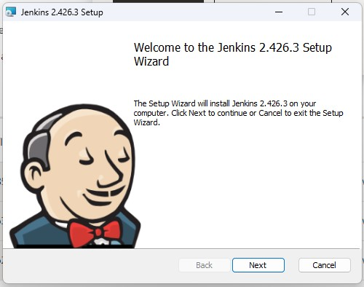

Step 2: Locate the folder where you want to install Jenkins in the location path:

Step 3: Select service as Local System and proceed to Next.

Step 4: Select the port 8080 and click Test Port button. The green tick will appear after which you can proceed to Next.

Step 5: Locate the folder where you have installed JDK in the location path:

Proceed to Next,

On clicking ‘Install’, installation is finished.

Step 6: Once Installation is done, you can test the Jenkins on http://localhost:8080 on the browser.

First time, when you open Jenkins portal it will ask to put admin default password which is stored in /var/lib/jenkins/secrets/initialAdminPassword file.

Step 7: On entering the password, you can continue to choose “Install Suggested Plugins”

Once plugins are installed, click on next and specify the admin details along with the new password for Jenkins admin and click on finish to complete the installation.

After filling the details, click on Save & Continue, you will be redirected to the dashboard.

